Department of Computer Science & Engineering
Report on Mini Project

Water Consumption Pattern Analysis

Course Code : CS2003-1
Course Name : Machine Learning
Semester: VI SEM
Section: B

Submitted To:
Mrs. Soumya Ashwath
Department of Computer Science and Engineering

Submitted By:
K Bhavana Sharma (NNM23CS088)

Date of submission:
27/03/2026


CERTIFICATE
This is to certify that K Bhavana Sharma, bearing USN NNM23CS088, of VI Semester B.Tech (Computer Science and Engineering) at NMAM Institute of Technology, Nitte, has successfully completed his Machine Learning mini-project titled "Water Consumption Pattern Analysis" during the period January 2026 – April 2026, in partial fulfillment of the requirements for the award of the degree of Bachelor of Technology in Computer Science and Engineering.

_______________ _______________
Name and Sign of Mentor Signature of HOD

ABSTRACT

Water usage prediction is an important application of machine learning that helps in understanding and managing water consumption efficiently. In this project, a machine learning model is developed to predict water usage based on factors such as number of people, temperature, and type of day (weekday or weekend).
The dataset is preprocessed by handling missing values and converting categorical data into numerical form. Various data visualization techniques such as histogram, countplot, and boxplot are used to understand the data distribution and relationships between variables.

TABLE OF CONTENTS

Chapter No. | Contents | Page No.
1 | INTRODUCTION | 5
2 | PROBLEM STATEMENT & OBJECTIVE | 6
3 | RESULT | 7-11

INTRODUCTION
Water is an essential resource for daily life, and efficient management of water usage is very important. With increasing population and changing environmental conditions, predicting water consumption has become necessary.

Machine learning provides a powerful way to analyze data and predict future outcomes. By using historical data such as number of people, temperature, and day type, it is possible to estimate water usage.

In this project, a machine learning model is developed to predict water usage. Data preprocessing and visualization techniques are used to understand the dataset. A regression model is then trained to predict water usage based on input features. This helps in better planning and efficient use of water resources.

A Random Forest Regression model is used to train the data and make predictions. The model is evaluated using performance metrics such as Mean Absolute Error (MAE), Mean Squared Error (MSE), and R² Score. The results show that the model performs very well with high accuracy and low error.

PROBLEM STATEMENT

Water consumption varies depending on several factors such as number of people, weather conditions, and type of day. Predicting water usage manually is difficult and inefficient.

Therefore, there is a need for an automated system that can predict water usage using machine learning techniques. This project aims to develop a model that can accurately estimate water consumption based on given inputs.

OBJECTIVES

- To analyze water usage data using machine learning.
- To clean and preprocess the dataset.
- To visualize data using graphs like histogram, countplot, and boxplot.
- To build a prediction model using Random Forest Regression.
- To evaluate the model using MAE, MSE, and R² Score.
- To predict water usage for new input values

RESULT

In this project, water usage data was analyzed and a machine learning model was developed to predict water consumption.
The dataset was first cleaned by removing missing values and converting categorical data into numerical form. Various visualizations such as histogram, countplot, and boxplot were used to understand the data.
A Random Forest Regression model was trained using the dataset. The performance of the model was evaluated using the following metrics:
- MAE: 7.66
- MSE: 98.94
- R² Score: 0.99
The high R² score indicates that the model performs very well and can accurately predict water usage.
Additionally, graphs such as Actual vs Predicted plot and Feature Importance were used to analyze the model performance. The results show that factors like number of people and temperature significantly affect water usage.
The model can also take user input and predict water usage, making it useful for real-world applications.

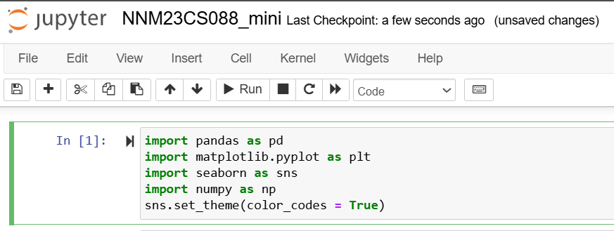

1.Importing libraries and adding dataset

Figure 1: Implementing Water Consumption Analysis Model in
Jupyter-Notebook

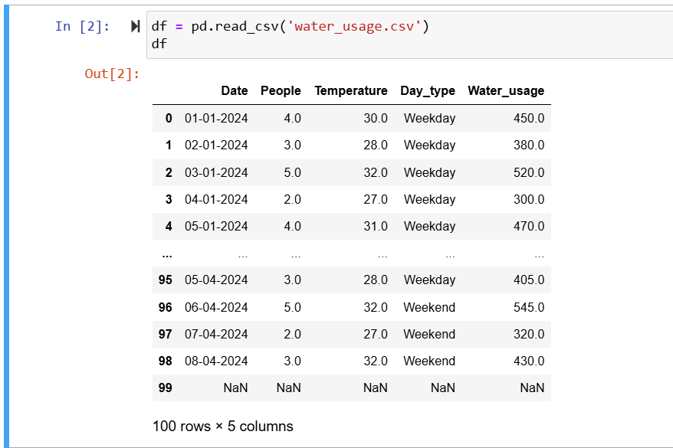

2. Loading dataset
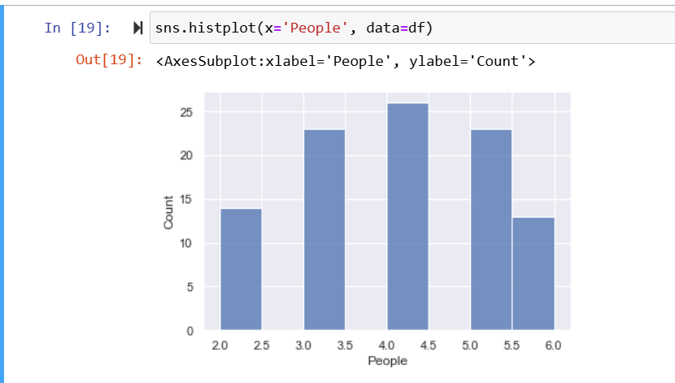

3. Data Visualisation
(a) Histogram

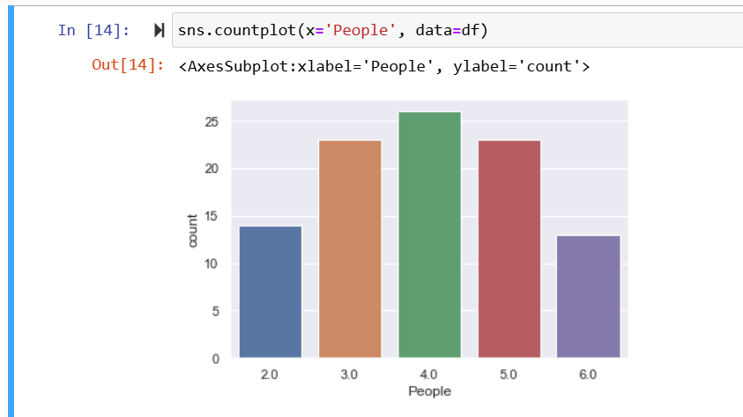

(b)Countplot

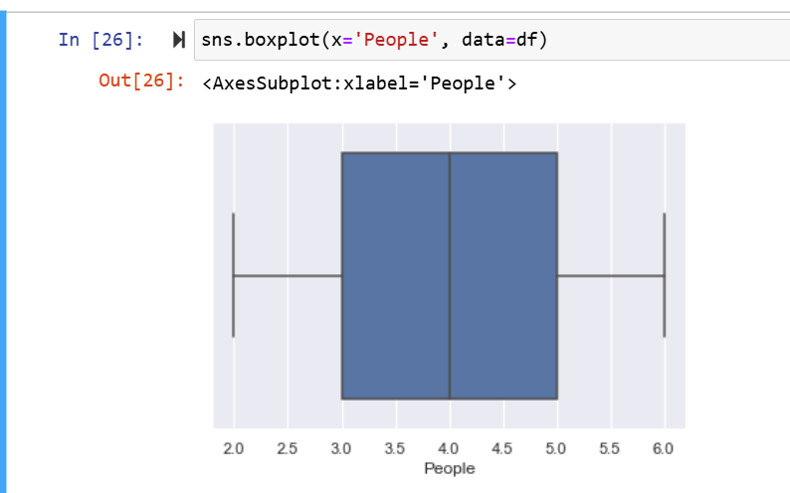

(c) Boxplot

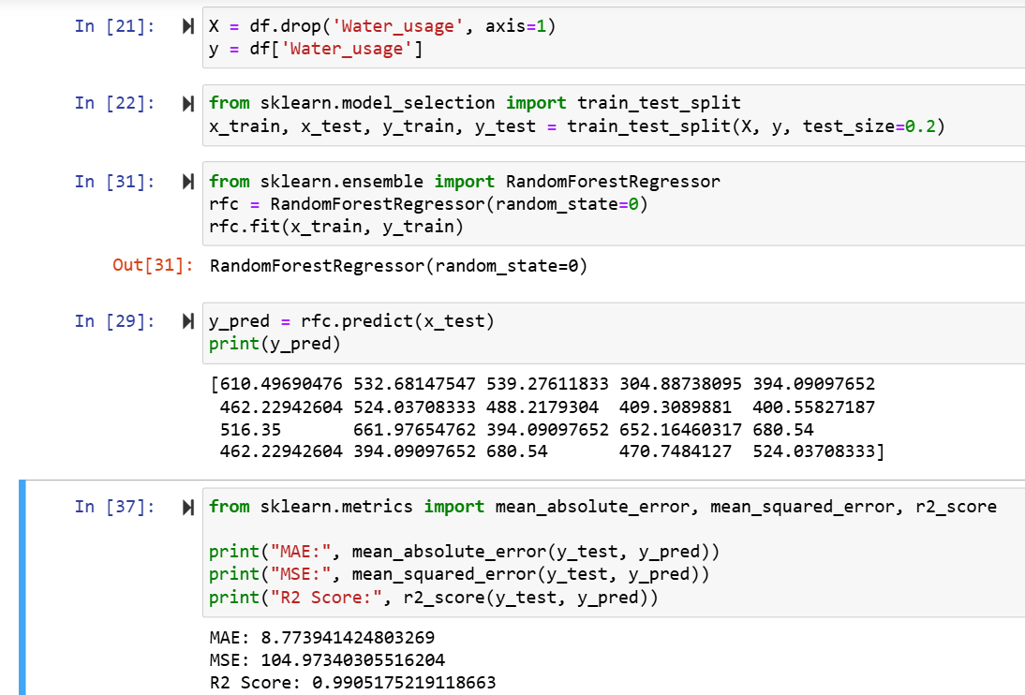

4. Model training

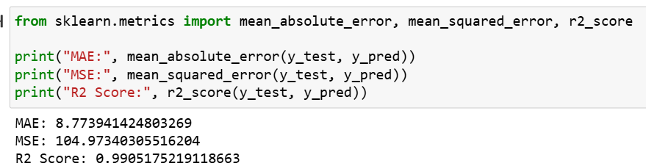

5. Evaluation results

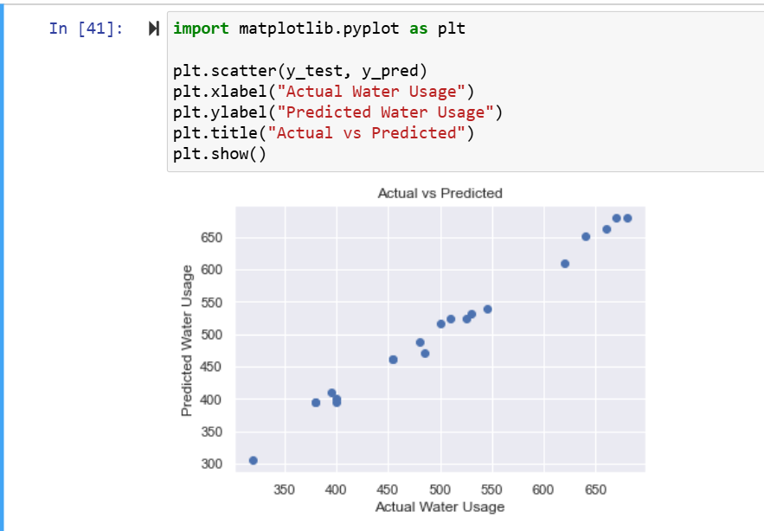

6. Actual vs Predicted graph

