AI ASSISTED CODING :-

NAME : BHAVANA.POMMEDI

Enroll No : 2403A54069

Batch : DS – Batch : 3

Assignment 7.3 :

Task Description 1  
• Paste a function with a missing colon (add(a, b)), and let AI fix the syntax error.

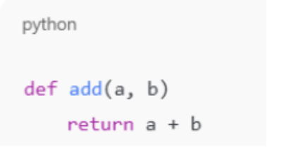

Prompt: correct the following code and input two numbers to find the sum

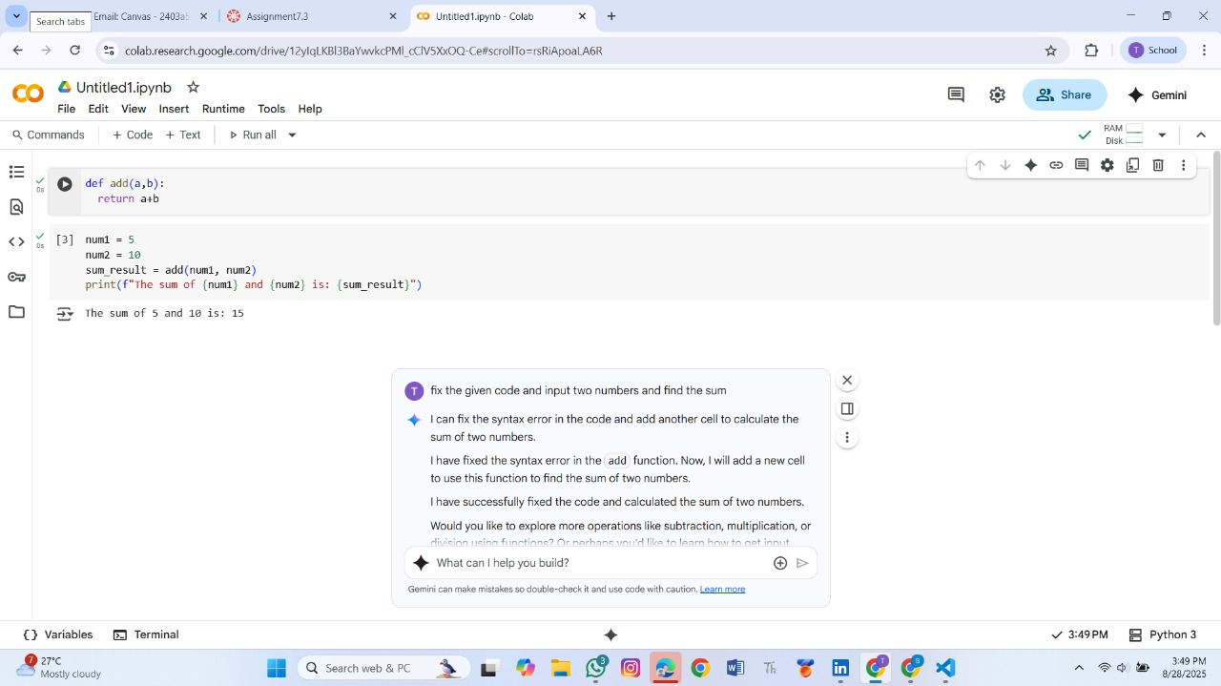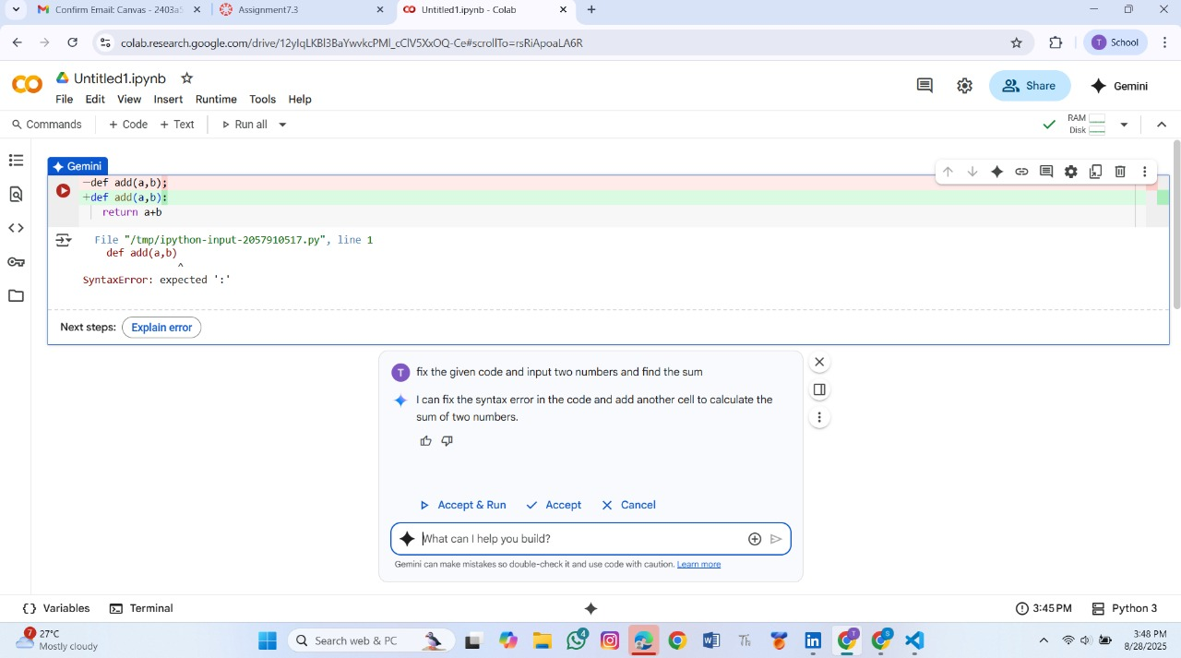

Output : Corrected function with syntax fix

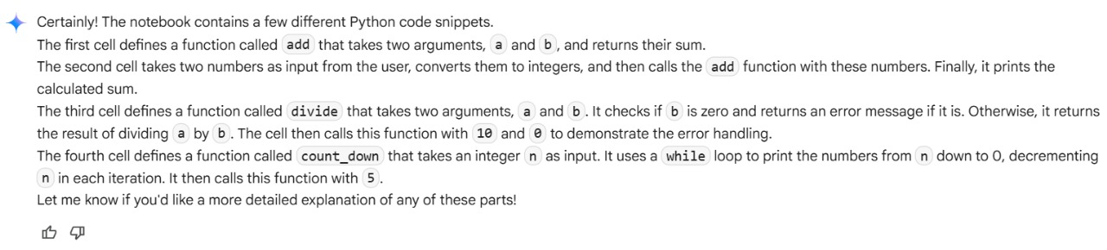

Task Description#2 (Loops)  
• Identify and fix a logic error in a loop that causes infinite iteration

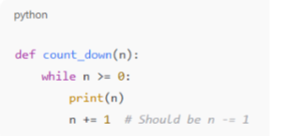

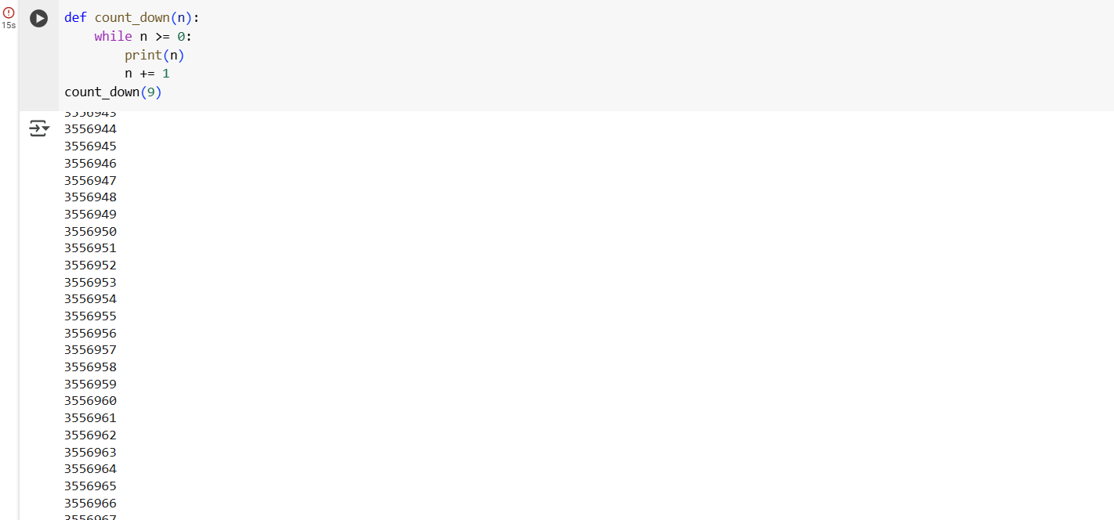Prompt :

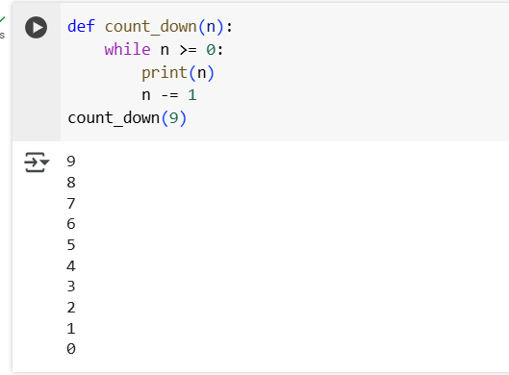

Output : AI fixes increment/decrement error

Explanation :

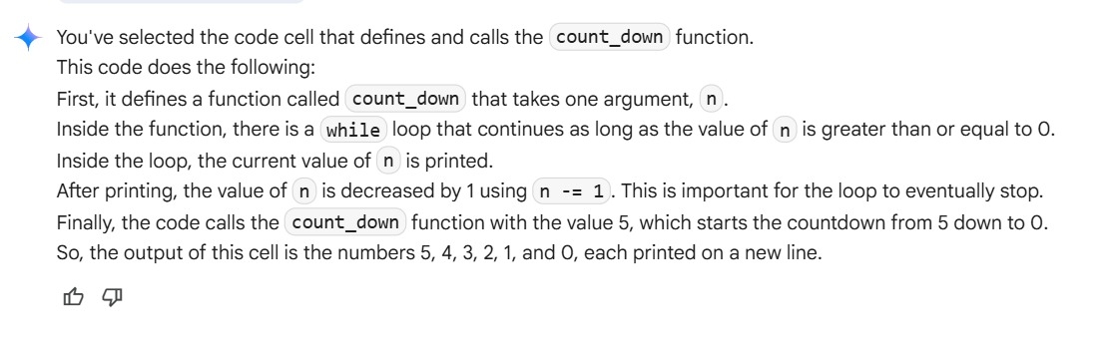

TASK 3:

Debug a runtime error caused by division by zero. Let AI insert try-except.

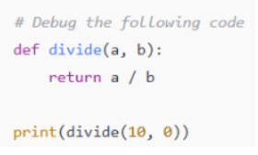

Prompt: correct the error and give the perfect input in the following code

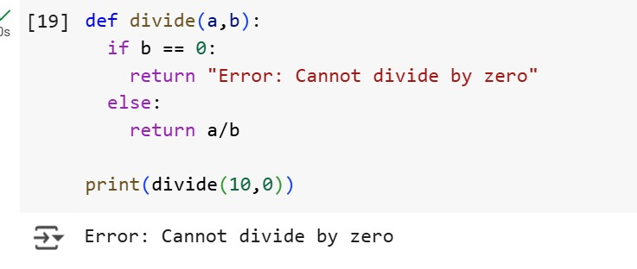

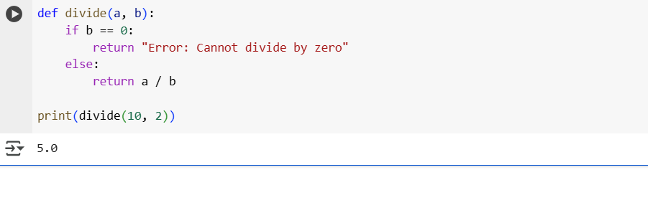

Output : Corrected function with safe error handling

Explanation :

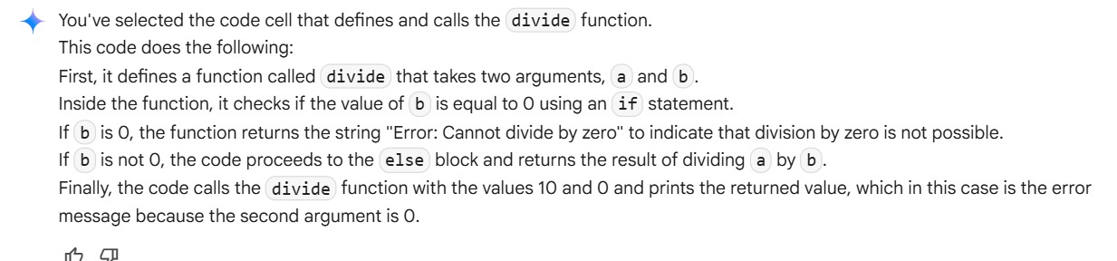

TASK 4 :

Provide a faulty class definition (missing self in parameters). Let AI fix it

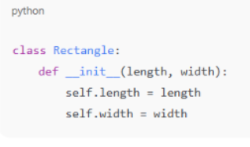

Prompt : correct the following code and give the suitable inputs

Code :

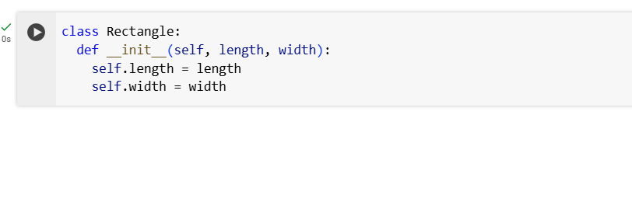 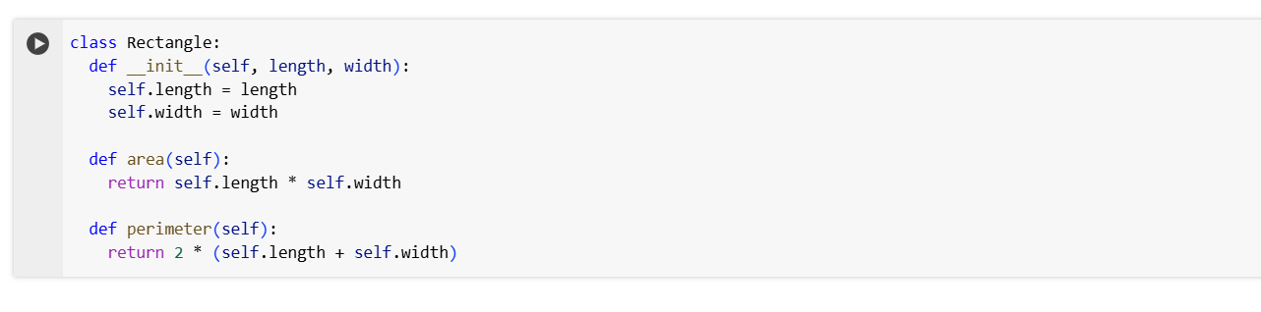

Output : Correct __init__() method and explanation

Explanation :

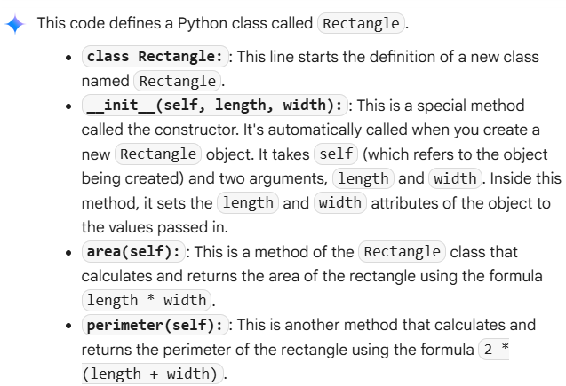

TASK 5 :

Access an invalid list index and use AI to resolve the Index Error

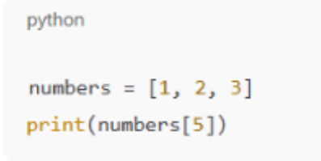

Prompt: fix the following code and explain it

Code : 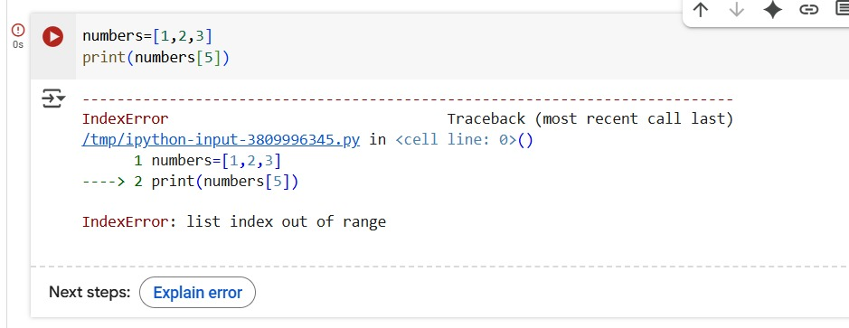

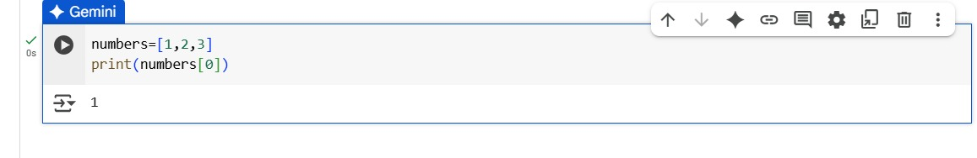

Output : AI suggests checking length or using safe access logic

Explanation :

