**LAB ASSIGNMENT-10**

**NAME:BHAVANA**

**ROLL – 2403a54069**

**Batch – 03 (DS)**

**Task 1: Syntax and Error Detection**

**Prompt:**

**Task: Fix the Python Code**

**What to do:**  
Look at the code below. It has some **mistakes** with **syntax** (like missing symbols), **spelling**, and **how the function is used**.  
Your job is to:

1. **Fix the code** so it runs correctly.
2. **Explain** what was wrong and what you fixed.

**Code:**

Output:

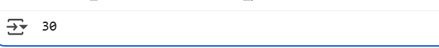

Explanation:

**Task 2: Logical and Performance Issue Review**

Prompt:

**Task:** Optimize the given function to find duplicates in a list more efficiently while keeping the result correct. Explain the improvements you made.

Code:

Output:

Explanation:

**Task 3: Code Refactoring for Readability**

Prompt:

Refactor the given messy code into clean, readable, and PEP 8–compliant code.

* Rename the function to something meaningful.
* Use proper indentation and variable names.
* Add a docstring to explain what the function does.

Code:

Output:

Explanation:

**Task 4: Security and Error Handling Enhancement**

**Prompt:**

**Task: Improve the given code by adding security measures and error handling.**

* **Prevent SQL injection by using parameterized queries.**
* **Add a try-except block to handle database errors gracefully.**
* **Validate user input before running the query.**

**Code:**

**Output:**



**Explanation:**

**Task 5: Automated Code Review Report Generation**

**Prompt:**

**Task: Review the following messy code and generate a detailed code review report.  
Your report should mention:**

* **Missing docstrings**
* **Inconsistent formatting (like indentation and inline returns)**
* **Lack of error handling (e.g., division by zero)**
* **Non-descriptive function and variable names**
* **Suggestions to improve readability and follow PEP 8 guidelines**

**Code:**

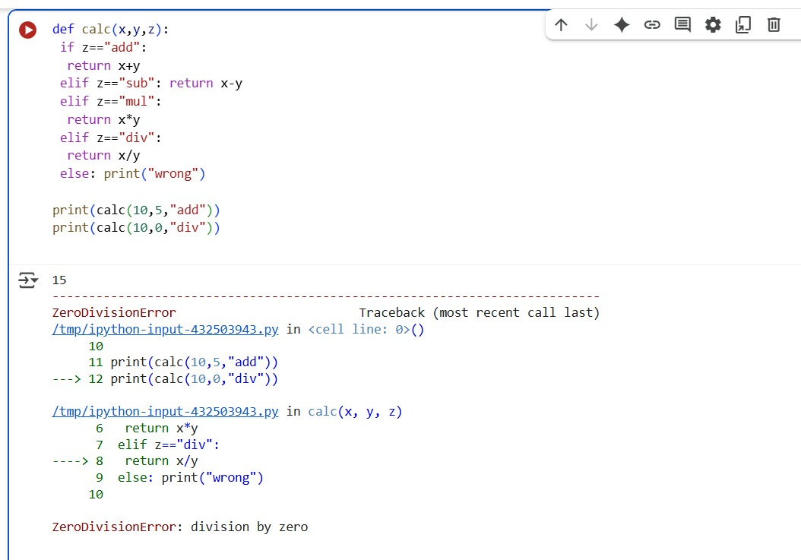

**Output:**

**Explanation:**

