**# Hotel Review Analysis For Business Prediction Using Deep Learning**

This project aims to analyze customer hotel reviews and classify them into sentiments (Positive, Negative, or Neutral) using deep learning models like LSTM and GRU. It also compares performance with traditional machine learning algorithms. This solution helps hotel businesses make data-driven decisions based on customer feedback.

**## Features**

- Sentiment classification of hotel reviews.

- Deep learning models: LSTM and GRU.

- Traditional ML models: Naïve Bayes, SVM, Decision Tree, Random Forest.

- Preprocessing of unstructured text data.

- Accuracy comparison between models.

- Simple Flask web interface for review prediction.

**## How to Run the Project**

**1. Clone the repository:**

git clone https://github.com/your-Bhavana157/hotel-review-analysis.git

cd hotel-review-analysis

**2. Install dependencies:**

pip install -r requirements.txt

**3. Run the Flask app:**

python app.py

**4. Open your browser and go to:**

http://localhost:5000

**## Output Screen:**

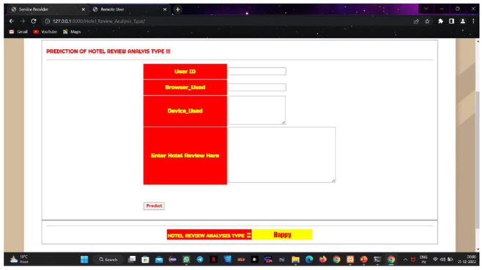

**## Reference Paper**

Ghosh, S., Mallick, P.K., & Sinha, B. (2020).

Sentiment Analysis of Hotel Reviews Using Machine Learning Techniques.

In 2020 IEEE 17th India Council International Conference (INDICON), pp. 1–5.

DOI: 10.1109/INDICON49873.2020.9342213

**## Author**

P.BHAVANA

B.Tech – Data Science

Malla Reddy Engineering College for Women, Secunderabad