

VISVESVARAYA TECHNOLOGICAL UNIVERSITY

**JNANA SANGAMA, MACHHE BELGAUM – 590018**

**KARNATAKA**



**A Mini-Project Report**

**On**

*“***COLLEGE EVENT MANAGEMENT”**

**SUBMITTED IN PARTIAL FULFILLMENT OF THE REQUIREMENTS FOR THE DBMS LABORATORY WITH MINI PROJECT OF 5th SEMESTER**

Submitted by

BHAVANA V [1CG17CS013] SUPRIYA N JAIN [1CG16CS103]

Under the guidance of

**Guide: HOD:**

**Mrs. Jyothi K S,( M.Tech) Dr.C P. Shantala, (Ph.D)**

Asst. Prof., Dept. of CSE Prof & Head, Dept. of CSE

CIT, Gubbi. CIT, Gubbi.

**DEPARTMENT OF COMPUTER SCIENCE & ENGINEERING**

**Channabasaveshwara Institute of Technology**

*(Affiliated to VTU, Belgaum & Approved by AICTE, New Delhi)*

(**NAAC Accredited & ISO 9001:2015 Certified Institution)**

*NH 206 (B.H. Road), Gubbi, Tumkur – 572 216. Karnataka.*

***2019-20***

** Channabasaveshwara Institute of Technology**

(Affiliated to VTU, Belgaum & Approved by AICTE, New Delhi)

(**NAAC Accredited & ISO 9001:2015 Certified Institution)**

NH 206 (B.H. Road), Gubbi, Tumkur – 572 216. Karnataka

### DEPARTMENT OF COMPUTER SCIENCE & ENGINEERING

**2019-20**

**CERTIFICATE**

This is to certify that the project entitled **“COLLEGE EVENT MANAGEMENT”** has been successfully carried out by **BHAVANA V[1CG17CS013] SUPRIYA N JAIN[1CG16CS103]** in partial fulfilment for the 5th semester during the academic year **2019-20**. It is certified that all the corrections / suggestions indicated for internal assessment have been incorporated in the report. The project report has been approved as it satisfies the academic requirements in respect of project work prescribed for the 5th semester.

**Signature of guide Signature of HOD**

**Mrs. Jyothi K S,( M.Tech) Dr.C P. Shantala, (Ph.D)**

Asst. Prof., Dept. of CSE Prof & Head, Dept. of CSE

CIT, Gubbi. CIT, Gubbi.

**Principal: Examiners:**

**Dr. Suresh** D S Ph.D 1.

CIT, Gubbi Tumakuru

2.

**Channabasaveshwara Institute of Technology**

(Affiliated to VTU, Belgaum & Approved by AICTE, New Delhi)

(**NAAC Accredited & ISO 9001:2015 Certified Institution)**

NH 206 (B.H. Road), Gubbi, Tumkur – 572 216. Karnataka.

### DEPARTMENT OF COMPUTER SCIENCE & ENGINEERING

**2019-20**

**DECLARATION**

I, **BHAVANA V[1CG17CS013], SUPRIYA N JAIN[1CG16CS103]** student of V Semester, **BE.,** in computer Science and Engineering**, C.I.T, Gubbi**, hereby declare that the Mini project entitled **“COLLEGE EVENT MANAGEMENT”**, embodies the report of my project work carried out independently by me under the guidance of **Mrs. Jyothi K S**,Assistant Professor Department CSE, CIT, Gubbi, as partial fulfilment of requirements for the 5th Semesterduring the academic year **2019-20**. I further declare that the project has not been submitted for the award of any other degree.

**Place: GUBBI BHAVANA V**

**USN: [1CG17CS013]**

**Date: SUPRIYA N JAIN**

**USN: [1CG16CS103]**

**ABSTRACT**

In these days almost every college is conducting technical / non-technical events where we can gain some knowledge by participating. College, which is conducting events, this project can be organizer for the various events offered by them. This provides college management to schedule events online and assign student volunteers for an event. Event Managers can upload information related to the event in the form of text, audio, video files. The students and participants can view these files online and download. Admins create schedules for events using interface and assign student volunteers at the time of schedule creation. The students register with the site and some of them register as coordinators. Only Admins and volunteers can upload event content to the site. College Event admins also provide facility to provide all information about all events which are being conducted. So, every student should get proper information about events and he/she can participate. College Event admins can be extended to organize the events conducted in a city so that this will be an online portal for any type of event conducted in a city.  It allows new students to fill application form through online. Staff can login to the system and they can post latest news and events.

**ACKNOWLEDGEMENT**

A great deal of time and lot of effort has gone into completing this project report and documenting it. The number of hours spent in getting through various books and other materials related to this topic chosen by me have reaffirmed its power and utility in doing this project.

Several special people have contributed significantly to this effort. First of all I am grateful to our institution **Channabasaveshwara Institute of Technology**, Gubbi, which provides me an opportunity in fulfilling my most cherished desire of reaching the goal.

I acknowledge and express my sincere thanks to our beloved Principal and Director (Tech.) **Dr. Suresh Kumar D.S** for his many valuable suggestions and continuous encouragement and support in the academic endeavors.

Thanks to **Dr. C P. Shantala,** head of the Department of Computer Science and Engineering for his guidance on how to approach an engineering problem and come up with a solution in an organized manner.

I wish to express my deep sense of gratitude to **Mrs.Jyothi K S** Asst.Prof Department of Computer Science and Engineering for all the guidance and who still remains a constant driving force and motivated through innovative ideas with tireless support and advice during the course of project to examine and helpful suggestions offered, which has contributed immeasurably to the quality of the final report.

**Project Associate:**

BHAVANA V [1CG17CS013]

SUPRIYA N JAIN[1CG16CS103]

**CONTENT**

1 Introduction………………………………………………………………. 7

2 System Analysis…………………………………………………………...8

2.1 Literature Survey………………………………………………. .8

2.2 Proposed System…………………………………………….......8

2.2.1 Scope of the Project…………………………………...8

2.2.2 Aim of the Project……………………………………..9

3 Requirement Specification………………………………………………..10

3.1 System Requirement…………………………………………....10

3.1.1 Hardware Requirement……………………………….10

3.1.2 Software Requirement………………………....10

3.2 Development Environment……………………………………..11

4 System Design…………………………………………………………....12

4.1Schema Diagram ………………………………………………..12

4.2 E R Diagram ……………………………………………………13

5 System Implementation…………………………………………………..14

5.1 Modules Description………………………………………….... 14

6 Sample Output Screenshots……………………………………………... 16

7 Conclusion……………………………………………………………… .21

**CHAPTER 1**

**INTRODUCTION**

The Event Management is the process of planning and coordinating the event is usually referred to as **event planning** and which can include budgeting, scheduling, site selection, acquiring necessary [permits](https://en.wikipedia.org/wiki/License), coordinating transportation and parking, arranging for speakers or entertainers, arranging decor, event security, [catering](https://en.wikipedia.org/wiki/Catering), coordinating with third party vendors, and emergency plans. Each event is different in its nature so process of planning & execution of each event differs on basis of type of event. An **event** can be described as a public assembly for the purpose of celebration, education, maketing or reunion. Events can be classified on the basis of size, type and context. The **event manager** is the person who plans and executes the event, taking responsibility for the creative, technical, and logistical elements. This includes overall event design, brand building, marketing and communication strategy, [audio-visual](https://en.wikipedia.org/wiki/Audio-visual) production, script writing, logistics, budgeting, negotiation, and client service.

Main aim in developing **College Management System** is to provide an easy way not only

to automate all functionalities of a college, but also to provide full functional reports to top

management of college with the finest of details about any aspect of college. College

Management System provides one attractive environment where you can manipulate data

and information about students and staff easily. So we can say the Core purpose of

designing “College Management System**”** is to manage the task related to the college

students and to reduce time to searching of appropriate candidates in college.

Now a days students are randomly developing new ideas and technology and they want to explore their idea and talent in other collages too. Our main aim of this project is to provide opportunities through ideal software solution for students to participate in different events conducted by different colleges through out the state. By using this student can register to any event conducted by any college and can get whole detail about the event which encourage them a healthy competition as student participate from different parts. The purpose of making this is to provide a easiness of finding the event schedule at different colleges. Students can find technical vent schedule in one application rather than visiting different college website.

**CHAPTER 2**

**SYSTEM ANALYSIS**

**2.1 Literature Survey**

Literature survey is mainly concern with study of previous research or other author paper in the similar area of study. The survey is organized into sections covering prior work on various aspects present in the subsequent topic. The project College Event Management system has been developed for college Users. The application is mainly focused on Event based services to the company, college network in mobile application. This application help to maintain the information of users account and its various details. The main advantage of using this application is it reduces the direct communication between student and event organizer and avoid the difficulties of the student to enter into event and participating. No matter where the participants and organizer is. This makes the application user friendly and easy to use for naive users and is explicitly simple.

**2.2 Proposed System**

**2.2.1 Scope of the project**

The purpose is to make a user friendly application that can gather students from different collage. He/she can select event according to his interest and location priority. Encourage usage of one application instead of 10 webpages. Project will help students to explore ideas and talents. This project also help event management to collect data easily about participants. Its easy to access the system anywhere and anytime. Overcomes the dependency of a single person handling all the activities. Students could easily register for the event of their choice. Multiple teacher can use the web interface to login and perform the desired task.

**2.2.2 Aim of the Project**

The main purpose of this project is to simplify the process of handling each event by providing a web interface. It provides time to time event information related to college. This application helps the users especially the students to provide reliability in finding the schedule of events at one place rather than to go for each of the college websites. It satisfies the foregoing and avoid the drawbacks and avoid the limitations and frustrations of prior art, and provides a better more, timely and effective process of communication to schedule & coordinate events by utilizing internet-based applications.

**CHAPTER 3**

**Requirement Specification**

**3.1 System requirements**

**3.1.1 Hardware configuration**

Hardware configuration references the details and system resources setting allotted for a specific device. It is the important concept related to the software development, insufficient random access memory may affect adversely on the speed and efficiency of the whole system.

The processor should be powerful to handle the entire process.

1GB ram(min)

Either Intel core processor or AMD processor

250GB Space(min)

**3.1.2 Software Configuration**

The output of a software process is information that may be divided into three categories[a]Computer program (both source level and executable level), [b]Work products that describes the computer program (targeted at both technical and end users), [c]Data (contained within the program or external to it).

The items that comprise all the information produced as part of software process are collectively called as software configuration. A major element in building the a system is selection of compatible software since the software in market experiencing in geometric progression selected software should be flexible to all system. This document gives the detailed description of the software requirement specification.

**Frontend-HTTP** Hypertext Transfer Protocol is an application protocol for distributed, collaborative, and hypermedia information systems. HTTP is the foundation of data communication for the World Wide Web. Hypertext is structured text that uses logical links between nodes containing text. Development of HTTP was initiated by Tim Berners-lee at CERN in 1989. Standards development of HTTP was coordinated by the Internet Engineering Task Force(IETF) and World Wide Consortium(W3C), culminating in the publication of series of Request for Comments(RFCs). The first definition of HTTP/1.1, the version of HTTP in common use, occurred in RFC 2068 in 1997, although this was obsolete by RFC 2616 in 1999 and then again by RFC 7230 family in RFCsin 2014. A later version, the successor HTTP/2 was standardized in 2015, and isnow supported by major web server and browsers over TLS using ALPN extension[2]where TLS 1.2 or newer is required.

**Backend-MySQL**is an open source relational database management system (RDBMS).

The MySQL development project has made its source code available under the terms of GNU General Public License, as well as under a variety of proprietary agreements. MySQL was owned and sponsored by a single for-profit firm, the Swedish company MySQL AB, now owned by Oracle Corporation. For proprietary use, several paid editions are available, and offered additional functionality. MySQL is central component of LAMP open-source web application software stack. LAMP is an acronym of “Linux, Apache, MySQL, Perl/PHP/Python”. Application that use the MySQL database include TTPO3, MODx, Joomal, WordPress, phpBB, MyBB, and Drupal. MySQL is also used in many high-profile. Large-scale websites, including Google, Facebook, Twitter, Flickr, YouTube.

Operating System : Windows 10

**3.2 Development environment**

XAMPP is a free and open source cross-platform web server software, released under terms of Apache License 2.0. Apache is maintained by open community of developers under the auspices of Apache Software Foundation. In XAMPPX stands for cross-platform, A stands for Apache, M stands for MariaDB, P stands for PHP, P stands for Perl.

* Developer(s)-Apache Friends
* Initial release-May 22,2002
* Stable release-7.1.11-Windows

7.1.11-Linux

7.1.11-macOS/November 10,2017

* Operating system-Cross-platform :Window

|  |
| --- |
|  |
|  |
| **CHAPTER 4**  **SYSTEM DESIGN:**  **4.1 Schema Diagram**  **University**   |  |  |  |  |  | | --- | --- | --- | --- | --- | | **University_name** | **University_ code** | **University_ phno** | **University_address** | **Eventhead_code** |     **event_head**   |  |  |  |  | | --- | --- | --- | --- | | **Eventhead_name** | **Eventhead_code** | **Eventhead_Phno** | **Coordinator_usn** |   **Coordinator**   |  |  |  | | --- | --- | --- | | **Coordinator_name** | **Coordinator_usn** | **Phone_no** |   **Event**   |  |  |  |  |  | | --- | --- | --- | --- | --- | | **Event_name** | **EVENT_CODE** | **Date** | **Time** | **University_code** |     **Participant**   |  |  |  |  |  | | --- | --- | --- | --- | --- | | **Student_Name** | **USN** | **STUDENT_UNIVERSITY** | **PHONE_NO** | **EVENT_CODE** |   **Fig.4.1 schema diagram**  **4.2 ER Diagram**  **Fig.4.2 ER diagram** |
|  |
|  |

**CHAPTER 5**

**SYSTEM IMPLEMENTATION**

**5.1 Modules description**

**\*Create,** create table statement is used to create table to store data. Integrity constraints like primary key, foreign key, unique key, can be defined while creating the table.

**Create code for every table**

**Coordinator_details:**

Create table coordinator(

Coordinator_name varchar(20) ,

Coordinator­_usn varchar(20) ,

Phone_no int ,

primary key (Coordinator_name));

**Event_details:**

Create table event(

Event_name varchar(10),

EVENT_CODE varchar(10),

Date date,

Time time,

University_code varchar(20),

University_code varchar(20) references university(University_code) on delete cascade,

primary key (EVENT_CODE)

);

**Eventhead_details:**

Create table event_head(

Eventhead_name varchar(100),

Eventhead_code varchar(100),

Eventhead_phno int(20),

Coordinator_usn varchar(10) references coordinator(Coordinator_usn) on delete cascade,

primary key (Eventhead_code)

);

**Participant_details:**

Create table participant(

Student_Name varchar(100),

USN varchar(100),

STUDENT_UNVERSITY varchar(20),

PHONE_NO int,

EVENT_CODE varchar(10) references event(EVENT_CODE) on delete cascade,

primary key(USN));

**University_details:**

Create table university(

University_name varchar(100),

University_code varchar(100),

University_phno int(20),

University_address varchar(100),

Eventhead_code varchar(10) references Event_head(EVENT_CODE) on delete cascade,

primary key(University_code));

**\*Update,** update will help to edit the tables in the database. In this project we have given update option for table event, to update the time column in event table.

**\*Delete,** delete will help us to delete a tuple or row from the table. In this project we have delete option for table event to delete the particular row or event information from the table.

**\*Trigger,** a trigger is a special kind of stored procedure that automatically executes when an event occurs in the database server. DML triggers execute when a user tries to modify data through a data manipulation language(DML) event. DML events are INSERT, UPDATE, OR DELETE statements on a table or view. In this project we added trigger on trigger on table participant.

**\*Stored procedure,** a stored procedure is a set of Structure Query Language(SQL) statements with an assigned name, which are stored in a relational database management system as a group, so it can be reused and shared by multiple programs. Stored procedure can access or modify data in a database, in this project we added stored procedure for table participant to count of usn.

**CHAPTER 6**

**SCREEN SHORTS**

**6.1** **WELCOME PAGE :**

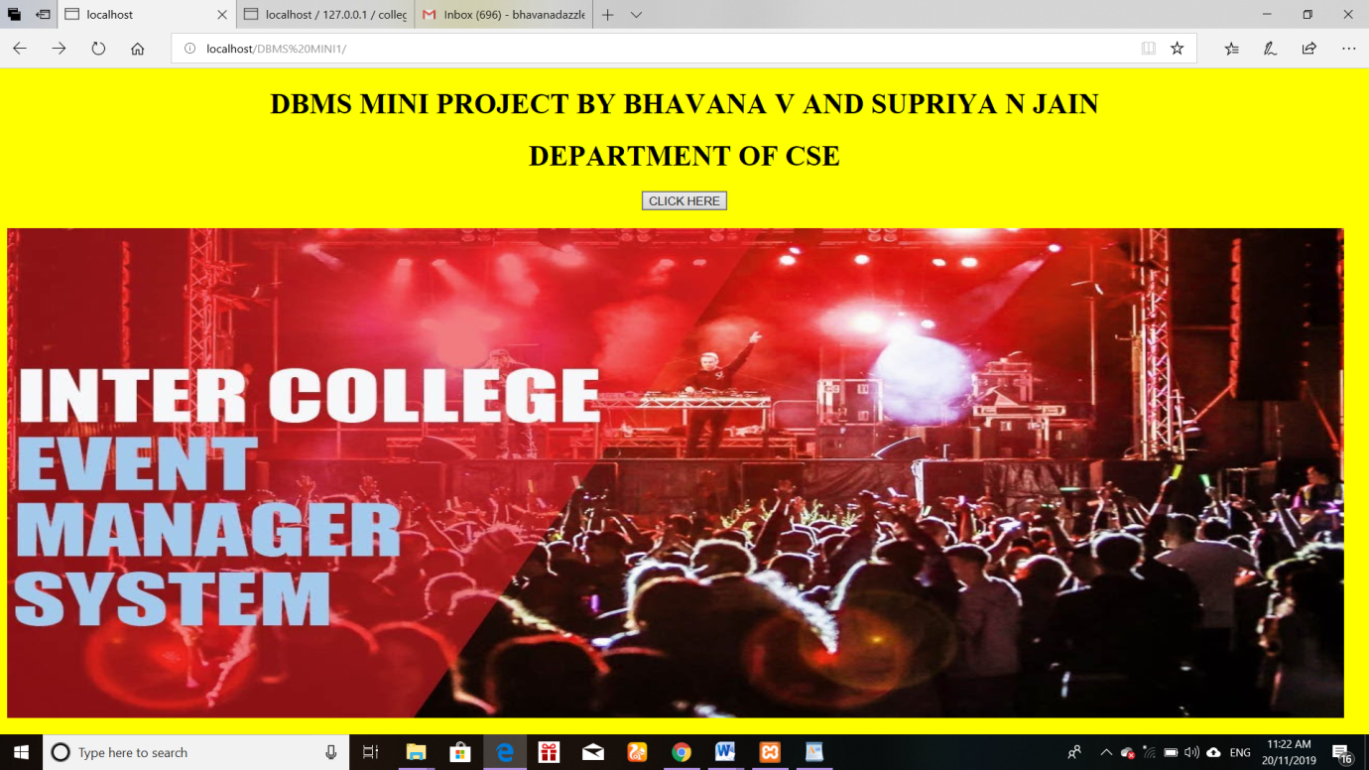

Fig.6.1 welcome page

**6.2 LOGIN PAGE**

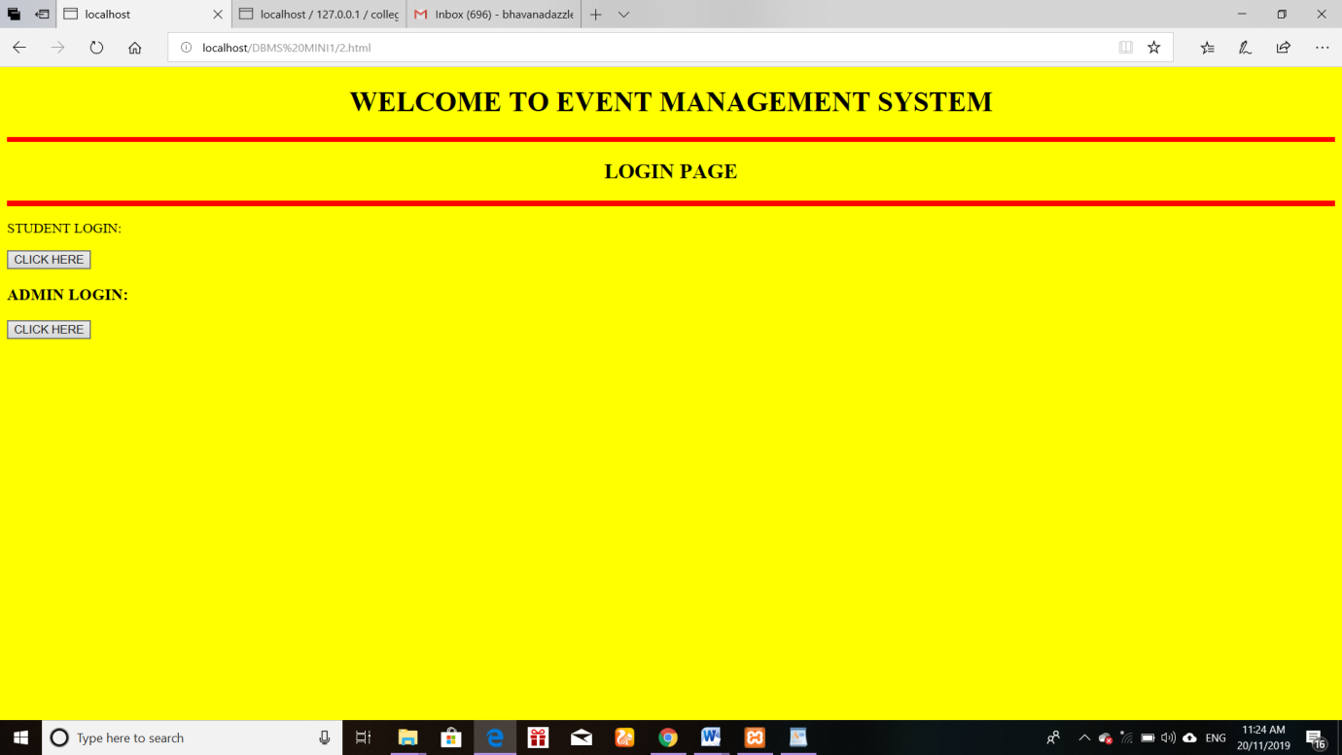

Fig.6.2 login page

**6.3** **STUDENT LOGIN:**

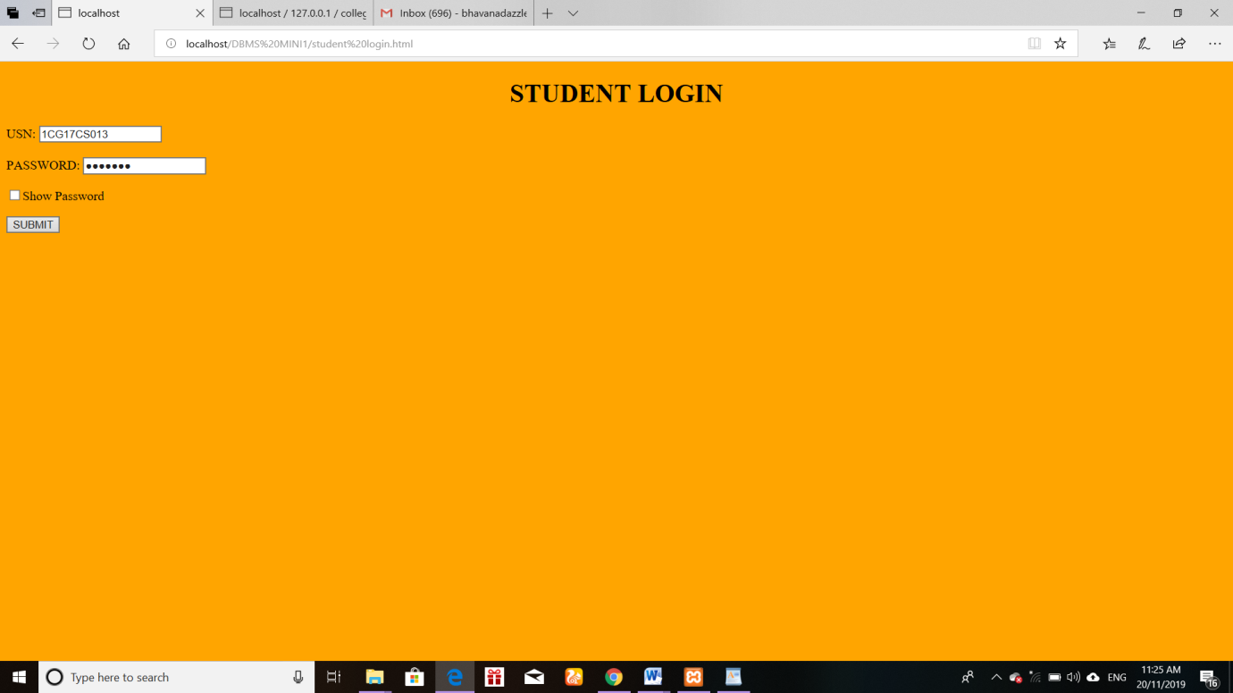

Fig.6.3 student details page

**6.4 PARTICIPANT REGISTRATION:**

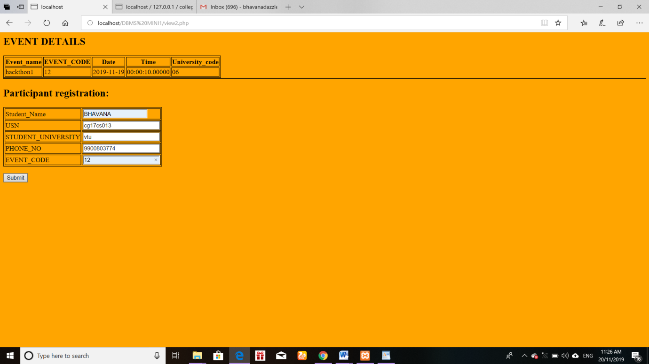

Fig.6.4 Event details page

**6.5 ADMIN PAGE:**

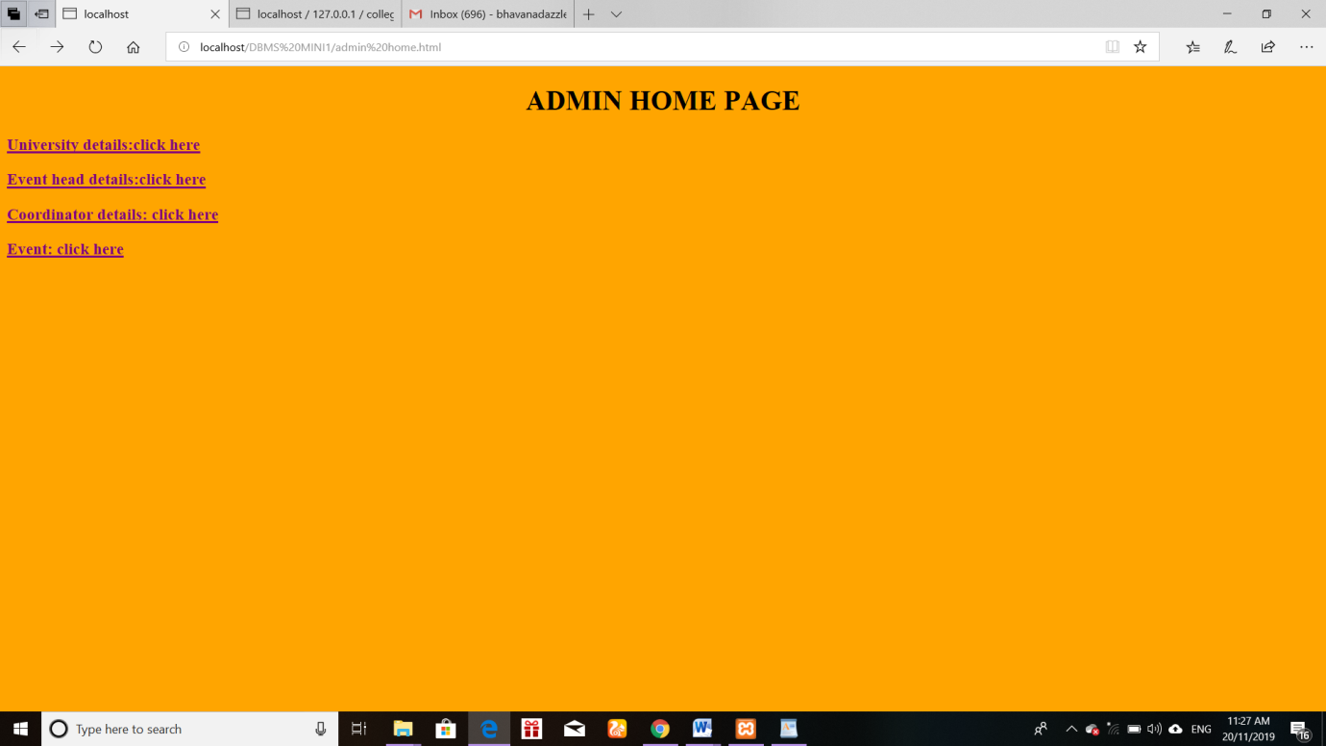

Fig.6.5 Admin page

**6.6 INSERTION:**

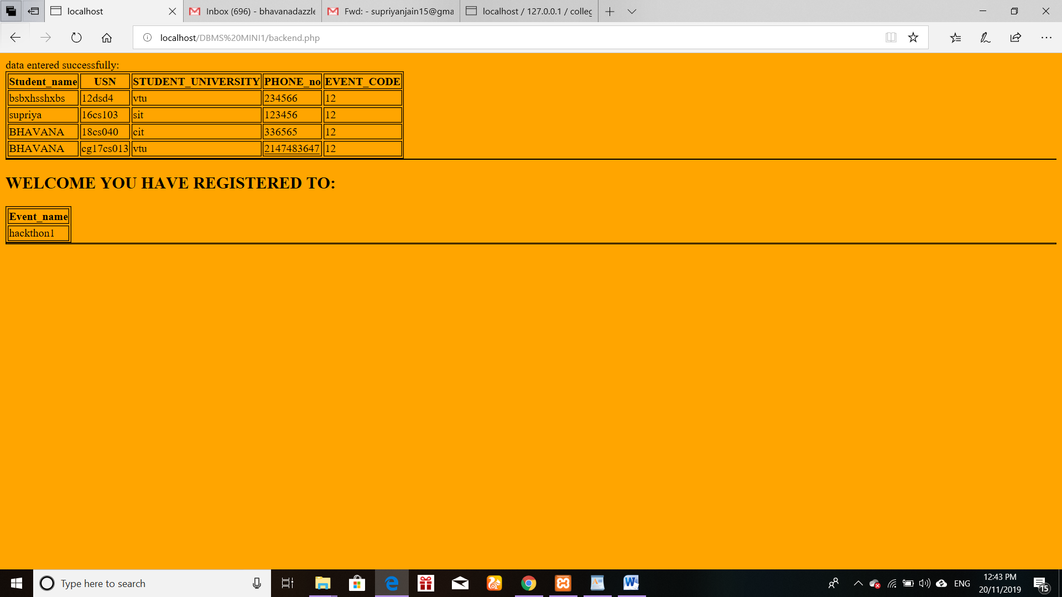

Fig.6.6 welcome page

**6.7 TRIGGER :**

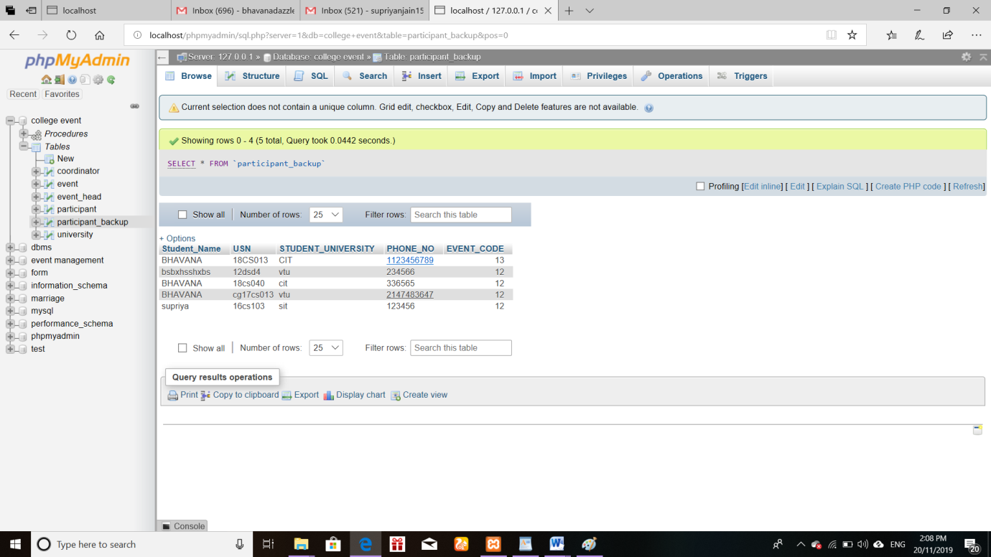

Fig.6.7 trigger page

**6.8 STORED PROCEDURE:**

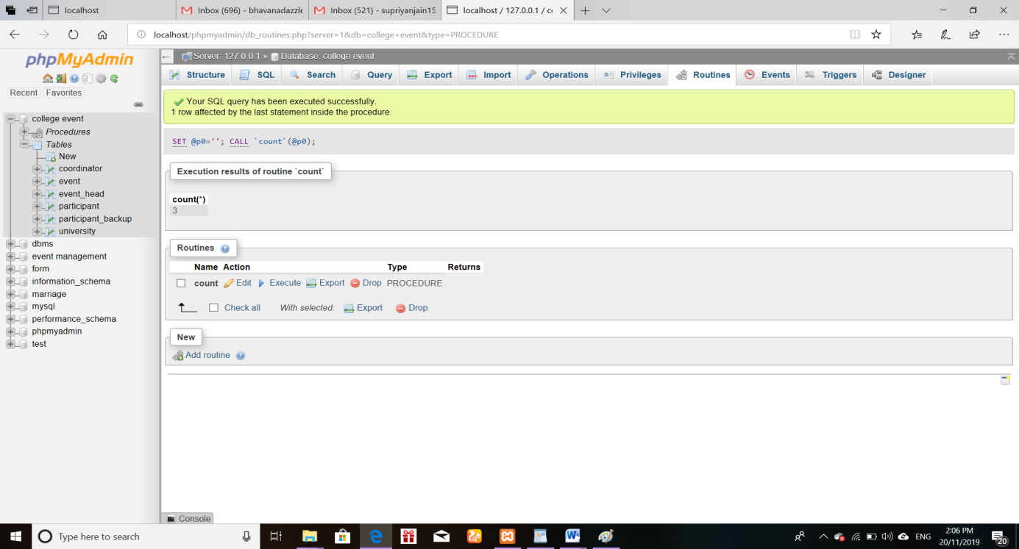

Fig.6.8 stored procedure page

**6.10 TABLE DETAILS :**

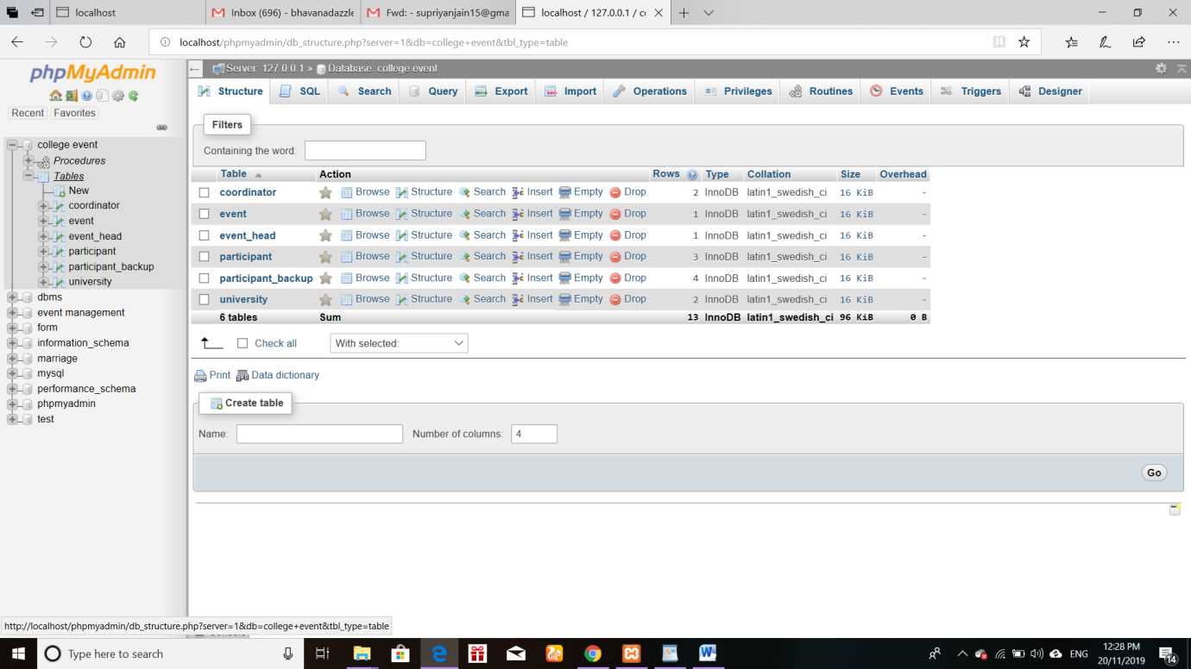

Fig.6.10 table details page

**CHAPTER 7**

**CONCLUSION**

Our aim is to make a user friendly application that can gather students from different collage. He/she can select event according to his interest and location priority. Encourage usage of one application instead of 10 webpages. Project will help students to explore ideas and talents.This project also help event management to collect data easily about participants**.**

**BIBLIOGRAPHY**

[1] [www.w3schools.com](http://www.w3schools.com)

[2] [www.php.net](http://www.php.net)

[3] [www.YouTube.com](http://www.YouTube.com)

[4] [www.quora.com](http://www.quora.com)

[5] [www.Wikipedia.org](http://www.Wikipedia.org)

|  |
| --- |
|  |
|  |
|  |
|  |
|  |
|  |
|  |

|  |
| --- |
|  |