**AIROBOTICA SERVICES PVT LTD.**



**AN INTERSHIP REPORT ON**

**“Razorpay’s Payment Gateway USING DJANGO FRAMEWORK”**

Submitted in partial fulfilment of the requirement for the award of degree of

**Bachelor of Engineering In**

**Computer Science Engineering**

Submitted By

**CHETAN M - 1CG17CS016 Bhavana V – 1CG17CS013**

**Shifa Khanum – 1CG17CS090 Varshini P – 1CG17IS040**

Under the Guidence Of

**MR.SHAIKH MOHAMMED RASOOL MR.ANEES REHMAN KHAN DIRECTOR INSTRUCTOR**



**Channabasaveshwara Institute of Technology**

*(Affiliated to VTU, Belgaum & Approved by AICTE, New Delhi)*

(NAAC Accredited & ISO 9001:2015 Certified Institution)

*NH 206 (B.H. Road), Gubbi, Tumkur – 572 216. Karnataka.*

## ACKNOWLEDGEMENT

The satisfaction and euphoria that accompanies the successful completion of any task would be incomplete without mentioning the people who made it possible. With deep gratitude, I acknowledge all those guidance and encouragement, which served as bacon of light and crowned our efforts with success. I thank each one of them for their valuable support.

I express my sincere thanks to **Mr. SHAIK MDR, DIRECTOR,** Airobotica services Pvt Ltd, for providing necessary facilities and motivation to carry out internship work successfully.

I would also like to express thanks to Project guide **MR. ANEES REHMAN KHAN,** Instructor, for his invaluable support and guidance to complete internship work successfully.

**Chetan M – 1CG17CS016**

**Bhavana V – 1CG17CS013**

**Varshini P – 1CG17IS040**

**Shifa Khanum – 1CG17CS090**

**i**

## ABSTRACT

This is to verify that the project work entitled " **Razorpay’s Payment Gateway** " is a bonafied worl carried out by **Chetan M** bearing the USN number **1CG17CS016**, **Bhavana V** bearing the USN number **1CG17CS013, Varshini P** bearing the USN number **1CG17IS040**, by **Shifa Khanum** bearing the USN number **1CG17CS090**,in partial fulfilment of the requirement for the award of degree of **Bachelor of Engineering in Computer Science and Engineering of Visvesvaraya Technological University, Belagavi** during the year 2020-2021.

………………………………… …………………………….

**PROJECT GUIDE DIRECTOR Mr. ANEES REHMAN KHAN Mr. SHAIK MD**

**ii**

## TABLE OF CONTENTS

**Acknowledgement i**

Abstract ii

Table of Contents

Chapter No CONTENTS PAGE NO

Chapter 1 Introduction 6 – 7

1.1 Introduction To Technology Used 6

Chapter 2 System Requirements and Specifications 8

* 1. Software Requirements 8
  2. Hardware Requirements 8

Chapter 3 System Analysis 9 – 11

* 1. Existing System 9
  2. Proposed System 9-10
  3. Objective of The System 11

Chapter 4 System Design 12

* 1. Schema Diagram 12

Chapter 5 APPENDIX A 13 - 18

Snapshots 13-16

Conclusion And References 17 – 18

**iii**

**ABOUT COMPANY**

**About AIROBOTICA!**

**BUILDING AN INNOVATIVE TOMORROW!**

**AIRobotica**

is a Bangalore (the Silicon Valley of India,Make in India) based firm that strives to foster Artificial Intelligence by bridging the unexplored realm of innovative opportunities in AeroSpace Technology, IOT ,IIOT R&D in Nano

,Micro Satellite research based Company We believe in the power of Futuristic technology, where Artificial Intelligence will establish its hold to solve the complex problems and to open up new avenues for businesses of all sizes, across all verticals. Hence,Our solutions are highly Industry and Requirement specific. Using AI, ML RPA, Space,IOT and SAP ERP services, we will help you promote agile and cost-effective business, administrative and marketing operations.

Our aim is to help enterprises create an automated environment to achieve accuracy. Our enterprise-friendly applications can be configured and managed within an IT governed framework and operating model, thereby unlocking the possibilities of becoming the Future Leaders.

Our company specializes in providing solutions for Small, Medium and Large Enterprises via our products and services.

**Submitted to:**

**Shaikh Mohammed Rasool,**

Director, Airobotica Services Pvt Ltd

**CHAPTER 1**

### INTRODUCTION

* **TITLE OF THE PROJECT**

RAZORPAY’S PAYMENT GATEWAY

### PROJECT DESCRIPTION

Razorpay’s Payment Gateway is a system designed to handle end-to-end payments. Why go through the pain of designing and coding checkouts when we’ve done all the work for you?

This project is mainly built to get all the information related to the transaction at hand will be passed securely from the consumer to the merchant and from the merchant to the consumer. Razorpay’s Payment Gateway also comes with Flash Checkout, which is a beautifully designed checkout form that you can add to your website or app with just a single line of code owed.

### INTRODUCTION TO THE TECHNOLOGY USED

As I have mentioned, this project of ours is being developed to help the company to maintain reports of payments done and also to reduce the human efforts. Here we are going to give brief information about the languages and technology which is going to be used.

* + - **Django framework**

Django is an open source web application frame work written in Python. The primary goal--- of Django is to make the development of complex, data-based websites easier. Thus Django emphasizes the reusability and pluggability of components to ensure rapid ---developments. Django consists of three major parts: model, view and template.

* + - **Model**

Model is a single, definite data source which contains the essential field and behaviour of the data. Usually one model is one table in the database. Each attribute in the model-- represents field table in the database. Django provides a set of automatically-generated database application programming interfaces (APIs) for the convenience of users.

* + - **View**

View is short form of view _le. It is a _le containing Python function which takes web requests and returns web responses. A response can be

HTML content or XML documents or a \404 error" and so on. The logic inside the view function can be arbitrary as long as it returns the desired response. To link the view function with a particular URL we need to use a structure called URL which maps URLs to view functions.

* + - **Template**

Template contains the .html files that are used for frontend display. If we don’t mention the templates directory in settings.py then the error occurs as “TEMPLATE DOESNOTEXIT /”

# CHAPTER 2

**SYSTEM REQUIREMENT SPECIFICATION**

To understand the nature of the software to be built, the software engineer must understand the information domain of the software, as well as the function, performance and interface. Requirement definition is the activity of translating information gathered during analysis activity into a document that defines a set of requirements. Requirement definition is the high abstract of requirements. Requirements may be functional or non-functional.

### Software Requirements:

* + - **Operating System :** Windows 7 and above
    - **User Interface :** HTML5, CSS,JS,PYTHON
    - **Web Framework :** DJANGO framework
    - **Editor :** VISUAL CODE STUDIO
    - **Web Server :** Google chrome/Internet Explorer
  1. **Hardware Requirements:**
     + **Hard disk :** 500GB
     + **RAM :** 8 GB
     + **Processor :** Intel

**CHAPTER 3**

**SYSTEM ANALYSIS**

System analysis in systems engineering and software engineering encompass a problem solving technique that break down a system into its component pieces for the purpose of the studying how well those components parts work and interact to accomplish their purpose.

The field of the system analysis relates closely to the requirements analysis. Focuses on those tasks that go into determining the needs or conditions to meet for new or altered products, tasking account of the possible conflicting requirements of the various payment methods.

* 1. **EXISTING SYSTEM:**  Before starting the project we have to study its limitations and objective, some of them are:-

The offline method is limited by many factors by distance and acceptance of another party.

It’s not safe at all. The party on the receiving end will have to check and recheck the received payment.

Not recommended for the transaction of a large amount.

* 1. **PROPOSED SYSTEM:**

The purpose of the payment gateway is to protect the credit card/financial data.

It is responsible for encrypting all sensitive information related to the transaction being processed (this includes the consumer’s credit card number). By using a reputable payment gateway service (like First Data Global Gateway Secure Payment Gateway), businesses can expect that all information related to the transaction at hand will be passed securely from the consumer to the merchant and from the merchant to the consumer.

Payment processor define the payment methods you want to use to make payments define rules to default payment methods onto documents payable assign validations to be run on documents payable, payments, and payment instructions.

The purpose of setting up payment method defaulting rules is to create and maintain defaulting rules for when payment methods are to default on documents to be paid.

**Advantages:**

* + - Secure transactions. Payment gateways utilize industry-standard encryption and effectively protect sensitive data, protecting both merchant and consumers from fraud.
    - Expanded customer base. Payment gateways enable shoppers from around the world to have access to your store and can expand your customer base exponentially.
    - Bundled with shopping cart. Payment gateways often bundle shopping cart software with their programs. The software allows your customer to select products with the click of a mouse, add them to his or her shopping cart, and complete the purchase at checkout. The shopping cart calculates the cost of the items, sales tax, and shipping charges without you or an employee having to be present to conduct the sale.
    - Faster transaction processing. A payment gateway is much faster than manual processing, and customers can make a purchase without the inconvenience of long waits or lines.
    - Added convenience. Having a payment gateway means your store is open 24/7, and your customers can shop at any hour of the day or night from the comfort of their own homes..

**Feasibility study:**

A feasibility study is undertaken to determine to the possibility or probability of either improving the existing system or developing a completely new system. It helps to obtain the overview of the problem and to get a rough assessment of whether other feasible solution exists.

* 1. **OBJECTIVE OF THE PROJECT:**
* Improve the ease of conducting card/digital transactions for an individual.
* Reduce the risks and costs of handling cash at the individual level.
* Reduce the costs of managing cash in the economy.
* Build a transaction history to enable improved credit access and financial inclusion.
* Reduce tax avoidance.
* Reduce the impact of counterfeit money.

**CHAPTER 4**

**SYSTEM DESIGN**

Once the software requirements have been analyzed and specified the software design. It involves 3 technical activities – design, coding, implementation and testing - these are required to build and verify the software.

The Design activities are of main importance in this phase, because in this activity, decisions ultimately affects the success of the software implementation and its case of maintenance are made. These decisions have the final bearing upon reliability and maintainability of the system. Design is the only way to accurately translate the customer’s requirements into finished software or a system.

Design is the place where quality is fostered in development. Software design is a process through which requirements are translated into a representation of software. Software design is conducted in 2 steps. Preliminary design is concerned with the transformation of requirements into data and Conceptual design is as follows.

### CONCEPTUAL DESIGN

* 1. **SCHEMA DIAGRAM**

A Schema is a collection of database objects associated with one particular database username. This username is called the schema owner, or the owner of related group of objects. You may have one or multiple schema in a database.

A Schema contains schema objects, which could be tables, columns, data types, views, stored procedures, relationships, primary keys, foreign keys, etc. A database schema can be represented in a visual diagram, which shows the database objects and their relationship with each other.

**CHAPTER - 5**

**APPENDIX AND SNAPSHOTS**

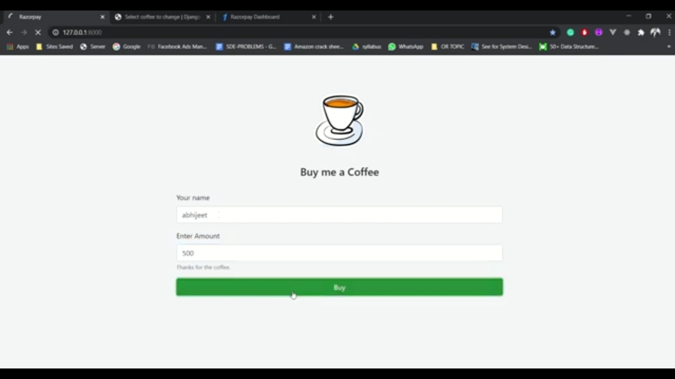

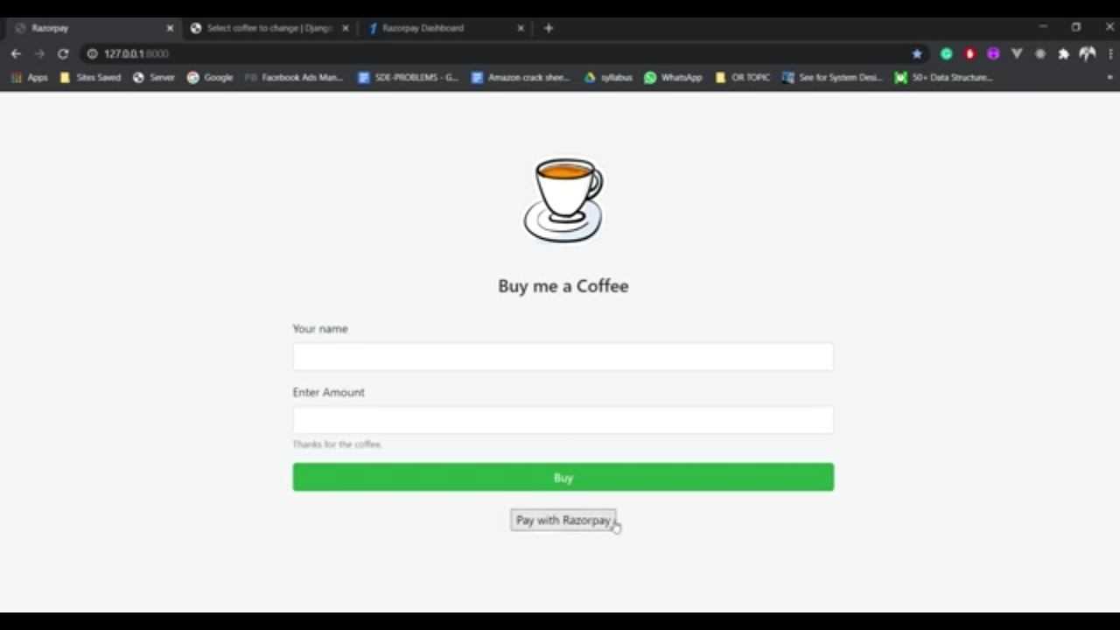

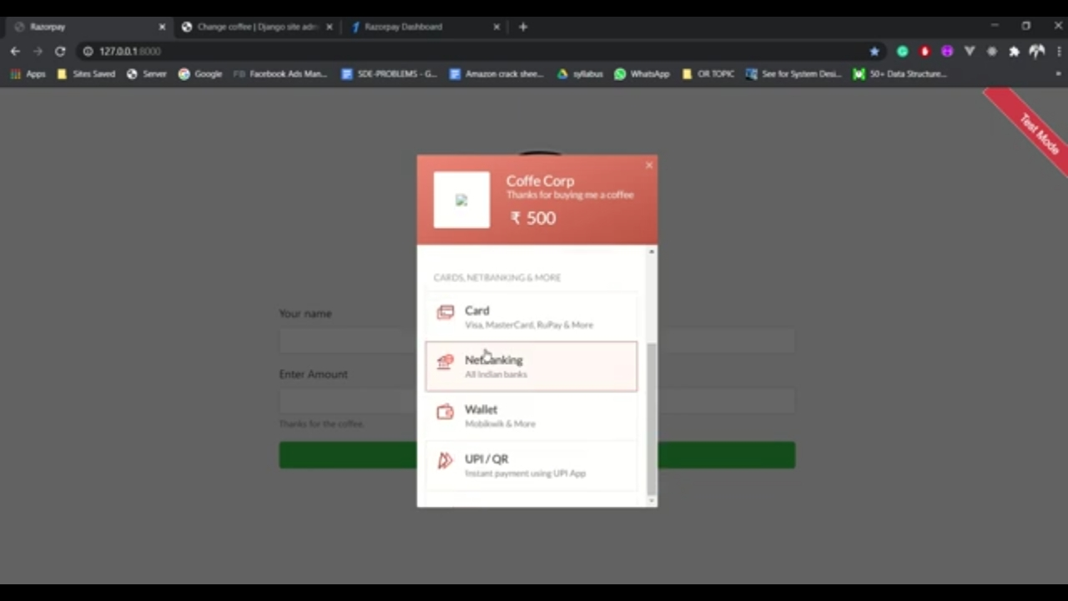

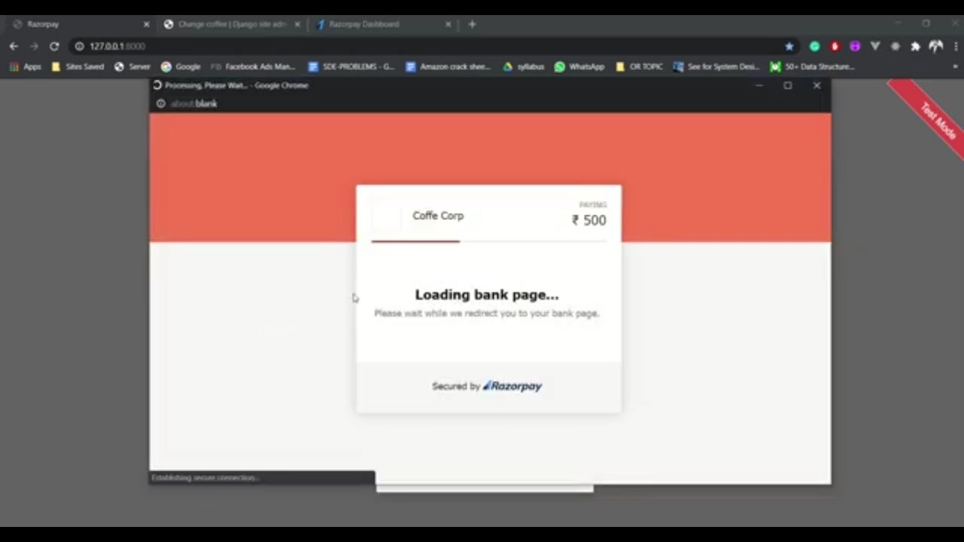

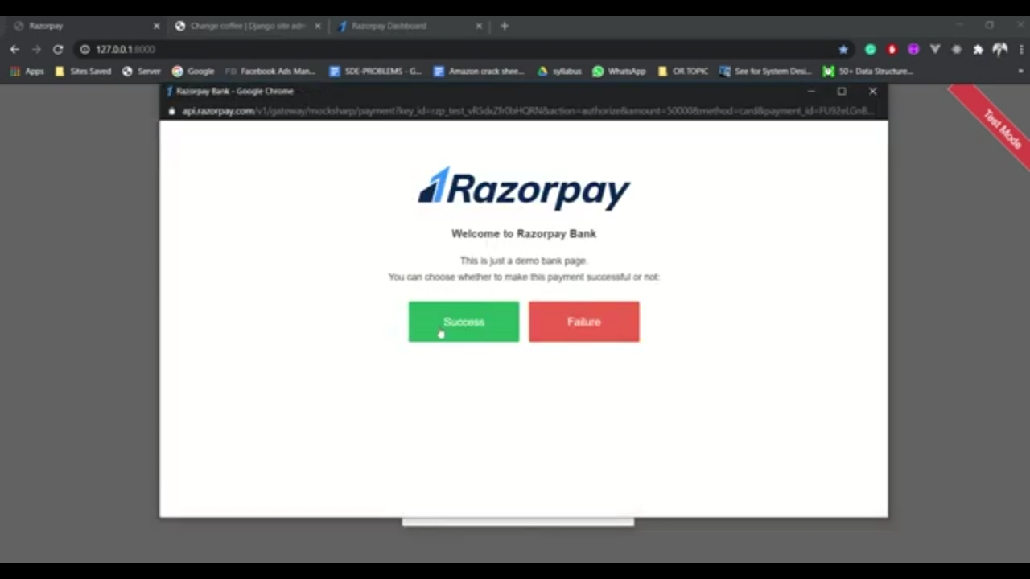

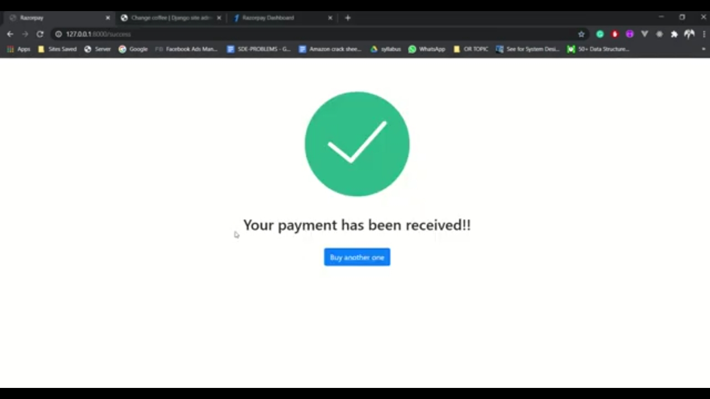

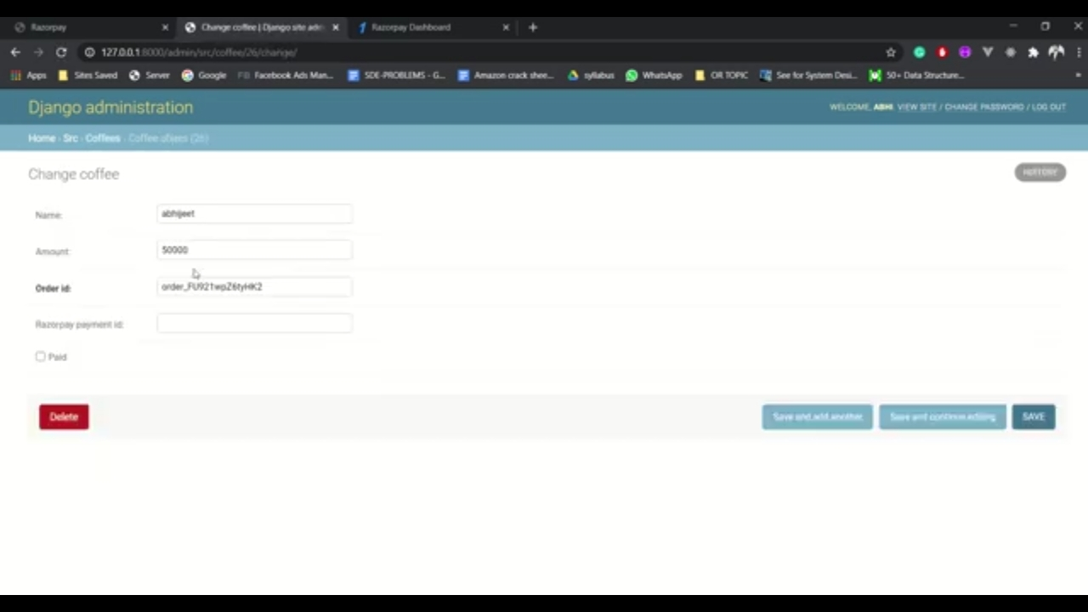

**CONCLUSION**

The Project titled as **"RAZORPAY’S PAYMENT GATEWAY "** was deeply studied and analyzed to design code and implement. It was done under the guidance of the experienced project guide.

The Main Objective of this project is to get all the information related to the transaction at hand will be passed securely from the consumer to the merchant and from the merchant to the consumer

Overall this will greatly simplify and speed up the result preparation and management process, and also reduce the human efforts.

# REFERENCES

For Django Framework

* <https://docs.djangoproject.com/en/3.1/>

For Python

* <https://www.python.org/doc/>

For Any Queries

* <https://stackoverflow.com/>