1. **Explain what is a view? What is the use of a view?**

A view is a virtual table. It is an SQL statement that is stored in the database with its associated name. Views can be created on multiple tables.

Views are used to structure the data. They restrict access to the data such that a user can see and modify only what they need. Views are used to summarize data from various tables which can be used to generate reports.

1. **Create a simple view**

Views are created using the CREATE VIEW statement.

Syntax for creating view is:

CREATE VIEW view_name AS

SELECT column1, column2..

FROM table_name

WHERE condition;

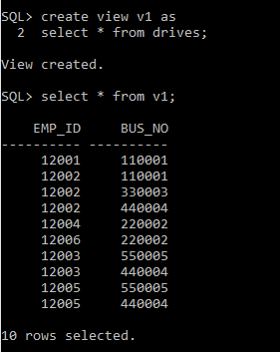

1. **Explain what is an updatable view?**

In SQL, some views are updatable and references to them can be used to specify tables to be updated. We can use DELETE, INSERT and UPDATE queries to modify the contents of associated table. The select statement of the view should not contain any of the following elements.

Aggregate functions like MIN, MAX, SUM, AVG,COUNT.

DISTINCT

GROUP BY

HAVING

UNION

LEFT JOIN

1. **Create an updatable view**

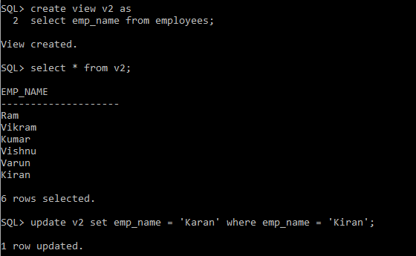

1. **How do you view the existing views?**

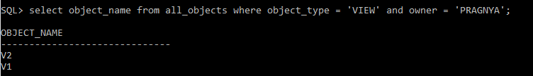

1. **Explain what is a materialized view?**

A materialized view is a database object that contains results of a query. These objects are collectively called as the master tables or detail tables. This reference uses master tables for consistency. The databases containing master tables are called master databases.

Materialized view is updated from one or more databases through individual updates known as refreshes. A materialized view has its own indexes. It is faster than a view.

1. **Create a materialized view?**

