1. **Explain index in oracle. Give examples of two common index techniques.**

Index is a special look up table that the database search engine can use to speed up data retrieval. In other words, an index is a pointer to data in a table. The two common indexing techniques are: Clustered indexing and non-clustered indexing.

Clustered Indexing: With a clustered index, rows are physically stored on the disk in the same order as the index. There can only be one clustered index.

Non-clustered Indexing: In non clustered indexing, there is a list that has pointers to the physical rows. It is faster than the clustered index.

1. **When is the bitmap index created?**

Bitmap indexes are created for low cardinality columns i.e., the columns which have less number of distinct values relative to the number of records in the table.

1. **Create a simple index on a column of a table?**

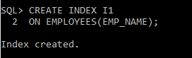

1. **Can we have more than a single index on a table? What is the overhead of creating many indexes for a table?**

Yes, we can have more than one index on a table.

Each time an SQL query is executed, the indexes will be processed. This affects the performance of the database.

1. **What are the restrictions on index columns?**

Indexes should not be created on primary key columns.

Columns that are frequently manipulated should not be indexed.

Also, columns that have high number of NULL values should not be indexed.

1. **Give an example of the function based index**

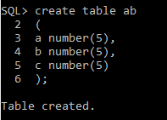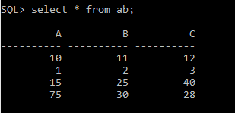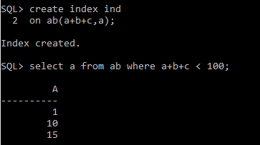

1. **Create an index on expression**

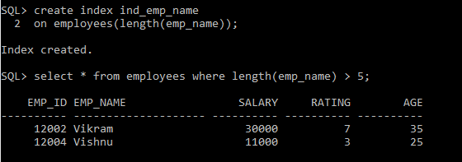

1. **What is a cluster? Create a cluster and add tables to it.**

A cluster is a schema object that contains data from one or more tables, which have at least one column in common. Database stores all the rows together from all the tables that share same cluster key.

1. **What is a sequence?**

A sequence is a system supported by some database systems to produce unique values. Auto incremented values are applied on the column for each new record.

The syntax to create a sequence is

CREATE SEQUENCE sequence_name

START with initial_value

Increment by increment_value

Maxvalue maximum_value

Cycle | nocylce

1. **How do we access the sequence once they are created?**

Select sequence_name from user_sequences;

1. **Create a sequence and use it in the insert statement?**

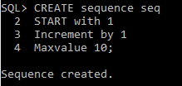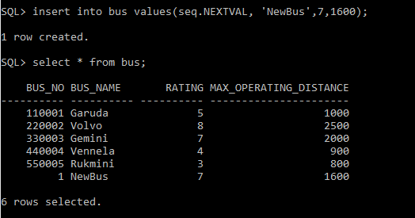

1. **How many types of index are there in the video?**

* Function-based index
* Bitmap index
* Simple index
* B-tree index
* B+ tree index
* Index on expression

1. **What object is used for automatic number generation**

For automatic number generation, a sequence object is used.

1. **What pseudo columns are used in sequence?**

CURRVAL, NEXTVAL, USER, SYSDATE, ROWNUM

1. **What is the overhead of creating many indexes for a table?**

When many indexes are created for a table, it creates overhead. For every index, data of the corresponding columns will be stored physically. Also, each time an SQL query is executed, the indexes will be processed. This affects the performance of the database.