**Problem Set 2**

Create three users of your choice

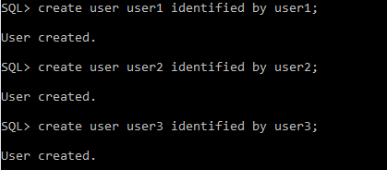

Create table, view from default user

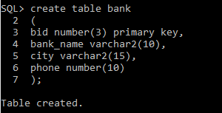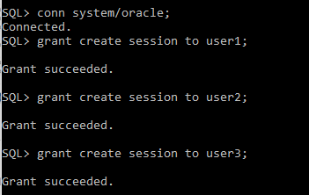

Open multi-session to perform the following operations. Multi-sessions are just to speed the operations, otherwise with a single session also you can perform the task.

Grant select on the table to one user

Grant insert on table to second user

Grant delete on table to third user

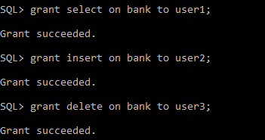

Execute the SQL Plus statement

SHOW USER



Perform the operations from the respective users.

Perform the operation which are not allowed and see the error message.

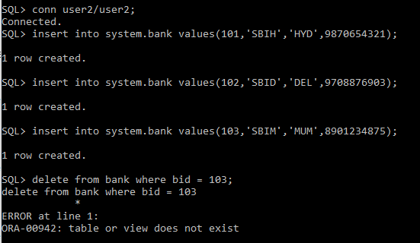

grant update for a particular field for different users.

Grant update on all fields to a user.

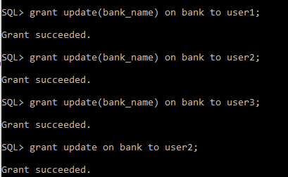

revoke the rights given to all the user.

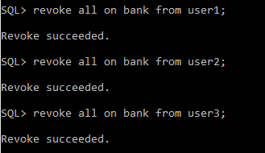

Grant select on table to first user with grant option.

From first user

Grant select on table to second user with grant option

From second user

Grant select on table to third user with grant option

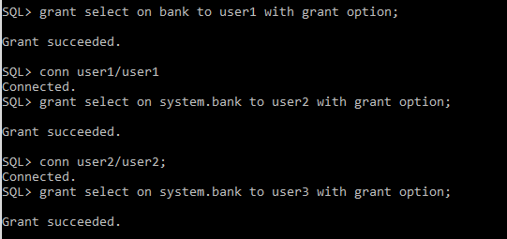

from your default

revoke rights on first user

See what happens to the rights of second and third user

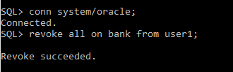

revoke all the rights.

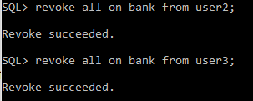

create a simple view

grant rights on view to first second users , not on the table

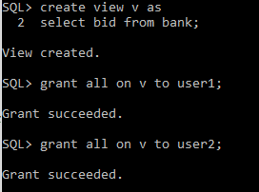

from first, second users

perform select on view

also perform DML operations.

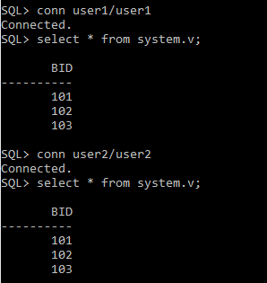

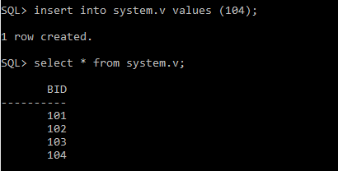

Create a complex view

Grant rights on view to first second users, not on the table

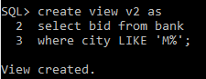

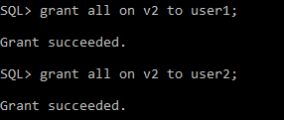

from first, second users

perform select on view

also perform DML operations.

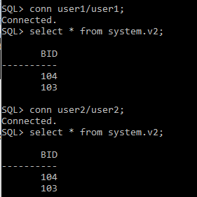



**Problem Set 3**

**What is locking a table? In how many modes we can lock a table give examples.**

**How do you make a transaction read only?**

Locking a table means permitting or denying access to a table by other users. The LOCK TABLE statement allows us to acquire a lock on the specified table. The table lock lasts until the current transaction. Only table owner or database owner can lock a table.

There are two modes of operation:

Shared Lock

Exclusive Lock

To make the transaction READ ONLY, we use SET TRANSACTION statement. It should be written as first statement in the transaction.