**4.PROBLEM SET**

**Step by Step Guide for SQL queries**  
**For the queries given, write the SQL statements**

1. Display first 5 record of the executive class type in Flight-class table?

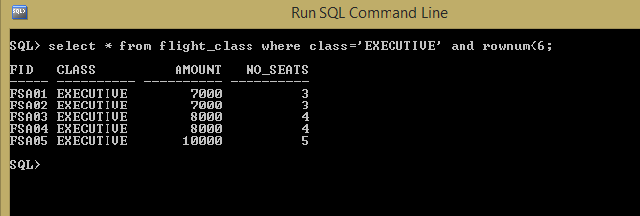

1. Display passenger details who traveled between 1st dec 2012 to 15th dec 2012

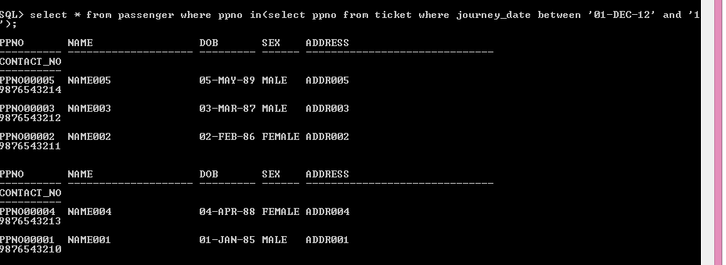

1. Display the flight details of all the flights whose first letter of its flight name is ‘C’ or ‘L’

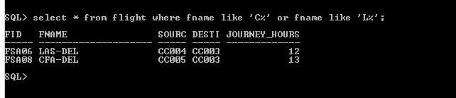

1. Display all the distinct prices in Flight table?

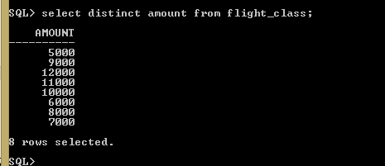

1. Display all the distinct Countries in City-Master?

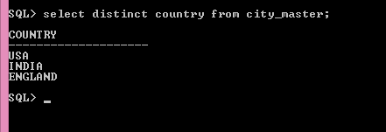

1. Display all the cities of India for which Flysafe airways provide service?

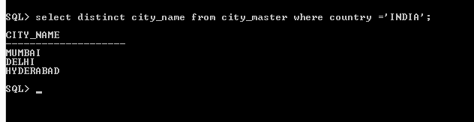

1. Find the common services provided by the Flights FSA02 and FSA04?

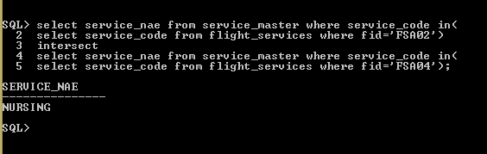

1. Display all the Flight Id’s whose departure time is between 9 to 15 hours?

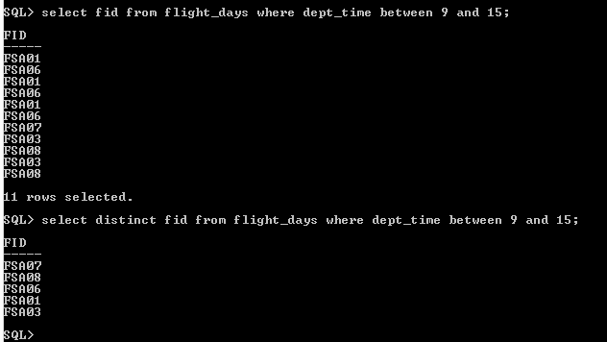

1. Display all the Flight Id’s whose business class price is between 6000 to 9000?

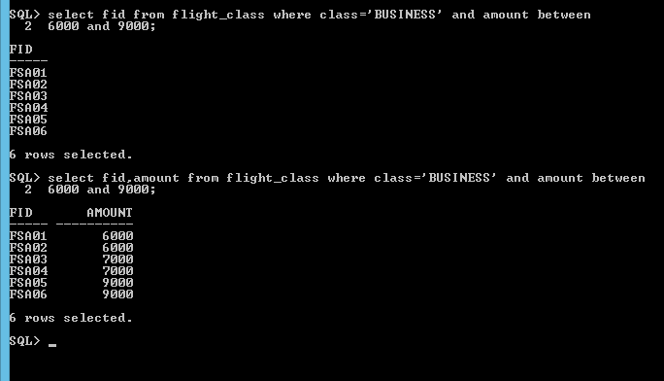

1. Find all the Flight Id’s that provide ‘Child Care’ or ‘Nursing’ Services.

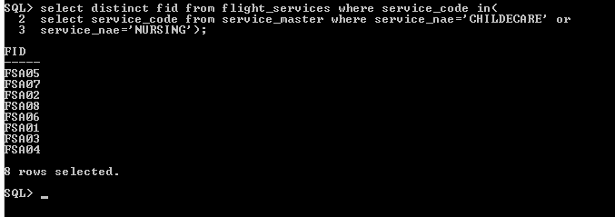

1. Find all the Flight Id’s that provide ‘Child Care’ and ‘Chinese Food’ Services.

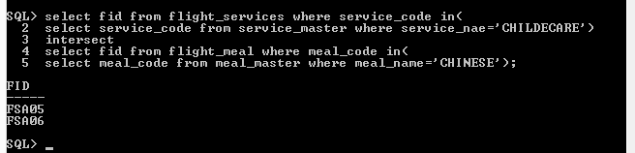

1. Display the flight details of all the flights which start from ‘Delhi’ on weekends?

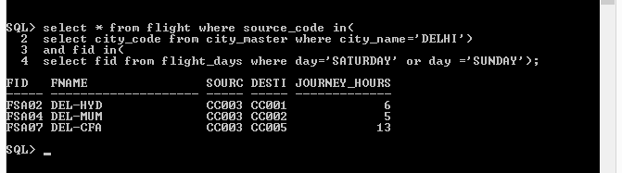

1. Find the source and destination of the flights for which the passengers selected CHINIESE for meals.

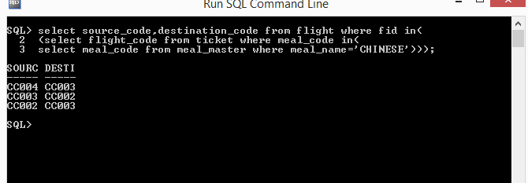

1. Display flight details of all the flights which start on weekdays?

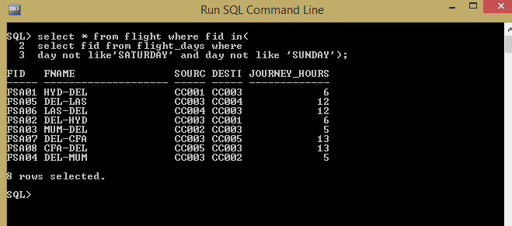

1. Display flight details of all the flights which offer meals whose Meal-Name is either ‘SOUTH’ or ‘NORTH’?

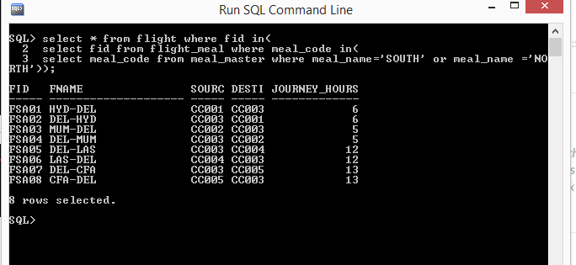

1. Find the passport number of the passengers whose name is “Name003” and travelled on 12th December 2012

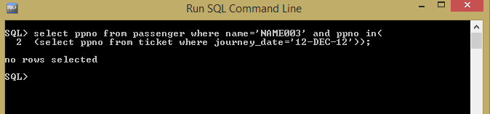

1. Display the details of all the passengers whose journey date is greater than today’s date and status is ‘waiting’?

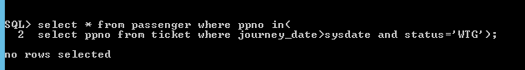

18)  Display the Flight-class details of all the Flight Id’s whose Source Name is “DELHI” and destination name is “HYDERABAD”

