**6.PROBLEM SET**

1)      Display the minimum of Journey hours

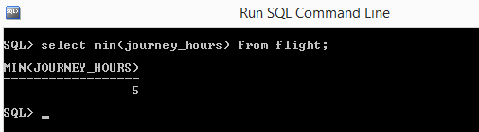

2)      Count the number of passengers who reserved a ticket.

Select count(*) from reservation;

3)      Find the number of passengers for each flight.

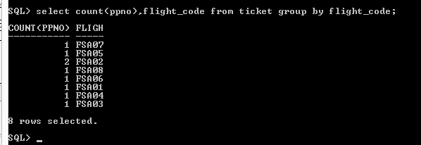

4)       Display the details of all the flight’s having maximum number of seats

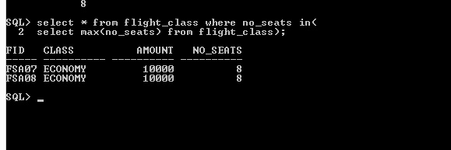

5)      Display all the type of meals provided by Fly Safe Airways

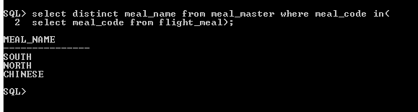

6)      Display the service names available in Flight Id ‘FSA003’

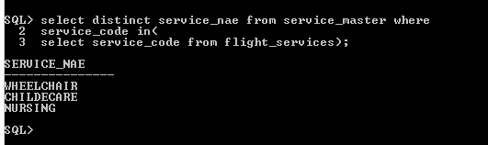

7)      Find the total number of passengers travelled in "FSA003" on 4 December 2012?

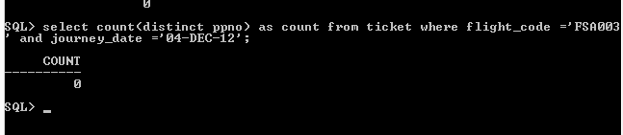

8)      Select all rows in Flight table whose Source Name is “DELHI” and Journey_Date on 24-dec-2012.

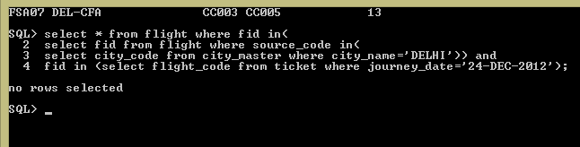

9)      Find the passenger names who travelled on 5th December,2012

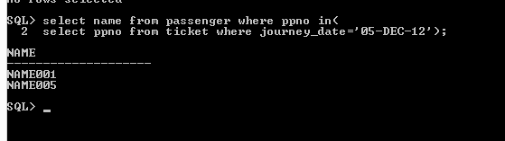

10)  Display total number of seats reserved for the class “ECONOMY” of all flights on date 5th December,2012

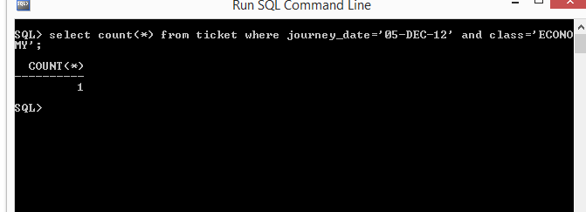

11)  Find the flight details of all the flights which travelled on 04-dec-2012

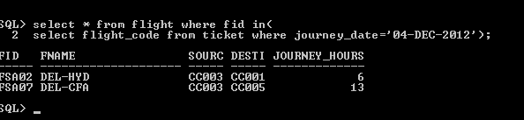

12)  Display the net income obtained from each class type

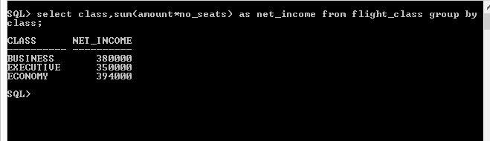

13)  Display the amount charged for luggage of 78Kg for an executive class passenger

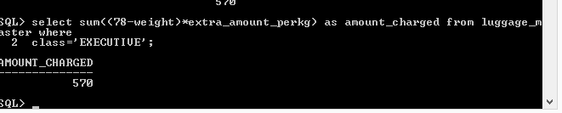

14)  Find the total amount charged for ‘north meals’ and ‘nursing service’?

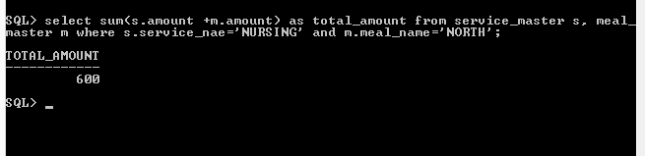

15)  Display the passenger details of all the passengers who have cancelled their ticket with journey date 04-dec-2012?

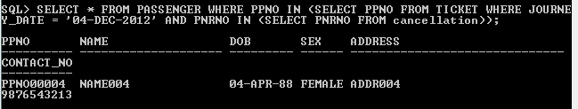

16)  Find the availability of the seats of all the flights whose Journey Date is 15-dec-2012, Source city Name is ‘Hyderabad’ and destination city name is ‘delhi’?

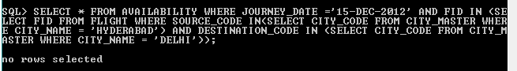

17)  Find the Destinations of all the flights which start from ‘Delhi’?

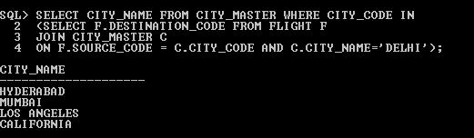

18)  Find the Net income obtained from passengers through Luggage charges

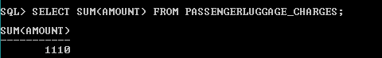

19)  Find the Net income obtained from passengers through Services

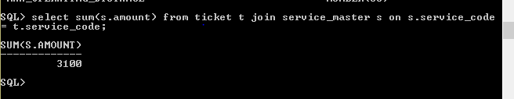

20)  Display number of seats available in each flight

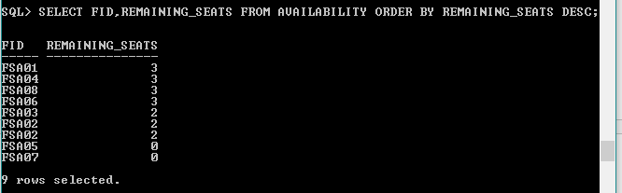

21)  Display number of seats available in each flight, where the price of each seat is greater than 6000

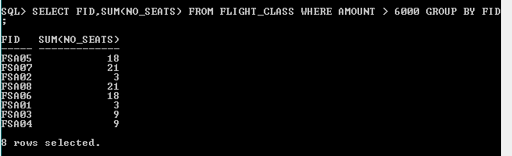

22)  Display the flight id’s which provide all the services?

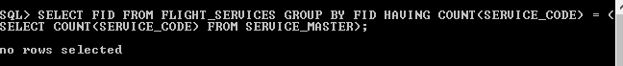

23)  Display the passenger details who travelled more than once?

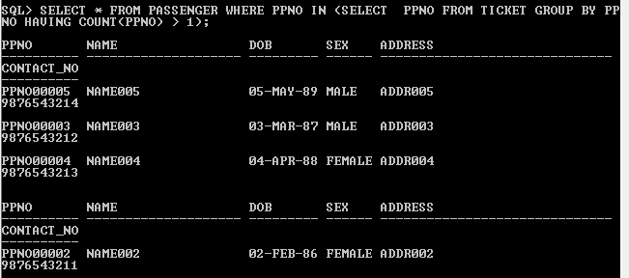

24)  Find the Passenger who travelled in every flight

