**Complex SQL Queries**

**Bus_Service( service_no : *integer***, Bus_no :*integer*, Source: *string*, Destination: *string*, Distance:*integer*, Departs :*time*, Arrives : *time*, Fare : *integer***)**

**Bus(Bus_no : *integer***, Bus_name : *string*, Rating:*integer*, Max_operating_distance : *integer***)**

**Drives( Emp_id : *integer*, Bus_no : *integer*)**

**Employees( Emp_id : *integer***, Emp_name : *string*, Salary : *integer ,*Rating*: integer,*Age: *integer***)**

**Assume that every bus operates daily

** The set of bold attributes is the primary key

**Write the following SQL Queries by considering the Schema Given above**

1. Find all those bus names such that all the drivers who operate on them earn more than 20k.

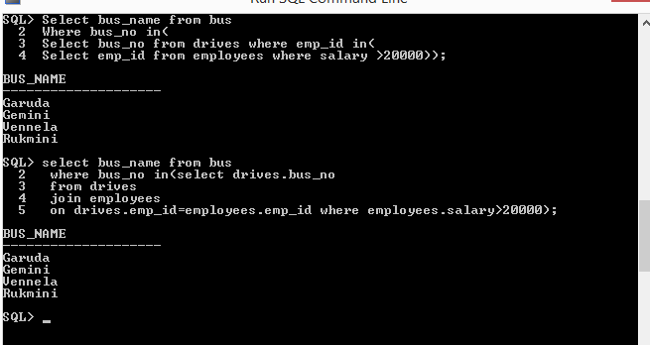

1. Find the routes that can be driven by every driver who salary is more than 25k. (Hint: The driver must operate at least one bus with a sufficiently large operating distance.)

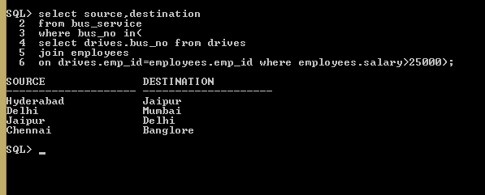

1. Find the names of drivers who can operate buses with operating distance greater than 1000 Km but are not drivers of any bus whose rating is less than 5.

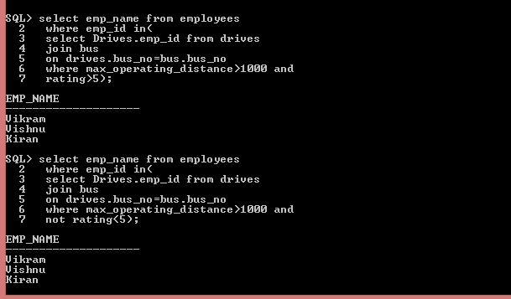

1. A person wants to travel from ‘Hyderabad’ to ‘Delhi’ with no more than two changes of buses. List all possible departure times from ‘Hyderabad’ if the person wants to arrive in ‘Delhi’ by 6 A.M.

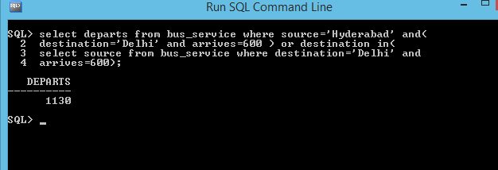

1. Find the names of the drivers who do not drive a bus with rating 7.



Select emp_name from employees where emp_id in(

Select emp_id from drives where bus_no =any(

Select bus_no from bus where rating<>7));

1. Find the names of the drivers who do not drive any bus with rating 7.



1. Find the rating of all drivers whose rating is better than some driver named ‘Ram’.

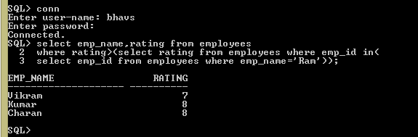

8.      Find the driver names whose rating is at least 7 or drives a bus with rating at least 7

