**Aggregation group by part1,2**

**Bus_Service( service_no : *integer***, Bus_no :*integer*, Source: *string*, Destination: *string*, Distance:*integer*, Departs :*time*, Arrives : *time*, Fare : *integer***)**

**Bus(Bus_no : *integer***, Bus_name : *string*, Rating:*integer*, Max_operating_distance : *integer***)**

**Drives( Emp_id : *integer*, Bus_no : *integer*)**

**Employees( Emp_id : *integer***, Emp_name : *string*, Salary : *integer ,*Rating*: integer,*Age: *integer***)**

1. Increment the salary of all those drivers by 10% who drives a bus with rating at least ‘8’.

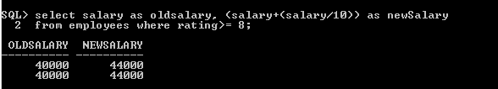

1. Retire all those employees whose age is greater than 60 and who drives only buses with rating at most 4. *(hint : Retirement here asks for deletion)*

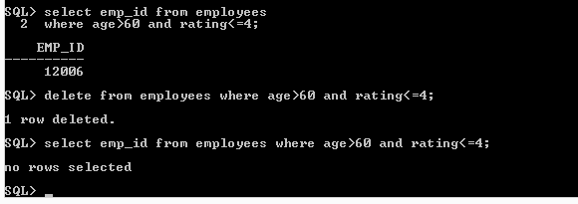

1. For all the employees who are not drivers and whose rating is at least 8, make each of them a driver by assigning each one to all buses with rating at most 4.

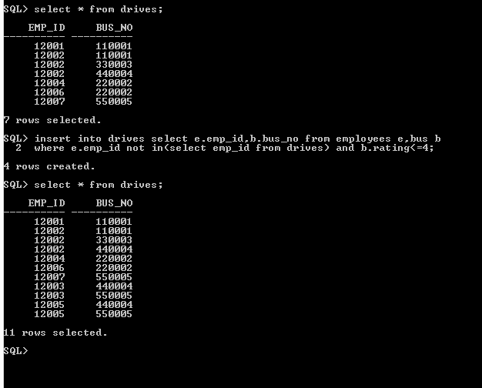

1. Find the difference between the average salary of all drivers and the average salary of all employees (including drivers).

SELECT ABS(AVG(E1.SALARY)-AVG(E2.SALARY)) AS AVG_SALARY FROM EMPLOYEES E1, EMPLOYEES E2 WHERE E1.EMP_ID IN (SELECT EMP_ID FROM EMPLOYEES) AND E2.EMP_ID IN (SELECT DISTINCT EMP_ID FROM DRIVES);

1. For each driver who drives more than three buses, find the emp_id and the maximum rating of the bus that he (or she) drives.

Select emp_id,max(b.rating) from bus b join drives d on b.bus_no=d.bus_no group by d.emp_id having count(*)>3;



1. Find the names of drivers whose salary is less than the minimum fare from ‘Hyderabad’ to ‘Bangalore’.
2. For all buses with rating over 8, find the name of the bus and the average salary of all drivers for this bus.
3. Find the name and salary of every employee who does not drive and whose salary is more than the average salary for drivers.
4. Find the names of drivers who drive only the buses with operating speed longer than 1000 Km.
5. Find the names of drivers who drive only the buses with operating speed longer than 1000 Km, but on at least two buses.
6. Find the names of drivers who drive only the buses with operating speed longer than 1000 Km and who drives some bus with rating at least 7.
7. For each bus driven by more than 5 drivers, find the bus name and the count of its drivers who earn more than 25k.
8. Find the driver names who drives all the buses
9. Find the top 5 employee names in terms of their salary.
10. Find the names of drivers who operates most number of buses
11. Find the names of drivers who operate most number of buses and along with the name find out the average rating of buses they drive.