1. Increment the salary of all those drivers by 10% who drives a bus with rating at least ‘8’.

UPDATE EMPLOYEES SET SALARY = SALARY * 1.10 WHERE EMP_ID IN ( SELECT EMP_ID FROM DRIVES WHERE BUS_NO IN ( SELECT BUS_NO FROM BUS WHERE RATING >= 8));

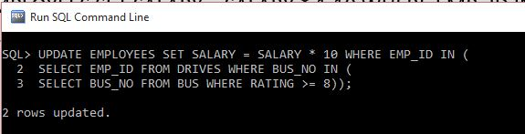

1. Retire all those employees whose age is greater than 60 and who drives only buses with rating at most 4. *(hint : Retirement here asks for deletion)*

DELETE FROM EMPLOYEES WHERE AGE > 60 AND EMP_ID IN (SELECT EMP_ID FROM DRIVES WHERE BUS_NO IN (SELECT BUS_NO FROM BUS WHERE RATING <=4 ));

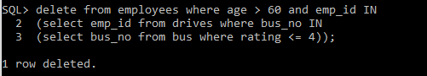

1. For all the employees who are not drivers and whose rating is at least 8, make each of them a driver by assigning each one to all buses with rating at most 4.

INSERT INTO DRIVES (EMP_ID,BUS_NO) SELECT E.EMP_ID,B.BUS_NO FROM EMPLOYEES E,BUS B WHERE E.EMP_ID NOT IN (SELECT EMP_ID FROM DRIVES) AND B.RATING <= 4;

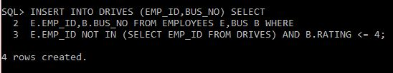

1. Find the difference between the average salary of all drivers and the average salary of all employees (including drivers).

SELECT ABS(AVG(E1.SALARY)-AVG(E2.SALARY)) AS AVG_SALARY FROM EMPLOYEES E1, EMPLOYEES E2 WHERE E1.EMP_ID IN (SELECT EMP_ID FROM EMPLOYEES) AND E2.EMP_ID IN (SELECT DISTINCT EMP_ID FROM DRIVES);

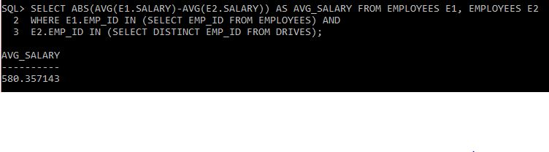

1. For each driver who drives more than three buses, find the emp_id and the maximum rating of the bus that he (or she) drives.

SELECT DISTINCT D.EMP_ID, MAX(B.RATING) FROM BUS B JOIN DRIVES D ON B.BUS_NO = D.BUS_NO GROUP BY D.EMP_ID HAVING COUNT(*) >3;

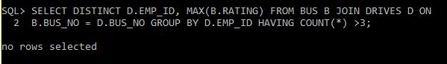

1. Find the names of drivers whose salary is less than the minimum fare from ‘Hyderabad’ to ‘Bangalore’.

SELECT EMP_NAME FROM EMPLOYEES WHERE SALARY < ANY ( SELECT FARE FARE FROM BUS_SERVICE WHERE SOURCE ='HYDERABAD' AND DESTINATION='BANGLORE');

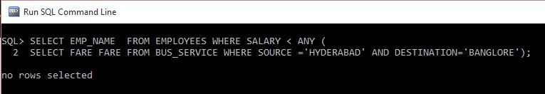

1. For all buses with rating over 8, find the name of the bus and the average salary of all drivers for this bus.

SELECT B.BUS_NAME, AVG(E.SALARY) FROM EMPLOYEES E, BUS B, DRIVES D WHERE E.EMP_ID = D.EMP_ID AND B.BUS_NO = D.BUS_NO AND B.RATING>8 GROUP BY B.BUS_NAME;

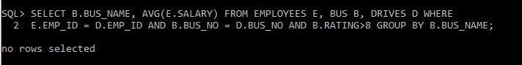

1. Find the name and salary of every employee who does not drive and whose salary is more than the average salary for drivers.

SELECT EMP_NAME ,SALARY FROM EMPLOYEES WHERE EMP_ID NOT IN (SELECT DISTINCT EMP_ID FROM DRIVES) AND SALARY > (SELECT AVG(SALARY) FROM EMPLOYEES);

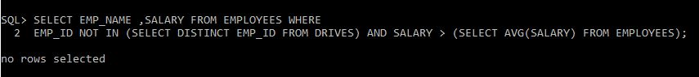

1. Find the names of drivers who drive only the buses with operating speed longer than 1000 Km.

SELECT EMP_NAME FROM EMPLOYEES WHERE EMP_ID IN (SELECT EMP_ID FROM DRIVES WHERE BUS_NO IN ( SELECT BUS_NO FROM BUS WHERE MAX_OPERATING_DISTANCE > 1000));

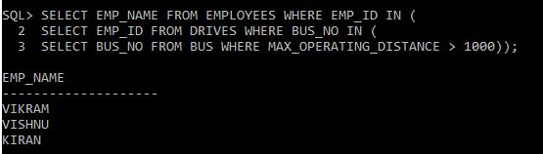

1. Find the names of drivers who drive only the buses with operating speed longer than 1000 Km, but on at least two buses.

SELECT EMP_NAME FROM EMPLOYEES WHERE EMP_ID IN (SELECT EMP_ID FROM DRIVES WHERE BUS_NO IN (SELECT BUS_NO FROM BUS WHERE MAX_OPERATING_DISTANCE > 1000) GROUP BY EMP_ID HAVING COUNT(*) >= 2);

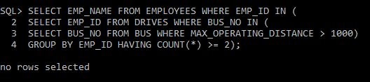

1. Find the names of drivers who drive only the buses with operating speed longer than 1000 Km and who drives some bus with rating at least 7.

SELECT EMP_NAME FROM EMPLOYEES WHERE EMP_ID IN (SELECT EMP_ID FROM DRIVES WHERE BUS_NO IN (SELECT BUS_NO FROM BUS_SERVICE WHERE DISTANCE > 1000) AND BUS_NO IN (SELECT BUS_NO FROM BUS WHERE RATING >= 7));

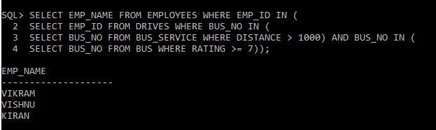

1. For each bus driven by more than 5 drivers, find the bus name and the count of its drivers who earn more than 25k.

SELECT B.BUS_NAME, COUNT(E.EMP_ID) FROM BUS B,EMPLOYEES E, DRIVES D WHERE E.EMP_ID = D.EMP_ID AND B.BUS_NO = D.BUS_NO AND E.SALARY>25000 GROUP BY B.BUS_NAME HAVING COUNT(E.EMP_ID) > 5;



1. Find the driver names who drives all the buses

SELECT EMP_NAME FROM EMPLOYEES WHERE EMP_ID IN (SELECT EMP_ID FROM DRIVES WHERE BUS_NO = ALL (SELECT BUS_NO FROM BUS));

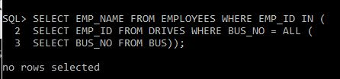

1. Find the top 5 employee names in terms of their salary.

SELECT EMP_NAME FROM EMPLOYEES WHERE ROWNUM <= 5 ORDER BY SALARY DESC;

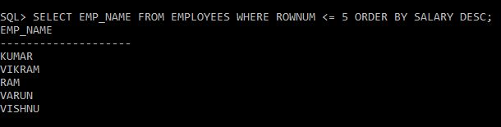

1. Find the names of drivers who operates most number of buses

SELECT EMP_NAME FROM EMPLOYEES WHERE EMP_ID IN (SELECT D.EMP_ID FROM DRIVES D, BUS B WHERE B.BUS_NO = D.BUS_NO GROUP BY D.EMP_IDHAVING COUNT(D.BUS_NO) = (SELECT MAX(COUNT(BUS_NO)) FROM DRIVES GROUP BY EMP_ID));

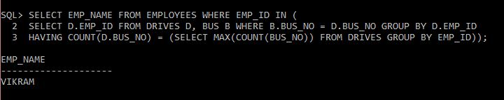

1. Find the names of drivers who operate most number of buses and along with the name find out the average rating of buses they drive.

SELECT E.EMP_NAME, AVG(B.RATING) FROM EMPLOYEES E, BUS B, DRIVES D WHERE E.EMP_ID = D.EMP_ID AND B.BUS_NO = D.BUS_NO GROUP BY E.EMP_NAME HAVING COUNT(D.BUS_NO) = (SELECT MAX(COUNT(BUS_NO)) FROM DRIVES GROUP BY EMP_ID);

