**PROBLEM SET**

So far, you have worked on MySQL for simple and complex queries. Now that you are familiar with the MySQL syntax attempt the following questions using MYSQL.

**Task:**

1. Create a cursor to display PNR number, names of the passengers from passenger table.

**taking rowtype variable**

declare

cursor cur1 is select ppno,name from passenger;

allrows cur1%rowtype;

begin

open cur1;

loop

fetch cur1 into allrows;

exit when cur1%notfound;

dbms_output.put_line('pp no: '||allrows.ppno);

dbms_output.put_line('name: '||allrows.name);

end loop;

close cur1;

end;

/

**Without taking rowtype variable**

declare

cursor cur1 is select ppno,name from passenger;

ppno passenger.ppno%type;

name passenger.name%type;

begin

open cur1;

loop

fetch cur1 into ppno,name;

exit when cur1%notfound;

dbms_output.put_line('pp no: '||ppno);

dbms_output.put_line('name: '||name);

end loop;

close cur1;

end;

/

1. Create a forward_only cursor in order to allow changes and that should fetch each row from the reservation table having class 'Business Clase' and the journey date at the current cursor position is changed to may 15,2001.

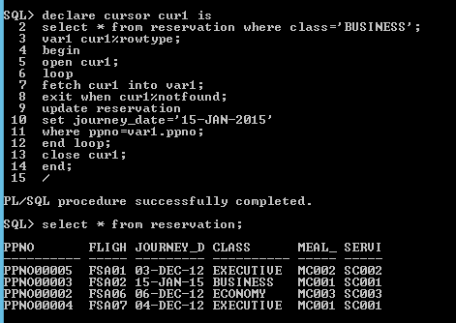

1. Create a cursor to display all rows in flight table having source as ‘mumbai’.

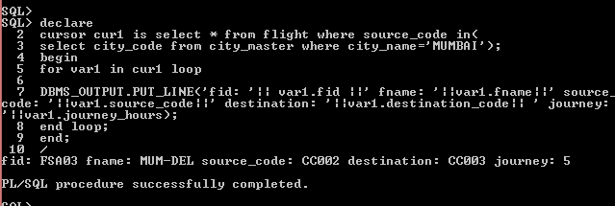

1. Create a keyset cursor to display passenger details from the reservation table and the meal_code is ‘V’ or ‘NV’.

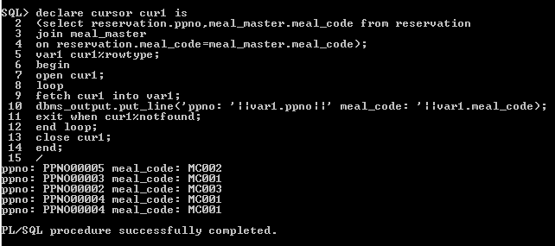

5.Create a read_only cursor to display all the rows from flight table and the aircraft code is ‘FSA08’ or ‘FSA07’.

