You are going to learn

1. How to handle Exception Handling.

* Exceptions occur at run time during the program execution.
* To handle the raised exceptions,we should write separate routines called exception handlers.
* Handling exception statements can be written in a block called exception block inside the procedure.
* We have both predefined and user defined exceptions.
* An excpetion is displayed as ORA-[exc code]=Message;

1. How to define user defined exception

Syntax:

DECLARE

user_define_exception_name EXCEPTION;

BEGIN

statement(s);

IF condition THEN

RAISE user_define_exception_name;

END IF;

EXCEPTION

WHEN user_define_exception_name THEN

User defined statement (action) will be taken;

END;

So far, you have worked on MySQL for simple and complex queries. Now that you are familiar with the MySQL syntax attempt the following questions using MYSQL.

**Task:**

1. **Write PL/SQL code with an exception handler**

DECLARE

i1 NUMBER := &i1;

i NUMBER;

BEGIN

FOR i IN (SELECT * FROM lol) LOOP

IF i.id = i1 THEN

EXCEPTION

WHEN no_data_found THEN

dbms_output.put_line('error.');

END IF;

END LOOP;

END;

1. /**List any few exception handlers with the corresponding comments when the exception will be raised?** 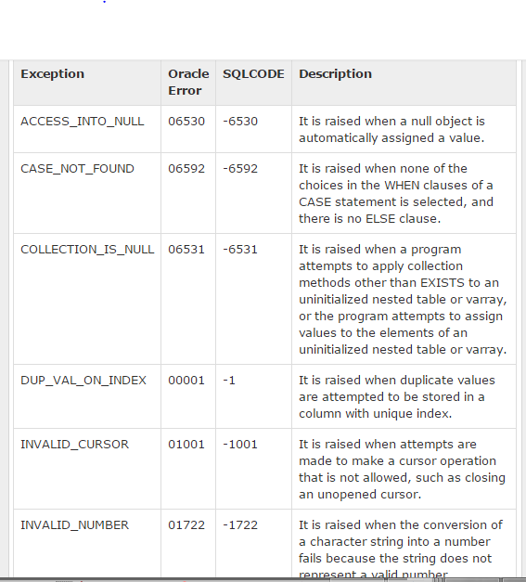
2. **Create a user-defined exception handler.**

DECLARE

myex EXCEPTION;

i1 NUMBER := &i1;

i NUMBER;

BEGIN

FOR i IN (SELECT * FROM lol) LOOP

IF i.id = i1 THEN

RAISE myex;

END IF;

END LOOP;

EXCEPTION

WHEN myex THEN

dbms_output.put_line('Employee number already exist in enum table.');

END;