1. Create a stored procedure to display the flight information that takes off from Mumbai.

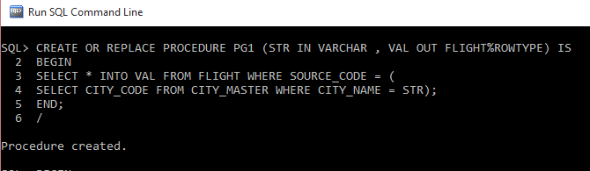

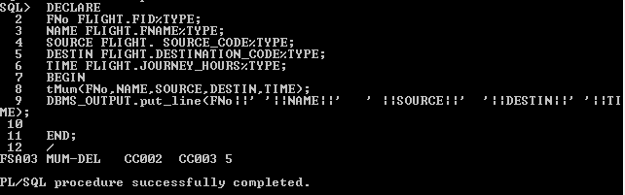

2.Create and execute a procedure to display all the meal options available in the British airways.

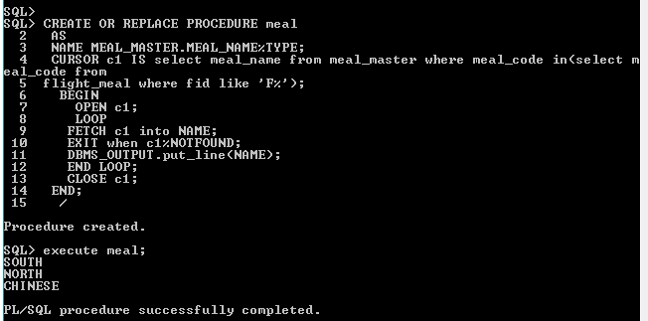

Display all the stored procedures present in the fly safe airways database.

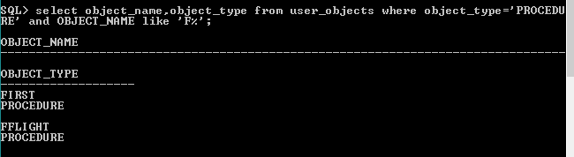

Create and execute a stored procedure to display the airlines that offer ‘child care’ as a service. Modify this procedure to display the airlines that offer the service ‘nurse’.

