**Step by Step Guide for SQL queries**  
**For the queries given, write the SQL statements**

Look at the queries asked by Client.

Try to solve them one after the other.

If you are stuck anywhere, look at the resources provided to you. If it is not helpful kindly contact respective mentor.

Finally create a sql dump of all the queries and submit it on or before deadline.

1. Find the details of the passport number ‘PPNO000005’?

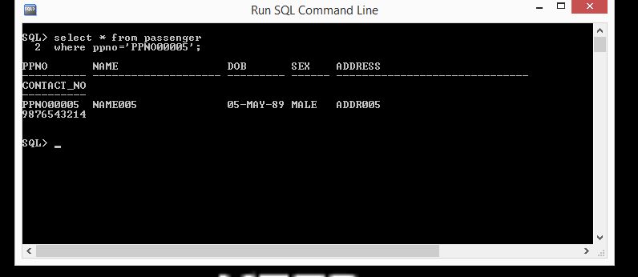

1. Find all the flight ids of FlySafe Airways.

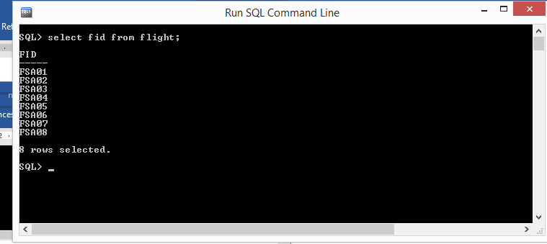

1. Find Flight names for the flights which start from DELHI

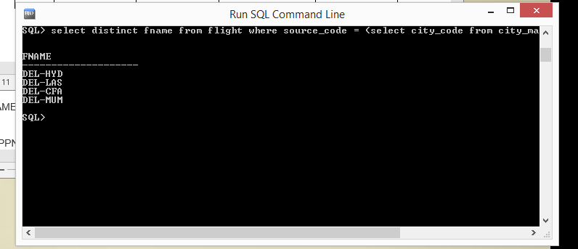

1. Find all the Flights which are between cities in INDIA only

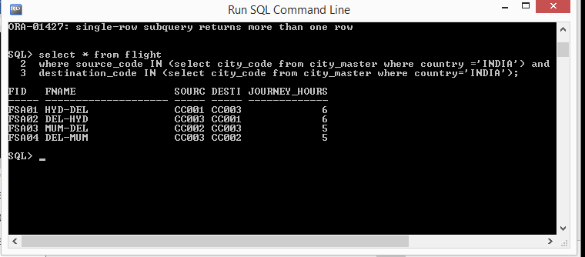

1. Find  all the services which are above 300

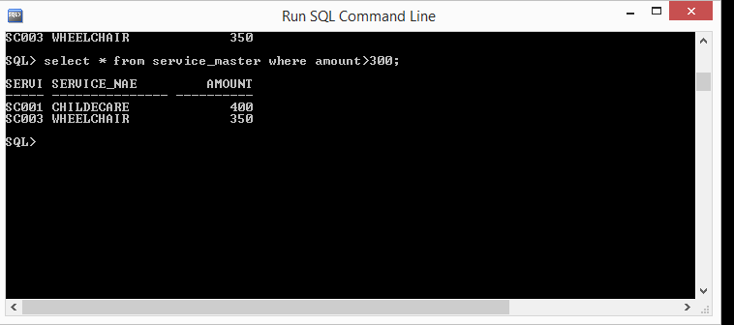

1. Find the flights which offer Wheel Chair services

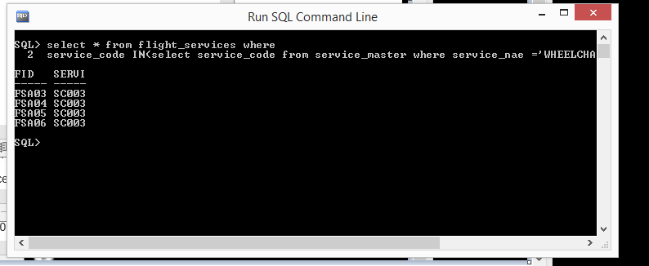

1. Find all the Passengers who cancelled their tickets before 12 hours.

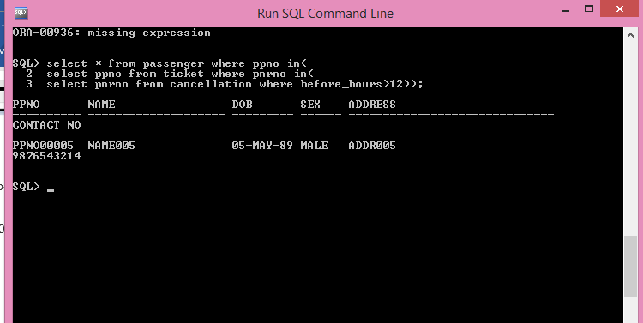

1. Find all the Passengers who opted for Child Care services.

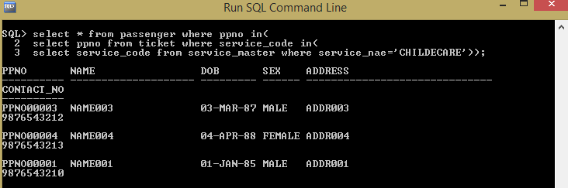

1. Insert a row in a passenger table with following details PPNO00006 NAME006 05-MAY-1989 MALE ADDR006 9876543214

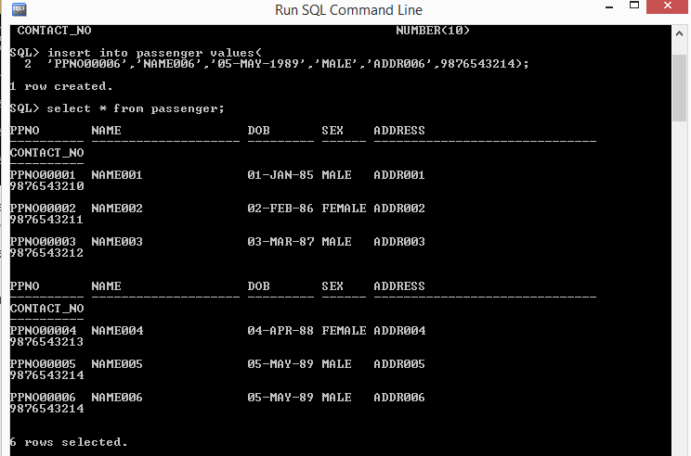

1. Update the passenger table with following details whose passport no is PPNO00006 DOB = 06-JUN-1990, SEX = FEMALE, PHONE NO = 9876543215

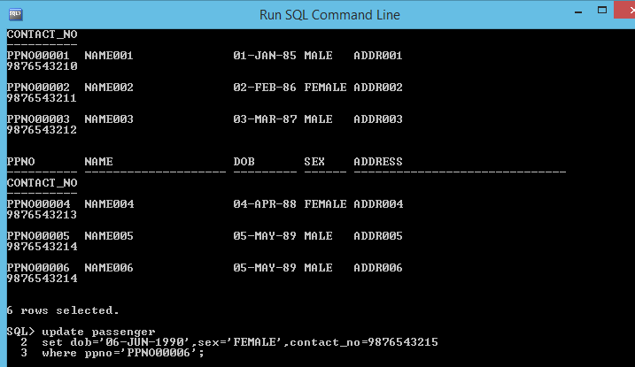

11)  Delete a row from the passenger table whose passport no is PPNO00006

