1)Select * from person where userid in(

Select userid from profession where sal=’>50K’);

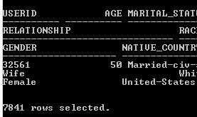

2) select * from person where userid in(

Select userid from profession where salary=’<=50K’);

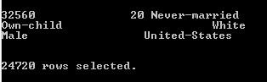

3) select count(userid) from profession group by education;

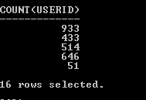

4) select userid from person where age between 20 and 30;

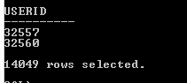

5) select count(userid) from person where age<30 and userid in(

Select userid from profession where salary=’>50K’);

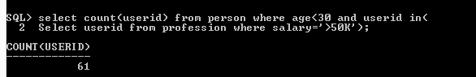

6) select userid from profession where education=’Bachelors’ and workclass=’Private’;

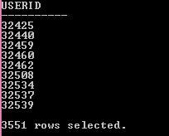

7) select userid from person where gender=’Female’ and userid in(

Select userid from profession where workclass=’Private’);

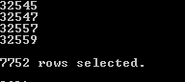

8) select userid from person where gender=’Male’ and age>30 and userid in(

Select userid from profession where occupation=’?’);

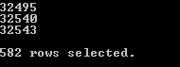

9) delete from profession where userid in(

Select userid from person where native_country=’Germany’) and workclass=’ State-gov’;

Select * from profession where userid in(

Select userid from person where native_country=’Germany’) and workclass=’ State-gov’;



10)

Select userid from person where native_country=’United-States’ and userid in(

Select userid from person where race=’White’ or race=’Black’);

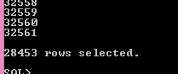

11)

Select salary,hours_per_week from profession where education=’ Doctorate’ group by education;

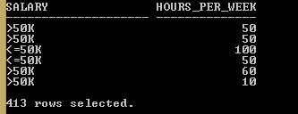

12) select * from person where native_country like ‘C%’ and userid in(

Select userid from profession where occupation=’ Tech-support’);

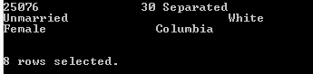

13)

Select * from profession where salary=’>=50K’ and (workclass=’State-gov’ and userid in(

Select userid from person where marital_status=’Never-married’) and rownum<=5);



14) select distinct native_country from person where userid in(

Select userid from profession where occupation=’Armed-Forces’) order by native_country;

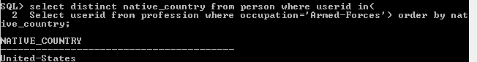

15)

Select person.userid,person.age,person.marital_status,person.relationship,person.race,person.gender,person.native_country,profession.workclass,

Profession.fnlwgt,profession.education,profession.education_num,profession.occupation,profession.capital_loss from person

Join profession

On person.userid=profession.userid;

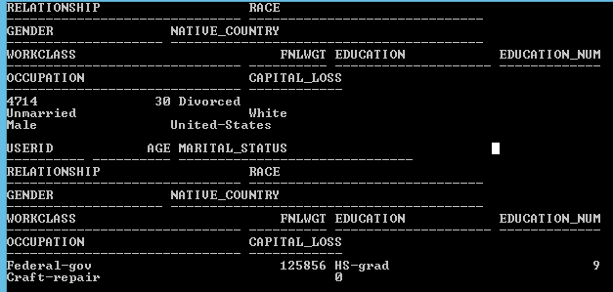

16) update person

Set race=’Black’,gender=’Female’

Where userid=106 ;

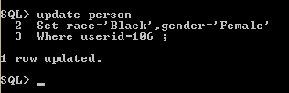

17)

Select userid from person where age>30 and userid in(

Select userid from profession where education_num in(

Select max(education_num) from profession));

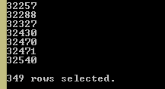

18)

Select count(userid) from profession where workclass=’Federal-gov’ and userid in(

Select userid from person where native_country=’United-States’);

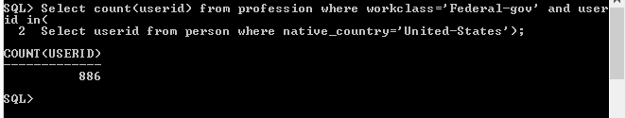

19)

select distinct age from person where age in(

select max(age) from person where userid in(

select uid from profession group by occupation));

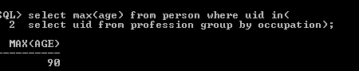

20)

Select distinct userid from person where age in(

Select min(age) from person where userid in(

Select userid from profession) group by age);

