Food Delivery Analytics Report

Introduction
In today’s data-driven environment, food delivery businesses generate large volumes of transactional, customer, delivery, financial, and operational data. Analysing this data helps businesses understand customer behaviour, monitor operational performance, improve profitability, reduce service issues, and make informed decisions.
This project focuses on analysing the Food Delivery Analytics dataset using SQL, Python, Power BI, Power Query, and DAX. The project follows an end-to-end process from raw data understanding and validation, through cleaning and transformation, exploratory analysis, data modelling, dashboard development, and business insight generation.

Objective
The primary objective is to transform raw food delivery transaction data into meaningful business insights covering orders, revenue/order value, profitability, customer satisfaction, delivery performance, complaints, refunds, customer segments, location performance, weather, demand, and churn risk.
Python is used mainly to explore the data and identify patterns, while Power BI is used to communicate findings through interactive KPIs, charts, slicers, and dashboard pages.

Dataset Description
The Food Delivery Analytics dataset contains order-level information related to food delivery operations. It includes customer, order, location, delivery, financial, customer-experience, service-quality, weather, demand, and churn-related fields.
Data Area | Examples | Purpose
Orders | Order ID, Order Value | Measure transaction activity and value.
Customers | Customer ID, Customer Type, Age | Understand customer segments and behaviour.
Location | Location/City | Compare geographic performance.
Delivery | Delivery Time | Evaluate operational efficiency.
Customer Experience | Customer Rating | Measure satisfaction.
Financial | Discount, Order Value, Profit | Analyse financial performance.
Operations | Complaint Flag, Refund Flag | Measure service problems and compensation.
External Factors | Weather | Provide operational context.
Business Indicators | Demand, Churn Risk | Support capacity planning and retention.
Time | Month, Quarter | Analyse trends over time.

Tools & Technologies
- MySQL / SQL
- Power BI
- Power Query
- DAX
- Python
- Pandas
- Matplotlib
- Excel dataset

Data Cleaning & Transformation

SQL Data Cleaning & Validation
SQL was used to validate the raw data before detailed analysis.
- Checked NULL/missing values.
- Checked duplicate records.
- Validated customer age and identified unrealistic values.
- Validated customer ratings against the 0–5 range.
- Checked complaint and refund flags for expected binary values.
- Reviewed order value, discount, delivery time, and profit.
- Validated dates, months, quarters, and categorical values.
- Negative profit was not automatically treated as an error because an order can legitimately generate a loss.

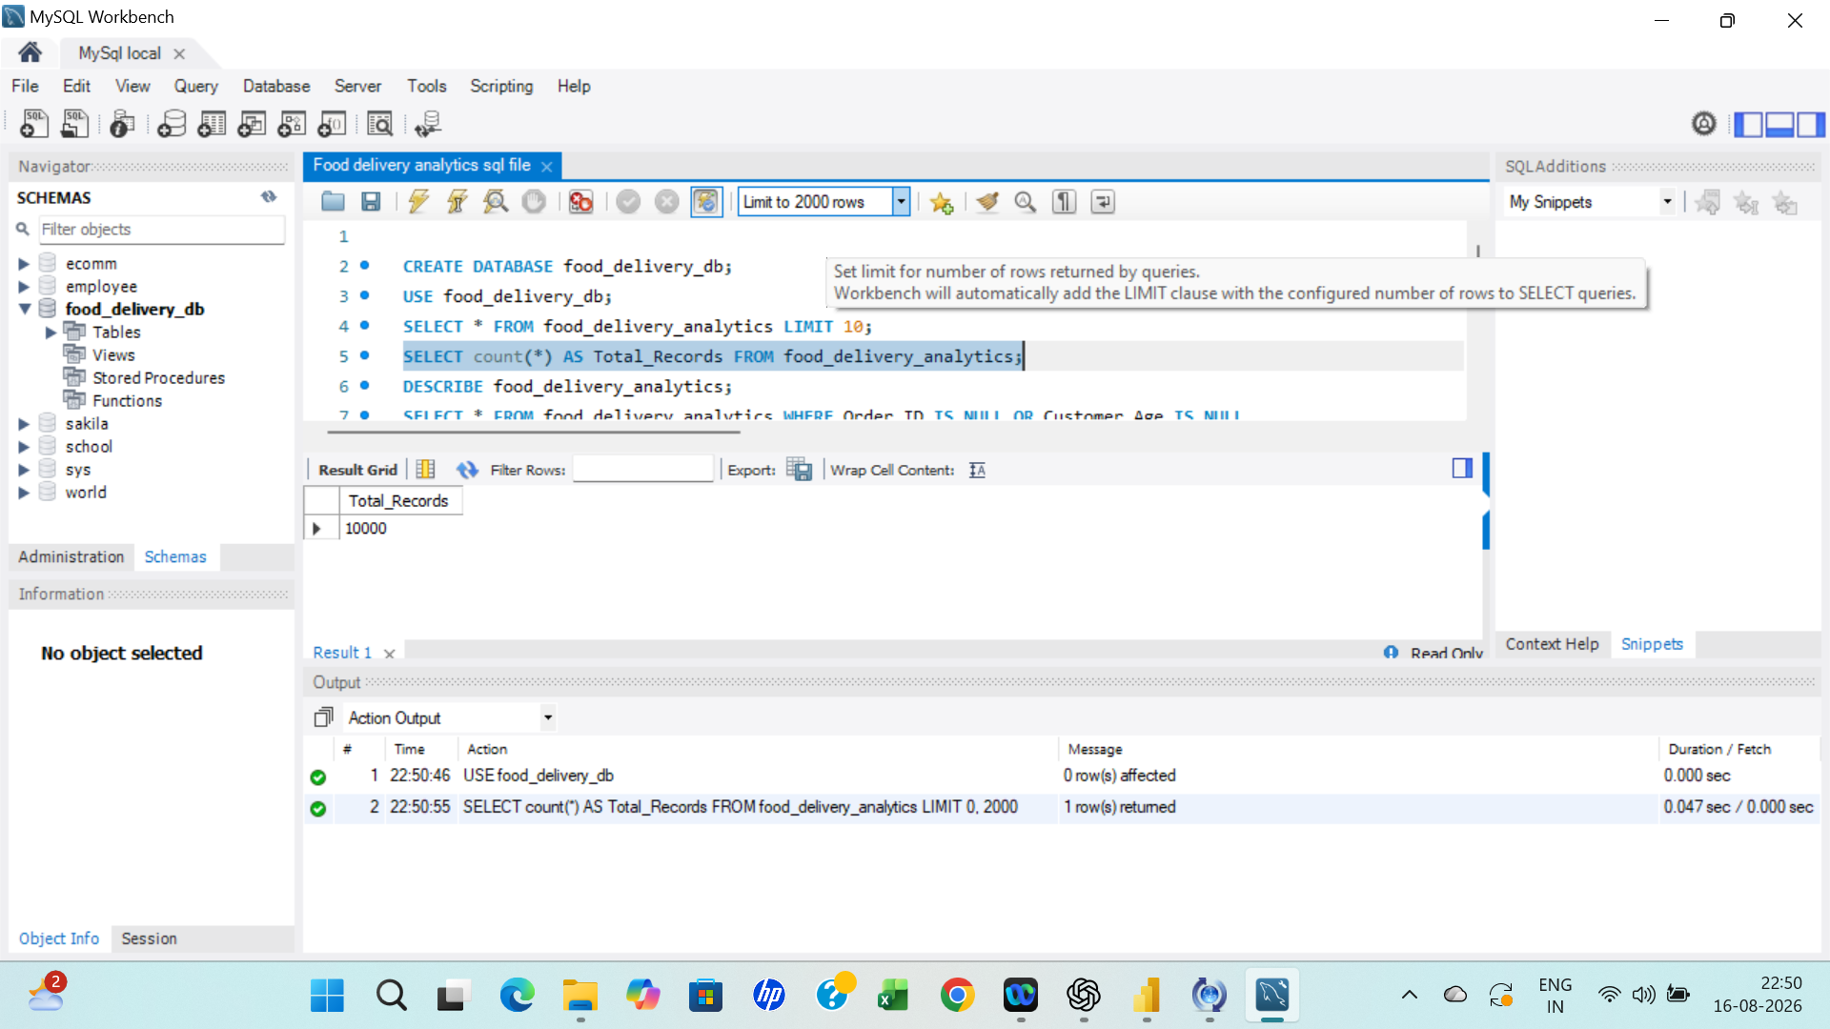

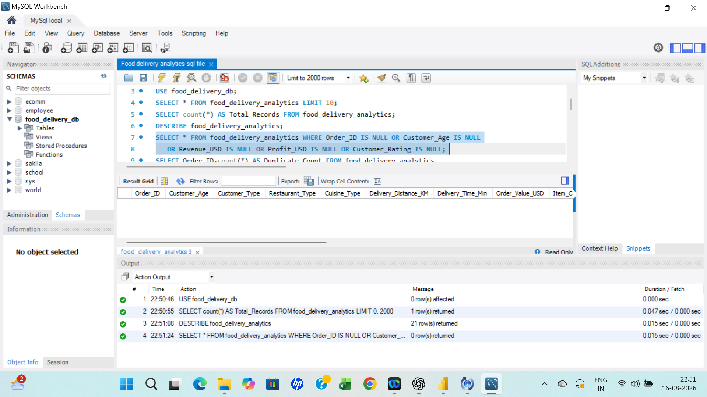

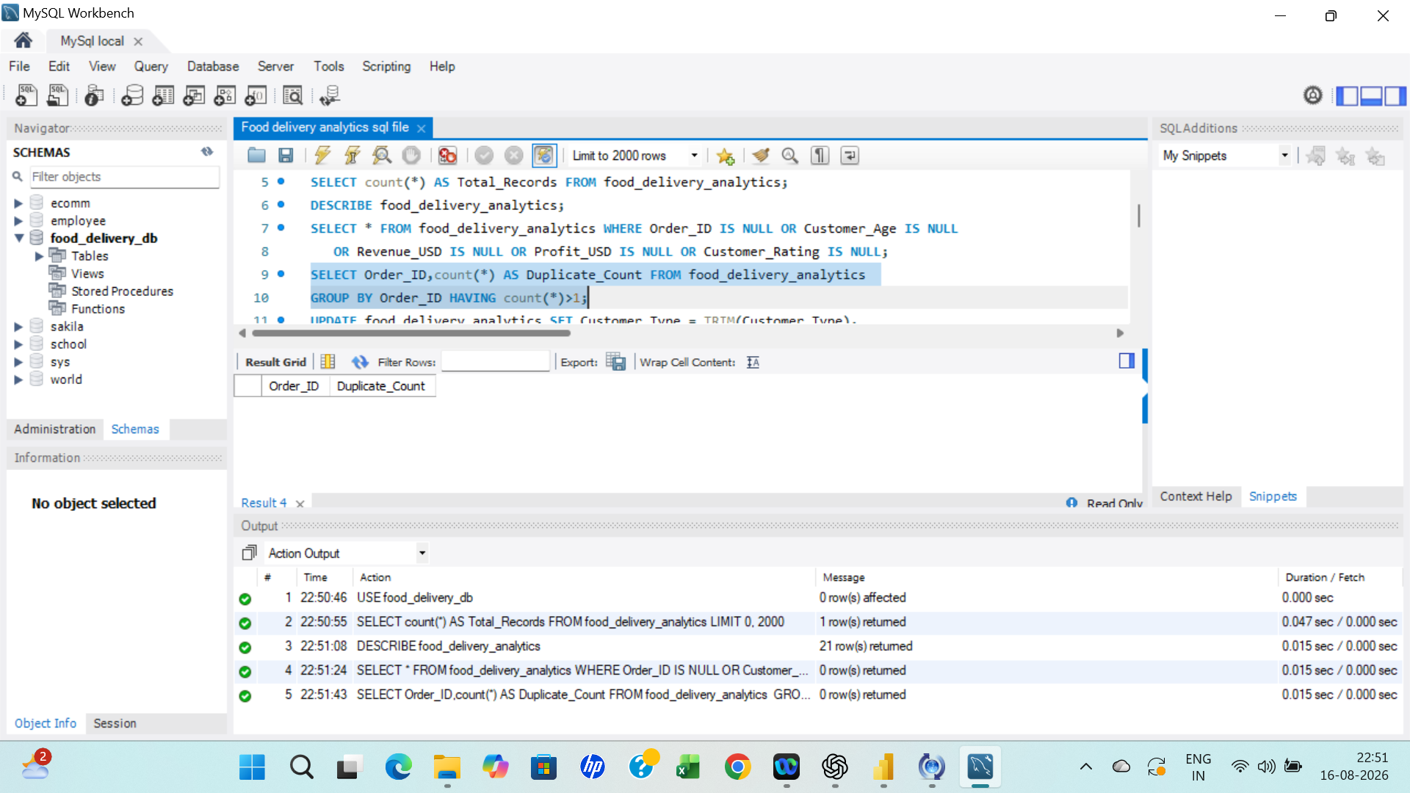

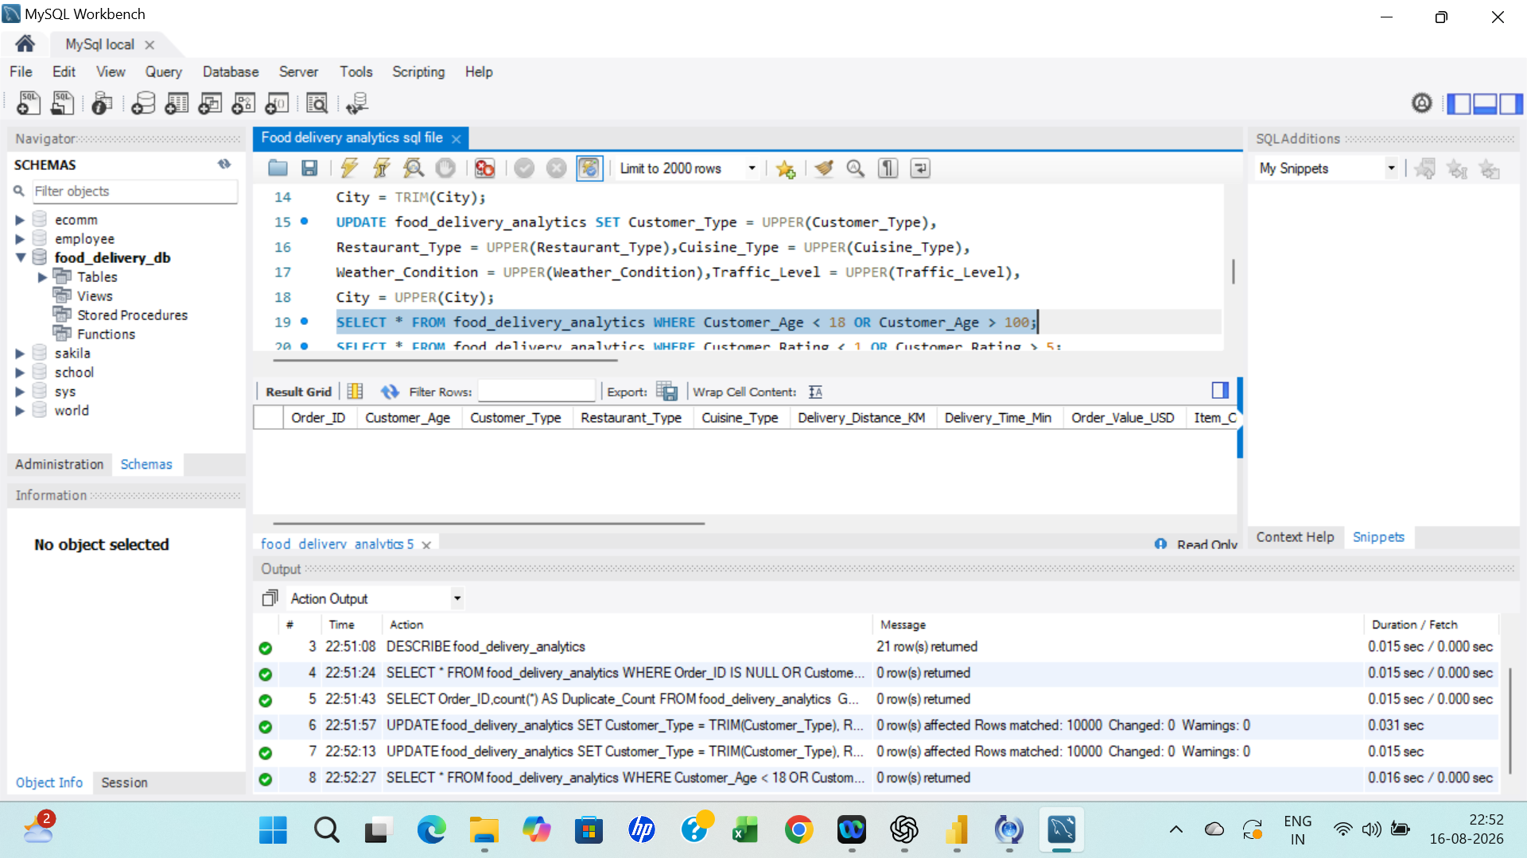

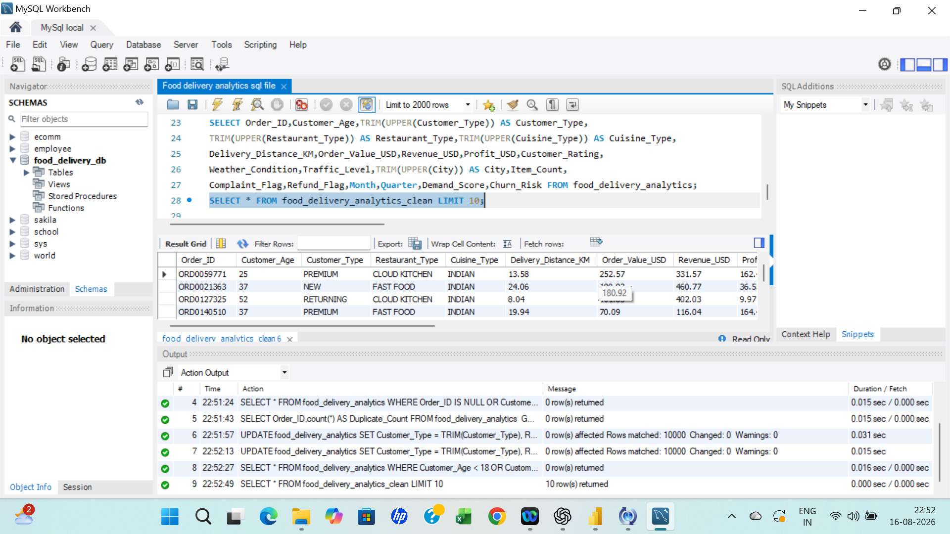

Power Query Data Cleaning
- Verified and corrected data types.
- Checked and handled missing values where required.
- Removed or investigated duplicates.
- Cleaned and standardized text/category values.
- Validated numerical fields and flags.
- Prepared month and quarter fields.
- Created dimension tables and keys.
- Prepared the final model for Power BI.
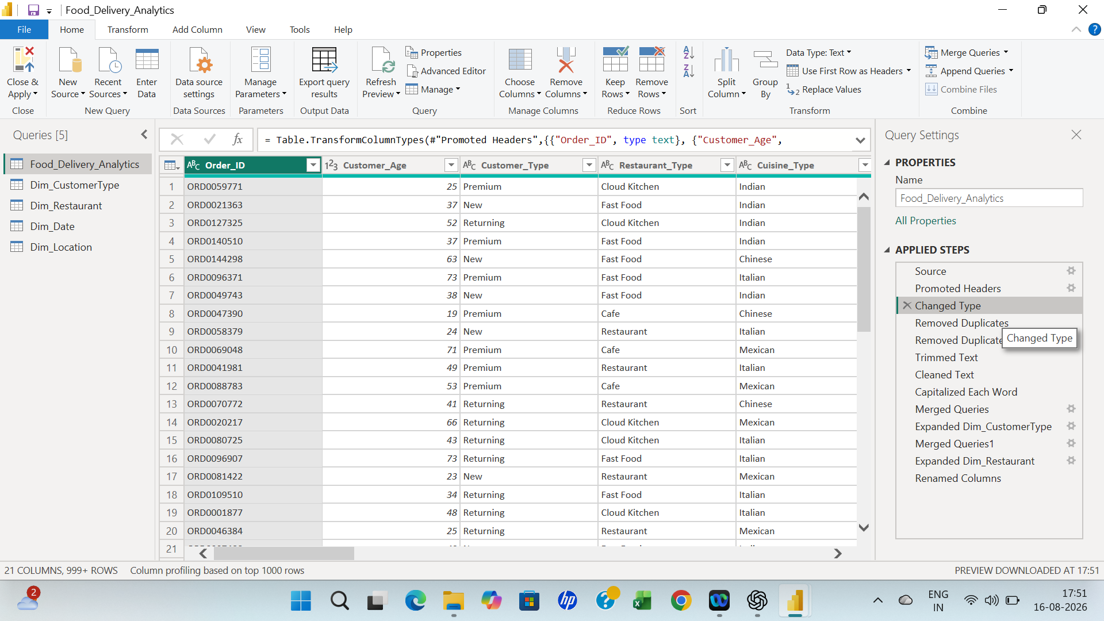

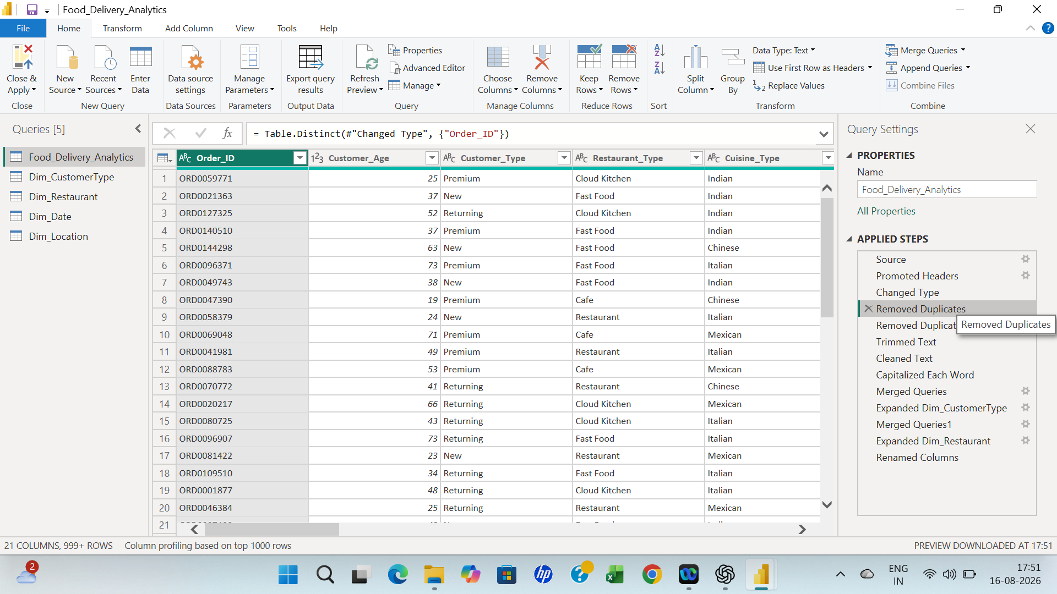

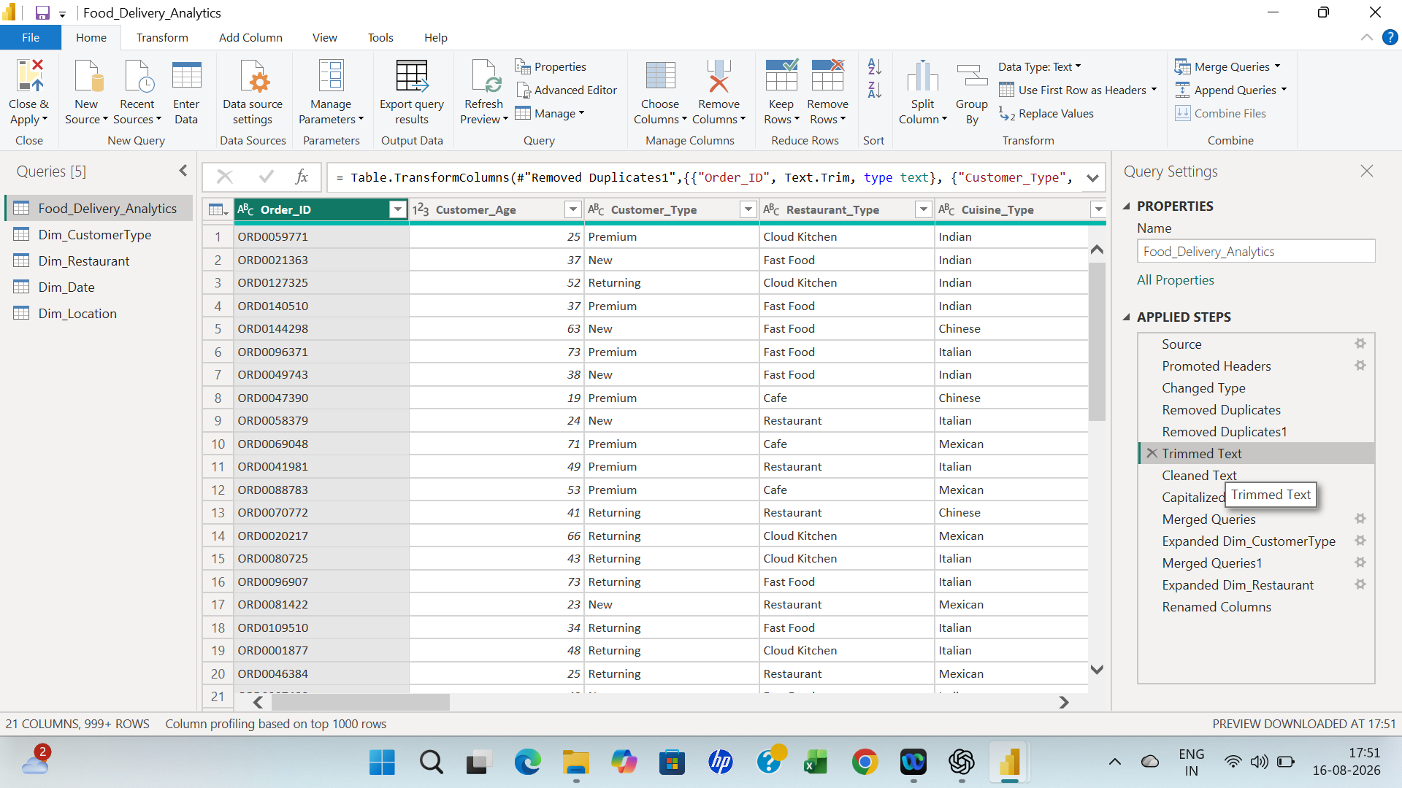

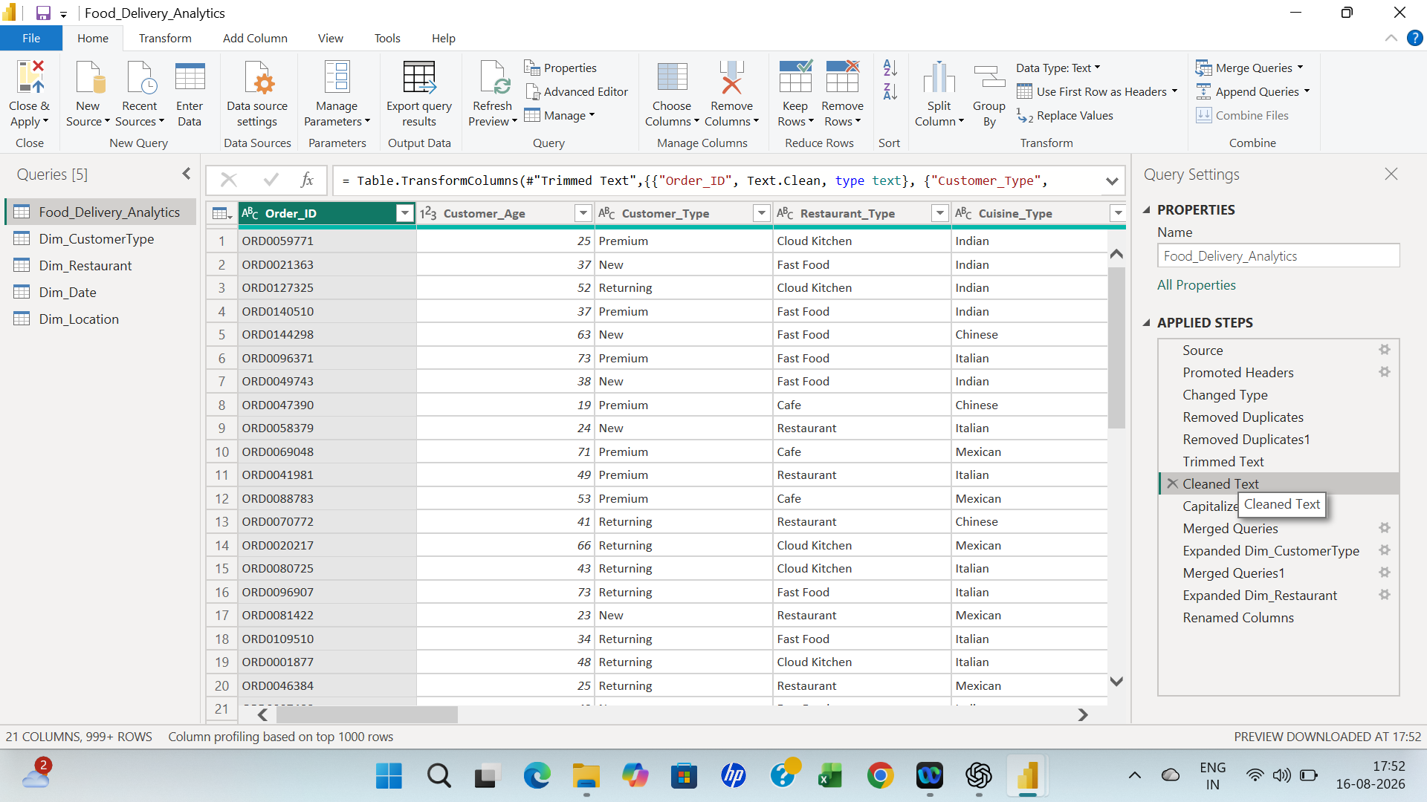

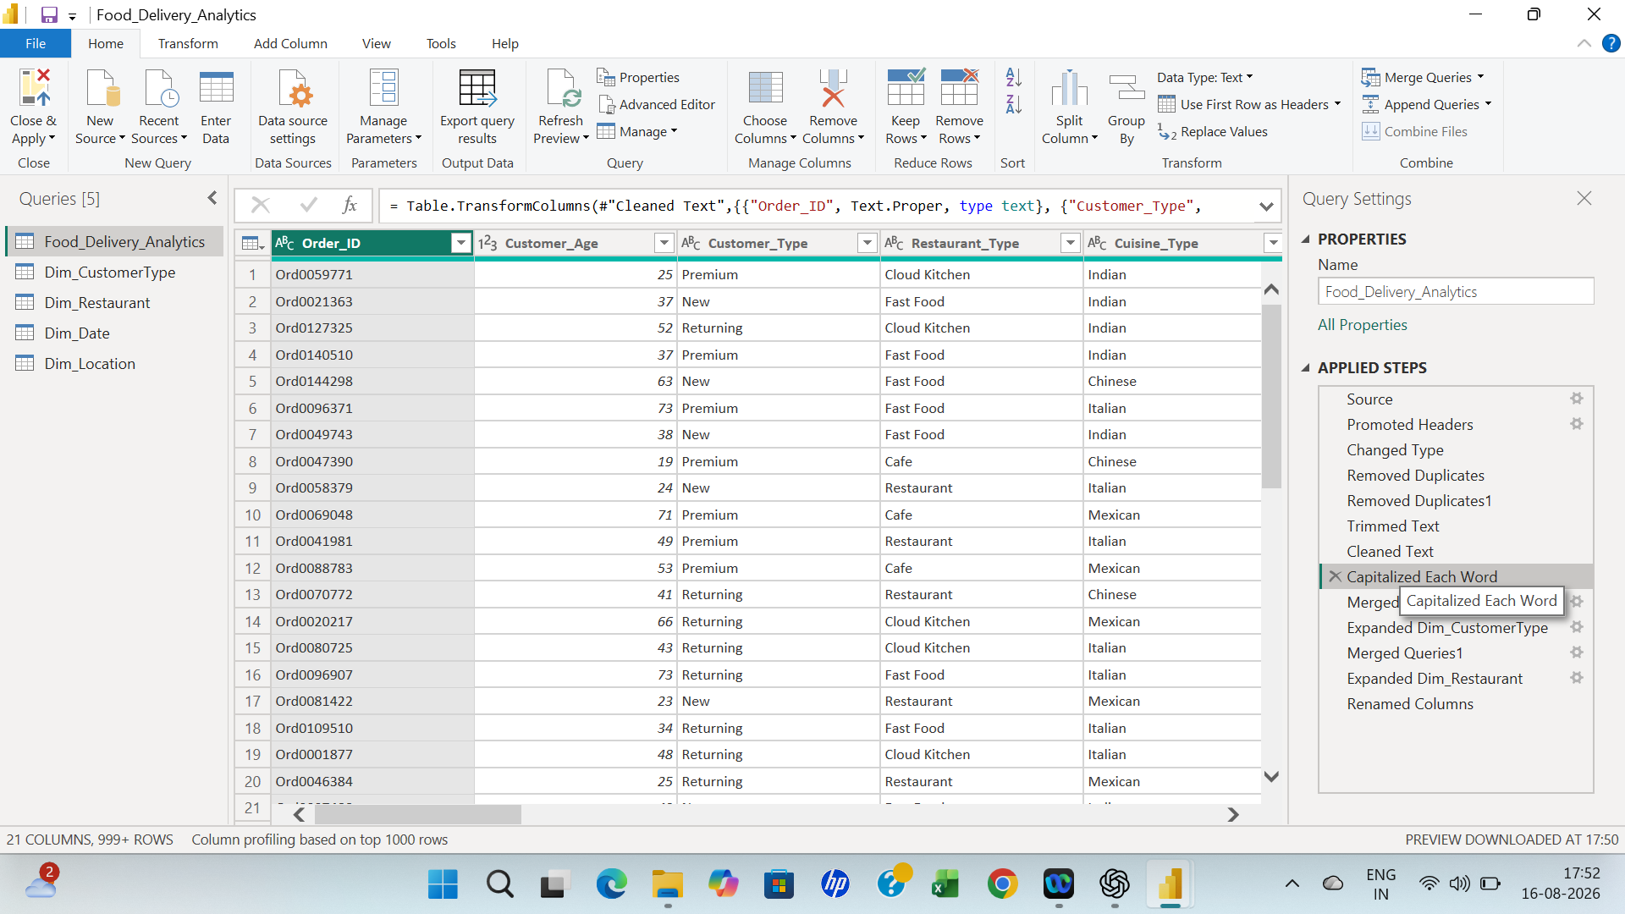
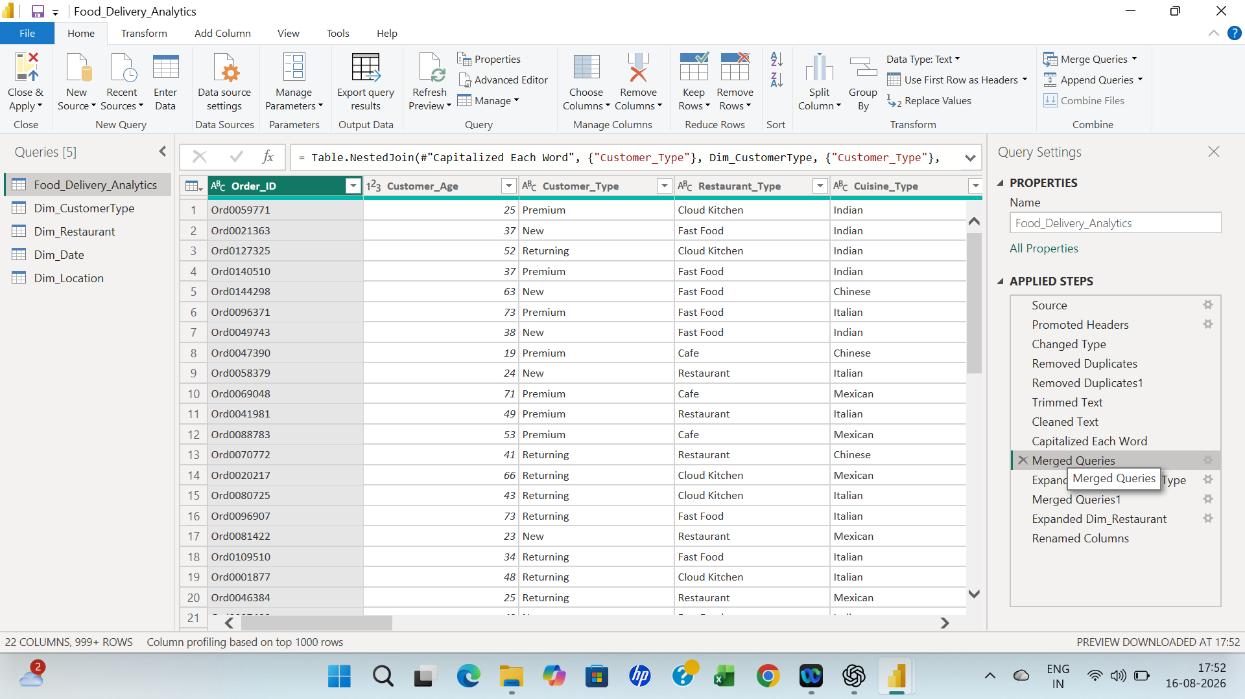

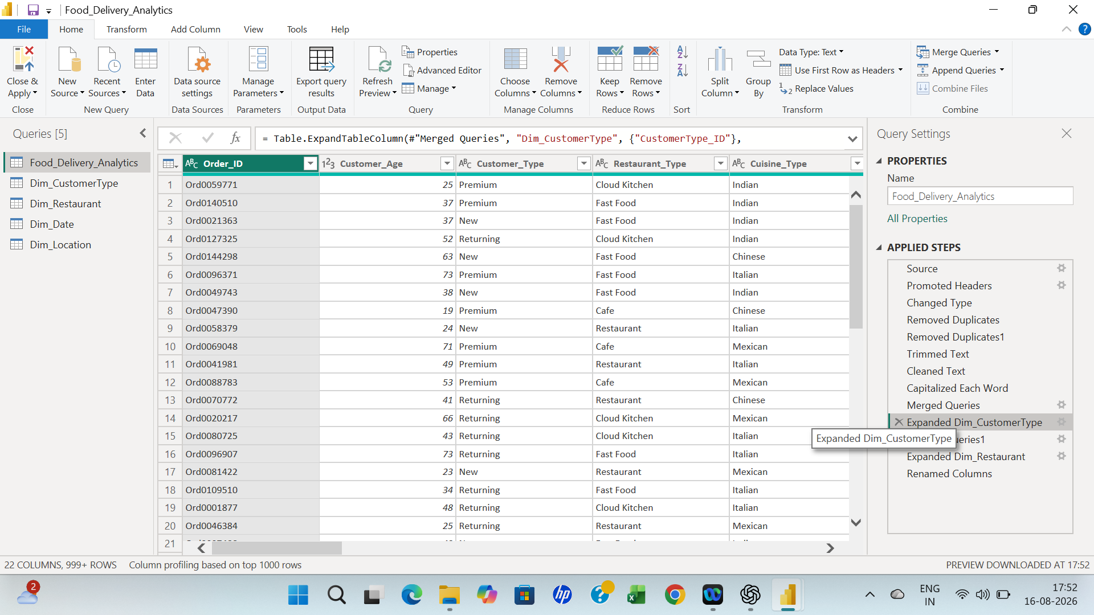

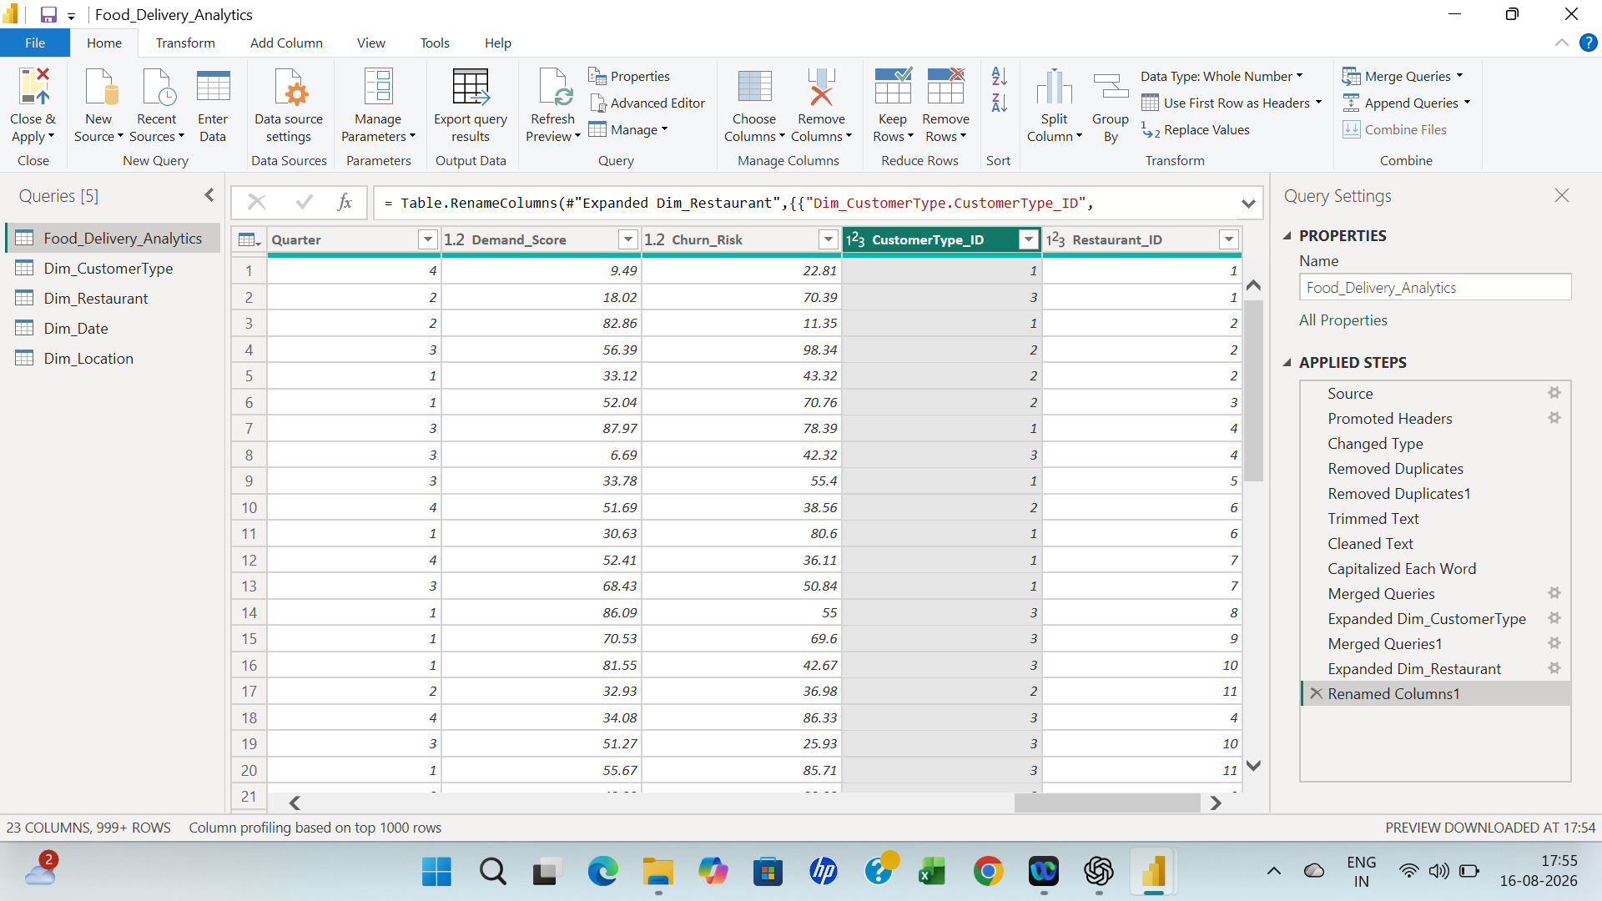

Data Modelling
After cleaning, the data was loaded into Power BI and a star schema was created. The central fact table contains transaction-level information and dimension tables provide descriptive attributes for filtering and grouping.
DIMENSION TABLES
Dim_Restaurant – Restaurant and cuisine type analysis.
Dim_Location – location attributes and geographic analysis.
Dim_Date – month and quarter analysis.
Dim_Customer_Type – customer segment analysis.
Relationships were created using common keys. The star schema improves organization and makes interactive filtering more reliable.
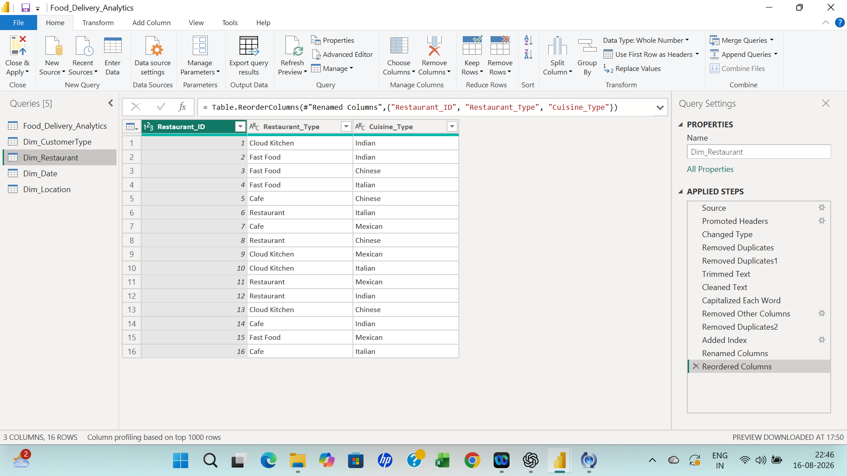
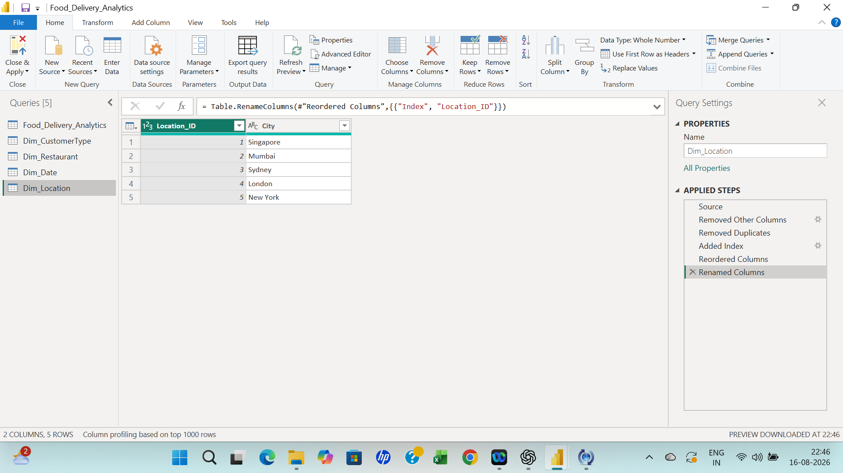
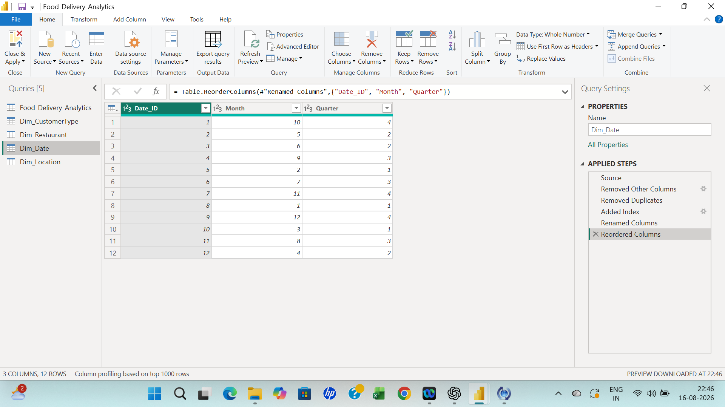
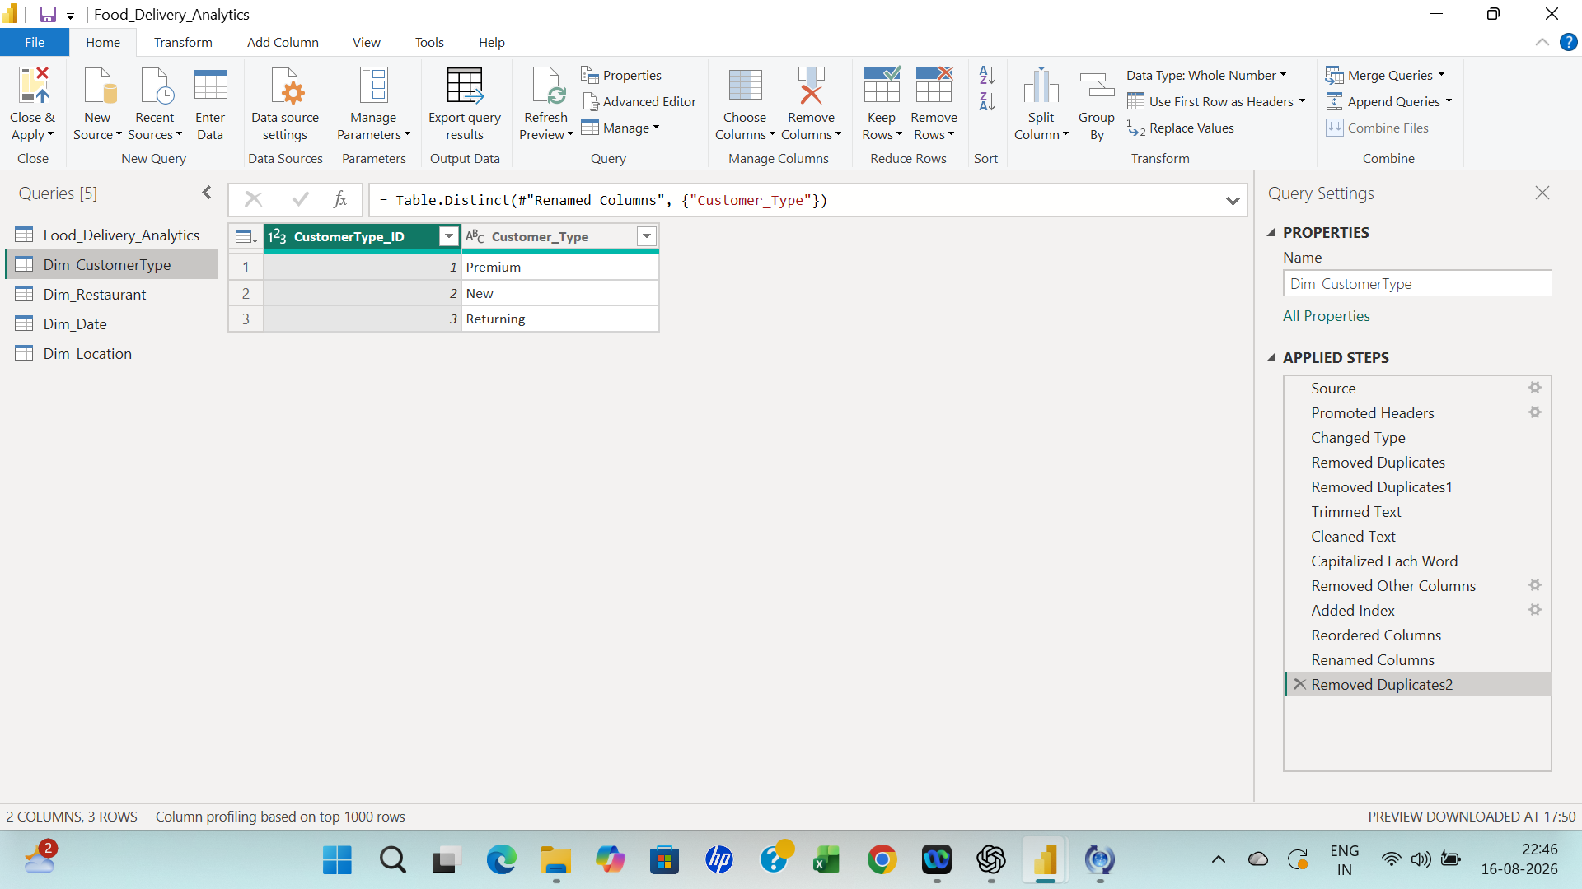

Star Schema Structure
FACT TABLE – Food_Delivery_Analytics
- Order ID
- Order Date
- Customer ID
- Customer Type
- Order Value
- Discount
- Profit
- Delivery Time
- Customer Rating
- Complaint Flag
- Refund Flag
- Demand
- Churn Risk
- Customer_Type ID
- Restaurant_ID

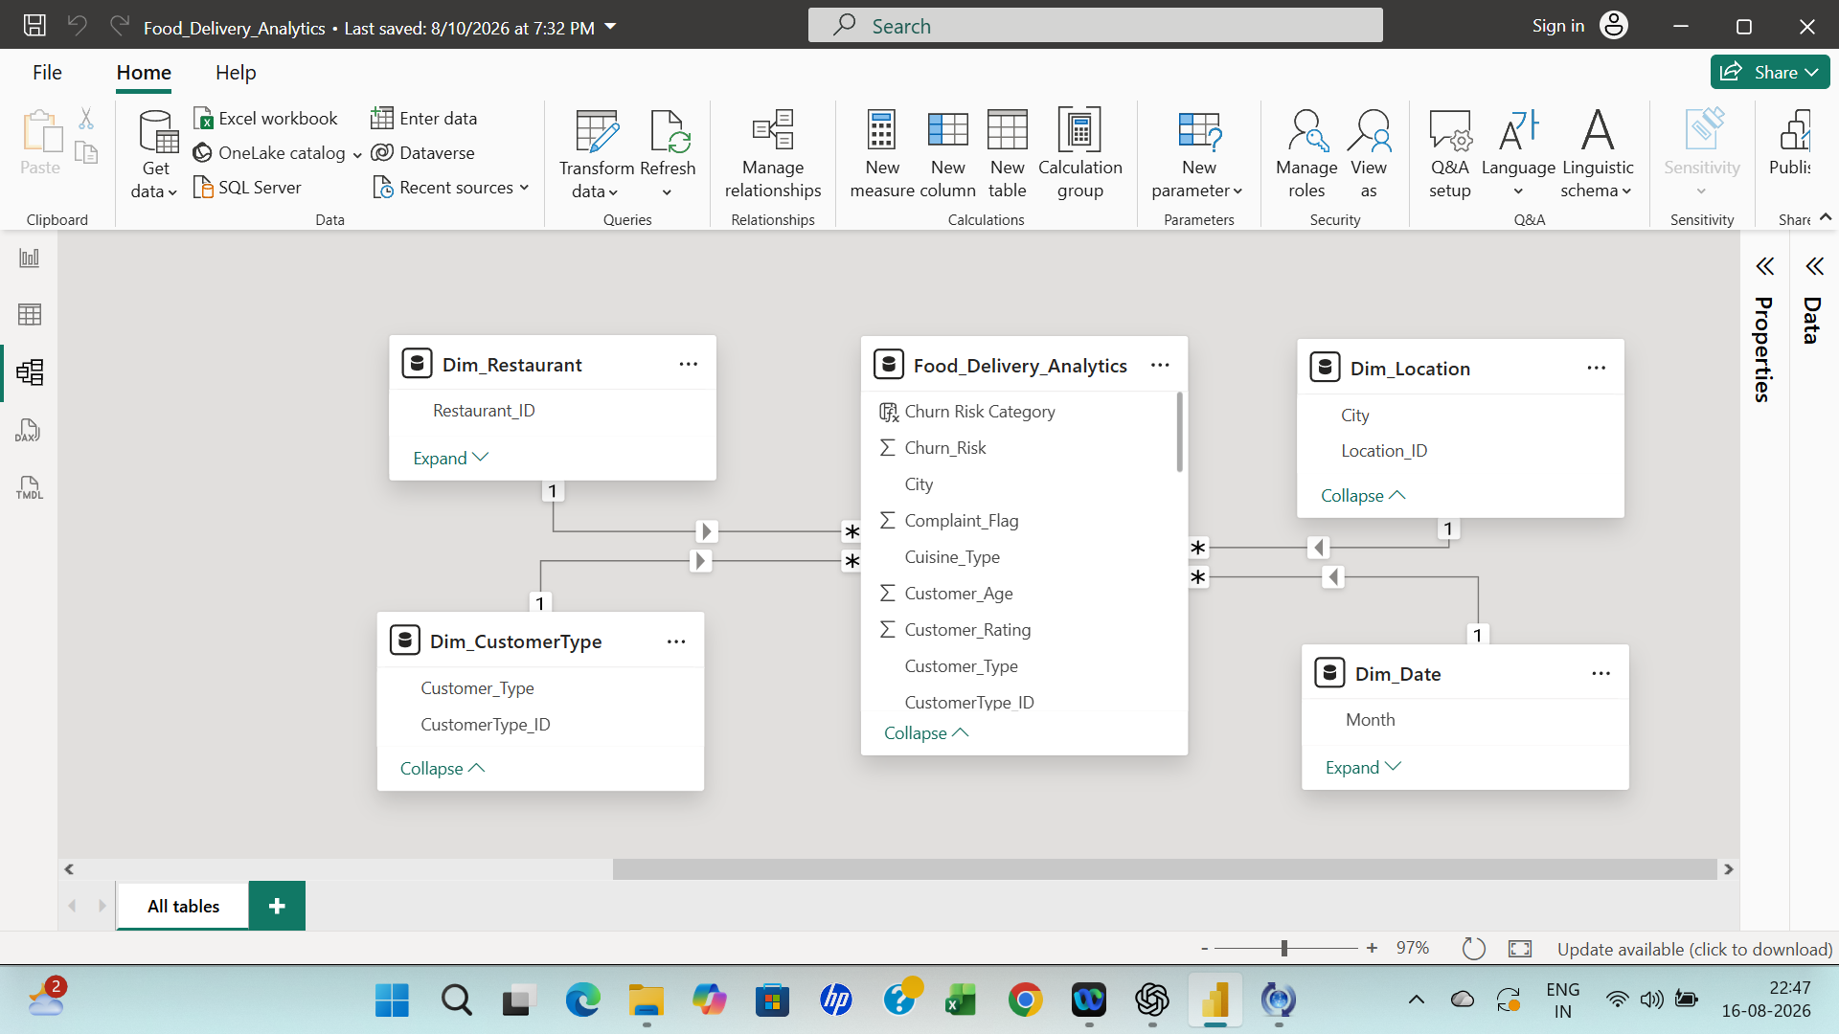

Python Data Cleaning
- Import the dataset
  - Import Pandas.
  - Load the cleaned/exported dataset into a DataFrame.
  - Check the first few rows using head ().
- Understand the dataset
  - Check number of rows and columns using shape.
  - Check column names using columns.
  - Use info () to review data types and non-null counts.
  - Use describe () for numerical statistics.
- Check missing values
  - Use isnull().sum() to identify missing values.
  - Calculate the percentage of missing values where required.
  - Decide whether to remove or appropriately handle missing records.
- Check duplicate records
  - Use duplicated().sum().
  - Remove duplicate records using drop_duplicates() where appropriate.
- Validate data types
  - Convert date columns to datetime.
  - Convert numerical columns such as order value, discount, profit and delivery time to appropriate numeric types.
  - Ensure categorical columns are treated consistently.
- Validate customer age
  - Check minimum and maximum age.
  - Identify unrealistic age values.
  - Correct or investigate invalid records rather than blindly deleting them.
- Validate customer ratings
  - Confirm that ratings fall within the expected 0–5 range.
  - Identify values outside the valid range.
- Validate complaint and refund flags
  - Confirm that the fields contain expected binary values such as 0 and 1.
  - Check for unexpected values.
- Validate numerical columns
  - Check order value, discount, delivery time, profit, demand and churn-risk values.
  - Look for unusual or extreme values.
  - Negative profit is not automatically considered an error because an order can legitimately make a loss.
- Check categorical values
  - Inspect unique values for customer type, weather condition, location, month and quarter.
  - Identify spelling inconsistencies or unexpected categories.
- Check date-related fields
  - Verify the date format.
  - Extract or validate month and quarter information.
  - Ensure that month/quarter values are consistent with the actual date.
- Final validation
  - Recheck nulls.
  - Recheck duplicates.
  - Recheck data types.
  - Confirm valid ranges.
  - Confirm that the DataFrame is ready for EDA.

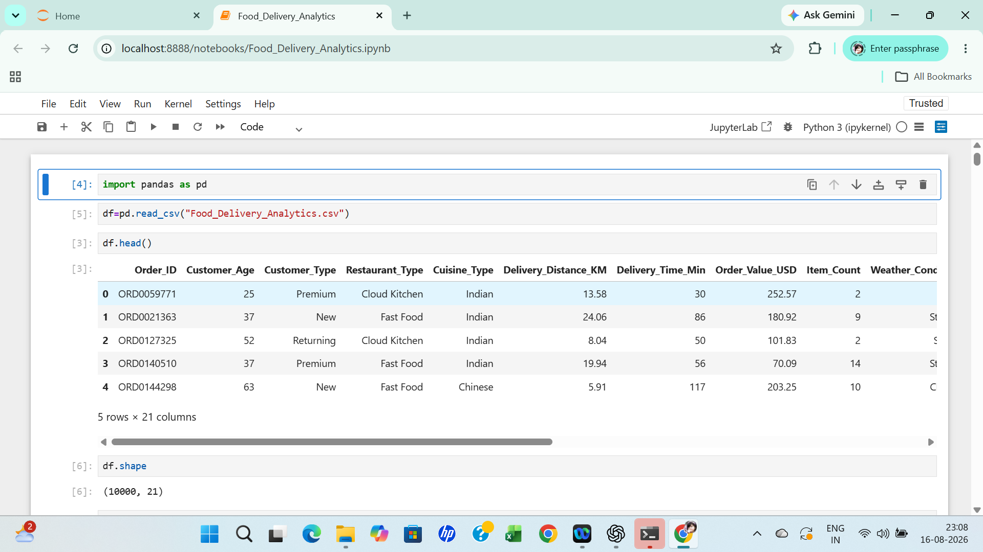
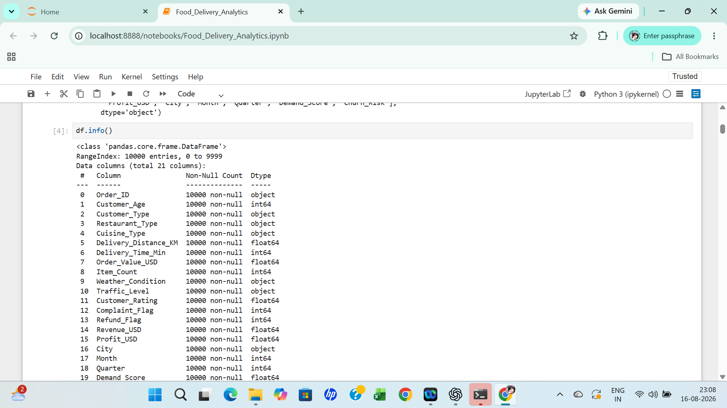
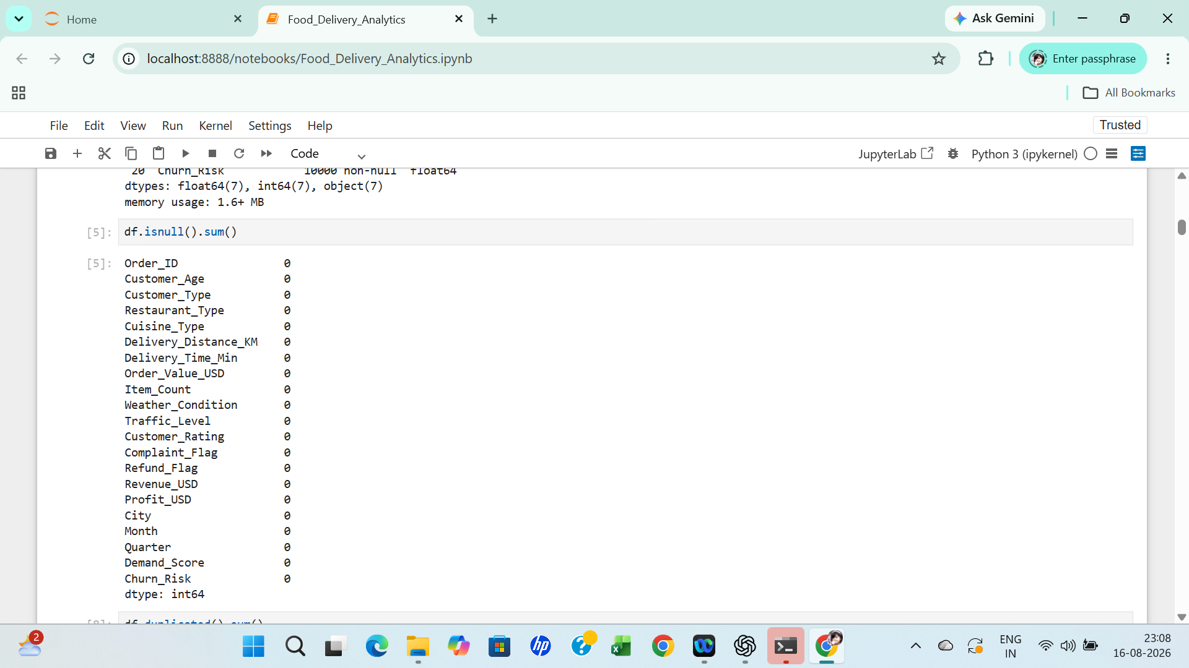
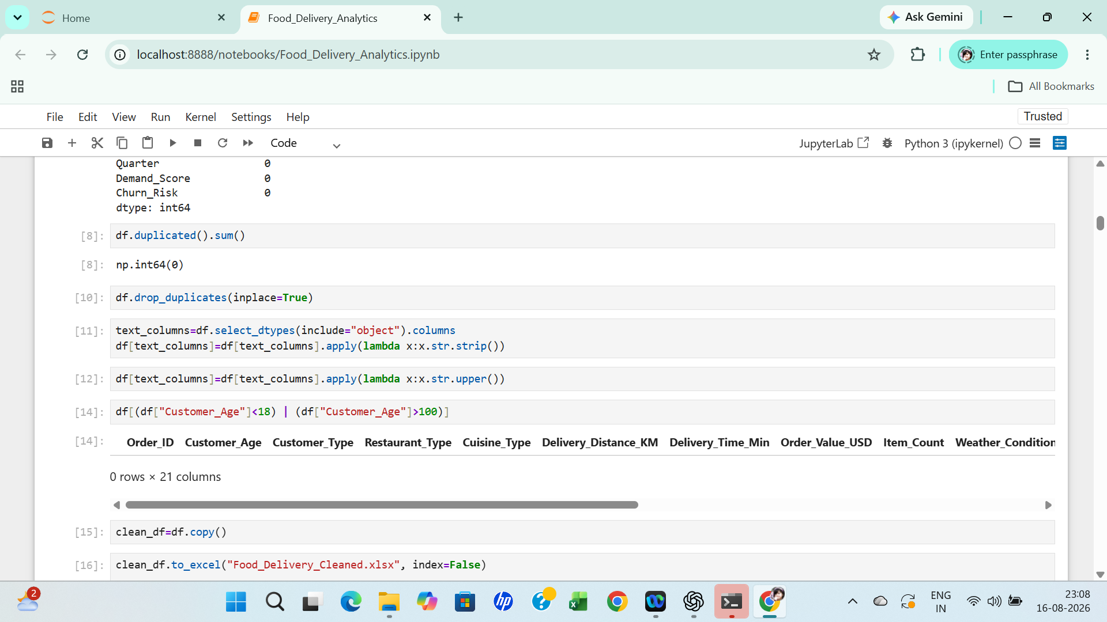

Python Exploratory Data Analysis
Python was used for Exploratory Data Analysis (EDA) to inspect distributions, compare categories, investigate relationships, and identify patterns before final dashboard reporting.
- Order and order-value analysis.
- Revenue and profitability analysis.
- Customer rating analysis.
- Delivery-time analysis.
- Complaint and refund analysis.
- Customer-type analysis.
- Location analysis.
- Weather analysis.
- Demand analysis.
- Churn-risk analysis.
- Relationship analysis such as Delivery Time versus Customer Rating.

Python Visual Analysis
Visual-1 - Order Distribution by Customer Type
Description:
This bar chart shows the number of orders generated by each customer type — New, Premium, and Returning. The X-axis represents the customer type, while the Y-axis represents the number of orders.
Insights:
- New customers have the highest number of orders, at approximately 3,400.
- Premium customers follow closely with around 3,350 orders.
- Returning customers have slightly fewer orders, at around 3,250.
- The difference between the three groups is relatively small, indicating that orders are fairly evenly distributed across customer segments.
- The company has a strong opportunity to convert new customers into returning or premium customers through loyalty programs, personalized offers, and targeted promotions.
Business takeaway:
The relatively balanced order distribution indicates that the business is not dependent on a single customer segment.

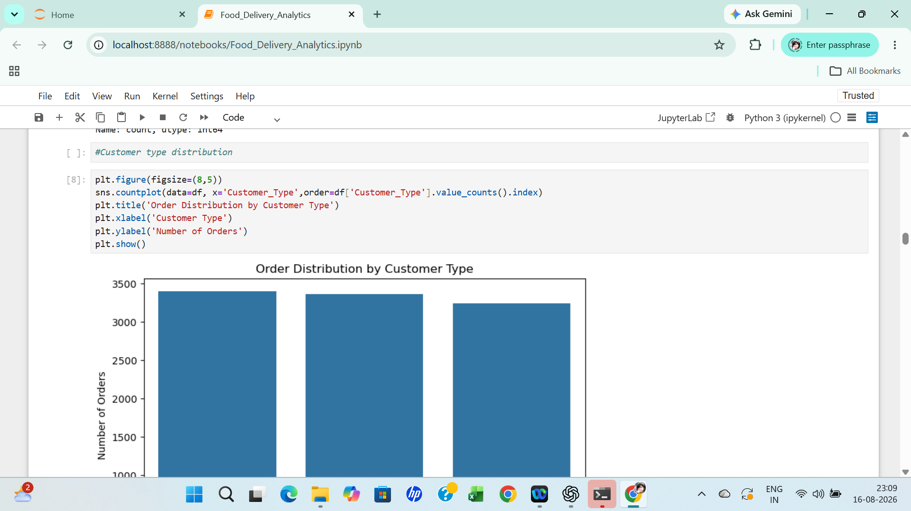

Visual 2- Revenue by Customer Type
Description:
This bar chart compares the total revenue generated by New, Premium, and Returning customers. The X-axis represents customer type and the Y-axis represents total revenue in USD.
Insights:
- New customers generate the highest revenue, at approximately $875K.
- Premium customers generate slightly less, around $855K.
- Returning customers generate approximately $820K.
- Revenue follows a similar pattern to the order distribution.
- The difference in revenue between the segments is not very large, suggesting that all three customer groups contribute significantly to overall revenue.
- Since new customers contribute the highest revenue, retaining these customers and encouraging repeat purchases could create additional long-term revenue.
Business takeaway:
New customers are currently the strongest revenue contributor, so customer retention strategies can help convert this initial revenue contribution into recurring revenue.
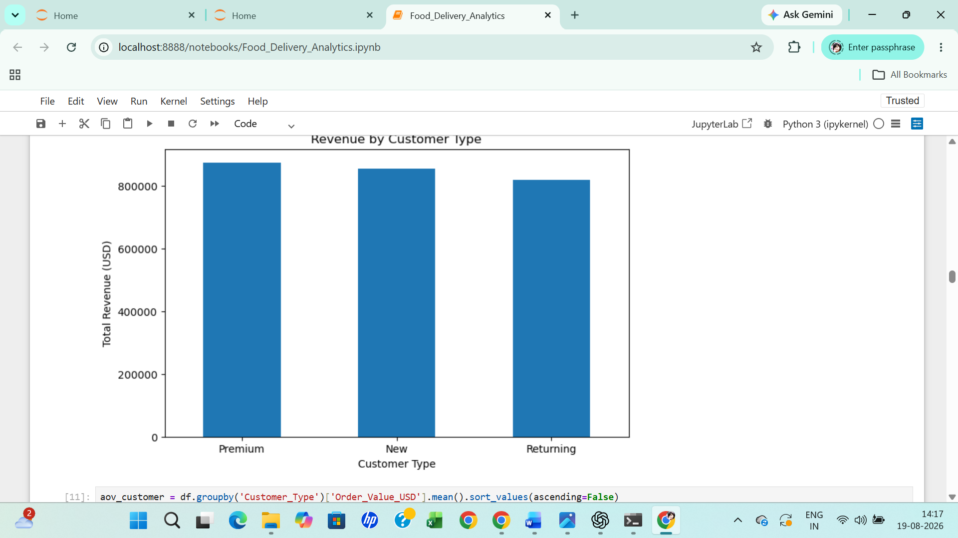

Visual 3 - Average Churn Risk by Customer Type
Description:
This bar chart compares the average churn risk across New, Returning, and Premium customers. The X-axis represents customer type and the Y-axis represents average churn risk.
Insights:
- New customers have the highest average churn risk, approximately 51.
- Returning customers have a slightly lower risk, around 50.
- Premium customers have the lowest churn risk, approximately 50.
- The differences are relatively small, so churn risk is high across all three customer segments.
- New customers may require additional attention because they have not yet developed strong loyalty to the platform.
- Premium customers show slightly better retention potential, which may indicate that loyalty programs or premium benefits are helping engagement.
Business takeaway:
Customer retention should be a major focus. The company should particularly target new customers with onboarding offers, personalized recommendations, loyalty rewards, and follow-up campaigns.
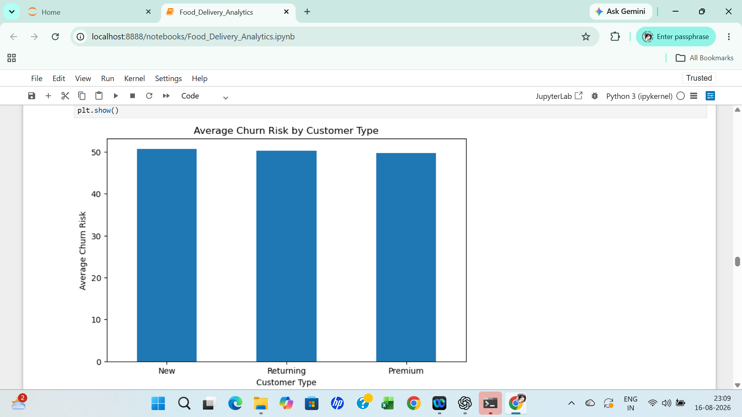

Visual 4– Order Value Distribution
Description: This histogram (with an overlaid KDE curve) shows the frequency of orders across different order value ranges, from $0 to $300. The X-axis represents Order Value in USD, and the Y-axis represents the Number of Orders.
Insights:
- Order values are distributed fairly evenly across the $0–$300 range, with each $15–20 bin containing roughly 460–520 orders.
- There is no strong concentration around a "typical" order value — no dominant peak or long tail.
- The KDE curve dips slightly at both extremes (very low and very high order values) but stays largely flat through the middle range.
- This near-uniform spread suggests order value in this dataset doesn't cluster around common price points (e.g., no visible spike around $50 or $100 combo-meal pricing).

Business takeaway:
Because order values are spread evenly rather than clustering around specific price points, there isn't an obvious "sweet spot" basket size to target with promotions — any upsell or bundling strategy would need to be tested rather than assumed from this distribution alone.
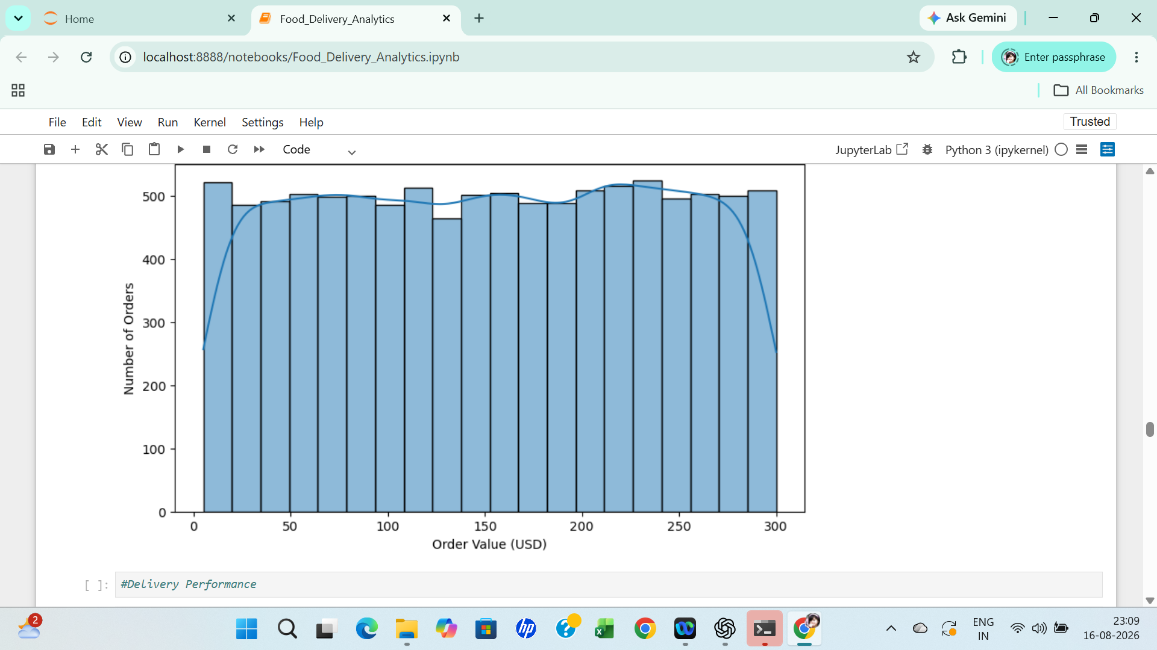

Visual 5– Delivery Distance vs Delivery Time by Traffic Level
Description: This scatter plot compares Delivery Distance (KM, X-axis, 0–25) against Delivery Time (Minutes, Y-axis, 0–120), with points color-coded by Traffic_Level (High, Low, Medium).
Insights:
- There is no visible correlation between delivery distance and delivery time — short-distance deliveries take anywhere from a few minutes to over 100 minutes, and the same is true for long-distance deliveries.
- The three traffic levels are heavily overlapping across the entire chart, with no distinct clustering by colour in any region.
- This suggests delivery time is being driven by factors other than distance and traffic level alone (e.g., restaurant prep time, rider availability).
Business takeaway:
Since distance and traffic level don't clearly explain delivery time variation here, operational improvements aimed purely at routing or traffic avoidance may have limited impact — it's worth investigating other potential drivers (kitchen prep time, order batching, rider assignment) before prioritizing a traffic-focused fix.
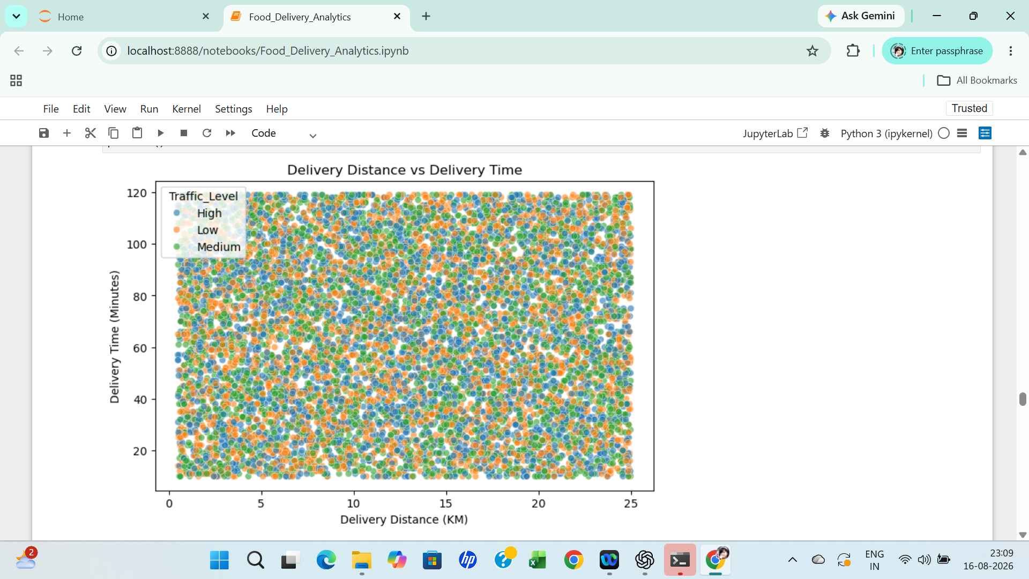

Visual 6– Customer Rating by Traffic Level
Description: This box plot compares Customer Rating (Y-axis, 0–5) across three Traffic Level categories (High, Low, Medium) on the X-axis.
Insights:
- All three traffic levels show nearly identical distributions — medians sit around 3, with interquartile ranges roughly spanning 2 to 4, and whiskers extending from 1 to 5.
- "Low" traffic has a marginally higher median (~3) compared to "Medium" (~2.8), but the difference is small relative to the overall spread.
- The near-identical box shapes indicate traffic level has little to no measurable effect on customer rating in this dataset.
Business takeaway:
Traffic conditions don't appear to meaningfully influence how customers rate their experience, so rating-improvement efforts are probably better focused elsewhere (e.g., delivery speed, order accuracy, food quality) rather than traffic mitigation.
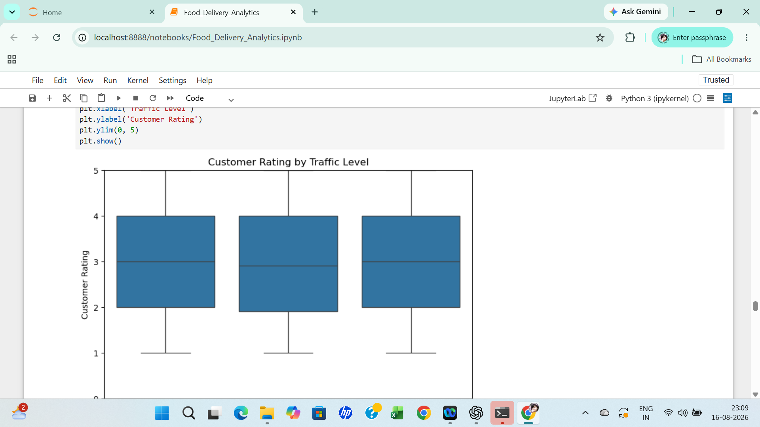

Visual 7 – Order Share by Cuisine Type
Description: This pie chart shows the percentage share of total orders by cuisine type: Indian, Italian, Chinese, and Mexican.
Insights:
- Indian cuisine holds the largest share at 26.2%, followed by Mexican (25.3%), Chinese (24.8%), and Italian (23.7%).
- The four cuisines are very evenly split, within a narrow 2.5-percentage-point band of each other.
- No single cuisine dominates order volume — customer cuisine preference appears broadly balanced.

Business takeaway:
With no cuisine category significantly outperforming the others, there's an opportunity to grow any of the four categories through targeted promotion rather than needing to defend a single dominant category — though the near-even split also means marketing spend could reasonably be distributed evenly across cuisines rather than concentrated.
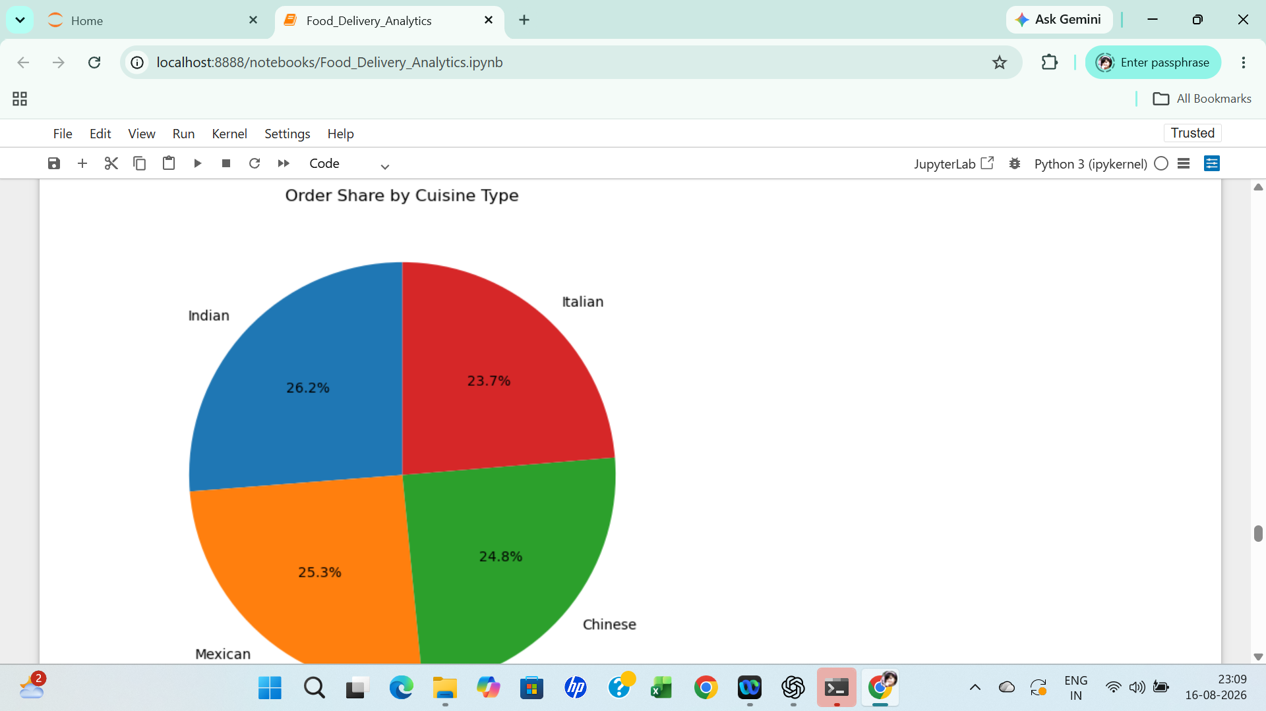

Visual 8– Revenue vs Profit by Customer Type
Description: This scatter plot plots Profit (USD, Y-axis, 0–200 shown) against what appears to be Revenue (X-axis, based on the chart title "Revenue vs Profit by Customer Type"), with points color-coded by customer type and a horizontal reference line around the $90 profit mark.
Insights:
- Profit values are widely and evenly scattered from near $0 to $200, with no clear upward or downward trend as revenue increases.
- The three customer type colors (New, Premium, Returning) are heavily intermixed throughout the chart, with no visible clustering by segment.
- The horizontal reference line (~$90) likely marks average/median profit, around which points are roughly symmetrically distributed.

Business takeaway:
Profit per order doesn't scale predictably with revenue or vary meaningfully by customer type in this dataset, so profitability improvements are unlikely to come from simply targeting a specific customer segment — margin-focused analysis (e.g., by cuisine, city, or order size) may be more productive.
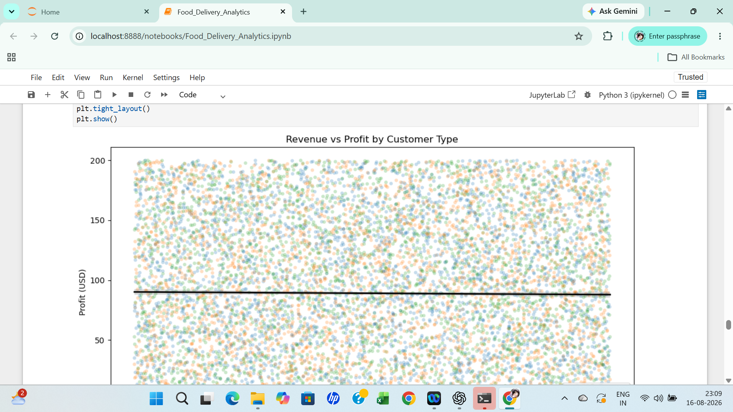

Visual 9– Monthly Revenue Trend
Description: This line chart tracks Revenue (USD, Y-axis, ~195,000–230,000) across 12 months (X-axis), with markers at each monthly data point.
Insights:
- Revenue is volatile month over month rather than showing a steady upward or downward trend — there's a sharp peak around month 5–6 (~$231K) and a sharp trough shortly after (~$196K).
- Excluding the single large spike, most months hover in the $205K–$220K range.
- No clear seasonal pattern (e.g., consistent holiday-quarter growth) is visible from 12 months of data alone.

Business takeaway:
The lack of a stable growth trend suggests revenue is currently driven by short-term fluctuations rather than sustained business growth — worth flagging as an area to monitor, and worth investigating what caused the month 5–6 spike and the immediate drop after it, since understanding that swing could reveal a repeatable revenue driver (or a one-off anomaly).
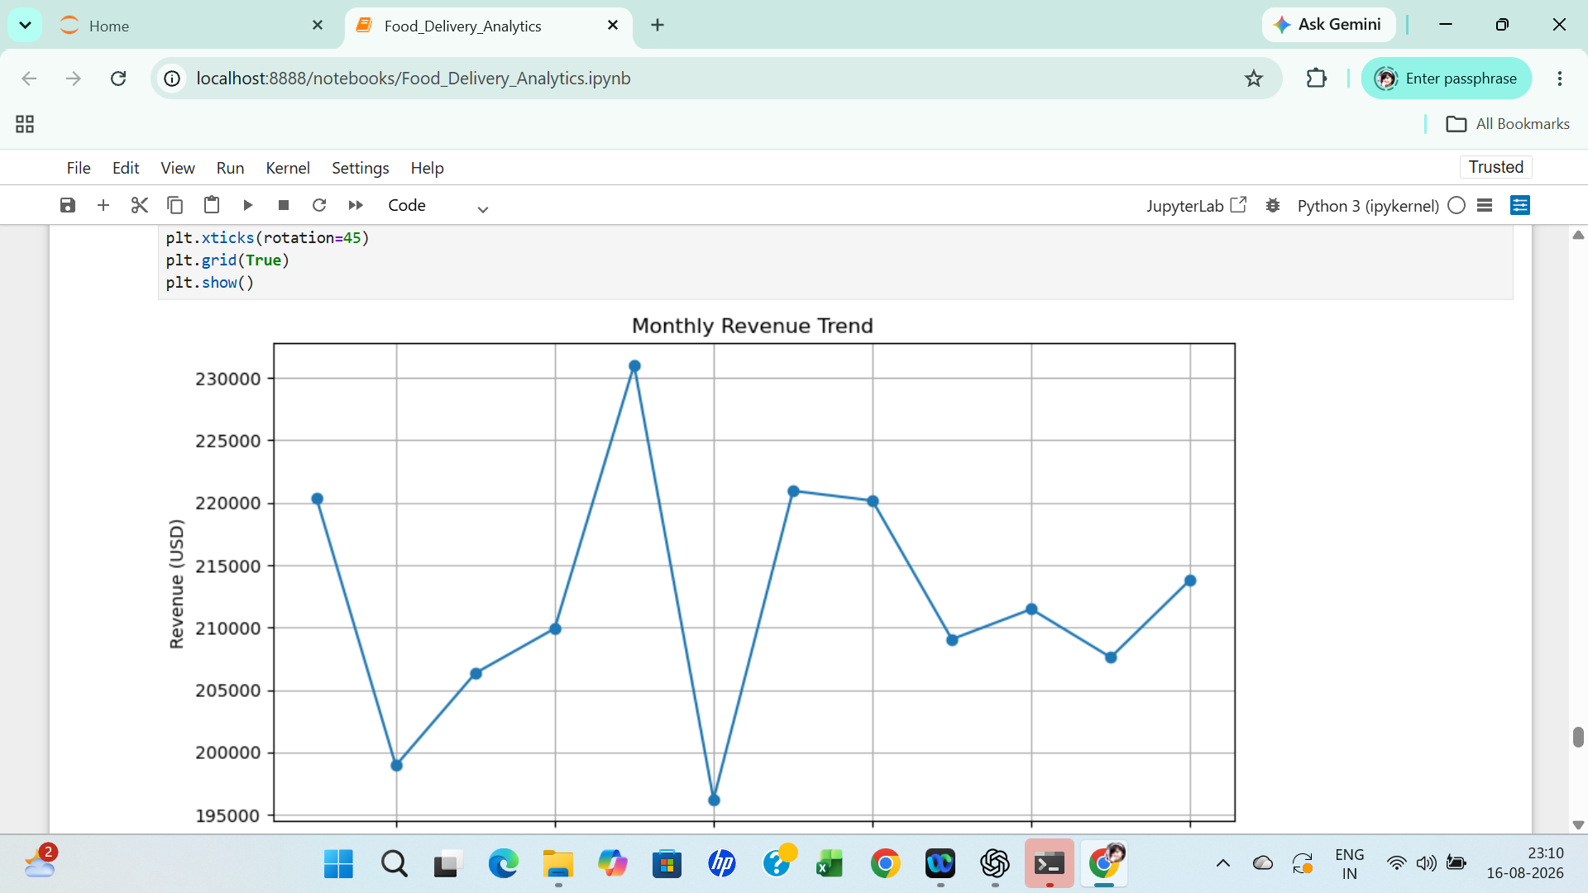

Visual 10– Customer Rating Distribution by Customer Type
Description: This violin plot shows the distribution shape of Customer Rating (Y-axis, 1–5) across the three Customer Type categories (Premium, New, Returning) on the X-axis.
Insights:
- All three customer types show a similar bimodal-ish "double-bulge" distribution shape, wide at the top (near 5) and bottom (near 1), narrower in the middle.
- Median ratings are similar across all three groups (roughly 3), and interquartile ranges (thicker black bars) also look comparable.
- No customer type stands out as rating the service notably higher or lower than the others.
Business takeaway:
Since satisfaction levels are consistent across New, Premium, and Returning customers, any rating-improvement initiative doesn't need to be segment-specific — a general service-quality improvement would likely benefit all customer types similarly.
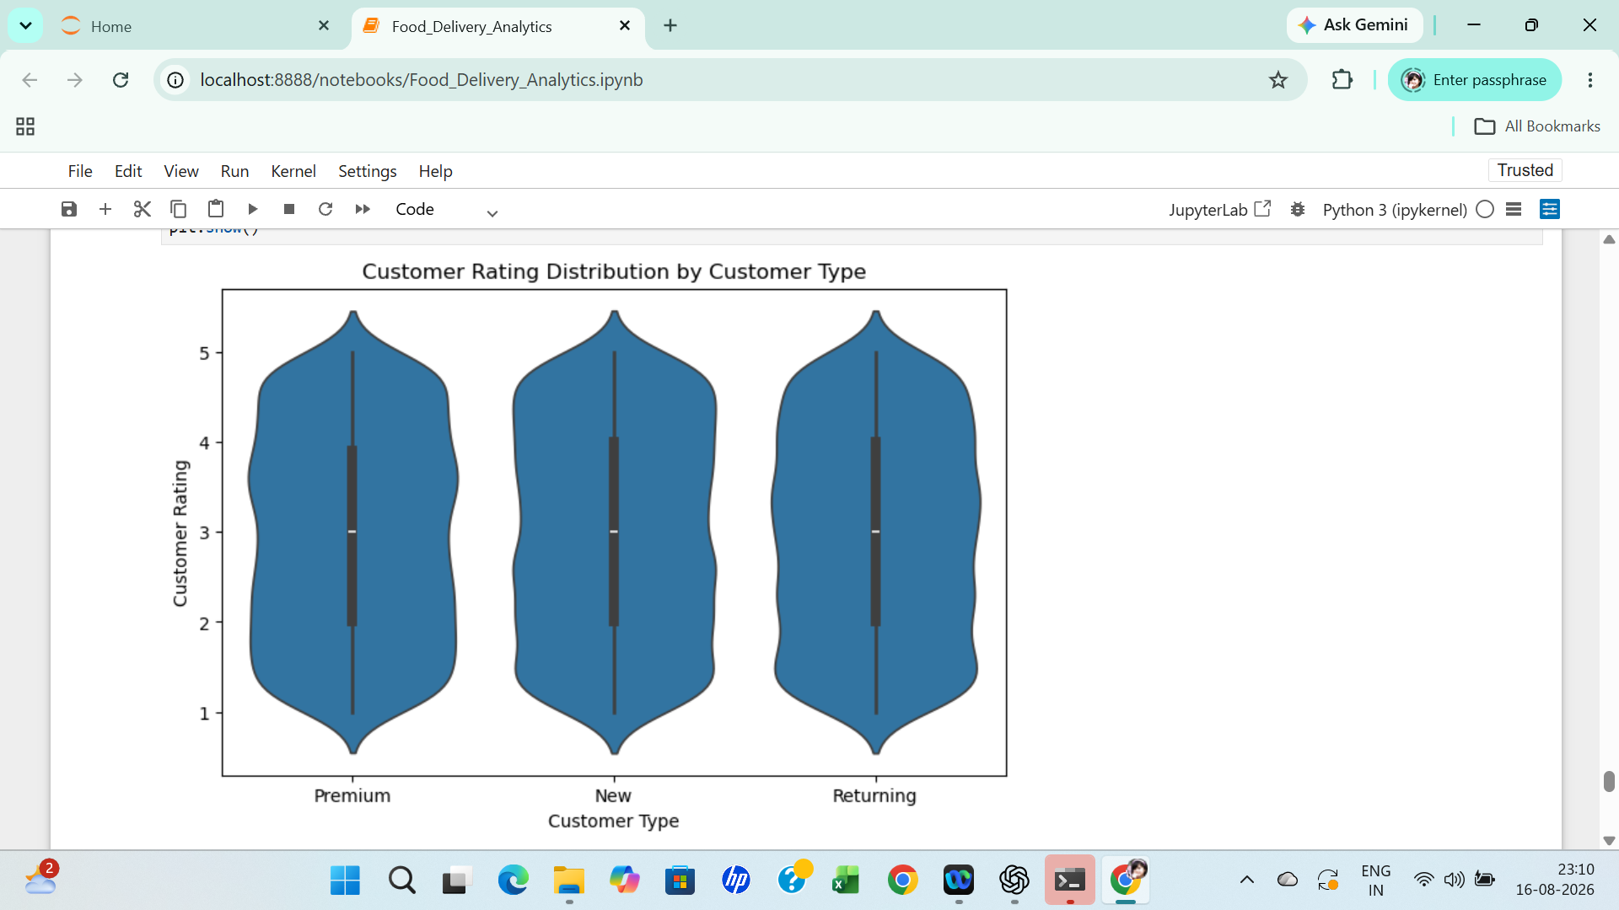

Visual 11– Complaints vs Refunds
Description: This bar chart compares the total count of Complaints against total Refunds, with Number of Orders on the Y-axis and the two categories (Complaints, Refunds) on the X-axis.
Insights:
- Complaints (~980) are more than double the number of Refunds (~450).
- This gap suggests that not every complaint results in a refund — roughly half of complaints may be resolved through other means (replacement orders, partial credit, no action) or may not meet refund criteria.
- This chart only shows two aggregate totals, so it doesn't indicate which complaint types are least likely to result in a refund — that would require a breakdown by complaint category or city.
Business takeaway:
The gap between complaints and refunds is worth investigating further — understanding why roughly half of complaints don't convert to refunds could reveal either an efficient resolution process (good) or unresolved customer dissatisfaction (a risk to retention) depending on how those remaining complaints were actually handled.
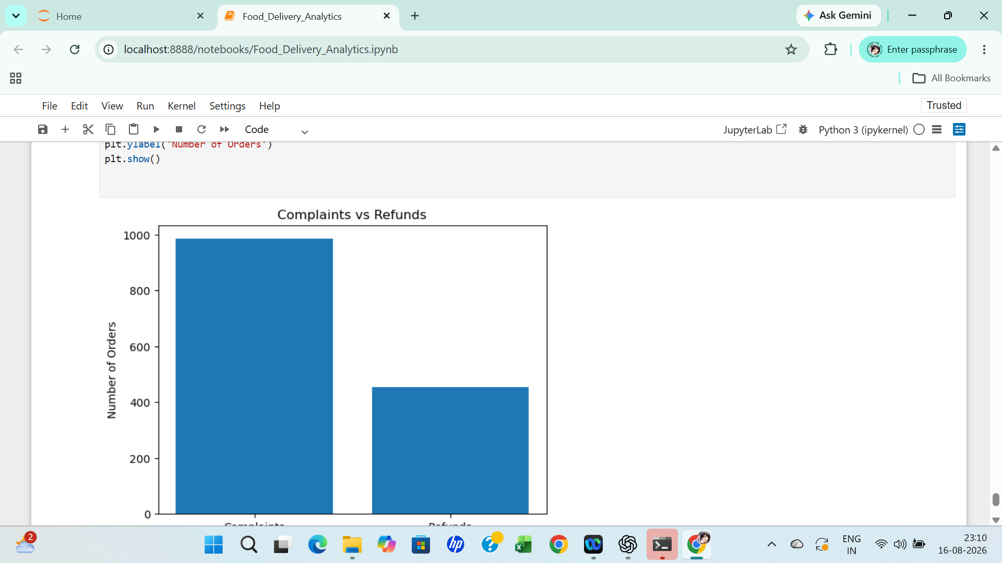

Power BI Dashboard
Power BI DAX Formulas & KPI Calculations
1. Total Orders
Total Orders =COUNTROWS(Food_Delivery_Analytics)
2. Total Revenue
Total Revenue = SUM(Food_Delivery_Analytics [Revenue_USD])
3. Average Order Value
Average Order Value =AVERAGE(Food_Delivery_Analytics[Order_Value_USD])
4. Total Profit
Total Profit =SUM(Food_Delivery_Analytics[Profit])
5. Total Complaints
Total Complaints =SUM(Food_Delivery_Analytics [Complaint_Flag])
6. Total Refunds
Total Refunds =
SUM(Food_Delivery_Analytics[Refund_Flag])
7. Refund Rate
Refund Rate =DIVIDE( [Total Refunds],[Total Orders],0)
8. Average Customer Rating
Average Customer Rating =AVERAGE(Food_Delivery_Analytics[Customer_Rating])
9. Average Delivery Time
Average Delivery Time =AVERAGE(Food_Delivery_Analytics[Delivery_Time])
10. Average Churn Risk
Average Churn Risk =AVERAGE(Food_Delivery_Analytics[Churn_Risk])
11. Average Demand Score
Average Demand Score = AVERAGE(Food_Delivery_Analytics[Demand_Score])
12. Average Delivery Distance
Average Delivery Distance = AVERAGE(Food_Delivery_Analytics[Delivery_Distance_KM])
13.Churn Risk Category
Churn Risk Category = SWITCH(TRUE(),'Food_Delivery_Analytics'[Churn_Risk]< 40, "Low", 'Food_Delivery_Analytics'[Churn_Risk] < 70, "Medium","High")

Food_Delivery_Analytics
Pages: 3 (Executive Overview, Customer & Sales Analysis, Operations & Customer Experience) Dataset scale: ~10,000 orders across 5 cities (London, Mumbai, New York, Singapore, Sydney), 3 customer types (New, Premium, Returning), 4 cuisine types (Indian, Mexican, Chinese, Italian)

Page 1: Executive Overview
Purpose: A top-level snapshot of business health — revenue, profitability, service quality, and churn risk — with cross-filtering by Customer Type, City, and Month.

KPI CARDS
Metric | Value
Total Orders | 10K
Total Revenue | $2.55M
Total Profit | $890.55K
Average Rating | 2.98 / 5
Average Delivery Time | 64.65 min
Average Churn (Risk Score) | 50.24

Insight: Profit margin sits at ~35% of revenue. An average rating just under 3/5 alongside a ~65-minute average delivery time suggests delivery speed may be a material driver of customer dissatisfaction — worth cross-referencing against the delivery-time-vs-rating scatter plot below.
Visual: Total Revenue by Month (Line Chart)
Axis: Month (X) vs Total Revenue (Y, 180K–240K range)
Insight: Revenue is volatile month-to-month rather than trending steadily — noticeable peaks and dips (e.g., a spike around month 5–6, a dip around month 7) rather than seasonal growth. Good candidate for calling out volatility/demand fluctuation rather than a "growth story."
Visual: Total Orders by Customer_Type (Donut Chart)
Segments: New (32.41%), Premium (33.99%), Returning (33.6%)
Insight: Order volume is almost perfectly evenly split across the three customer segments (~33% each). This is unusually even — flag it as a balanced acquisition/retention mix, but also worth noting in documentation that this near-equal split may reflect how the dataset was generated rather than an organic customer behaviour pattern.
Visual: Delivery Time vs Customer Rating by City (Scatter Plot)

Axis: Average Delivery Time (X, 63–66 min) vs Average Customer Rating (Y, 2.95–3.05)

Insight: There's a rough inverse relationship — Singapore has the shortest delivery time but not the highest rating, while the point clusters are tight, meaning delivery time differences across cities are small (a 3-minute spread) and unlikely to be the sole driver of rating differences. Useful to note the correlation is weak, not to overstate it.

Visual: Total Revenue by City (Horizontal Bar Chart)

Insight: Revenue is fairly evenly distributed across all five cities (each roughly in the $0.4M–0.6M range), meaning no single city dominates the business — a geographically balanced revenue base.
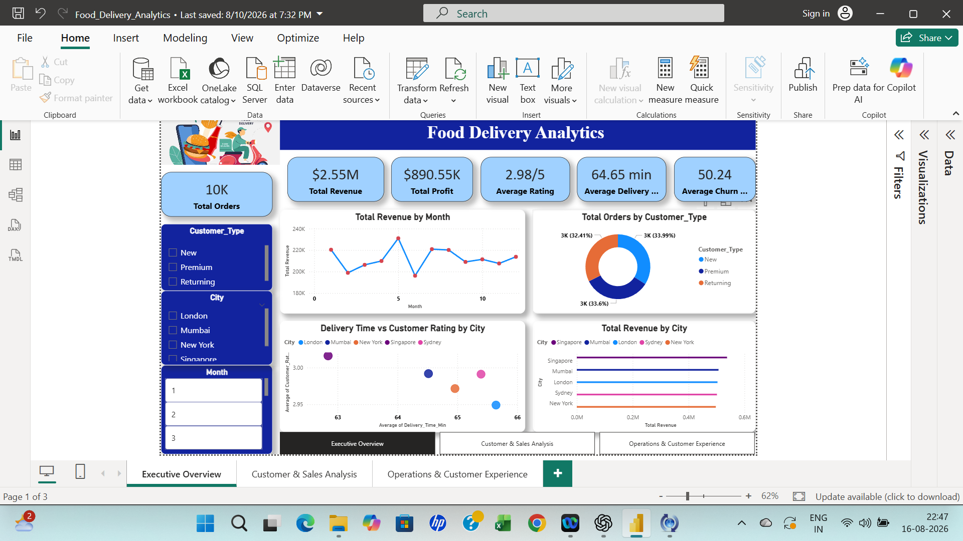

Page 2: Customer and Sales analysis:

Purpose: deeper dive into customer spending behaviour, cuisine preferences, and city × customer-type revenue breakdowns.

Visual: Average Order Value by Customer_Type (Column Chart)

Values: Returning $153, Premium $153, New $152

Insight: Practically no difference in spend across customer segments (a $1 spread). This is worth flagging explicitly in your documentation as a limitation: normally you'd expect Premium customers to have a meaningfully higher AOV — the near-identical values here suggest either (a) the "Premium" segment isn't actually driving more valuable orders, which is itself a finding worth discussing, or (b) the underlying data doesn't have strong differentiation by segment.

Visual: Total Revenue by Cuisine Type (Horizontal Bar Chart)

Values: Indian $0.67M, Mexican $0.64M, Chinese $0.63M, Italian $0.61M

Insight: Indian cuisine leads in revenue, but the four cuisines are within a fairly narrow band (~$0.06M spread), so there isn't a single dominant category — demand is fairly evenly spread across cuisine preference.

Visual: Customer Age vs Average Order Value (Scatter Plot)

Axis: Customer Age (20–80) vs Average Order Value (100–200)

Insight: No visible correlation between age and order value — points are scattered evenly across the full age range with no upward/downward trend and no clear clustering by customer type. Good to explicitly state "no significant relationship observed" rather than force an insight that isn't there.

Visual: Revenue by City & Customer Type (Matrix Table)

Rows: City | New | Premium | Returning | Total

Insight: Singapore has the highest "New" customer revenue (1,90,473), while every city shows Premium slightly ahead of New and Returning — useful for a city-level breakdown but again the differences between customer types within each city are small (roughly ±10-15%).
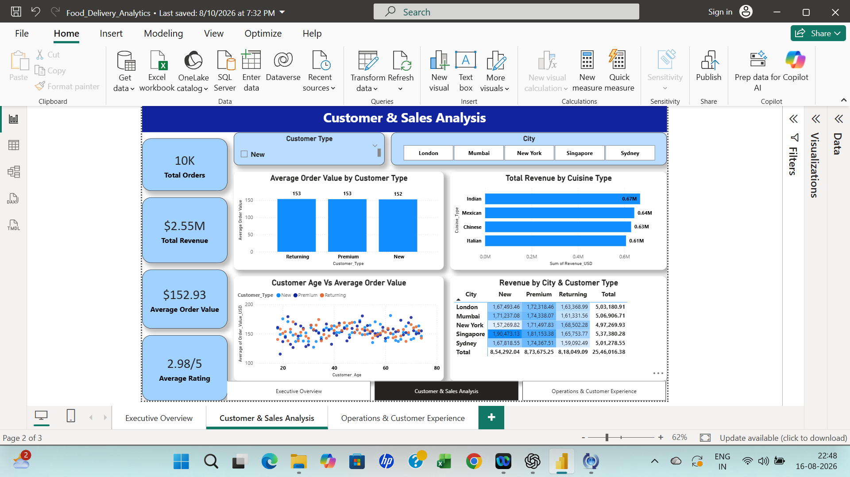
Page 3: Operations & Customer Experience
Purpose: operational performance — delivery, complaints, refunds, churn risk, and demand patterns by weather/month — filterable by City, Weather, Month, and Churn Risk Category.
Visual: Churn Risk Distribution (Donut Chart)
Segments: Medium 29.74% (2.97K), low 39.8% (3.98K), High 30.46% (3.05K)
Insight: Low risk is actually the largest single segment at 39.8%, with High and Medium fairly close behind at 30.46% and 29.74% respectively. Combined, High + Medium risk still account for roughly 60% of the customer base, so retention still deserves attention.
Visual: City-Level Operations Table
Columns: City | Average Delivery Time | Average Customer Rating | Refund Rate | Total Complaints
Insight: Singapore stands out positively — fastest average delivery time (62.84 min), highest rating (3.02), and lowest refund rate (4.30%). London and New York are the weaker performers — New York has the highest refund rate (5.18%) and London has the lowest rating (2.95) despite a mid-pack delivery time. This table is your strongest source for "which city needs operational attention" framing.
Visual: Demand Score by Weather Condition (Bar Chart)
Values: Cloudy 51, Stormy 50, Rainy 50, Sunny 50Insight: Demand score is essentially flat across all weather conditions (a 1-point spread out of ~50). Flag this as a non-finding in your documentation rather than a meaningful pattern — weather doesn't appear to meaningfully influence demand in this dataset, which is itself worth stating explicitly (readers may expect rainy/stormy weather to spike delivery demand, and this dashboard shows that's not the case here).

Visual: Average Demand Score by Month (Line Chart)

Range: 48.7–51.8 across 12 months

Insight: Mild month-to-month fluctuation with a peak around month 5–6 (51.8) and troughs around month 2 (48.7) and month 12 (48.2) — no strong seasonal trend, just minor variability.
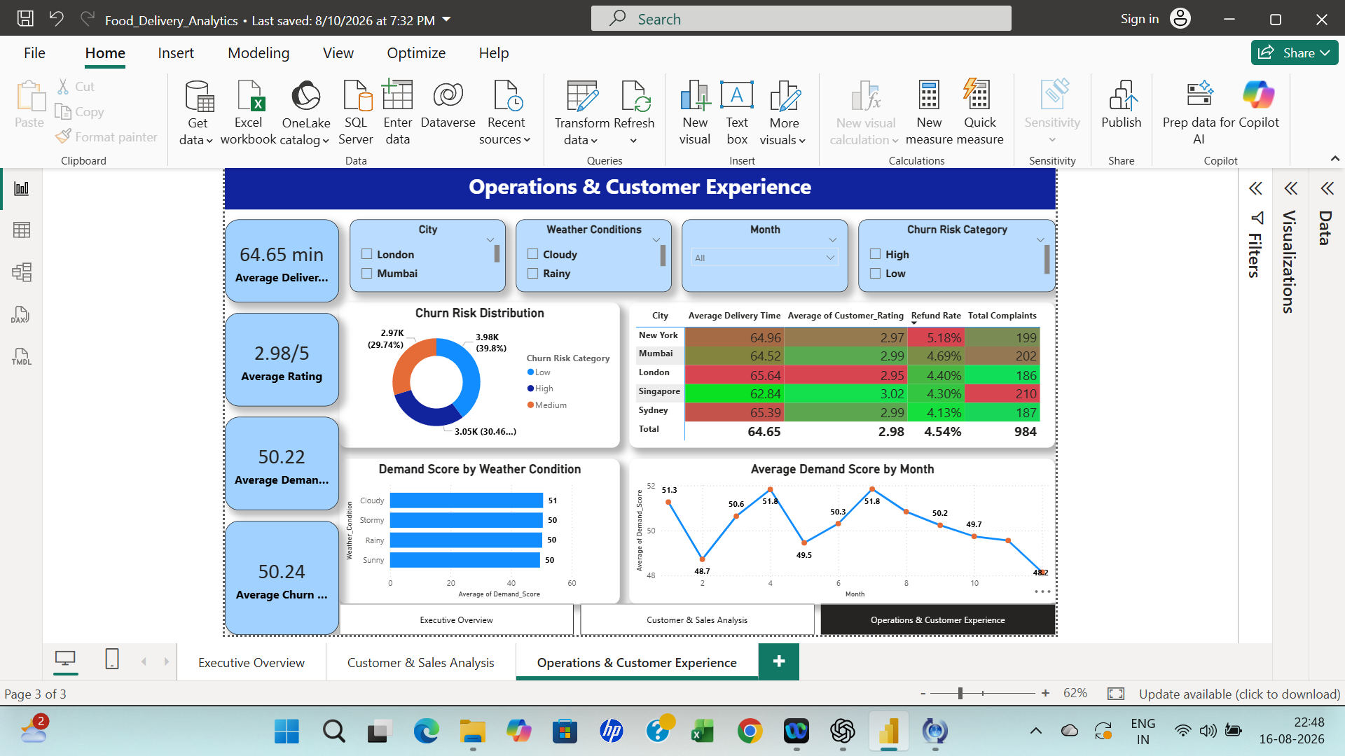

Overall Insights (With Reasons)

1. Customer Satisfaction Has Room for Improvement
Insight: Ratings are concentrated around approximately 3.
Reason: A middle-of-scale rating indicates moderate satisfaction and an opportunity to improve delivery, order accuracy, food quality and support.

2. Complaints Are a Major Operational Issue
Insight: Complaints are approximately 1,000 compared with approximately 420 refunds.
Reason: Complaint volume is broader than the refund process and should be investigated at its root causes.

3. Delivery Performance Should Be Monitored
Insight: Delivery Time versus Customer Rating provides a relationship-based operational view.
Reason: If longer delivery is associated with lower ratings, reducing delays can improve customer experience.

4. Revenue and Profit Must Be Analysed Together
Insight: High order value does not automatically mean high profit.
Reason: Discounts and costs can reduce margins, so profitable growth requires both revenue and profit monitoring.

5. Customer Segmentation Supports Targeted Strategy
Insight: Customer types can be compared by orders, value, ratings, complaints and churn risk.
Reason: Different segments can receive differentiated loyalty and marketing strategies.

6. Demand Supports Capacity Planning
Insight: Demand identifies stronger periods or locations.
Reason: Capacity can be aligned with customer requirements.

7. Churn Risk Supports Proactive Retention
Insight: Churn risk is forward-looking.
Reason: High-risk customers can be prioritized for retention activity.

8. Weather Is a Supporting Factor
Insight: The previously observed weather-category values were very similar.
Reason: The current visual does not support treating weather as a major driver without further evidence.

Overall Insights from Python and Power BI

Python and Power BI provide complementary perspectives. Python supports detailed exploration, while Power BI communicates the findings through interactive reporting.
Scale of the data: 10,000 orders across 5 cities (London, Mumbai, New York, Singapore, Sydney), 3 customer types (New, Premium, Returning), and 4 cuisines (Indian, Mexican, Chinese, Italian), generating $2.55M in revenue and $890.55K in profit.
1. Customer satisfaction is the project's central concern.
The average rating (2.98/5) appears consistently low across every dashboard page and every EDA visual that touches ratings. Nothing in the data — not traffic level, not customer type, not weather — explains why ratings are low, which means the cause likely lies outside what this dataset captures (e.g., food quality, order accuracy) rather than the operational variables analyzed here.
2. Churn risk is spread across the base, with a majority carrying some elevated risk. Low risk is the largest single segment at 39.8%, but High (30.46%) and Medium (29.74%) risk combined make up roughly 60% of customers. This is still worth flagging in the conclusion — not because one dominant "High risk" group stands out, but because well over half the customer base isn't in the safely "Low risk" bucket.
3. Operational performance varies meaningfully by city — this is where the real signal is.
Unlike most other segmentations in this project, city-level performance actually differentiates: Singapore leads on speed, rating, and refund rate, while London and New York lag. This is the clearest opportunity for targeted operational improvement.
4. Most customer- and product-level segmentations show little to no differentiation.
Order volume, average order value, revenue, and rating distribution are all nearly identical across New/Premium/Returning customers and across the four cuisines. This is a legitimate finding, not a gap in your analysis — it tells you that broad segment-based strategies (segment-specific pricing, cuisine-specific promotion) probably won't move the needle much on their own.
5. Several expected relationships don't hold up in this data.
Delivery distance vs. delivery time, traffic level vs. rating, and weather vs. demand all show essentially flat/uncorrelated patterns. Worth stating explicitly rather than omitting — it shows analytical rigor to report a "no effect" finding rather than only reporting the visuals that show a pattern.
6. Revenue is volatile, not trending.
Monthly revenue fluctuates within a $195K–$231K band with no clear seasonal or growth trajectory across the year, including one sharp spike-then-drop that's worth investigating as either a repeatable driver or a one-off anomaly.
7. Complaint resolution is a hidden risk area.
Complaints (~980) run roughly double the number of refunds (~450), meaning about half of dissatisfied customers aren't being made whole through refunds — a plausible contributor to the churn risk and low ratings noted above, even though the dashboards don't directly link these two datasets.

One-line project summary
"While the business shows a stable and evenly distributed revenue base across cities, customer types, and cuisines, the data points to two connected priorities: a below-average customer rating with no clear operational cause, and a high proportion of customers at churn risk — together suggesting that service quality, not demand or geography, is the primary lever for improving business outcomes."

Business Recommendations

1. Prioritize churn risk reduction — it's the standout red flag
Nearly 30% of customers fall into the "High" churn risk category (Operations & Customer Experience page). This is your most urgent finding. Recommend a targeted retention program (discounts, loyalty perks, proactive outreach) for customers flagged High risk, and track whether the % shrinks over subsequent months.
2. Investigate London and New York's operational gaps
The city performance table shows London has the lowest rating (2.95) despite average delivery time, and New York has the highest refund rate (5.18%) and delivery time (64.96 min). Singapore, by contrast, leads on speed (62.84 min), rating (3.02), and lowest refunds (4.30%). Recommend auditing what Singapore's operations does differently (rider staffing, restaurant partnerships, order routing) and piloting those practices in London/New York.
3. Address the average rating (2.98/5) directly
This shows up consistently across all three dashboard pages and is below the midpoint of "good." Recommend a root-cause review tied to delivery time and complaint data, since these are the operational levers most likely to move ratings.
4. Close the gap between complaints and refunds
Your Python EDA shows ~980 complaints against only ~450 refunds — roughly half of complaints aren't resulting in a refund. Recommend a review of complaint resolution paths to confirm whether the other half are being resolved satisfactorily (replacements, credits) or going unaddressed, since the latter is a retention risk hiding behind the aggregate numbers.
5. Don't over-invest in customer-type-specific strategies
Order volume, average order value, and rating distribution are all nearly identical across New, Premium, and Returning customers. Recommend against heavily differentiated marketing/pricing by segment until the data shows the segments actually behave differently — resources may be better spent on city-level or operational fixes, which show real variation.
6. Diversify menu/cuisine investment rather than picking a "winner"
Cuisine order share is close to evenly split (Indian 26.2%, Mexican 25.3%, Chinese 24.8%, Italian 23.7%). Recommend spreading restaurant-partnership and promotional investment across all four rather than concentrating on Indian just because it's nominally on top — the margin is too thin to treat as a clear leader.
7. Investigate the month 5–6 revenue spike and the drop right after
The monthly revenue trend shows a sharp peak (~$231K) followed immediately by the lowest point of the year (~$196K). Recommend identifying what drove the spike (promotion, event, seasonal demand) — if it's repeatable, it's a lever worth reusing deliberately rather than an anomaly to ignore.

Conclusion
The Food Delivery Analytics project demonstrates an end-to-end data analytics workflow from raw data to business decision support. SQL was used for validation, Power Query for transformation, Python for exploration, and Power BI for interactive reporting.
The final analysis highlights the importance of monitoring customer satisfaction, delivery performance, complaints, refunds, profitability, demand and churn risk together. By combining Python analysis with Power BI visualization, the project converts raw transactional data into understandable and actionable business insights.

