**ASSIGNMENT 3**

CREATING THE PROGRAMMER TABLE

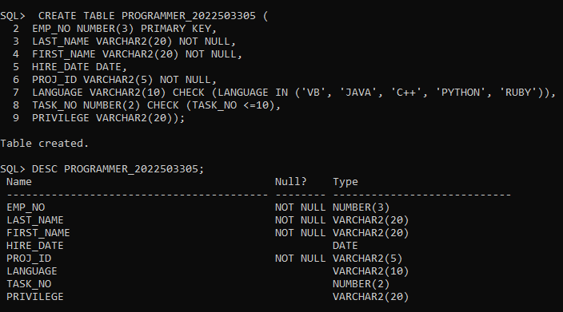

INSERTING VALUES

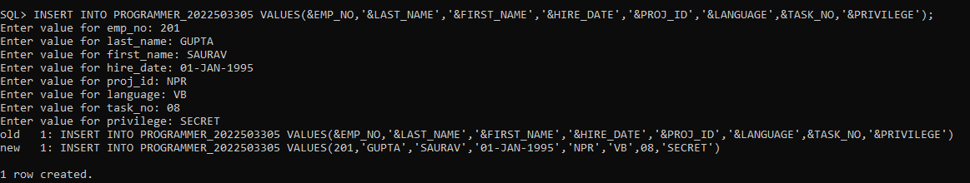

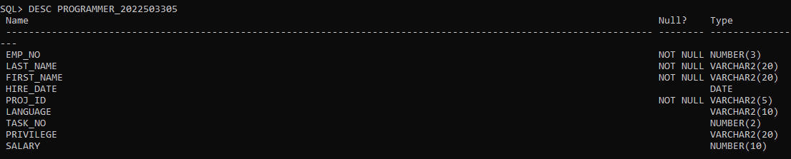

VALUES IN THE TABLE AFTER INSERTION

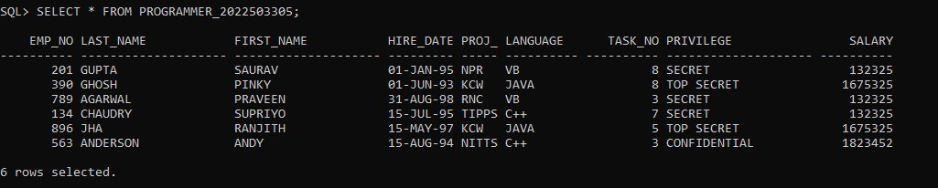

I) RETRIVING ALL THE COLUMNS FROM THE TABLE PROGRAMMER



II) RETRIVING UNIQUE PROJ_ID FROM THE TABLE PROGRAMMER

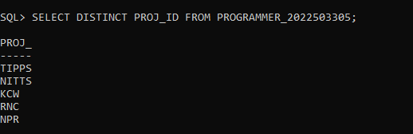

III) RETRIVING TOTAL NUMBER OF EMPLOYEES IN THE TABLE PROGRAMMER

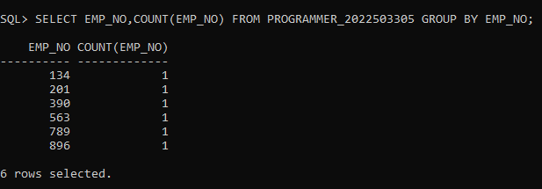

IV) RETRIVING LAST NAME AND FIRST NAME FROM THE TABLE PROGRAMMER

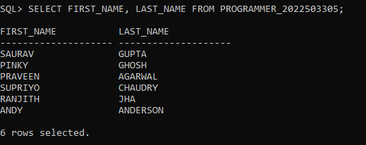

V) CALCULATING ANNUAL SALARY FOR EACH EMPLOYEE AND MUL BY 12

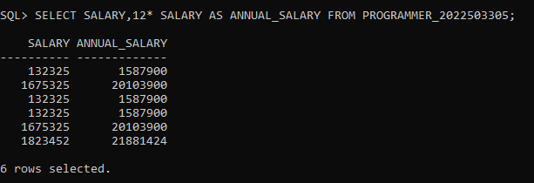

VI) RETRIVING THE LAST AND FIRST NAME FROM THE TABLE BY ALIAS

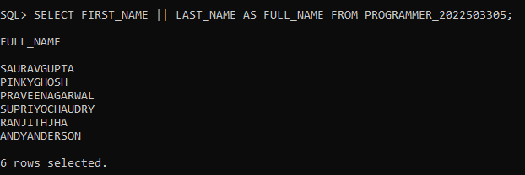

VII) RETRIVING LAST AND FIRST NAME FROM THE TABLE BY ALIAS DOING CONTATENATE WITH SPACE BETWEEN THEM

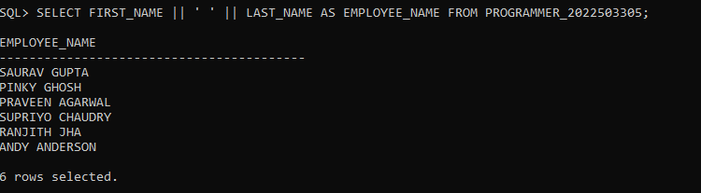

VIII) RETRIVING ALL ROWS WHERE THE PRIVILEGE IS ‘TOP SECRET’

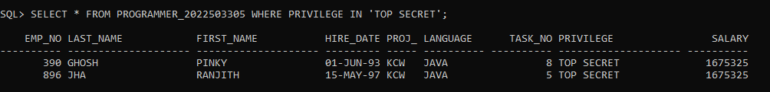

IX) RETRIVING ALL ROWS WHERE THE HIRE_DATE BETWEEN 1995-01-01 TO 1998-12-31

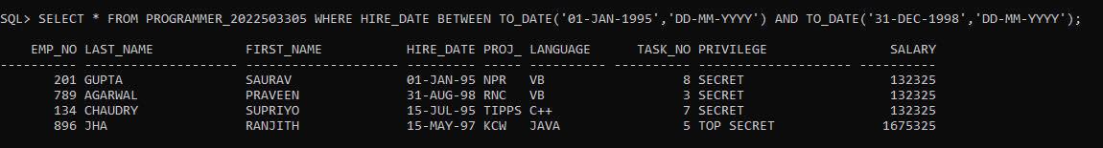

X) RETRIVING ALL ROWS WHERE THE HIRE_DATE FALLS IN THE MONTH AUGUST

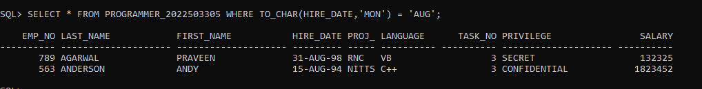

XI) RETRIVING ALL ROWS WHERE THE HIRE _DATE FALLS IN THE MONTH OF AUG AND NOV

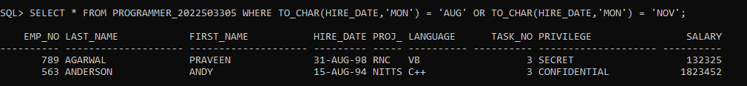

XII) RETRIVING ALL ROWS WHERE THE HIRE_DATE FALLS IN THE MONTH GIVEN BY USER INPUT

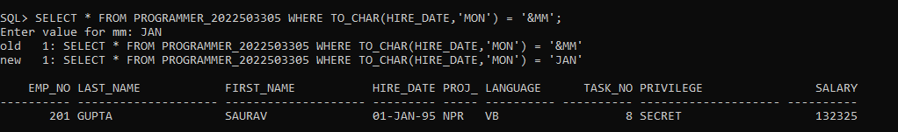

XIII) RETRIVING ALL ROWS WHERE THE SALARY IS GREATER THAN 50000

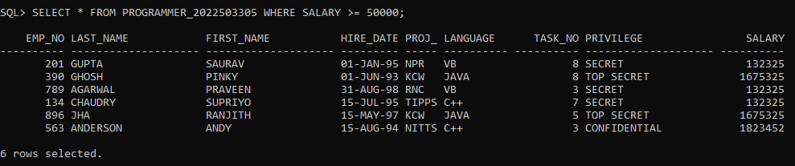

XIV) RETRIVING ALL ROWS WHERE THE SALARY IS GREATER THAN 50000, PROJ_ID NOT TIPPS

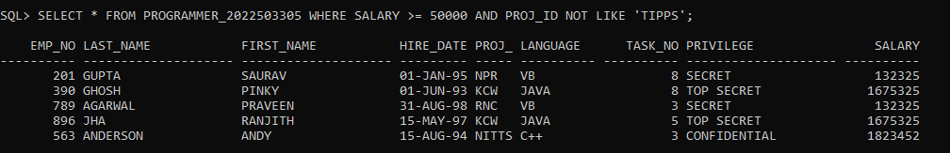

XV) RETRIVING ALL THE ROWS WHERE THE LANGUAGE IS EITHER JAVA OR C++

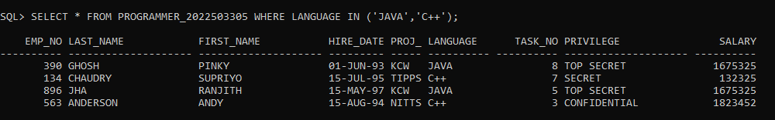

XVI) RETRIVING ALL THE ROWS WHERE THE PRIVILEGE IS NULL

1. INSERTING A ROW WITH PRIVILEGE NULL

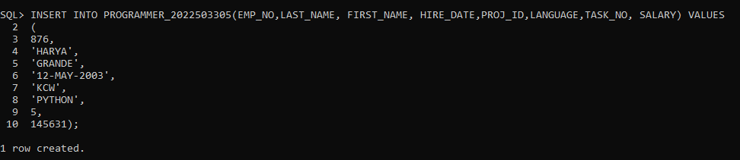

II) RETRIVING THE ROWS WHICH CONTAINS NULL IN PRIVILEGE COLUMN



XVII) CALCULATING THE COUNT OF DISTINCT ENTRIES OF ‘PROJ_ID’ IN THE TABLE

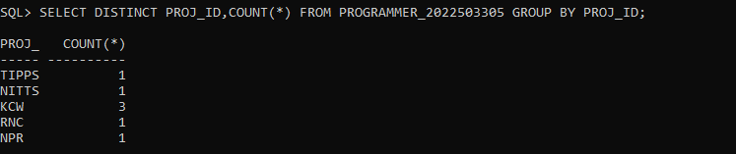

XVIII) RETRIVING THE ALL ROWS FOR EMPLOYEES WHO JOINED IN JAN,FEB OR MARCH



XIX) RETRIVING THE DETAILS OF THE EMPLOYEES WHOSE NAME STARTS WITH ‘S’

