EMPLOYEE TABLE

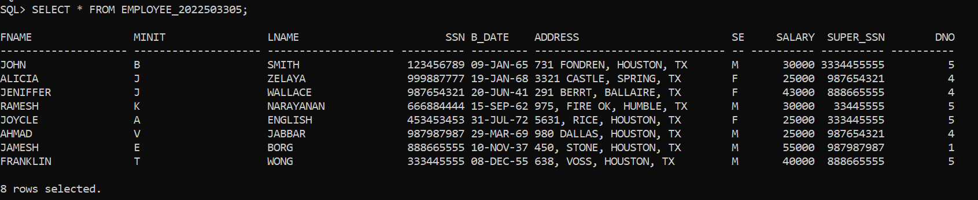

DEPARTMENT TABLE

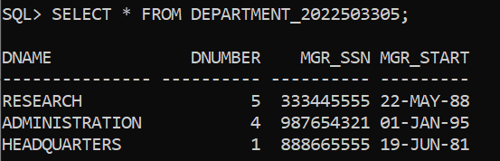

1. How many employees are working in each department? 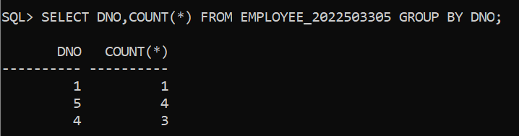
2. What is the average salary for employees in each department? 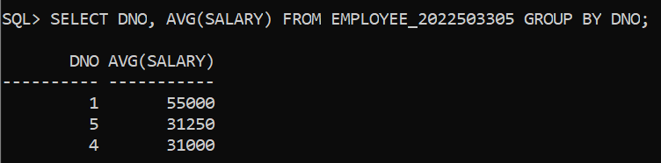
3. How many departments have more than 10 employees?

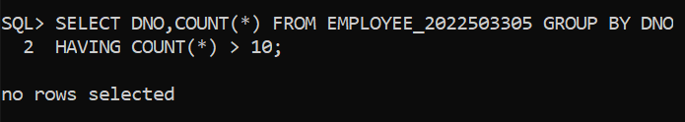

1. What is the total salary expense for each department?

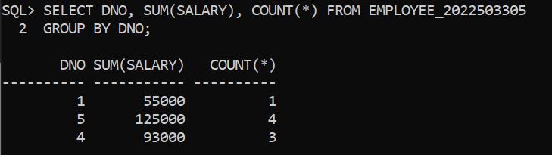

1. How many employees have a salary greater than $50,000? 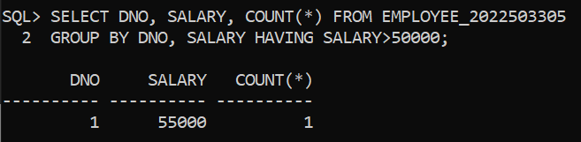
2. What is the highest salary in the company? 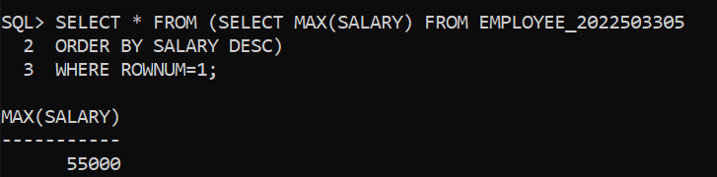
3. Find the number of employees directly managed by each employee.

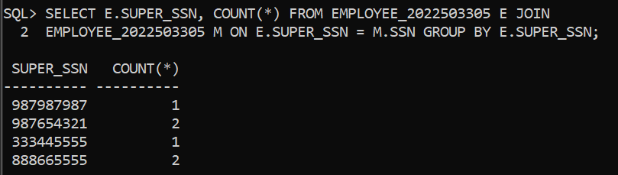

1. How many employees have the same salary? 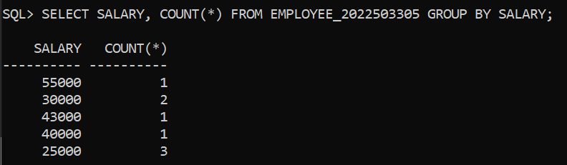
2. Which department has the highest average salary? 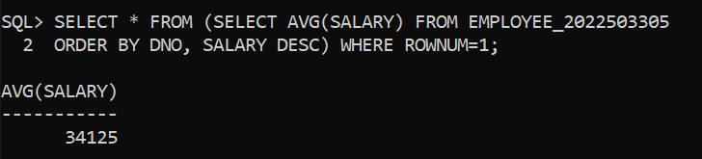
3. How many employees were born in each year? 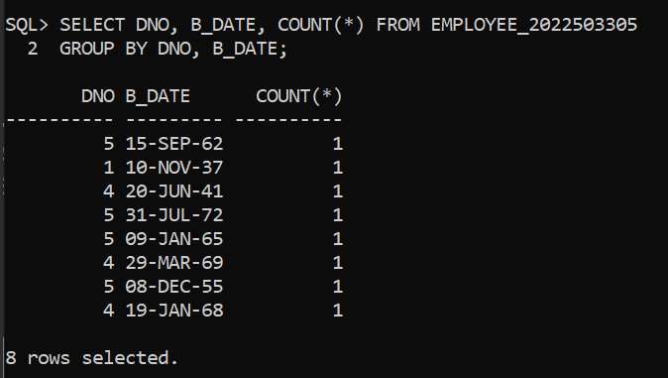
4. What is the total salary expense for male and female employees separately? 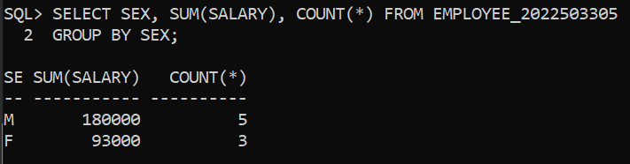
5. How many employees have the same last name?

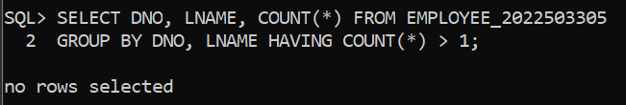

1. Which department has the most employees?

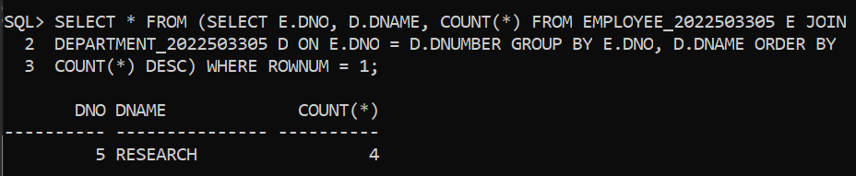

1. What is the average age of employees in each department?

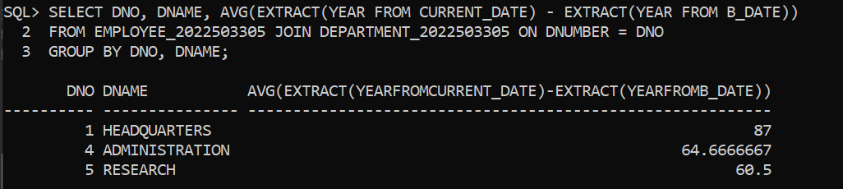

1. How many employees have a salary within a specific range?

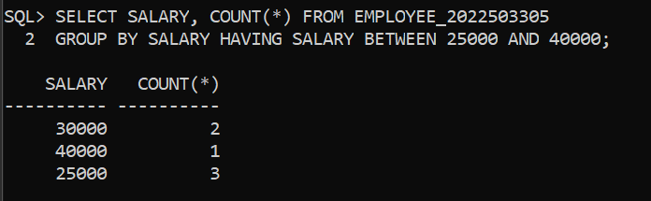

1. What is the total salary expense for employees supervised by each supervisor?

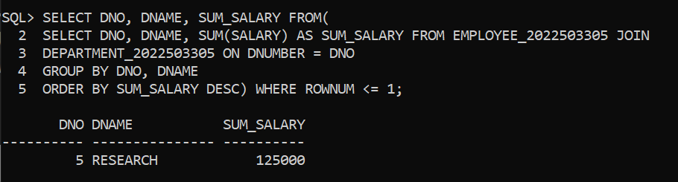

1. How many employees have the same birthdate?

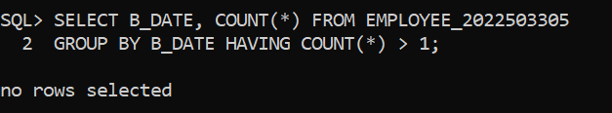

1. Which department has the highest total salary expense?

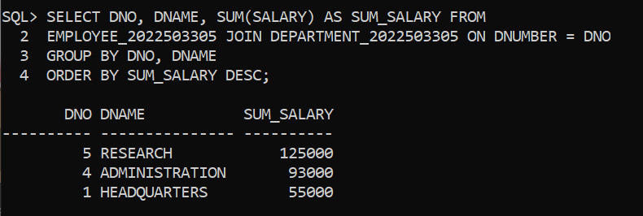

1. What is the average salary for employees hired in each year? 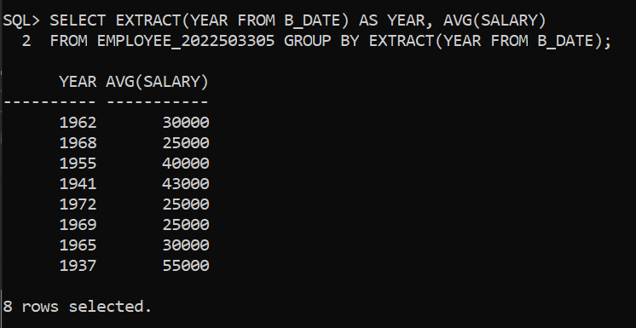
2. How many employees live in each city?

