1) Create a Emp_Table and Mgr_Table details using Employee table.

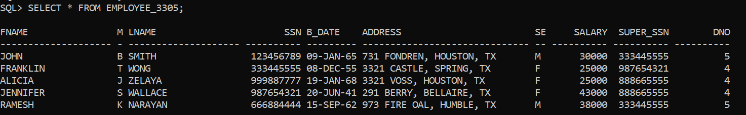

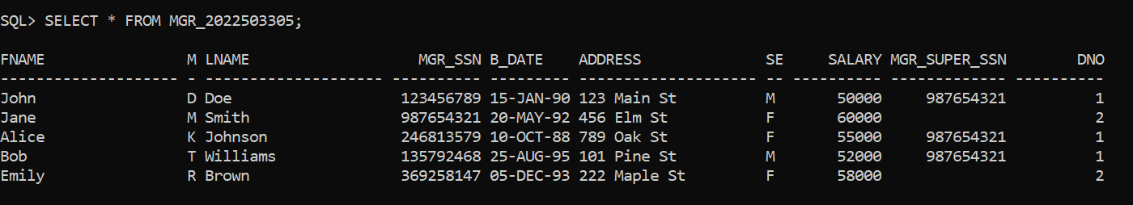

2) List all unique department IDs from both Employees and Managers

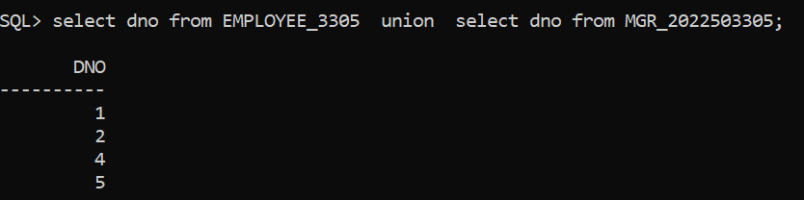

3) Find common department IDs between Employees and Managers

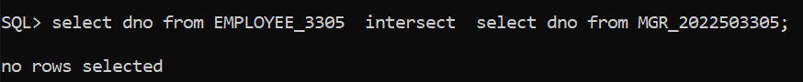

4) Find employees and managers who are in the same department

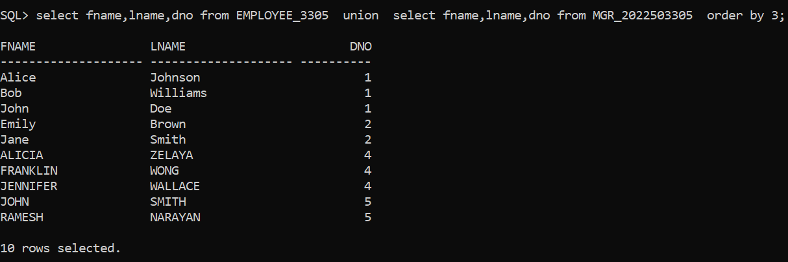

5) List department IDs that are in Employees but not in Managers

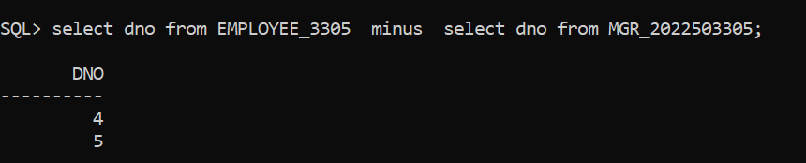

6) Find all employees and managers.

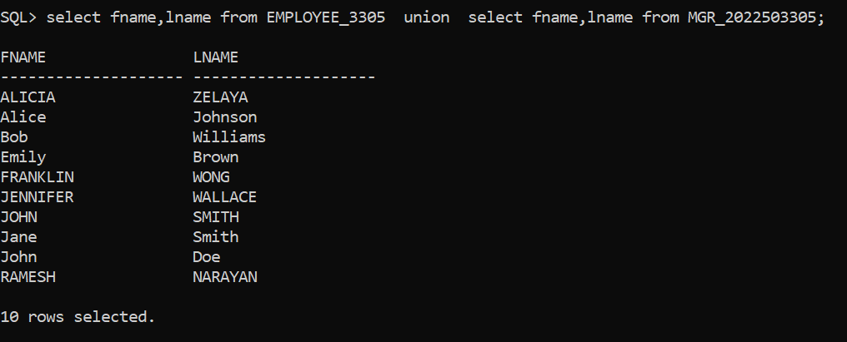7) List employees who are not managers

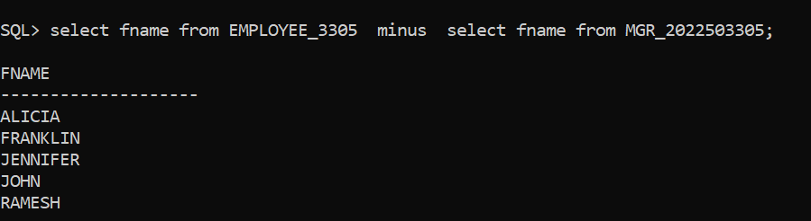

8) Identify departments with employees but no managers

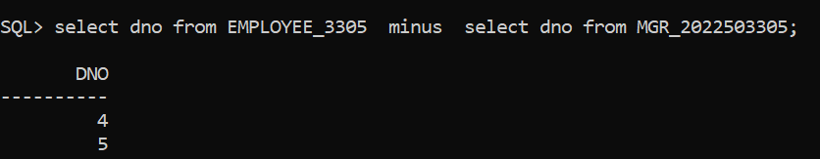

9) Find the employees who works in department as Manager=33344555 works in.

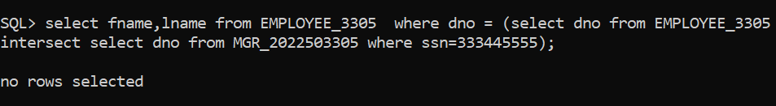

10) Find the employees and managers who work in department 5 but not department 4.

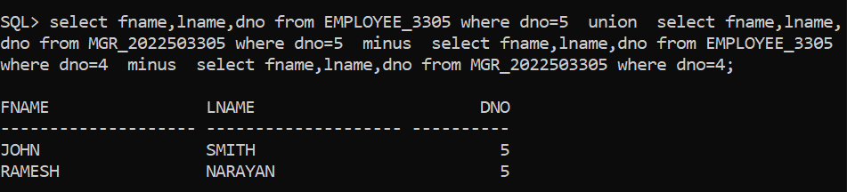

11) List employees and managers working in departments with IDs greater than 55555555

