**Business Problem**

**/* 1. Total Revenue generated */**

**SQL Query:**

SELECT concat(round(SUM(total_amount)/1000000,2),'M') TotalRevenue

FROM Orders

INNER JOIN Payments on Orders.payment_id=Payments.payment_id

where Payment_status = 'Completed';

**Output:**

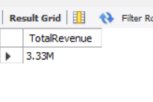

**/* 2.Analyzing the sales trend over the past few years, and identifying patterns of growth or decline. */**

**SQL Query:**

SELECT YEAR(Orders.order_date) YEARNUM, concat(round(SUM(total_amount)/1000,2),'k') sales

FROM Orders

INNER JOIN Payments on Orders.payment_id=Payments.payment_id

where Payment_status = 'Completed'

GROUP BY YEARNUM

ORDER BY YEARNUM;

**Output:**

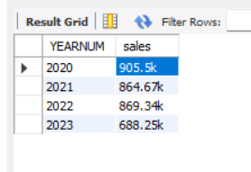

**/* 3. Total no of orders placed successfully with no payment failed and refunds. */**

**SQL Query:**

SELECT count(*) OrdersCount

FROM Orders

INNER JOIN Payments on Orders.payment_id=Payments.payment_id

where Payment_status = 'Completed';

**Output:**

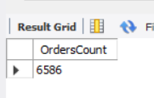

**/* 4. Get count of products for each category top 5*/**

**SQL Query:**

SELECT categories.categorie_name, COUNT(product_id) Productcount

FROM Products

INNER JOIN Categories on Products.Categorie_id=Categories.categorie_id

GROUP BY categories.categorie_name

ORDER BY Productcount DESC

LIMIT 5;

**Output:**

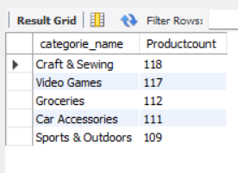

**/* 5. Calculate the most profitable product category */**

**SQL Query:**

SELECT categories.categorie_name, SUM(Order_items.quantity*Order_items.price) AS Total_Amount

FROM Categories

INNER JOIN Products on Categories.Categorie_id=Products.categorie_id

INNER JOIN Order_items on Products.product_id=Order_items.product_id

GROUP BY categories.categorie_name

ORDER BY Total_Amount DESC;

**Output:**

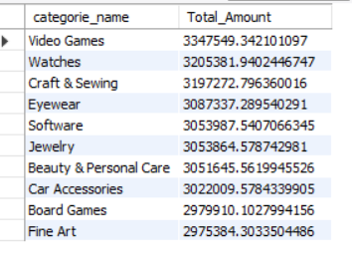

**/* 6. Top 5 states with high revenue generation.*/**

**SQL Query:**

SELECT Customers.state, round(SUM(orders.total_amount),2) Total_Revenue

FROM Customers

INNER JOIN Orders ON Orders.customer_id=Customers.customer_id

INNER JOIN Payments ON Orders.payment_id=Payments.payment_id

WHERE Payments.payment_status != "Refunded"

GROUP BY Customers.State

LIMIT 5;

**Output:**

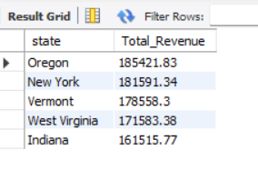

**/* 7. From which States the products are highly in returned. */**

**SQL Query:**

SELECT Customers.state, COUNT(shipping.shipping_status) Returned_count

FROM Customers

INNER JOIN Orders ON Customers.customer_id=Orders.customer_id

INNER JOIN Shipping ON Orders.shipping_id=Shipping.shipping_id

WHERE Shipping.shipping_status= "Returned"

GROUP BY Customers.state

ORDER BY Returned_count DESC

LIMIT 4;

**Output:**

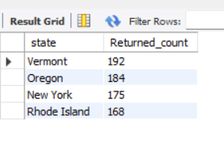

/* **8.** **List all products with low inventory (stock less than 20)**\*/

**SQL Query:**

SELECT products.name, inventory.stock

FROM products

JOIN inventory ON products.product_id = inventory.product_id

WHERE inventory.stock < 20

ORDER BY inventory.stock;

**Output:**

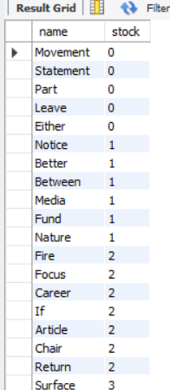

**/* 9. Compute the average order value for each customer. Include customers with more than 5 orders.*/**

**SQL Query:**

SELECT Customers.customer_id, Customers.First_name, AVG(Orders.total_amount)/COUNT(Orders.order_id) AOV

FROM Customers

INNER JOIN Orders ON Customers.customer_id=Orders.customer_id

GROUP BY Customers.customer_id, Customers.First_name

HAVING COUNT(Orders.order_id) > 5

ORDER BY AOV DESC;

**Output:**

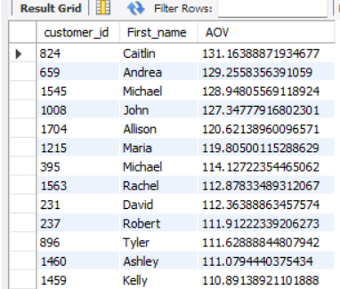

**\* /10. Query monthly total sales for last year from the current month*/**

**SQL Query:**

SELECT MONTH(Orders.order_date) MonthNO, YEAR(Orders.order_date) YearNO, ROUND(SUM(total_amount),2) Total_Sales

FROM Orders

GROUP BY MonthNO, YearNO

HAVING YearNO=2023

ORDER BY MonthNO, YearNO;

**Output:**

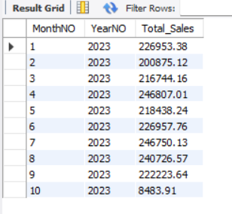

**/* 11. Find the customers who have registered but never placed orders. Include customer details and the time since their registration.*/**

**SQL Query:**

SELECT customer_id, First_name, timestampdiff(MONTH,created_at,now()) monthdiff

FROM customers

WHERE customer_id NOT IN (SELECT customer_id FROM Orders)

ORDER BY monthdiff DESC;

**/* 12. Find the orders with delays in delivery where the date is 7 days after the shipping date. Include customer, order details.*/**

**SQL Query:**

WITH delay_days_calcu AS(

SELECT customers.first_name, orders.order_id, orders.order_date, shipping.shipping_date, datediff(shipping.shipping_date,orders.order_date) delay_days

FROM orders

INNER JOIN customers ON customers.customer_id=orders.customer_id

INNER JOIN shipping ON orders.shipping_id=shipping.shipping_id

WHERE shipping.shipping_status='Shipped')

SELECT * FROM delay_days_calcu

WHERE delay_days>7

ORDER BY delay_days;

**Output:**

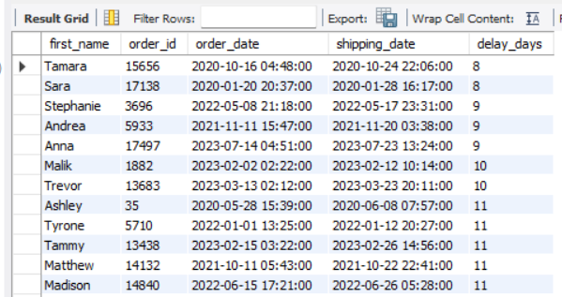

**/* 13. Calculate the percentage of successful payments across all orders. Include other */**

**SQL Query:**

SELECT Payments.payment_status, COUNT(*) Total_payments, COUNT(*)/(SELECT COUNT(*) FROM payments) *100 Percentage

FROM Payments

INNER JOIN Orders ON Payments.payment_id=orders.payment_id

GROUP BY Payments.payment_status;

**Output:**

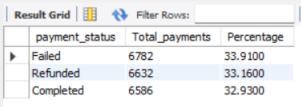

**/* 14. Find the top 5 sellers based on total value.*/**

**SQL Query:**

SELECT Sellers.seller_id, sellers.seller_name, SUM(order_items.quantity*order_items.price) total_value

FROM sellers

INNER JOIN Products ON sellers.seller_id=Products.seller_id

INNER JOIN order_items ON order_items.product_id=Products.product_id

GROUP BY Sellers.seller_id, sellers.seller_name

ORDER BY total_value DESC

LIMIT 5;

**Output:**

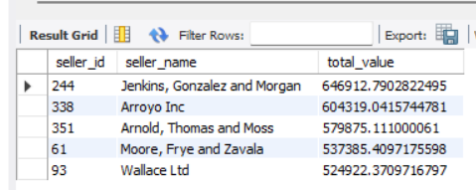

**/* 15. Calculate the profit margin for each product (difference between products and cost of goods sold). Rank produced by their profit margin, showing highest to lowest.*/**

**SQL Query:**

SELECT products.product_id, products.name, (SUM(order_items.price-products.price)/(SELECT SUM(order_items.price) FROM order_items)) * 100 PROFIT_MARGIN,

DENSE_RANK() OVER(ORDER BY (SUM(order_items.price-products.price)/(SELECT SUM(order_items.price) FROM order_items)) * 100 DESC) PRODUCT_RANK

FROM Products

INNER JOIN order_items ON Products.product_id=order_items.product_id

GROUP BY products.product_id, products.name;

**Output:**

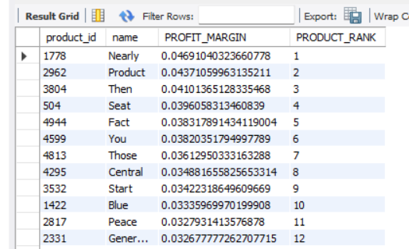

**/* 16. Query top 10 product by their return number.*/**

**SQL Query:**

SELECT products.product_id, products.name, count(*) return_count FROM products

INNER JOIN order_items ON Products.product_id=order_items.product_id

INNER JOIN orders ON order_items.order_id=orders.order_id

INNER JOIN shipping ON orders.shipping_id=shipping.shipping_id

where shipping_status='Returned'

GROUP BY products.product_id, products.name

ORDER BY return_count DESC

LIMIT 10:

**Output:**

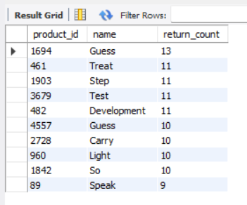

**/* 17. Query the distribution of orders placed by hour of a day. Create a time-based analysis to understand the peak time. */**

**SQL Query:**

SELECT HOUR(order_date) hour_number, COUNT(*) orders_count FROM orders

GROUP BY hour_number

ORDER BY orders_count DESC;

**Output:**

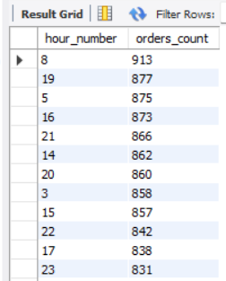

**/* 18. Query top 5 customers with the highest no of orders for each state. */**

**SQL Query:**

WITH customer_rank AS(

SELECT customers.customer_id, first_name, state , count(orders.order_id) orders_count, DENSE_RANK() OVER(PARTITION BY state ORDER BY count(orders.order_id) DESC ) RANK_CUSTOMER

FROM customers

INNER JOIN orders ON customers.customer_id=orders.customer_id

GROUP BY customers.customer_id, first_name, state

)

SELECT * FROM customer_rank

WHERE RANK_CUSTOMER <=5;

**Output:**

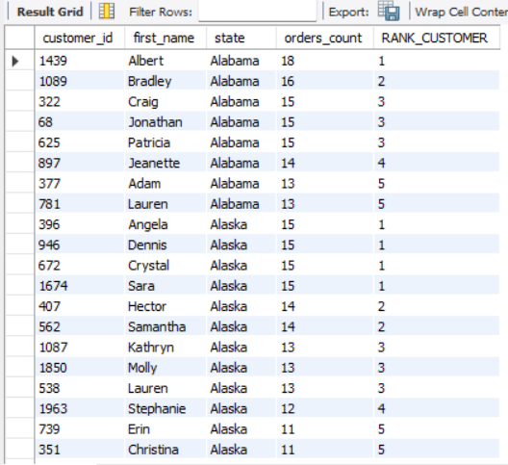

**/* 19. Calculate the total revenue handled by each seller. Include the total no of orders handled and the average delivery time for each provider. */**

**SQL QUERY:**

SELECT sellers.seller_id, sellers.seller_name, SUM(order_items.price) total_revenue, count(order_items.order_item_id) no_of_orders,

AVG(datediff(orders.order_date,shipping.shipping_date)) avg_delivery_time

FROM sellers

INNER JOIN products ON sellers.seller_id=products.seller_id

INNER JOIN order_items ON products.product_id=order_items.product_id

INNER JOIN orders ON order_items.order_id=orders.order_id

INNER JOIN shipping ON orders.shipping_id=shipping.shipping_id

GROUP BY sellers.seller_id, sellers.seller_name

ORDER BY sellers.seller_name;

**Output:**

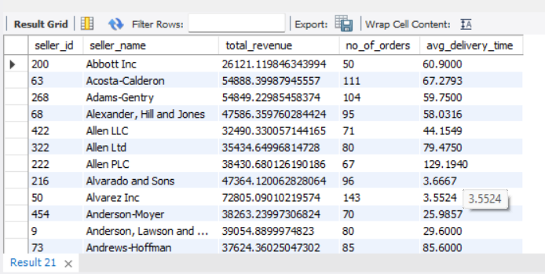

**/* 20. Create a function that the same quantity should be reduced from the inventory table as soon as the product is sold.**

**After adding any sales records it should update the stock in the inventory table and the product and quantity purchased. */**

**SQL Query:**

DELIMITER $$

CREATE PROCEDURE Update_Inventory(IN c_product_id INT, IN c_quantity INT)

BEGIN

DECLARE stockValue INT;

SELECT stock INTO stockValue

FROM inventory

WHERE product_id=c_product_id;

IF stockValue > c_quantity THEN

UPDATE inventory

SET stock=stock-c_quantity, last_updated= now()

WHERE product_id=c_product_id;

SELECT 'Inventory updated successfully';

ELSE

SELECT 'Insufficient stock' AS message;

END IF;

END $$

DELIMITER ;

CALL Update_Inventory(669,100)

**Output:**

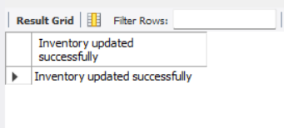

**Before Updating:**

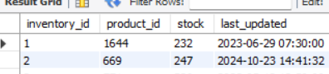

**After Updating:**

