Requirements

Introduction

Employee Management System is essentially a software designed to keep track of employee information in any company efficiently. It is helpful to department of the organization which maintains data of employees related to an organization.

Objective

The main objectives of this project are:

* To create and modify the employee records
* To view the records individually or all at a time
* To delete the records if needed

4W’s and 1H

Who

The person who is authorized for employee records management

What

The project is concerned about the efficient management of employee information

When

Whenever there is a need to create, update, delete and view the employee information

Why

As this project has simple interface, it would be easy to work efficiently to the anyone

How

Implemented using structure, pointers and other functionalities of C

Advantages

* Easy to understand and use
* Good security system
* Information can be accessed anytime

Disadvantages

* Skilled person is required
* Lack of Graphical user interface
* More storage is required

Swot

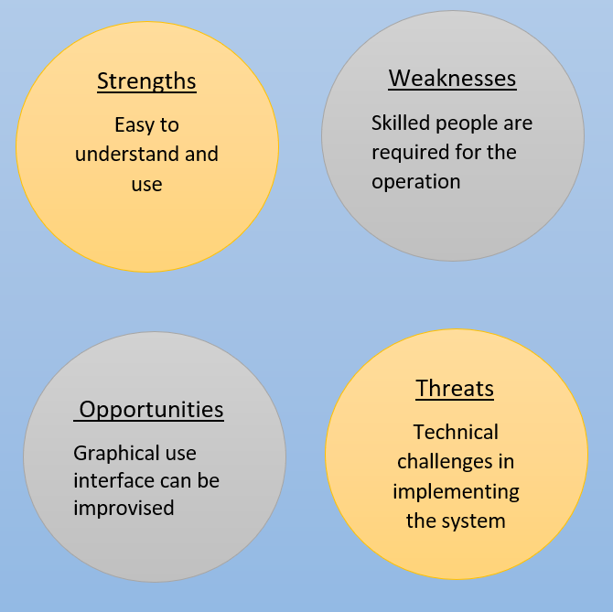

**High Level Requirements**

|  |  |  |
| --- | --- | --- |
| **ID** | **Description** | **Status** |
| HR01 | Login Interface | Implemented |
| HR02 | Menu | Implemented |
| HR03 | Adding and modifying | Implemented |
| HR04 | Viewing records individually and all at a time | Implemented |
| HR05 | Deleting and change password | Implemented |

**Low Level Requirements**

|  |  |  |  |
| --- | --- | --- | --- |
| **ID** | **Description** | **HR**  **ID** | **Status** |
| LR01 | Enter password and login | HR01 | Implemented |
| LR02 | Menu has 6 options Add, Modify, Individual view, View all, Delete, Change password | HR02 | Implemented |
| LR03 | Reads option from user and performs the action | HR03 | Implemented |
| LR04 | Displays the required information | HR04 | Implemented |
| LR05 | Reads the option to Perform delete and password changing operation | HR05 | Implemented |