Create authentication service that returns JWT
Folder Structure:
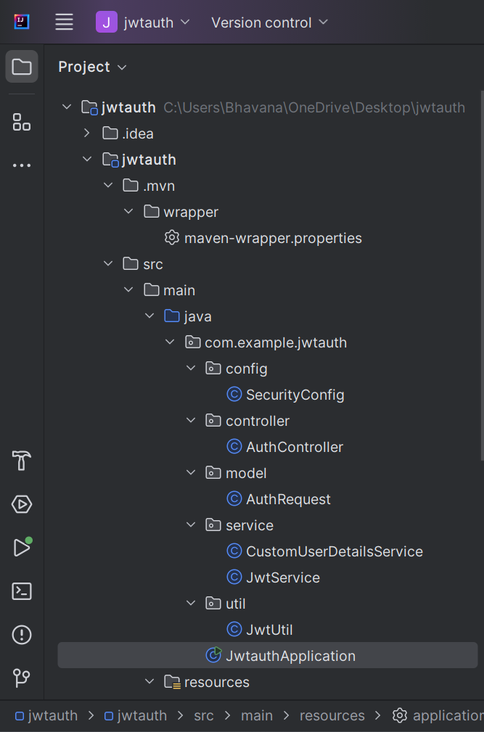

Securityconfig.java
package com.example.jwtauth.config;
import com.example.jwtauth.service.CustomUserDetailsService;
import org.springframework.context.annotation.Bean;
import org.springframework.context.annotation.Configuration;
import org.springframework.security.authentication.AuthenticationManager;
import org.springframework.security.config.annotation.authentication.builders.AuthenticationManagerBuilder;
import org.springframework.security.config.annotation.web.builders.HttpSecurity;
import org.springframework.security.config.annotation.web.configuration.EnableWebSecurity;
import org.springframework.security.crypto.password.NoOpPasswordEncoder;
import org.springframework.security.web.SecurityFilterChain;
@Configuration
@EnableWebSecurity
public class SecurityConfig {
private final CustomUserDetailsService userDetailsService;
public SecurityConfig(CustomUserDetailsService userDetailsService) {
this.userDetailsService = userDetailsService;
}
@Bean
public SecurityFilterChain filterChain(HttpSecurity http) throws Exception {
http
.csrf(csrf -> csrf.disable())
.authorizeHttpRequests(auth -> auth
.anyRequest().authenticated()
)
.httpBasic(basic -> {});
return http.build();
}
@Bean
public AuthenticationManager authManager(HttpSecurity http) throws Exception {
return http.getSharedObject(AuthenticationManagerBuilder.class)
.userDetailsService(userDetailsService)
.passwordEncoder(NoOpPasswordEncoder.getInstance())
.and().build();
}
}

AuthController.java

package com.example.jwtauth.controller;
import com.example.jwtauth.service.JwtService;
import jakarta.servlet.http.HttpServletRequest;
import org.springframework.beans.factory.annotation.Autowired;
import org.springframework.security.authentication.AuthenticationManager;
import org.springframework.security.authentication.UsernamePasswordAuthenticationToken;
import org.springframework.web.bind.annotation.*;
import java.util.Base64;
import java.util.Map;
@RestController
public class AuthController {
@Autowired
private AuthenticationManager authManager;
@Autowired
private JwtService jwtService;
@PostMapping("/authenticate")
public Map<String, String> authenticate(HttpServletRequest request) {
String[] creds = extractBasicAuthCredentials(request);
UsernamePasswordAuthenticationToken authInputToken =
new UsernamePasswordAuthenticationToken(creds[0], creds[1]);
authManager.authenticate(authInputToken);
String token = jwtService.generateToken(creds[0]);
return Map.of("token", token);
}
private String[] extractBasicAuthCredentials(HttpServletRequest request) {
String authHeader = request.getHeader("Authorization").substring("Basic ".length());
String decoded = new String(Base64.getDecoder().decode(authHeader));
return decoded.split(":", 2);
}
}

AuthRequest.java
package com.example.jwtauth.model;
public class AuthRequest {
private String username;
private String password;
public String getUsername() { return username; }
public void setUsername(String username) { this.username = username; }
public String getPassword() { return password; }
public void setPassword(String password) { this.password = password; }
}
CustomUserDetailService
package com.example.jwtauth.service;
import org.springframework.security.core.userdetails.User;
import org.springframework.security.core.userdetails.UserDetails;
import org.springframework.security.core.userdetails.UserDetailsService;
import org.springframework.security.core.userdetails.UsernameNotFoundException;
import org.springframework.stereotype.Service;
import java.util.ArrayList;
@Service
public class CustomUserDetailsService implements UserDetailsService {
@Override
public UserDetails loadUserByUsername(String username) throws UsernameNotFoundException {
if ("user".equals(username)) {
return new User("user", "pwd", new ArrayList<>());
} else {
throw new UsernameNotFoundException("User not found");
}
}
}

JwtService
package com.example.jwtauth.service;
import io.jsonwebtoken.Jwts;
import io.jsonwebtoken.SignatureAlgorithm;
import org.springframework.beans.factory.annotation.Value;
import org.springframework.stereotype.Service;
import java.util.Date;
@Service
public class JwtService {
@Value("${jwt.secret}")
private String secret;
public String generateToken(String username) {
return Jwts.builder()
.setSubject(username)
.setIssuedAt(new Date(System.currentTimeMillis()))
.setExpiration(new Date(System.currentTimeMillis() + 1000 * 60 * 60 * 10))
.signWith(SignatureAlgorithm.HS256, secret)
.compact();
}
}
JwtUtil
package com.example.jwtauth.util;
import io.jsonwebtoken.Claims;
import io.jsonwebtoken.Jwts;
import io.jsonwebtoken.SignatureException;
import org.springframework.beans.factory.annotation.Value;
import org.springframework.stereotype.Component;
import java.util.Date;
import java.util.function.Function;
@Component
public class JwtUtil {
@Value("${jwt.secret}")
private String secret;
public String extractUsername(String token) {
return extractClaim(token, Claims::getSubject);
}
public Date extractExpiration(String token) {
return extractClaim(token, Claims::getExpiration);
}
public <T> T extractClaim(String token, Function<Claims, T> claimsResolver) {
final Claims claims = extractAllClaims(token);
return claimsResolver.apply(claims);
}
public boolean isTokenExpired(String token) {
return extractExpiration(token).before(new Date());
}
public boolean validateToken(String token, String username) {
final String tokenUsername = extractUsername(token);
return (tokenUsername.equals(username) && !isTokenExpired(token));
}
private Claims extractAllClaims(String token) throws SignatureException {
return Jwts.parser()
.setSigningKey(secret)
.parseClaimsJws(token)
.getBody();
}
}

JwtauthApplication.java
package com.example.jwtauth;
import org.springframework.boot.SpringApplication;
import org.springframework.boot.autoconfigure.SpringBootApplication;
@SpringBootApplication
public class JwtauthApplication {
public static void main(String[] args) {
SpringApplication.run(JwtauthApplication.class, args);
}
}

POM.XML
<?xml version="1.0" encoding="UTF-8"?>
<project xmlns="http://maven.apache.org/POM/4.0.0" xmlns:xsi="http://www.w3.org/2001/XMLSchema-instance"
xsi:schemaLocation="http://maven.apache.org/POM/4.0.0 https://maven.apache.org/xsd/maven-4.0.0.xsd">
<modelVersion>4.0.0</modelVersion>
<parent>
<groupId>org.springframework.boot</groupId>
<artifactId>spring-boot-starter-parent</artifactId>
<version>3.2.5</version>
<relativePath/>
</parent>
<groupId>com.example</groupId>
<artifactId>jwtauth</artifactId>
<version>0.0.1-SNAPSHOT</version>
<name>jwtauth</name>
<description>JWT Authentication Project</description>
<properties>
<java.version>17</java.version>
</properties>
<dependencies>
<dependency>
<groupId>org.springframework.boot</groupId>
<artifactId>spring-boot-starter-web</artifactId>
</dependency>
<dependency>
<groupId>org.springframework.boot</groupId>
<artifactId>spring-boot-starter-security</artifactId>
</dependency>
<dependency>
<groupId>io.jsonwebtoken</groupId>
<artifactId>jjwt-api</artifactId>
<version>0.11.5</version>
</dependency>
<dependency>
<groupId>io.jsonwebtoken</groupId>
<artifactId>jjwt-impl</artifactId>
<version>0.11.5</version>
<scope>runtime</scope>
</dependency>
<dependency>
<groupId>io.jsonwebtoken</groupId>
<artifactId>jjwt-jackson</artifactId>
<version>0.11.5</version>
<scope>runtime</scope>
</dependency>
<dependency>
<groupId>org.springframework.boot</groupId>
<artifactId>spring-boot-starter-test</artifactId>
<scope>test</scope>
</dependency>
</dependencies>
<build>
<plugins>
<plugin>
<groupId>org.springframework.boot</groupId>
<artifactId>spring-boot-maven-plugin</artifactId>
</plugin>
</plugins>
</build>
</project>

Output:
