1.ReactJS-HOL

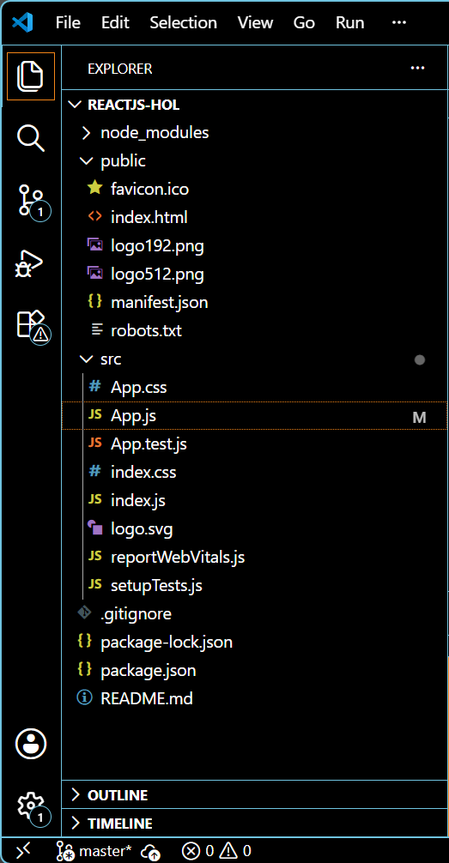

App.js
import logo from './logo.svg';
import './App.css';

function App() {
return (
<div className="App">
<h1>Welcome to the first session of React</h1>
</div>
);
}
export default App;

OUTPUT:

