Hello World RESTful Web Service
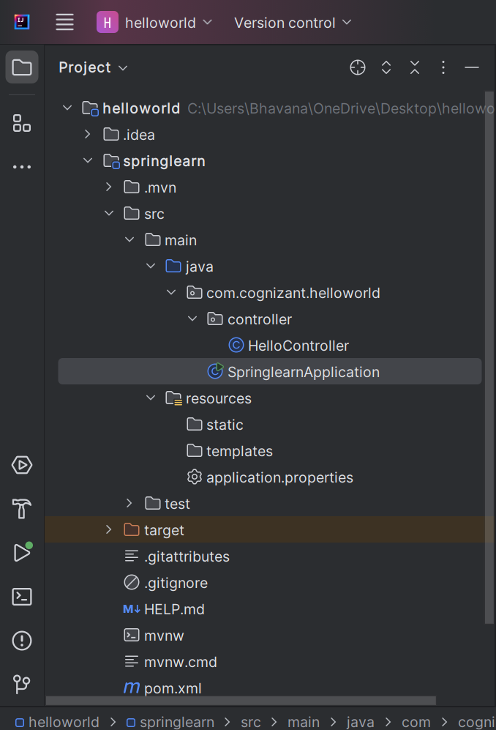

HelloController.java

package com.cognizant.helloworld.controller;
import org.slf4j.Logger;
import org.slf4j.LoggerFactory;
import org.springframework.web.bind.annotation.GetMapping;
import org.springframework.web.bind.annotation.RestController;
@RestController
public class HelloController {
private static final Logger LOGGER = LoggerFactory.getLogger(HelloController.class);
@GetMapping("/hello")
public String sayHello() {
LOGGER.info("START: sayHello()");
String message = "Hello World!!";
LOGGER.info("END: sayHello()");
return message;
}
}

SpringlearnApplication

package com.cognizant.helloworld;
import org.springframework.boot.SpringApplication;
import org.springframework.boot.autoconfigure.SpringBootApplication;
@SpringBootApplication
public class SpringlearnApplication {
public static void main(String[] args) {
SpringApplication.run(SpringlearnApplication.class, args);
}
}
Output:

