1 - Create a Spring Web Project using Maven
Folder structure:
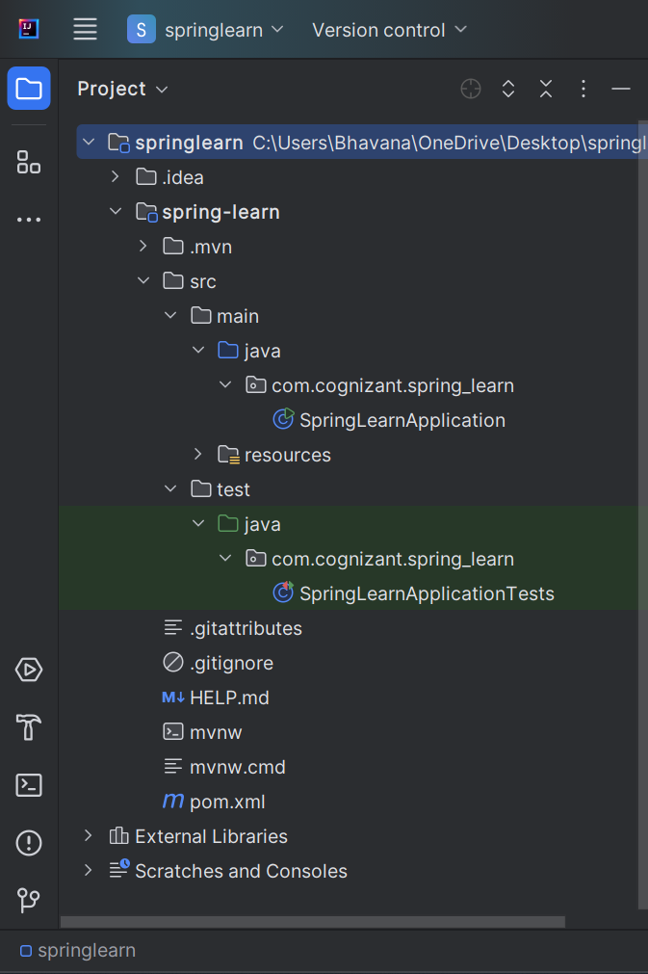

Output:
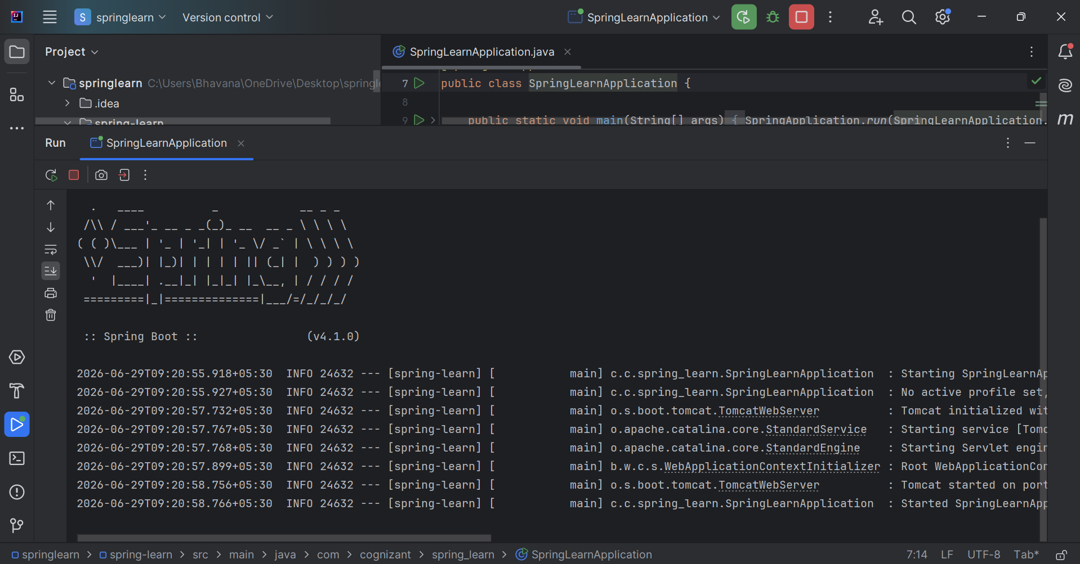

2 - Spring Core – Load SimpleDateFormat from Spring Configuration XML :

SpringLearnApplication.java
package com.cognizant.spring_learn;
import org.springframework.context.ApplicationContext;
import org.springframework.context.support.ClassPathXmlApplicationContext;
import java.text.ParseException;
import java.text.SimpleDateFormat;
import java.util.Date;
public class SpringLearnApplication {
public static void main(String[] args) {
displayDate();
}
public static void displayDate() {
ApplicationContext context = new ClassPathXmlApplicationContext("date-format.xml");
SimpleDateFormat format = context.getBean("dateFormat", SimpleDateFormat.class);
try {
Date date = format.parse("31/12/2018");
System.out.println("Parsed Date: " + date);
} catch (ParseException e) {
System.out.println("Invalid date format!");
e.printStackTrace();
}
}
}

Date-format.xml
<?xml version="1.0" encoding="UTF-8"?>
<beans xmlns="http://www.springframework.org/schema/beans"
xmlns:xsi="http://www.w3.org/2001/XMLSchema-instance"
xsi:schemaLocation="http://www.springframework.org/schema/beans
https://www.springframework.org/schema/beans/spring-beans.xsd">
<bean id="dateFormat" class="java.text.SimpleDateFormat">
<constructor-arg value="dd/MM/yyyy"/>
</bean>
</beans>

Output:
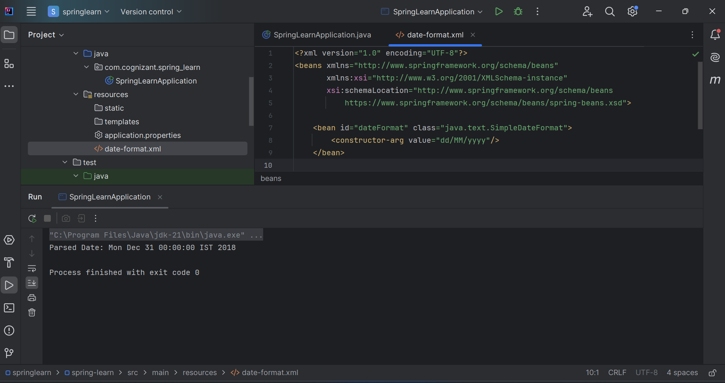

3 . Spring Core - Incorporate Logging
SpringLearnApplication.java
package com.cognizant.spring_learn;
import org.slf4j.Logger;
import org.slf4j.LoggerFactory;
import org.springframework.context.ApplicationContext;
import org.springframework.context.support.ClassPathXmlApplicationContext;
import java.text.ParseException;
import java.text.SimpleDateFormat;
import java.util.Date;
public class SpringLearnApplication {
private static final Logger LOGGER = LoggerFactory.getLogger(SpringLearnApplication.class);
public static void main(String[] args) {
LOGGER.info("Inside main()");
displayDate();
}
public static void displayDate() {
LOGGER.info("START");
ApplicationContext context = new ClassPathXmlApplicationContext("date-format.xml");
SimpleDateFormat format = context.getBean("dateFormat", SimpleDateFormat.class);
try {
Date date = format.parse("31/12/2018");
LOGGER.debug("Parsed Date: {}", date.toString());
LOGGER.info("Parsed Date (forcing debug as info): {}", date.toString());
} catch (ParseException e) {
LOGGER.error("Error parsing date", e);
}
LOGGER.info("END");
}
}

Application.properties
spring.application.name=spring-learn
logging.level.org.springframework=info
logging.level.com.cognizant.spring_learn=debug
logging.pattern.console=%d{yyMMdd}|%d{HH:mm:ss.SSS}|%-20.20thread|%5p|%-25.25logger{25}|%25M|%m%n
Output:

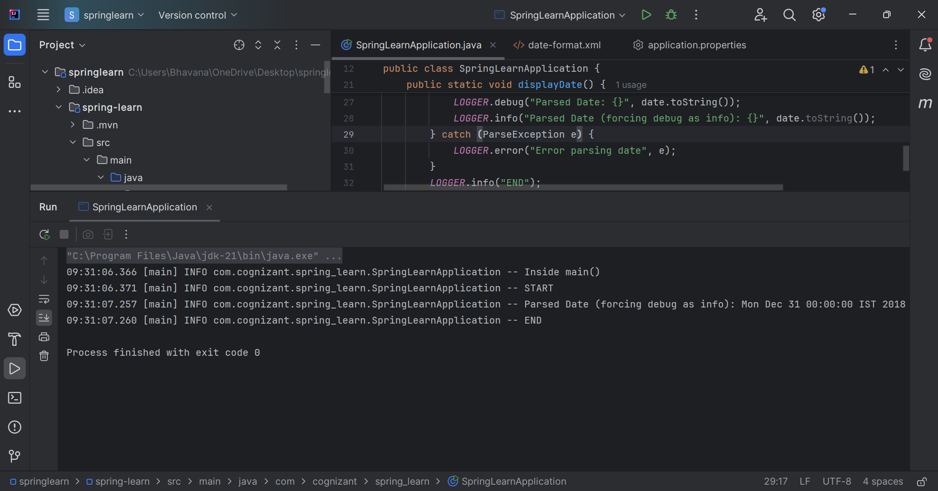

5 - Spring Core – Load Country from Spring Configuration XML

Country.java
package com.cognizant.spring_learn;
import org.slf4j.Logger;
import org.slf4j.LoggerFactory;
public class Country {
private static final Logger LOGGER = LoggerFactory.getLogger(Country.class);
private String code;
private String name;
public Country() {
LOGGER.debug("Inside Country Constructor.");
}
public String getCode() {
LOGGER.debug("Inside getCode()");
return code;
}
public void setCode(String code) {
LOGGER.debug("Inside setCode()");
this.code = code;
}
public String getName() {
LOGGER.debug("Inside getName()");
return name;
}
public void setName(String name) {
LOGGER.debug("Inside setName()");
this.name = name;
}
@Override
public String toString() {
return "Country [code=" + code + ", name=" + name + "]";
}
}

Country.xml
<?xml version="1.0" encoding="UTF-8"?>
<beans xmlns="http://www.springframework.org/schema/beans"
xmlns:xsi="http://www.w3.org/2001/XMLSchema-instance"
xsi:schemaLocation="http://www.springframework.org/schema/beans
https://www.springframework.org/schema/beans/spring-beans.xsd">
<bean id="country" class="com.cognizant.spring_learn.Country" scope="singleton">
<property name="code" value="IN" />
<property name="name" value="India" />
</bean>
</beans>

SpringLearnApplication.java

package com.cognizant.spring_learn;
import org.slf4j.Logger;
import org.slf4j.LoggerFactory;
import org.springframework.context.ApplicationContext;
import org.springframework.context.support.ClassPathXmlApplicationContext;
import java.text.ParseException;
import java.text.SimpleDateFormat;
import java.util.Date;
public class SpringLearnApplication {
private static final Logger LOGGER = LoggerFactory.getLogger(SpringLearnApplication.class);
public static void main(String[] args) {
LOGGER.info("Inside main()");
displayDate();
displayCountry();
}
public static void displayDate() {
LOGGER.info("START");
ApplicationContext context = new ClassPathXmlApplicationContext("date-format.xml");
SimpleDateFormat format = context.getBean("dateFormat", SimpleDateFormat.class);
try {
Date date = format.parse("31/12/2018");
LOGGER.info("Parsed Date: {}", date.toString());
} catch (ParseException e) {
LOGGER.error("Error parsing date", e);
}
LOGGER.info("END");
}
public static void displayCountry() {
LOGGER.info("START");
ApplicationContext context = new ClassPathXmlApplicationContext("country.xml");
Country country1 = context.getBean("country", Country.class);
Country country2 = context.getBean("country", Country.class);
LOGGER.info("Country1 : {}", country1);
LOGGER.info("Country2 : {}", country2);
LOGGER.info("Are both country beans the same? {}", country1 == country2);
LOGGER.info("END");
}
}

Output:
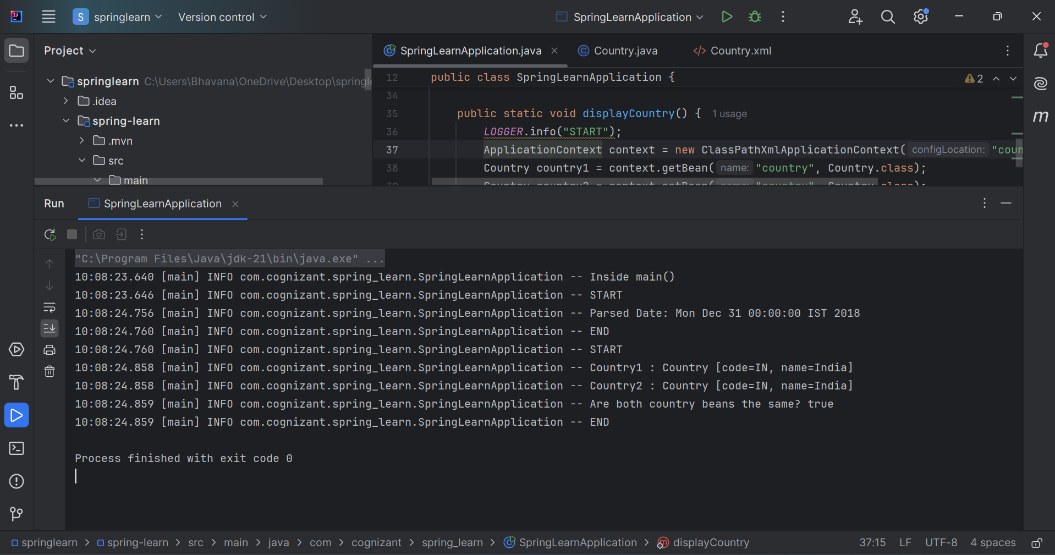

6-Spring Core – Load list of countries from Spring Configuration XML
Country.java
package com.cognizant.spring_learn;
import org.slf4j.Logger;
import org.slf4j.LoggerFactory;
public class Country {
private static final Logger LOGGER = LoggerFactory.getLogger(Country.class);
private String code;
private String name;
public Country() {
LOGGER.debug("Inside Country Constructor.");
}
public String getCode() {
LOGGER.debug("Inside getCode()");
return code;
}
public void setCode(String code) {
LOGGER.debug("Inside setCode()");
this.code = code;
}
public String getName() {
LOGGER.debug("Inside getName()");
return name;
}
public void setName(String name) {
LOGGER.debug("Inside setName()");
this.name = name;
}
@Override
public String toString() {
return "Country [code=" + code + ", name=" + name + "]";
}
}

Country.xml
<?xml version="1.0" encoding="UTF-8"?>
<beans xmlns="http://www.springframework.org/schema/beans"
xmlns:xsi="http://www.w3.org/2001/XMLSchema-instance"
xsi:schemaLocation="http://www.springframework.org/schema/beans
https://www.springframework.org/schema/beans/spring-beans.xsd">
<bean id="country" class="com.cognizant.spring_learn.Country" scope="singleton">
<property name="code" value="IN" />
<property name="name" value="India" />
</bean>
<bean id="in" class="com.cognizant.spring_learn.Country">
<property name="code" value="IN" />
<property name="name" value="India" />
</bean>
<bean id="us" class="com.cognizant.spring_learn.Country">
<property name="code" value="US" />
<property name="name" value="United States" />
</bean>
<bean id="de" class="com.cognizant.spring_learn.Country">
<property name="code" value="DE" />
<property name="name" value="Germany" />
</bean>
<bean id="jp" class="com.cognizant.spring_learn.Country">
<property name="code" value="JP" />
<property name="name" value="Japan" />
</bean>
<bean id="countryList" class="java.util.ArrayList">
<constructor-arg>
<list>
<ref bean="in"/>
<ref bean="us"/>
<ref bean="de"/>
<ref bean="jp"/>
</list>
</constructor-arg>
</bean>
</beans>

SpringLearnApplication.java
package com.cognizant.spring_learn;
import org.slf4j.Logger;
import org.slf4j.LoggerFactory;
import org.springframework.context.ApplicationContext;
import org.springframework.context.support.ClassPathXmlApplicationContext;
import java.text.ParseException;
import java.text.SimpleDateFormat;
import java.util.ArrayList;
import java.util.Date;
import java.util.List;
public class SpringLearnApplication {
private static final Logger LOGGER = LoggerFactory.getLogger(SpringLearnApplication.class);
public static void main(String[] args) {
LOGGER.info("Inside main()");
displayDate();
displayCountry();
displayCountries();
}
public static void displayDate() {
LOGGER.info("START");
ApplicationContext context = new ClassPathXmlApplicationContext("date-format.xml");
SimpleDateFormat format = context.getBean("dateFormat", SimpleDateFormat.class);
try {
Date date = format.parse("31/12/2018");
LOGGER.info("Parsed Date: {}", date.toString());
} catch (ParseException e) {
LOGGER.error("Error parsing date", e);
}
LOGGER.info("END");
}
public static void displayCountry() {
LOGGER.info("START");
ApplicationContext context = new ClassPathXmlApplicationContext("country.xml");
Country country1 = context.getBean("country", Country.class);
Country country2 = context.getBean("country", Country.class);
LOGGER.info("Country1 : {}", country1);
LOGGER.info("Country2 : {}", country2);
LOGGER.info("Are both country beans the same? {}", country1 == country2);
LOGGER.info("END");
}
public static void displayCountries() {
LOGGER.info("START");
ApplicationContext context = new ClassPathXmlApplicationContext("country.xml");
List<Country> countryList = context.getBean("countryList", ArrayList.class);
LOGGER.info("Country List: {}", countryList);
LOGGER.info("END");
}
}
Output:
