12. Using git-Bash or Git Desktop to create a repository, (Attach the following screenshots and send it to your mentor)

1. Push any of the sample code to your personal GitHub. Create like student, employee etc.,

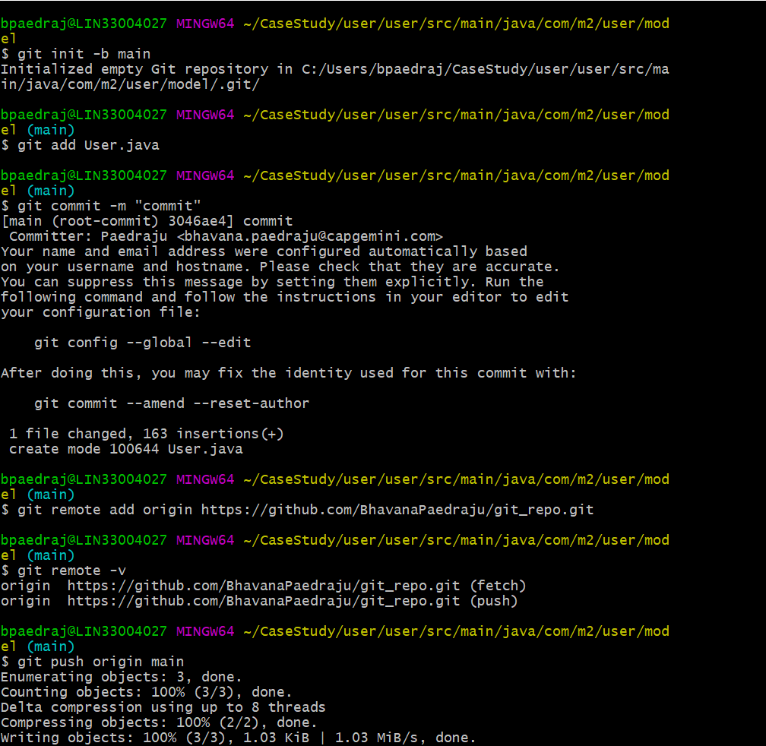

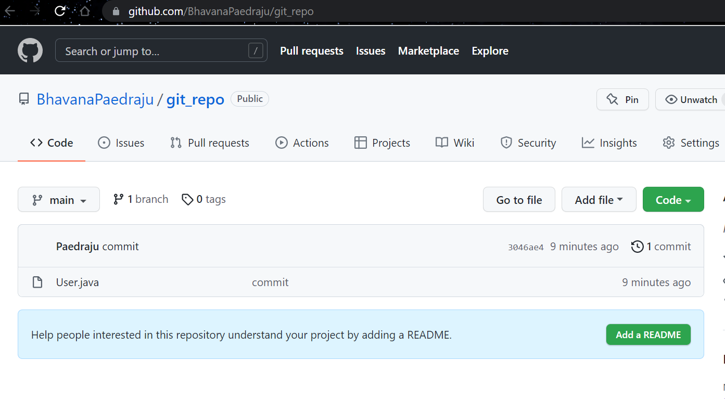

1. Clone the project using git bash/git desktop to your local computer (your personal repo).

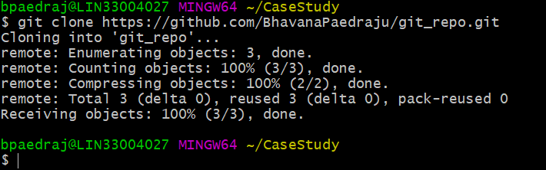

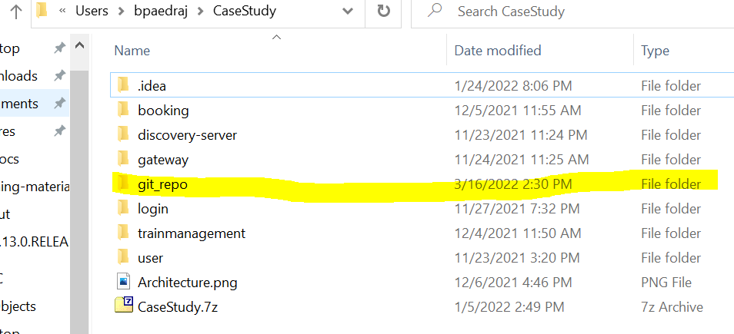

1. Do Some code changes and try pushing the code back to the GitHub using gitbash/git-desktop.

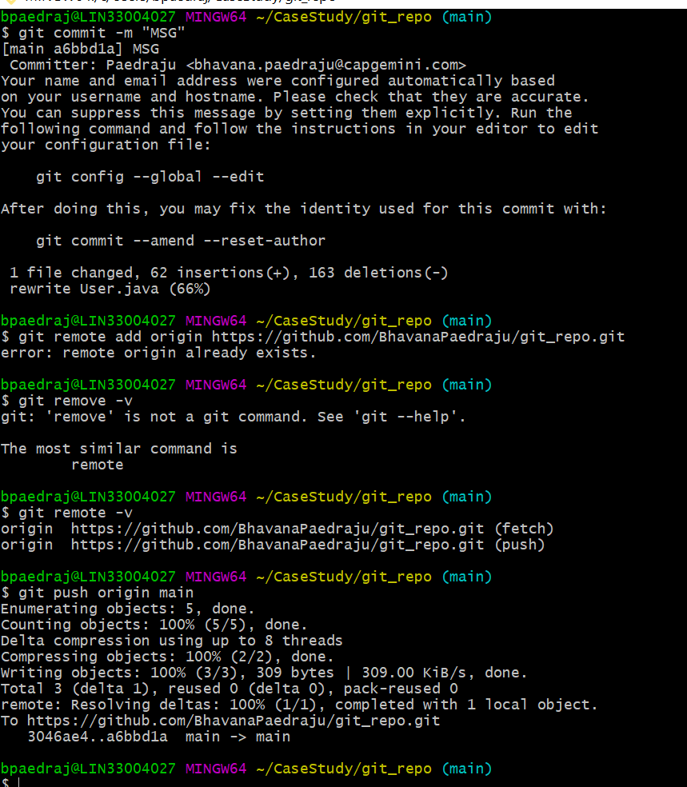

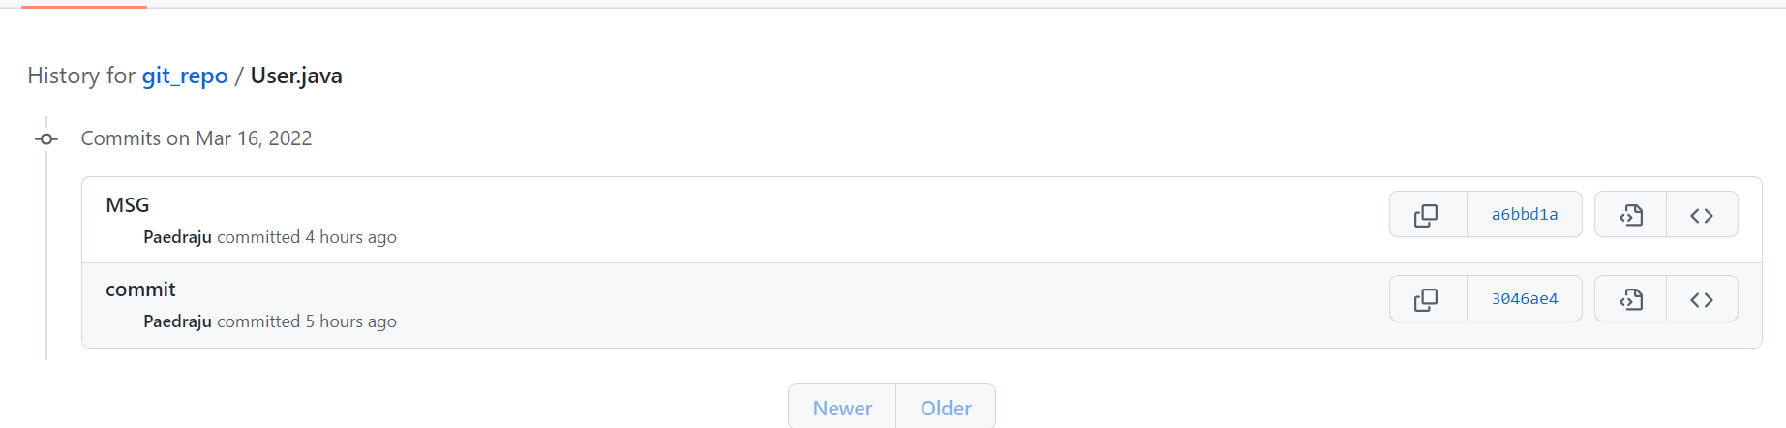

1. Create a feature branch with any name. do commit by changing any code.

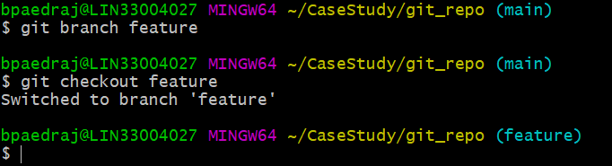

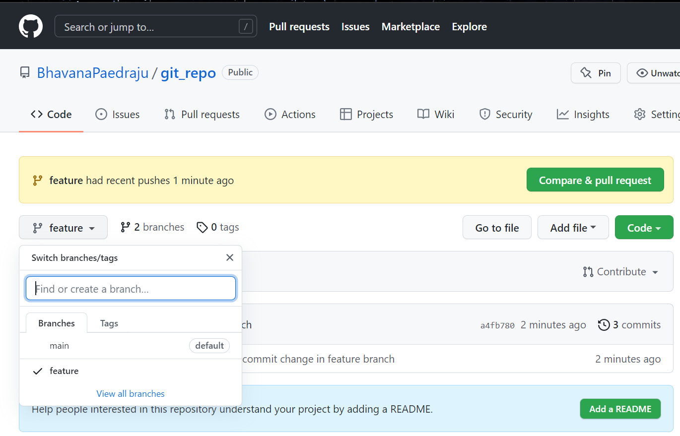

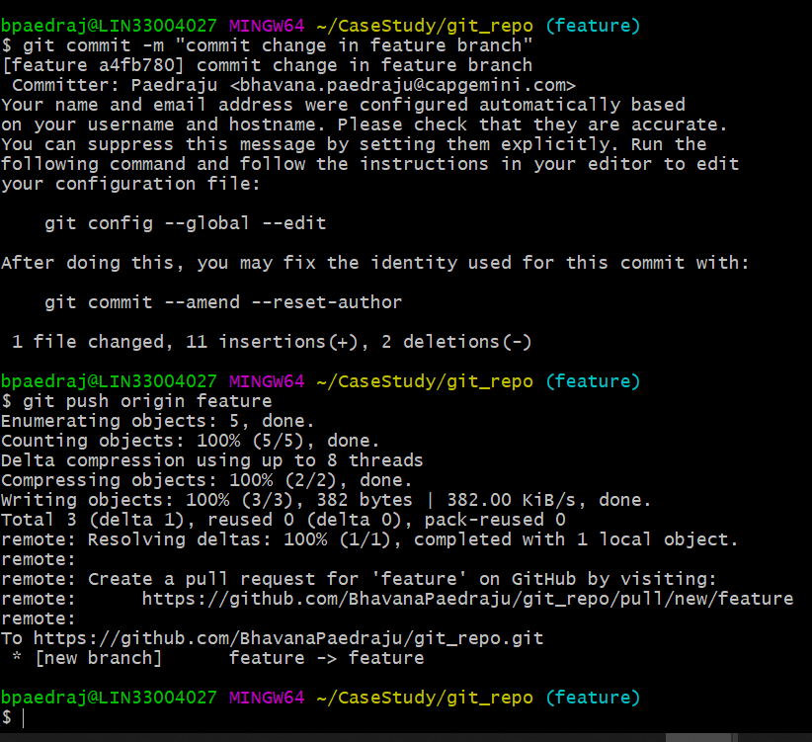

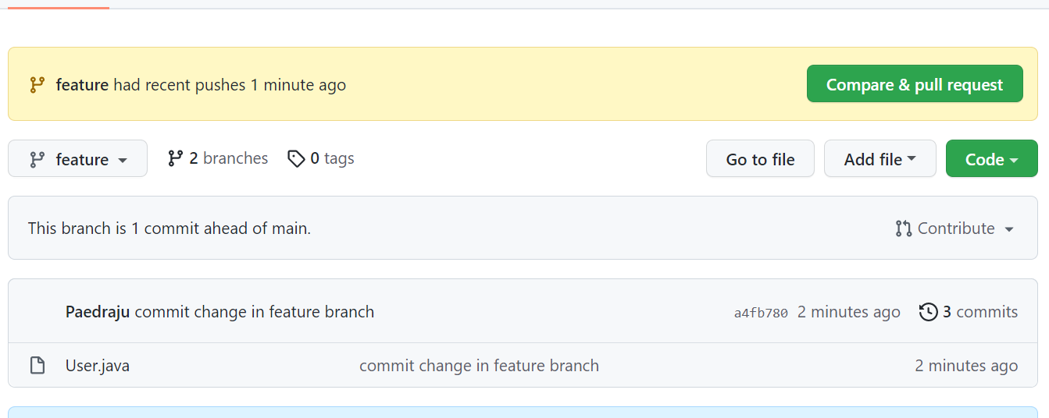

1. After committing the code in feature branch. Raise the Pull Request (PR) and you can merge the PR(Pull Request) on your repository.

