**CS 6643 Computer Vision  
Final Project – Game of Football**

Bhavana Ramakrishna (br1525)  
Nirupama Suresh (ns3981)  
Shishir Singapura Lakshminarayan (ssl495)

**Motivation**

Sports in the present day use various technologies to provide real time analysis of the game. For instance, in football, it would be ideal to tracking the motion of the ball every instance of time would serve beneficial in case of any decisions that have to be taken during the game such as to check if a goal was made, to inspect foul play or to issue penalties. Goal detection by tracking the motion of the ball also serves useful in making decisions in situations where a team requests for a review. This motivated the need for a robust way of tracking the motion of the ball during every instance of time. Thus, we came up with a project to implement a game of football where we track the ball at every instance and also estimate whether it made the goal or not.

**Approach**

For this project, a miniaturized version of the game is considered. A red ball is thrown toward a green goal, the motion of the ball is tracked at every instance and the program checks if the ball made the goal each time.

The input video is read into frames. For every frame, a threshold is applied to remove the background from the foreground to obtain a black and white image. Edge detection performed on this image by finding the magnitude of the gradient. This is done by filtering the image with the derivative kernels along the horizontal and vertical directions and computing the magnitude of the gradient. The resulting image is used to compute Hough Transform to detect the ball.

Hough Transform is computed by finding the center and radii parameters of the circle from a known number of edge points on the perimeter. A circle with radius *r* and center *(a,b)* is described by the following equations where *theta* ranges from 0 o 360 degrees to sweep the whole perimeter.

x = a + r *cos(theta)  
y = b + r *sin(theta)

The locus of the parameter points in the parameter space with two variable parameters (*a,b)* falls on a circle and three variable parameters *(a,b,r)* falls on the surface of a cone. The accumulator tracks the number of circles that pass through the coordinates of each edge point and votes to find the highest votes. The accumulation cells where a large number of circles/cone surfaces intersect have the largest number of votes and comprise the maxima. The peaks in the Hough accumulator determine the circles in the original image.

The ball is detected throughout its course of motion. Once the ball hits the goal, the goal is detected by segmenting the goal from the background. All these images are stored in a folder. The output video is generated by using these output images.

**Data used**

The input data is a video of a ball thrown aimed at a hitting a goal. The video is broken down into image frames for processing.

The output data is a video where the motion of the ball is tracked, and the ball scoring a goal is checked.

**Discussion of Results**

The following three images taken at different points in the video are considered for the discussion.

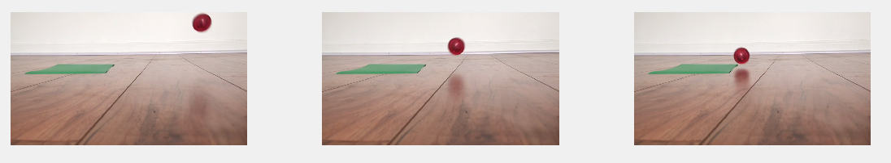Figure: Images from the input video

The goal of the Hough transform in this project is to detect circles. In order to do this clearly, images where the edges are well defined have to be used. Therefore, the image is converted to a black and white image by thresholding. All values below the threshold are considered background and all values above are considered the object. Here are the resulting images after applying thresholding.

Figure: Images after applying threshold to separate foreground and background

Edge detection is used on these images to obtain regions of strong variation in the gray level. In order to do this, the gradient image is computed by filtering using the x derivative and y derivative kernels. Here are the results after applying edge detection.

Figure: Images after edge detection

Hough Transform for circles is applied to detect the circle in the original image. Here are the results of the Hough accumulator space for each of the three images.

Figure: Hough space for each of the images

In the above images, the horizontal axis is the *a* axis, the vertical axis is the *b* axis. The brighter a spot in the Hough space image, more the number of votes cast at the point. And more votes imply a greater probability of a point being a center. These points are extracted and a circle of radius *r* is drawn around them in the original image. Here are the results obtained.

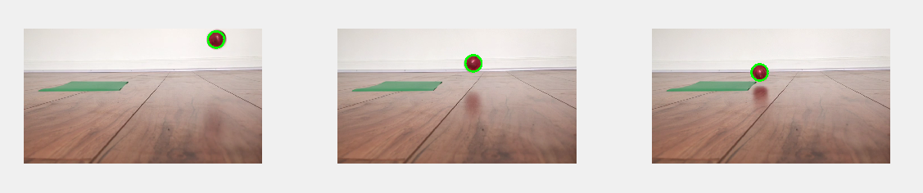Figure: Ball detection in each of the three images.

When he ball makes a goal, the goal is detected by finding the position of the goal using a color based segmentation and tracking the ball using the Hough Transform. Here is the result obtained when the ball makes a goal.

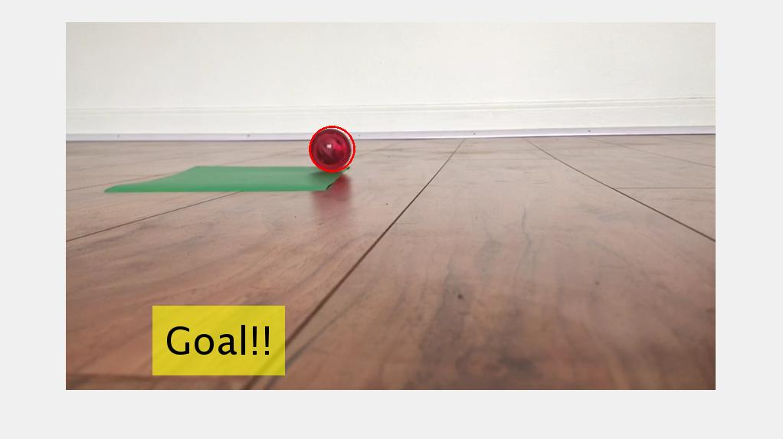

Figure: Goal detection

From the results obtained, it can be observed that the program is able to track the motion of the ball effectively throughout its course of motion. The program is able to detect the goal when the ball hits it.

By using Hough Transform, we are able to obtain good results. However, it is dependent on factors such as the radii range and edge detection. This is why image pre-processing with the right thresholding and edge detection is important. It can be observed from the image that the threshold value chosen was appropriate to detect the circles correctly in the image. Sometimes, the Hough Transform produces false peaks due to detection of neighboring pixels of maximum value. Therefore, it is important to choose the right grid discretization.and a good threshold value for peak detection as achieved by the program. Hough Transform is also susceptible to the distance between the ball and the camera and can produce varying results. Sometimes, spurious circles which can be overcome by checking if circles actually exists at the highest voted accumulator cells.

**Future Work**

This project can be developed into an app for a football game. This project can also be extended to track the motion of the ball in real time and in an actual football game. It can also be extended to other sports such as basketball and ice hockey where the same concept can be used to track the motion of the ball throughout the play and detect goals.

**Contributions**

**Bhavana Ramakrishna (br1525)**

* Video Processing: Reading, writing and display of image fames.
* Color Thresholding: Separating foreground and background for the ball using color based thresholding.
* Edge Detection: Using horizontal and vertical derivative kernels to compute gradient magnitude.
* Video Display: Generating video by combining image frames superimposed with detected circle.

**Nirupama Suresh (ns3981)**

* Image and Video data: Capturing videos of the game being played in action.
* Goal Detection: Detecting goal by separating it from the background using color based thresholding.
* Video Display: Generating video for image frames involving goal detection.
* Demonstration video: Making a demonstration video summarizing the goal, data and results obtained in the project.

**Shishir Singapura Lakshminaryan (ssl495)**

* Computing Hough Transform: Implementing the algorithm for detecting circles in every image frame by using the Hough Transform.
* Peak detection: Apply thresholding to obtain the maxima in the Hough accumulator array.
* Display detected circles: Draw circles on the original image using the center and radii peaks obtained in peak detection.
* Report: Making a comprehensive report summarizing motivation, approach, data used, results, critical discussion and future work.