**COGNIZANT - DIGITALNURTURE4.0**

**DEEPSKILLING JAVA FSE**

**WEEK 05: MICROSERVICES WITH SPRING BOOT 3 AND SPRING CLOUD**

Superset ID: 6384852

Name: BHAVANA REDDY M

**Exercise 1: Creating Microservices for account and loan**

**Account Microservice**

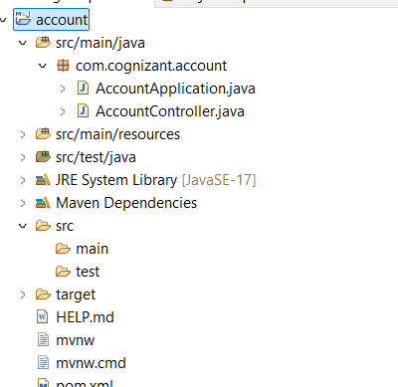

**AccountController.java**

package com.cognizant.account;

import org.springframework.web.bind.annotation.*;

import java.util.Map;

@RestController

public class AccountController {

@GetMapping("/accounts/{number}")

public Map<String, Object> getAccount(@PathVariable String number) {

return Map.of(

"number", number,

"type", "savings",

"balance", 234343

);

}

}

**application.properties**

spring.application.name=account

server.port=8080

**Output:**

**Response:**

{

"number": "00987987973432",

"type": "savings",

"balance": 234343

}

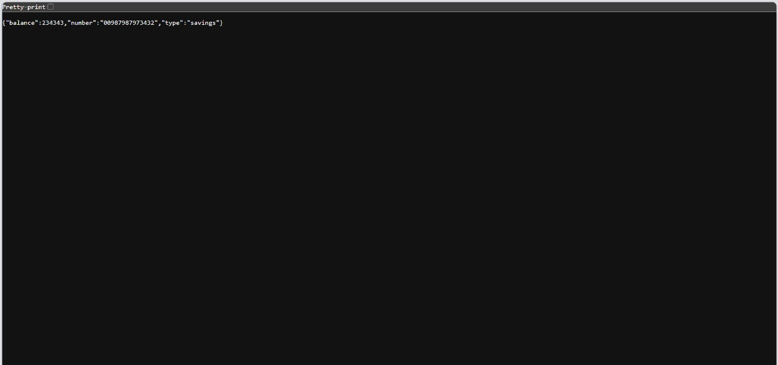

**Loan Microservice**

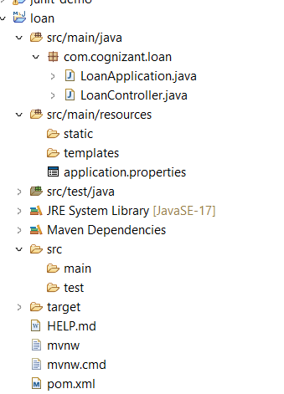

**LoanController.java**

package com.cognizant.loan;

import org.springframework.web.bind.annotation.*;

import java.util.Map;

@RestController

public class LoanController {

@GetMapping("/loans/{number}")

public Map<String, Object> getLoan(@PathVariable String number) {

return Map.of(

"number", number,

"type", "car",

"loan", 400000,

"emi", 3258,

"tenure", 18

);

}

}

**application.properties**

spring.application.name=loan

server.port=8081

**Output:**

**Response:**

{

"number": "H00987987972342",

"type": "car",

"loan": 400000,

"emi": 3258,

"tenure": 18

}

