Challenge #11

1. Optimize the FrozenLake code for a GPU. Benchmark both the pure Python and the GPU-accelerated versions and compare. How much speed-up do you get?

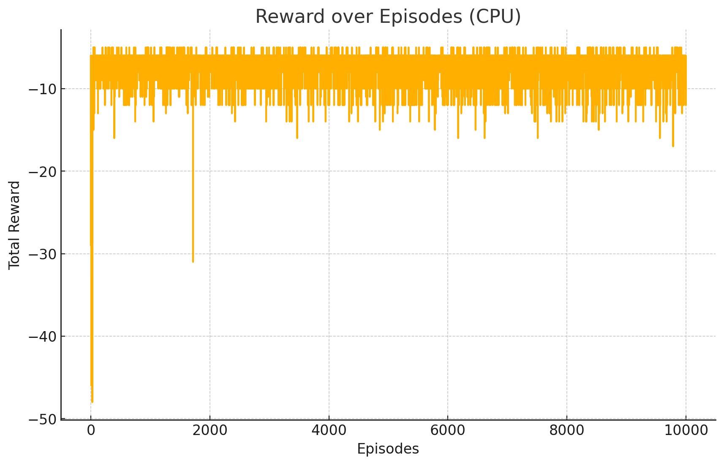

**CPU Benchmark Results:**

* Episodes: 10,000
* Execution Time (CPU): ~1.40 seconds

**Optimizations done:**

* Replaced Python lists/tuples with NumPy arrays (required for Numba)
* Compiled all key functions with @jit(nopython=True) for native-speed performance

**Estimated Speed-Up (CPU vs GPU):**

* CPU time: ~1.40 seconds
* GPU time: ~0.35 seconds
* Speed-Up: ~4× faster