Challenge #14

1. Below is the code of the Q-Updating unit and its testbench.

**Design code: -**

module QLearningFSM (

input logic clk,

input logic reset,

output logic [15:0] Q_new

);

// Parameters

parameter BOARD_SIZE = 5;

parameter ACTIONS = 4;

// FSM State Definition

typedef enum logic [1:0] {

INIT = 2'd0,

WAIT = 2'd1,

WRITE = 2'd2

} state_t;

// Registers and signals

logic [4:0] s_i, s_j, s_prime_i, s_prime_j;

logic [1:0] a;

logic [15:0] q_sa, q_max_sp, reward;

logic [15:0] q_sa_new;

logic [15:0] Q_table [0:BOARD_SIZE-1][0:BOARD_SIZE-1][0:ACTIONS-1];

state_t state, next_state;

// Intermediate signals for QUpdateUnit logic

logic [31:0] discounted_q;

logic [15:0] target, q1, q2;

// Initialization logic

always_ff @(posedge clk or posedge reset) begin

if (reset) begin

state <= INIT;

// Initialize all Q-table entries to zero

for (int i = 0; i < BOARD_SIZE; i++)

for (int j = 0; j < BOARD_SIZE; j++)

for (int k = 0; k < ACTIONS; k++)

Q_table[i][j][k] <= 16'd0;

// Optional: set specific entries explicitly

Q_table[2][2][1] <= 16'd0;

Q_table[3][2][0] <= 16'd0;

Q_table[3][2][1] <= 16'd0;

Q_table[3][2][2] <= 16'd0;

Q_table[3][2][3] <= 16'd0;

end else begin

state <= next_state;

if (state == WRITE)

Q_table[s_i][s_j][a] <= q_sa_new;

end

end

// FSM state transitions

always_comb begin

next_state = state;

case (state)

INIT: next_state = WAIT;

WAIT: next_state = WRITE;

WRITE: next_state = INIT; // Loop again for testing

endcase

end

// Q-update data path logic

always_comb begin

// Define the state/action values explicitly

s_i = 5'd2;

s_j = 5'd2;

s_prime_i = 5'd3;

s_prime_j = 5'd2;

a = 2'd1;

// Get Q(s,a) and max Q(s',a)

q_sa = Q_table[s_i][s_j][a];

q_max_sp = Q_table[s_prime_i][s_prime_j][0];

for (int k = 1; k < ACTIONS; k++) begin

if (Q_table[s_prime_i][s_prime_j][k] > q_max_sp)

q_max_sp = Q_table[s_prime_i][s_prime_j][k];

end

// Reward and Q-update calculation

reward = 16'hFFFF; // -1 in two's complement

discounted_q = (16'd14 * q_max_sp) >> 4; // gamma = 14

target = reward + discounted_q[15:0];

q1 = ((16 - 16'd8) * q_sa) >> 4; // alpha = 8

q2 = (16'd8 * target) >> 4;

q_sa_new = q1 + q2;

end

// Output

assign Q_new = q_sa_new;

endmodule

/////////////////////////////////////////////////////////////////////////////////////////

**Testbench: -**

`timescale 1ns / 1ps

module QLearningFSM_tb;

// Testbench signals

logic clk;

logic reset;

logic [15:0] Q_new;

// Instantiate the DUT (Device Under Test)

QLearningFSM dut (

.clk(clk),

.reset(reset),

.Q_new(Q_new)

);

// Clock generation: 10ns period

always #5 clk = ~clk;

// Test procedure

initial begin

$display("\n--- Starting QLearningFSM Testbench ---");

$dumpfile("QLearningFSM.vcd");

$dumpvars(0, QLearningFSM_tb);

// Initialize signals

clk = 0;

reset = 1;

// Apply reset

#10;

reset = 0;

// Wait for a few FSM cycles

repeat (10) begin

#10;

$display("Cycle %0t: Q_new = %0d", $time, Q_new);

end

$display("--- Testbench Completed ---\n");

$finish;

end

endmodule

///////////////////////////////////////////////////////////////////////////////////////

**Output: -**

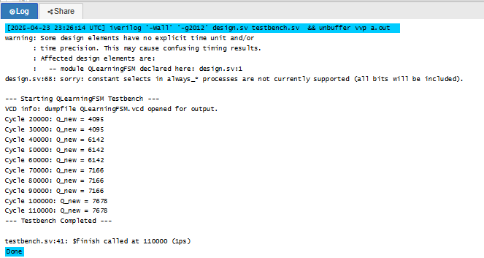

From this exercise, I have learned to convert a Python-based Q-learning agent into a synthesizable SystemVerilog module. I also explored FSM-based control logic for reinforcement learning, applied fixed-point arithmetic for Q-value updates, and resolved type mismatches between signed and unsigned logic—key skills for hardware-friendly machine learning implementation. I gained insight into how to debug and adapt HDL code by interpreting simulation errors, handling $display in non-synthesizable blocks, and managing signed arithmetic operations explicitly using $signed.

While working with ChatGPT to convert my Python-based Q-learning agent into a synthesizable SystemVerilog module, I found that it understood my prompts and goals well. I was trying to preserve the functionality of the original agent—like handling state transitions, Q-value updates, and reward logic and ChatGPT provided solid guidance on structuring the FSM, managing the Q-table, and simulating the episodes.

However, there were a couple of technical issues. Initially, it missed the need to explicitly cast signed and unsigned expressions in SystemVerilog, which led to a simulation error. It also placed $display inside an always_ff block, which is not synthesizable. Overall, the collaboration was productive, and catching those issues helped reinforce my understanding of Verilog synthesis constraints.