Challenge #20

1. Write SPICE code for a 4x4 resistive crossbar (with fixed resistances). Demonstrate that the resulting output currents represent the product of the 4x1 input vector and the 4x4 weight matrix.

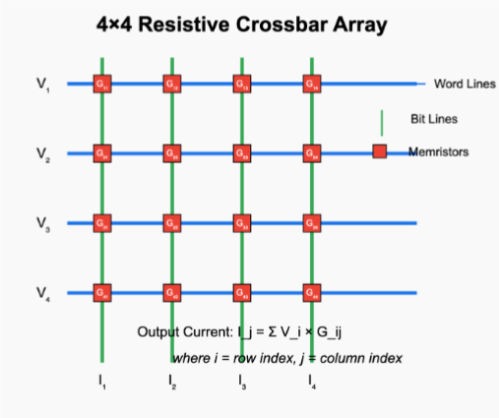

→ # Write your 4x4 crossbar SPICE netlist to a file

spice_code = """

* 4x4 Resistive Crossbar Matrix-Vector Multiplication

V1 WL1 0 DC 1

V2 WL2 0 DC 2

V3 WL3 0 DC 0

V4 WL4 0 DC 1

RB1 BL1 0 1

RB2 BL2 0 1

RB3 BL3 0 1

RB4 BL4 0 1

R11 WL1 BL1 1k

R21 WL2 BL1 1k

R31 WL3 BL1 1k

R41 WL4 BL1 1k

R12 WL1 BL2 2k

R22 WL2 BL2 1k

R32 WL3 BL2 2k

R42 WL4 BL2 1k

R13 WL1 BL3 500

R23 WL2 BL3 1k

R33 WL3 BL3 1k

R43 WL4 BL3 2k

R14 WL1 BL4 1k

R24 WL2 BL4 2k

R34 WL3 BL4 1k

R44 WL4 BL4 1k

.OP

.END

"""

# Save to file

with open("crossbar.cir", "w") as f:

    f.write(spice_code)

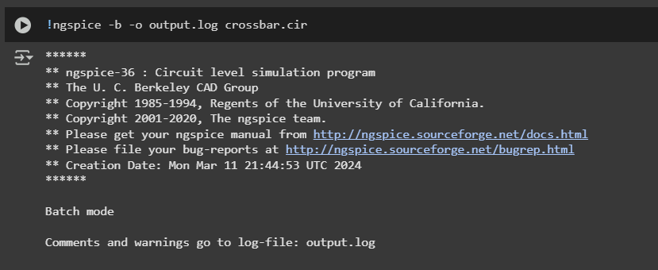

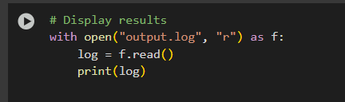

Circuit:

Doing analysis at TEMP = 27.000000 and TNOM = 27.000000

No. of Data Rows : 1

Node Voltage

---- -------

---- -------

bl4 2.989537e-03

bl3 4.479841e-03

bl2 3.489531e-03

bl1 3.984064e-03

wl4 1.000000e+00

wl3 0.000000e+00

wl2 2.000000e+00

wl1 1.000000e+00

Source Current

------ -------

v1#branch -4.48232e-03

v2#branch -6.98655e-03

v3#branch 1.319821e-05

v4#branch -3.48730e-03

Resistor models (Simple linear resistor)

model R

rsh 0

narrow 0

short 0

tc1 0

tc2 0

tce 0

defw 1e-05

l 1e-05

kf 0

af 0

r 0

bv_max 1e+99

lf 1

wf 1

ef 1

Resistor: Simple linear resistor

device r44 r34 r24

model R R R

resistance 1000 1000 2000

ac 1000 1000 2000

dtemp 0 0 0

bv_max 1e+99 1e+99 1e+99

noisy 1 1 1

i 0.00099701 -2.98954e-06 0.000998505

p 0.00099403 8.93733e-09 0.00199403

Resistor: Simple linear resistor

device r14 r43 r33

model R R R

resistance 1000 2000 1000

ac 1000 2000 1000

dtemp 0 0 0

bv_max 1e+99 1e+99 1e+99

noisy 1 1 1

i 0.00099701 0.00049776 -4.47984e-06

p 0.00099403 0.00049553 2.0069e-08

Resistor: Simple linear resistor

device r23 r13 r42

model R R R

resistance 1000 500 1000

ac 1000 500 1000

dtemp 0 0 0

bv_max 1e+99 1e+99 1e+99

noisy 1 1 1

i 0.00199552 0.00199104 0.00099651

p 0.0039821 0.00198212 0.000993033

Resistor: Simple linear resistor

device r32 r22 r12

model R R R

resistance 2000 1000 2000

ac 2000 1000 2000

dtemp 0 0 0

bv_max 1e+99 1e+99 1e+99

noisy 1 1 1

i -1.74477e-06 0.00199651 0.000498255

p 6.08841e-09 0.00398605 0.000496517

Resistor: Simple linear resistor

device r41 r31 r21

model R R R

resistance 1000 1000 1000

ac 1000 1000 1000

dtemp 0 0 0

bv_max 1e+99 1e+99 1e+99

noisy 1 1 1

i 0.000996016 -3.98406e-06 0.00199602

p 0.000992048 1.58728e-08 0.00398408

Resistor: Simple linear resistor

device r11 rb4 rb3

model R R R

resistance 1000 1 1

ac 1000 1 1

dtemp 0 0 0

bv_max 1e+99 1e+99 1e+99

noisy 1 1 1

i 0.000996016 0.00298954 0.00447984

p 0.000992048 8.93733e-06 2.0069e-05

Resistor: Simple linear resistor

device rb2 rb1

model R R

resistance 1 1

ac 1 1

dtemp 0 0

bv_max 1e+99 1e+99

noisy 1 1

i 0.00348953 0.00398406

p 1.21768e-05 1.58728e-05

Vsource: Independent voltage source

device v4 v3 v2

dc 1 0 2

acmag 0 0 0

pulse - - -

sin - - -

exp - - -

pwl - - -

sffm - - -

am - - -

trnoise - - -

trrandom - - -

i -0.0034873 1.31982e-05 -0.00698655

p -0.0034873 0 -0.0139731

Vsource: Independent voltage source

device v1

dc 1

acmag 0

pulse -

sin -

exp -

pwl -

sffm -

am -

trnoise -

trrandom -

i -0.00448232

p -0.00448232

Total analysis time (seconds) = 0

Total elapsed time (seconds) = 0.006

Total DRAM available = 12977.953 MB.

DRAM currently available = 6951.777 MB.

Maximum ngspice program size = 19.902 MB.

Current ngspice program size = 12.227 MB.

Shared ngspice pages = 10.371 MB.

Text (code) pages = 5.316 MB.

Stack = 0 bytes.

Library pages = 1.957 MB.