VERIFICATION TEST PLAN

ECE-593: Fundamentals of Pre-Silicon Validation
Maseeh College of Engineering and Computer Science
Winter, 2025

Project Name: AHB to APB Bridge
Members: Bhavana Manikyanahalli Srinivasegowda
Harsha Vardhan Duvvuru
Lokarjun Ramesh
Date: 01/31/2025

Table of Contents
2 Introduction: 4
2.1 Objective of the verification plan 4
2.2 Top Level block diagram 4
2.3 Specifications for the design 5
3 Verification Requirements 5
3.1 Verification Levels 5
3.1.1 What hierarchy level are you verifying and why? 5
3.1.2 How is the controllability and observability at the level you are verifying? 5
3.1.3 Are the interfaces and specifications clearly defined at the level you are verifying. List them. 6
4 Required Tools 6
4.1 List of required software and hardware toolsets needed. 6
5 Risks and Dependencies 7
5.1 List all the critical threats or any known risks. List contingency and mitigation plans. 7
6 Functions to be Verified. 7
6.1 Functions from specification and implementation 7
6.1.1 List of functions that will be verified. Description of each function 7
6.1.2 List of critical functions and non-critical functions for tapeout 8
7 Tests and Methods 8
7.1.1 Testing methods to be used: Black/White/Gray Box. 8
7.1.2 Testbench Architecture; Component used (list and describe Drivers, Monitors, scoreboards, checkers etc.) 9
7.1.3 Verification Strategy: (Dynamic Simulation, Formal Simulation, Emulation etc.) Describe why you chose the strategy. 9
7.1.4 What is your driving methodology? 10
7.1.5 What will be your checking methodology? 10
8 Coverage Requirements 11
8.1.2 Assertions 11
9 Resources requirements 11
9.1 Team members and who is doing what and expertise. 11
10 Schedule 12
10.1 Create a table with a plan of completion. You can use milestones as a guide to fill this. 12
11 References Uses / Citations/Acknowledgements 12

Introduction:

The AHBtoAPB Bridge is an AHB slave, providing an interface between the high-speed AHB and low-power APB. Read and write transfers on the AHB are converted into equivalent transfers on the APB. As the APB is not pipelined, then wait states are added during transfers to and from the APB when the AHB is required to wait for the APB.
The bridge unit converts system bus transfers into APB transfers and performs the following functions:
- Latches the address and holds it valid throughout the transfer.
- Decodes the address and generates a peripheral select, PSELx. Only one select signal can be active during a transfer.
- Drives the data onto the APB for a write transfer.
- Drives the APB data onto the system bus for a read transfer.
- Generates a timing strobe, PENABLE, for the transfer.

Objective of the verification plan

- Verify correct AHB-to-APB protocol conversion.
- Ensure data integrity across the bridge.
- Validate read and write transactions.
- Ensure APB timing constraints are met.
- Validate throughput and performance metrics.

Top Level block diagram
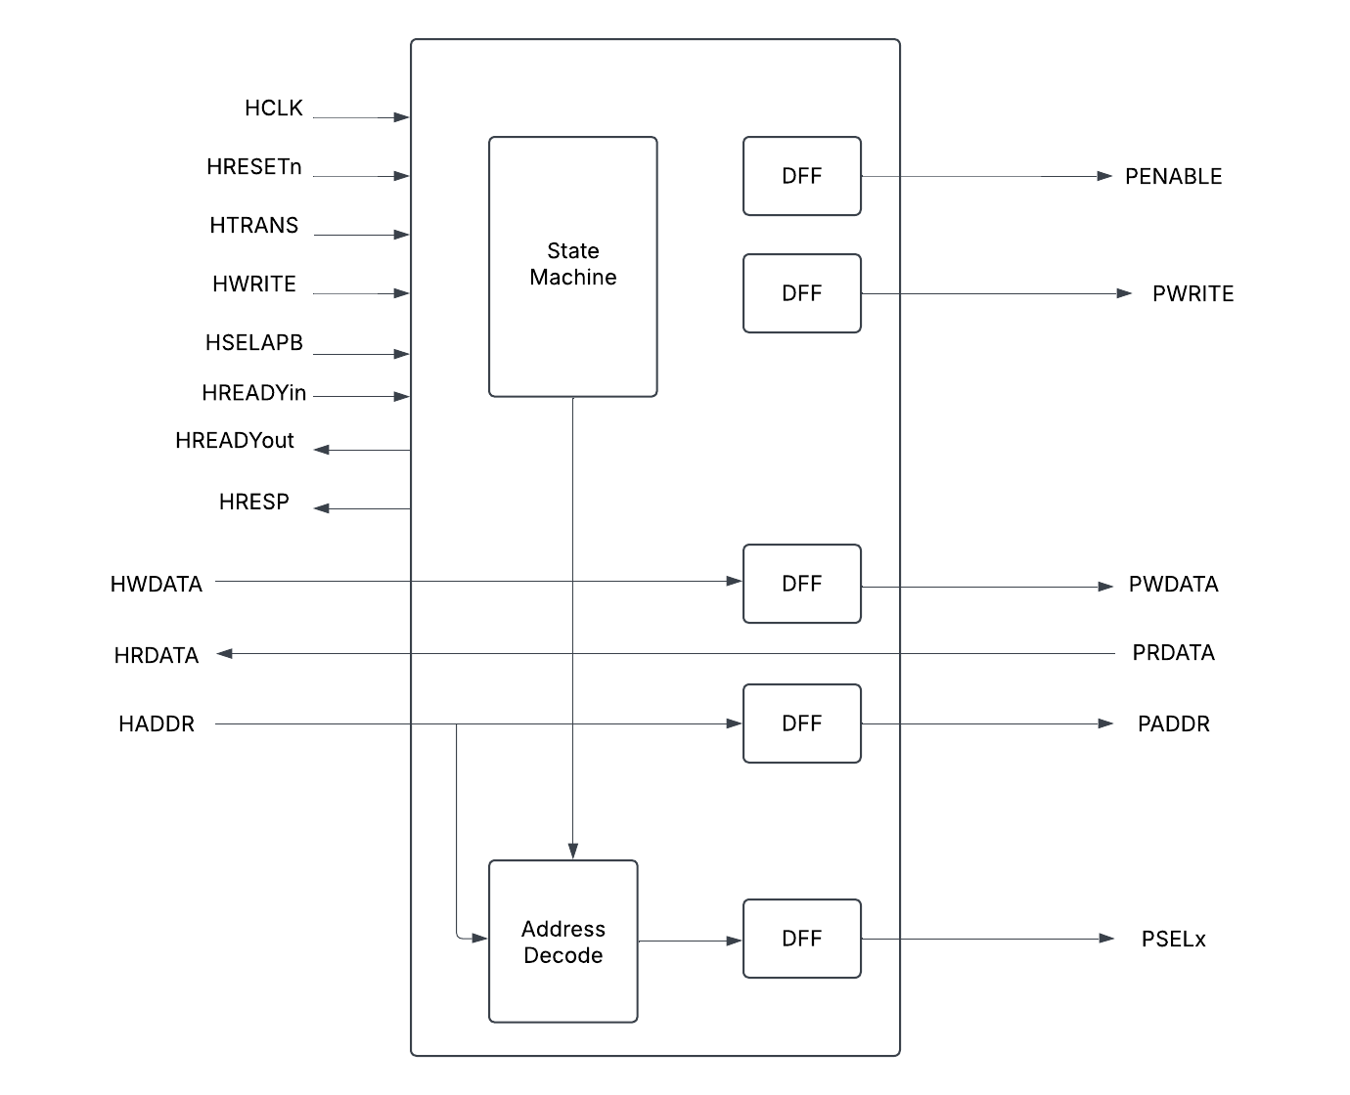

The above diagram shows the top-level model of AHB to APB bridge. In our design, we are not focusing much on the state machine, address decode and DFF. More prominence is given to the input and output signals, AHB – APB interface.

Specifications for the design

Specifications to be implemented in milestone-1:
Feature | Description
AHB Interface | Supports AHB-lite/AHB protocol for master-side communication
APB Interface | Generates APB transactions with correct timing and control
Write transactions | Ensure data is correctly written from AHB-APB
Read transactions | Ensure data is correctly read from APB_AHB
Reset Handling | Ensure bridge recovers correctly after rest

Specifications to be implemented in future milestones:
Feature | Description
Binary Encoding | Ensure binary encoding instead of one-hot encoding
Slave | Implement 4 slaves

Verification Requirements

Verification Levels

Verification will be performed at two levels: block (module) level and top level.
- At the block level, each individual component/module—AHB Master, AHB Slave Interface, APB Controller, and APB Interface—will undergo verification separately.
- At the top level, the complete AHB-APB Bridge will be verified as an integrated system.

What hierarchy level are you verifying and why?
TBD

How is the controllability and observability at the level you are verifying?
TBD

Are the interfaces and specifications clearly defined at the level you are verifying. List them.

  - AHB_slave_interface: This module handles the interface with the AHB bus. It implements pipeline logic for address, data, and control signals. It also generates valid logic and implements tempselx logic. The complexity of this module is moderate due to the pipelining and logic generation involved.
  - APB_FSM_Controller: This module is a finite state machine (FSM) that controls the APB bus. It has several states and transitions between them based on various conditions. The complexity of this module is high due to the FSM implementation.
  - APB_Interface: This module interfaces with the APB bus. It maps input signals to output signals and generates random data for read operations. The complexity of this module is low.
  - Bridge_Top: This module is the top-level module that instantiates the AHB_slave_interface and APB_FSM_Controller. The complexity of this module is low as it primarily serves as a structural component to connect the other modules.

  - The design has clean interfaces between the AHB bus, APB bus, and the bridge. Each module has clearly defined inputs and outputs, and the data flow between modules is well-structured.
  - The specification of the design is clear, with each module's functionality and interaction with other modules well-defined. The FSM in the APB_FSM_Controller is particularly well-specified, with clear states and transitions.

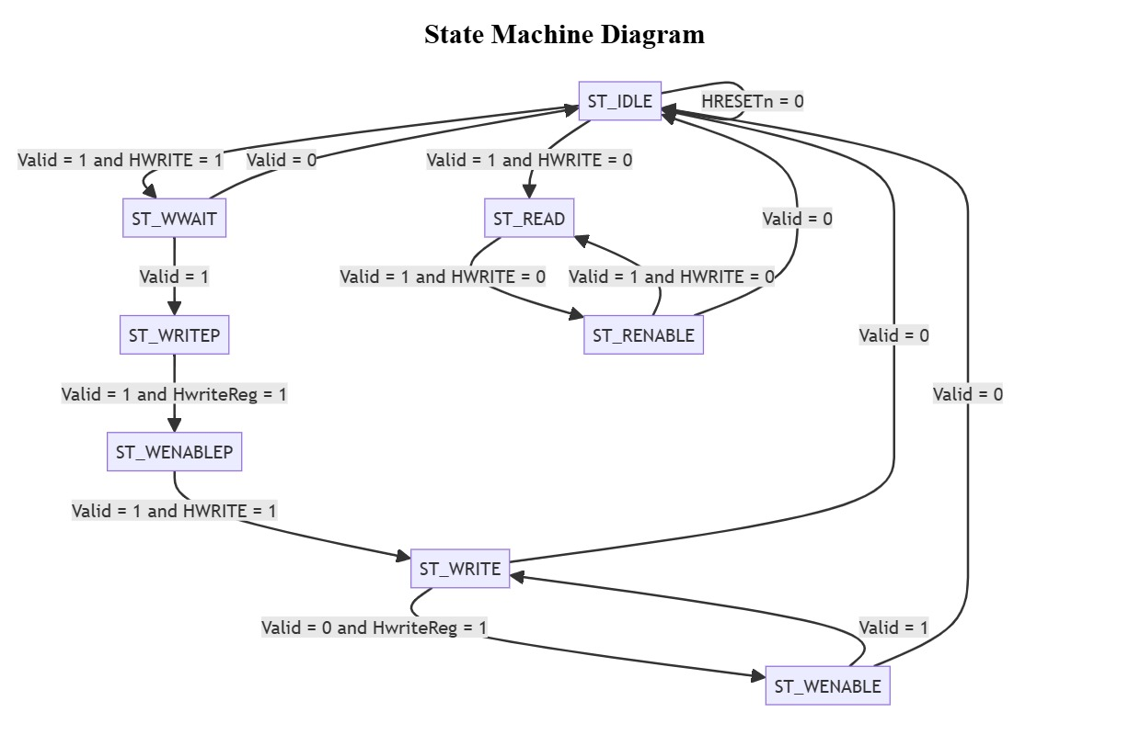

FSM state diagram of APB controller

Required Tools

List of required software and hardware toolsets needed.

- The QuestaSim simulator will be utilized for simulation and coverage analysis. QuestaSim is a comprehensive tool that supports advanced verification methodologies and provides extensive debugging features. It supports both VHDL and Verilog languages, which makes it suitable for our project as we are using SystemVerilog for our design. QuestaSim will be used to run the simulations of our testbenches against the RTL design.
- SystemVerilog (SV) and SystemVerilog Assertions (SVA) will be used to develop the testbench. SystemVerilog is a hardware description and hardware verification language used to model, design, and verify electronic systems. It extends the Verilog hardware description language with powerful verification features. We will use SystemVerilog to write our testbenches due to its advanced verification capabilities, such as classes, randomization, and functional coverage, which will help us create robust and comprehensive tests for our design.

Risks and Dependencies

List all the critical threats or any known risks. List contingency and mitigation plans.
- Potential risks include design bugs and verification delays due to the initially tight schedule.
- Dependencies involve the availability of the QuestaSim simulator and its license.

Functions to be Verified.

Functions from specification and implementation

List of functions that will be verified. Description of each function
- Address Latching (to be verified):
The bridge latches the address and maintains its validity throughout the transfer, ensuring the correct address is used during the entire transfer process.
- Address Decoding and Peripheral Select (to be verified):
The bridge decodes the address and generates a corresponding peripheral select signal, ensuring that only one select signal is active at a time, which guarantees the correct peripheral is selected.
- Bus Handshake and Control Signal Retiming (to be verified):
The bridge manages the bus handshake and control signal retiming for the local peripheral bus, ensuring proper interface with both the AHB and APB.
- Data Transfer (to be verified):
The bridge facilitates data transfer between the AHB and APB, handling both read and write operations.
- Reset and Clock Signal Handling (to be verified):
The bridge manages reset and clock signals, ensuring it functions correctly within the broader system context.
- Error Handling (to be verified):
The bridge must detect and properly respond to any errors that arise during the transfer process.
- Timing Parameters (to be verified):
The bridge must comply with the timing parameters outlined in the AMBA specification, covering both input and output signals.
- Support for Different Transfer Types (to be verified):
The bridge should accommodate various transfer types, including single and burst transfers.
- Support for Different Bus Masters (to be verified):
The bridge should correctly handle transfers initiated by different bus masters.
- Support for Different Peripheral Devices (to be verified):
The bridge should interface properly with a range of peripheral devices on the APB.
- System Debug (not to be verified):
The RTL code does not explicitly address system debugging. However, system debug functionality is typically integrated into the system design at a higher level.

List of critical functions and non-critical functions for tapeout
- Critical: System reset, data write, data read, and addressing are essential functions that must be correct before further verification can take place.
- Not verified at this level: System debugging is not explicitly defined in the RTL code and may not be verified at this stage.
- Secondary: After verifying the critical functions, additional checks can be carried out to ensure the system behaves properly under various conditions. This could involve testing the system's response to invalid data, incorrect addresses, and other error scenarios.

Tests and Methods

Testing methods to be used: Black/White/Gray Box.
- In the early stages, we will use black box verification, focusing on the system's inputs and outputs. This method is ideal for initial testing, where we aim to confirm that the system behaves as expected based on the provided inputs. We will also utilize assertions for sanity checks and to verify the transitions of the finite state machine.
- As we advance, we will shift to grey box verification. This hybrid method combines our understanding of the system's internal components, allowing us to gain deeper insights into how the AHB Master, AHB Slave Interface, APB FSM Controller, and APB Interface interact and contribute to the overall functionality of the AHB-APB bridge design.

Testbench Architecture; Component used (list and describe Drivers, Monitors, scoreboards, checkers etc.)

Component | Description
AHB Master | Generates AHB transactions to drive the bridge
AHB to APB Bridge | Converts AHB transactions to APB transactions
APB Slave | Emulates APB peripherals to receive transactions
Scoreboard | Compares expected vs actual transactions
Assertions | Ensure protocol rules are followed
Coverage Model | Monitors functional and code coverage
Future Milestones
Milestone-1

Verification Strategy: (Dynamic Simulation, Formal Simulation, Emulation etc.) Describe why you chose the strategy.
  - AHB_slave_interface: We will provide inputs like the AHB bus signals and verify outputs such as the valid signal and the tempselx logic. Additionally, we will check the pipelining of address, data, and control signals.
  - APB_FSM_Controller: We will supply inputs like the valid signal, Hwrite signal, and Hwritereg signal, and check the FSM state transitions. We will also verify the output signals that control the APB bus.
  - APB_Interface: We will apply inputs such as the Pwrite signal and the Penable signal, and verify outputs like the Prdata signal and the Pready signal.
  - Bridge_Top: We will drive inputs to both the AHB_slave_interface and the APB_FSM_Controller, and check the outputs from these modules to ensure proper interaction.
  - We will design our testbench in a modular fashion, enabling the reuse of test sequences and scenarios. This approach will allow us to efficiently test different components and levels of the design.

What is your driving methodology?
  - Deterministic: This approach works well for small, simple, and straightforward designs under verification (DUV). However, due to the complexity of our design, relying solely on a deterministic approach may not be sufficient.
  - Random: Random testing can reveal unexpected issues, but excessive random testing might miss problems due to a lack of focus, and insufficient random testing might result in inadequate coverage. We will use constrained random testing, which allows us to control the injection of sequences into the random environment. This method is particularly well-suited for our design, as it involves numerous permutations.
  - Formal Verification: Formal verification is ideal for designs with many permutations, using mathematical techniques to prove correctness under all possible conditions. However, it demands significant resources and expertise. Given our current resources and timeline, we will focus on simulation-based verification (both black box and grey box) for now, but may consider formal verification for critical parts of the design if needed.

What will be your checking methodology?

- Based on box, stimulus strategy, abstraction level: Our verification strategy will follow the grey box verification approach, using a constrained random stimulus strategy and considering the abstraction level of intent/context. This means we will evaluate both the external behavior of the system (inputs and outputs) and certain internal aspects, with a range of test scenarios generated through constrained random stimulus.
- Check all outputs: We will verify all system outputs to ensure they function as expected for the given inputs. This includes checking FSM state transitions, data read from the system, and signals controlling the APB bus.
- Design context vs microarchitecture vs architecture checking: Our checks will focus on the design context and microarchitecture levels, as we are primarily concerned with the behavior and functionality of the AHB-APB bridge and its components. We will verify that the design performs as intended in its context and that the microarchitecture operates correctly.
- Style: golden vector, reference model, transaction-based: Given our schedule, resource constraints, and access to the RTL Design and the ARM bridge documentation/user manual, the most feasible approach will be using a Transaction-Based Reference Model. Here's why:
- Transaction-Based Reference Model: This method aligns well with our available resources. We can define various transactions (e.g., read, write, reset) based on the ARM documentation and verify that the system behaves correctly for each. This approach is especially suitable for our grey box testing, where we have some visibility into the internal design.

Coverage Requirements

Describe Code and Functional Coverage goals for the DUV

The target is to cover all functional stimulus requirements and to ensure the design has reached interesting points as well as corner cases. Coverage will be measured using code coverage tool in Questasim to ensure all lines of code and branches have been executed. We will also implement a transaction model checking and coverage to make sure we covered all the interesting bus transactions.

Formulate conditions of how you will achieve the goals. Explain the Covergroups and Coverpoints and your selection of bins.
TBD

Assertions

Describe the assertions that you are planning to use and how it will help you improve the overall coverage and functional aspects of the design.
TBD

Resources requirements

Team members and who is doing what and expertise.

Milestone -1:

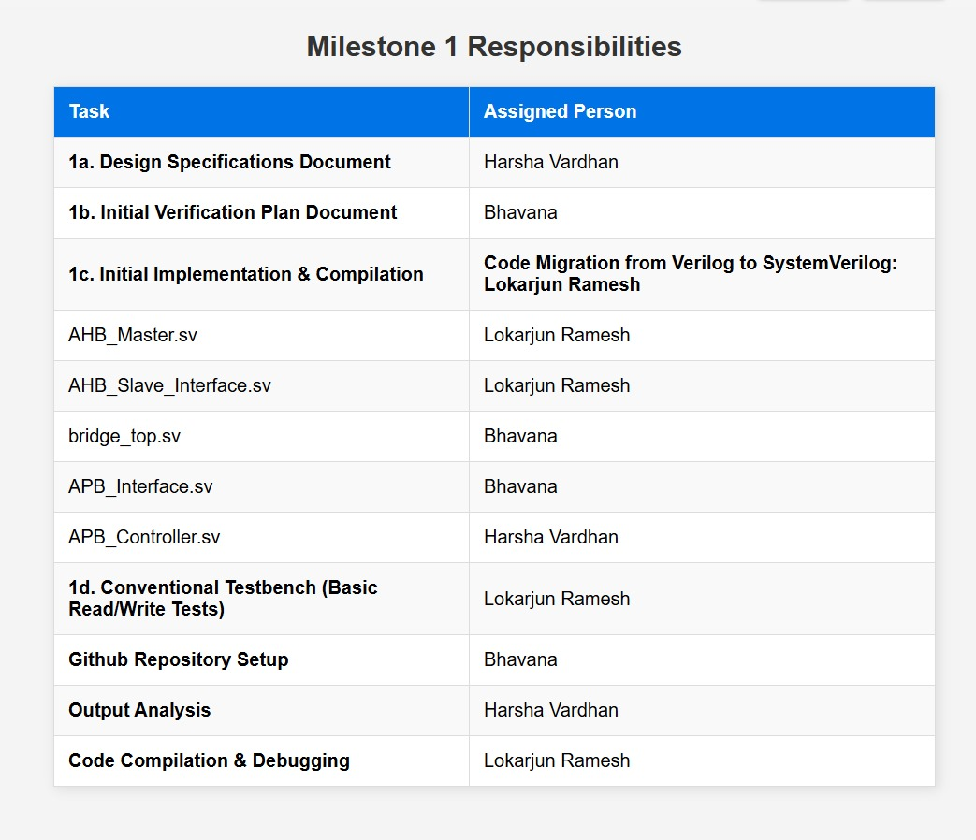

Schedule

Create a table with a plan of completion. You can use milestones as a guide to fill this.
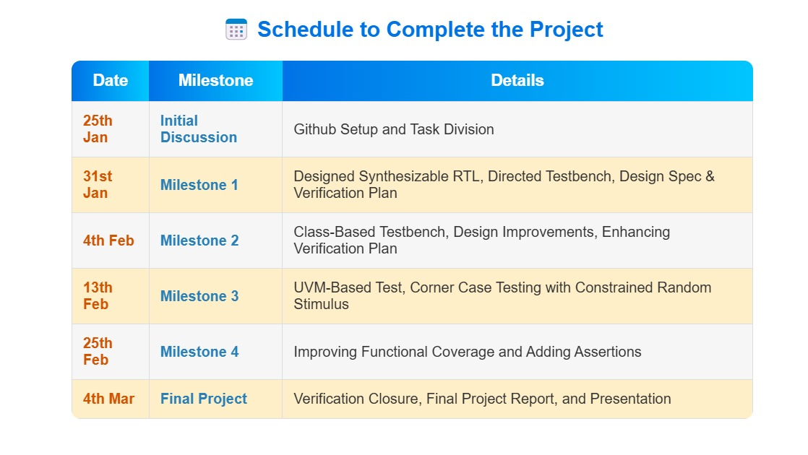

References Uses / Citations/Acknowledgements

The resources include:
- Two graduate students work.
- computing resources.
- and software licenses.

