VERIFICATION TEST PLAN

ECE-593: Fundamentals of Pre-Silicon Validation
Maseeh College of Engineering and Computer Science
Winter, 2025

Project Name: AHB to APB Bridge
Members:
Bhavana Manikyanahalli Srinivasegowda
Harsha Vardhan Duvvuru
Lokarjun Ramesh
Date: 01/31/2025

Github Link: https://github.com/BhavanaSrinivasegowda/team8_AHB2APB

Table of Contents
2 Introduction: 4
2.1 Objective of the verification plan 4
2.2 Top Level block diagram 4
2.3 Specifications for the design 5
3 Verification Requirements 5
3.1 Verification Levels 5
3.1.1 What hierarchy level are you verifying and why? 5
3.1.2 How is the controllability and observability at the level you are verifying? 6
3.1.3 Are the interfaces and specifications clearly defined at the level you are verifying. List them. 6
4 Required Tools 7
4.1 List of required software and hardware toolsets needed. 7
5 Risks and Dependencies 7
5.1 List all the critical threats or any known risks. List contingency and mitigation plans. 7
6 Functions to be Verified. 8
6.1 Functions from specification and implementation 8
6.1.1 List of functions that will be verified. Description of each function 8
6.1.2 List of critical functions and non-critical functions for tapeout 9
7 Tests and Methods 9
7.1.1 Testing methods to be used: Black/White/Gray Box. 9
7.1.2 Testbench Architecture; Component used (list and describe Drivers, Monitors, scoreboards, checkers etc.) 9
7.1.3 Verification Strategy: (Dynamic Simulation, Formal Simulation, Emulation etc.) Describe why you chose the strategy. 12
7.1.4 What is your driving methodology? 12
7.1.5 What will be your checking methodology? 12
7.1.6 Testcase Scenarios (Matrix) 13
7.1.7 Coverage requirements 14
8 Coverage Requirements 15
8.1.2 Assertions 16
9 Resources requirements 16
9.1 Team members and who is doing what and expertise. 16
10 Schedule 17
10.1 Create a table with a plan of completion. You can use milestones as a guide to fill this. 17
11 References Uses / Citations/Acknowledgements 18

Introduction:

The AHBtoAPB Bridge is an AHB slave, providing an interface between the high-speed AHB and low-power APB. Read and write transfers on the AHB are converted into equivalent transfers on the APB. As the APB is not pipelined, then wait states are added during transfers to and from the APB when the AHB is required to wait for the APB.
The bridge unit converts system bus transfers into APB transfers and performs the following functions:
- Latches the address and holds it valid throughout the transfer.
- Decodes the address and generates a peripheral select, PSELx. Only one select signal can be active during a transfer.
- Drives the data onto the APB for a write transfer.
- Drives the APB data onto the system bus for a read transfer.
- Generates a timing strobe, PENABLE, for the transfer.

Objective of the verification plan

- Verify correct AHB-to-APB protocol conversion.
- Ensure data integrity across the bridge.
- Validate read and write transactions.
- Ensure APB timing constraints are met.
- Validate throughput and performance metrics.

Top Level block diagram
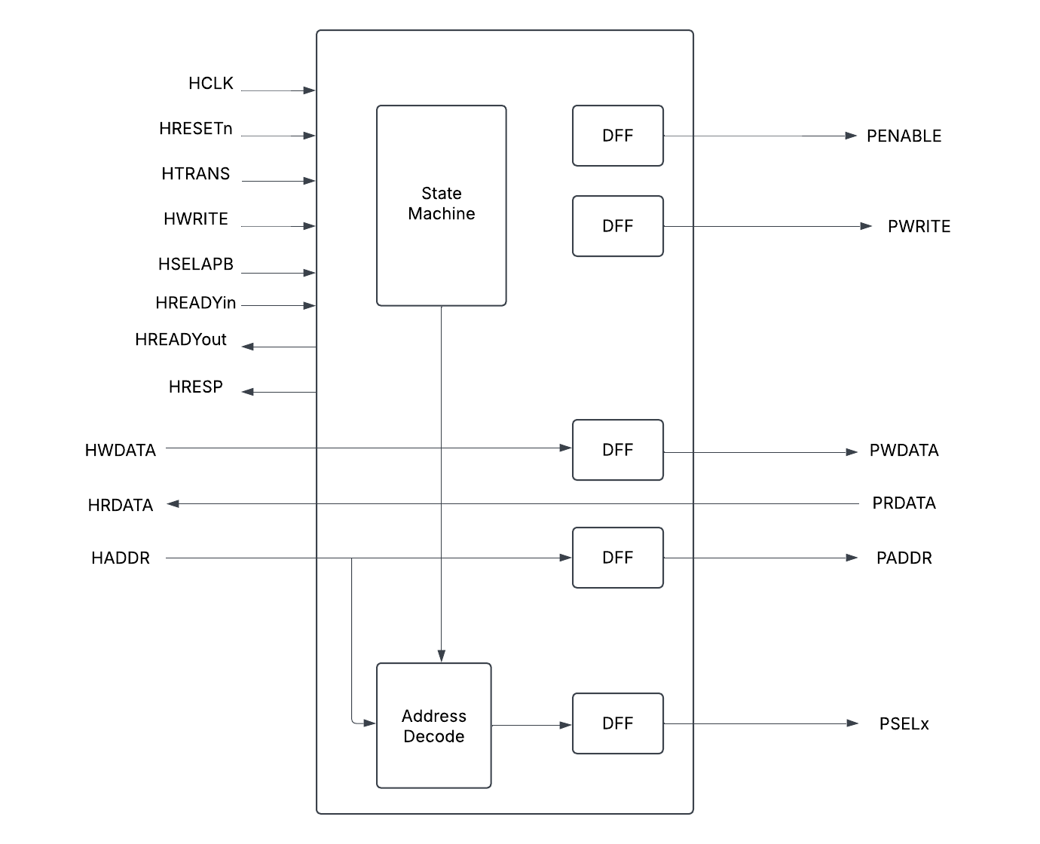

The above diagram shows the top-level model of AHB to APB bridge. In our design, we are not focusing much on the state machine, address decode and DFF. More prominence is given to the input and output signals, AHB – APB interface.

Specifications for the design

Specifications to be implemented in milestone-1:
Feature | Description
AHB Interface | Supports AHB-lite/AHB protocol for master-side communication
APB Interface | Generates APB transactions with correct timing and control
Write transactions | Ensure data is correctly written from AHB-APB
Read transactions | Ensure data is correctly read from APB_AHB
Reset Handling | Ensure bridge recovers correctly after rest

Specifications to be implemented in future milestones:
Feature | Description
Binary Encoding | Ensure binary encoding instead of one-hot encoding
Slave | Implement 4 slaves

Verification Requirements

Verification Levels

Verification will be performed at two levels: block (module) level and top level.
- At the block level, each individual component/module—AHB Master, AHB Slave Interface, APB Controller, and APB Interface—will undergo verification separately.
- At the top level, the complete AHB-APB Bridge will be verified as an integrated system.

What hierarchy level are you verifying and why?
- The AHB to APB Bridge is the hierarchy level that is being verified.
- The top-level module combines all sub-modules, such as the AHB slave interface and APB FSM controller, ensuring seamless integration and functionality.
- Verification at this stage allows us to test the complete AHB-to-APB bridge, checking signal flow, timing, and adherence to protocol specifications.
- It ensures correct interaction between the AHB and APB protocols while confirming that the bridge meets the overall system requirements.

How is the controllability and observability at the level you are verifying?
- At the AHB to APB bridge level, both controllability and observability are high because we can:
- Easily control different stimulus scenarios via the testbench components.
- Monitor and verify expected vs. actual results using monitors, scoreboards, coverage, and assertions.
This ensures thorough verification of the bridge’s functionality before integrating it into a larger SoC.

Are the interfaces and specifications clearly defined at the level you are verifying. List them.

  - AHB_slave_interface: This module handles the interface with the AHB bus. It implements pipeline logic for address, data, and control signals. It also generates valid logic and implements tempselx logic. The complexity of this module is moderate due to the pipelining and logic generation involved.
  - APB_FSM_Controller: This module is a finite state machine (FSM) that controls the APB bus. It has several states and transitions between them based on various conditions. The complexity of this module is high due to the FSM implementation.
  - APB_Interface: This module interfaces with the APB bus. It maps input signals to output signals and generates random data for read operations. The complexity of this module is low.
  - Bridge_Top: This module is the top-level module that instantiates the AHB_slave_interface and APB_FSM_Controller. The complexity of this module is low as it primarily serves as a structural component to connect the other modules.
  - The design has clean interfaces between the AHB bus, APB bus, and the bridge. Each module has clearly defined inputs and outputs, and the data flow between modules is well-structured.
  - The specification of the design is clear, with each module's functionality and interaction with other modules well-defined. The FSM in the APB_FSM_Controller is particularly well-specified, with clear states and transitions.

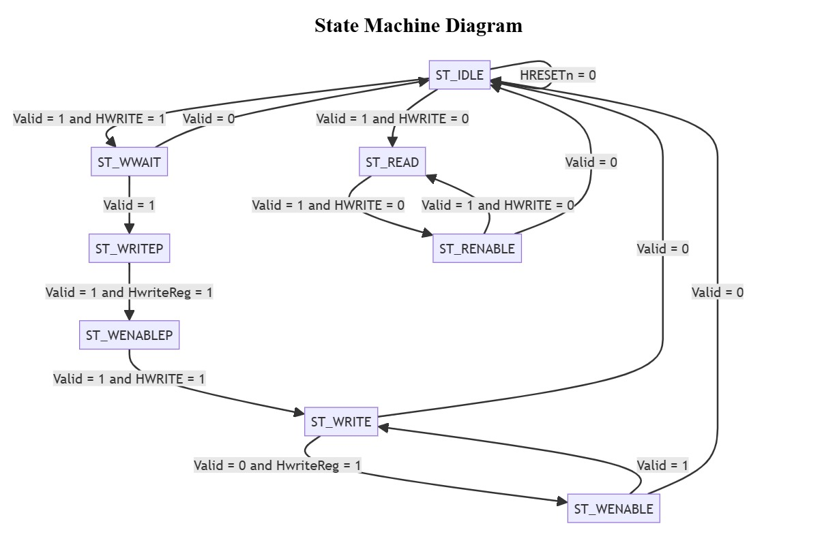

FSM state diagram of APB controller

Required Tools

List of required software and hardware toolsets needed.
- The QuestaSim simulator will be utilized for simulation and coverage analysis. QuestaSim is a comprehensive tool that supports advanced verification methodologies and provides extensive debugging features. It supports both VHDL and Verilog languages, which makes it suitable for our project as we are using SystemVerilog for our design. QuestaSim will be used to run the simulations of our testbenches against the RTL design.
- SystemVerilog (SV) and SystemVerilog Assertions (SVA) will be used to develop the testbench. SystemVerilog is a hardware description and hardware verification language used to model, design, and verify electronic systems. It extends the Verilog hardware description language with powerful verification features. We will use SystemVerilog to write our testbenches due to its advanced verification capabilities, such as classes, randomization, and functional coverage, which will help us create robust and comprehensive tests for our design.

Risks and Dependencies

List all the critical threats or any known risks. List contingency and mitigation plans.

- Risks: The main risks in our project include potential bugs in the design, delays in the verification process due to unforeseen complexities or difficulties, and the learning curve associated with using advanced verification methodologies and tools. We also have a very tight schedule. To mitigate these risks, we will use a systematic and thorough verification approach, start our work early, and seek help when needed.

- Dependencies: Our project depends on the availability of the QuestaSim simulator, the completion of the RTL design, and the availability of the ARM documentation for the AHB-APB bridge. We will need to coordinate with the design team to ensure that the design is completed on schedule and that any changes to the design are communicated to us promptly.

Functions to be Verified.

Functions from specification and implementation

List of functions that will be verified. Description of each function
- Address Latching (to be verified):
The bridge latches the address and maintains its validity throughout the transfer, ensuring the correct address is used during the entire transfer process.
- Address Decoding and Peripheral Select (to be verified):
The bridge decodes the address and generates a corresponding peripheral select signal, ensuring that only one select signal is active at a time, which guarantees the correct peripheral is selected.
- Bus Handshake and Control Signal Retiming (to be verified):
The bridge manages the bus handshake and control signal retiming for the local peripheral bus, ensuring proper interface with both the AHB and APB.
- Data Transfer (to be verified):
The bridge facilitates data transfer between the AHB and APB, handling both read and write operations.
- Reset and Clock Signal Handling (to be verified):
The bridge manages reset and clock signals, ensuring it functions correctly within the broader system context.
- Error Handling (to be verified):
The bridge must detect and properly respond to any errors that arise during the transfer process.
- Timing Parameters (to be verified):
The bridge must comply with the timing parameters outlined in the AMBA specification, covering both input and output signals.
- Support for Different Transfer Types (to be verified):
The bridge should accommodate various transfer types, including single and burst transfers.
- Support for Different Bus Masters (to be verified):
The bridge should correctly handle transfers initiated by different bus masters.
- Support for Different Peripheral Devices (to be verified):
The bridge should interface properly with a range of peripheral devices on the APB.
- System Debug (not to be verified):
The RTL code does not explicitly address system debugging. However, system debug functionality is typically integrated into the system design at a higher level.

List of critical functions and non-critical functions for tapeout
- Critical: System reset, data write, data read, and addressing are essential functions that must be correct before further verification can take place.
- Not verified at this level: System debugging is not explicitly defined in the RTL code and may not be verified at this stage.
- Secondary: After verifying the critical functions, additional checks can be carried out to ensure the system behaves properly under various conditions. This could involve testing the system's response to invalid data, incorrect addresses, and other error scenarios.

Tests and Methods

Testing methods to be used: Black/White/Gray Box.
- In the early stages, we will use black box verification, focusing on the system's inputs and outputs. This method is ideal for initial testing, where we aim to confirm that the system behaves as expected based on the provided inputs. We will also utilize assertions for sanity checks and to verify the transitions of the finite state machine.
- As we advance, we will shift to grey box verification. This hybrid method combines our understanding of the system's internal components, allowing us to gain deeper insights into how the AHB Master, AHB Slave Interface, APB FSM Controller, and APB Interface interact and contribute to the overall functionality of the AHB-APB bridge design.

Testbench Architecture; Component used (list and describe Drivers, Monitors, scoreboards, checkers etc.)

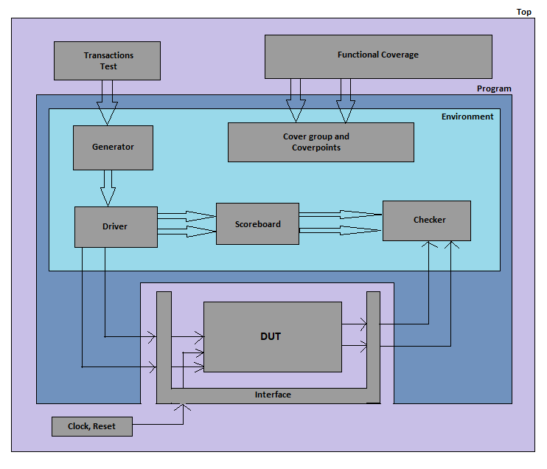

1. Transactions Test
- This block defines various test scenarios for verification.
- It generates different types of transactions to validate the bridge’s functionality.
2. Functional Coverage
- Collects coverage metrics to ensure all required scenarios are exercised.
- Uses cover groups and cover points to track transaction types, sizes, bursts, etc.
3. Generator
- Generates stimulus (AHB transactions) based on the test scenarios.
- Sends transactions to the Driver for execution.
4. Driver
- Converts the generated transactions into real AHB signals.
- Drives the interface signals to the DUT (Design Under Test).
5. Scoreboard
- Stores expected results and compares them with actual outputs.
- Ensures correctness by checking if the DUT behaves as expected.
6. Checker
- Monitors and validates data flow between AHB and APB.
- Detects errors in protocol transactions.
7. Cover Group and Cover Points
- Defines coverage metrics for functional verification.
- Ensures all operational conditions are tested.
8. DUT (Design Under Test)
- The actual AHB to APB Bridge that is being tested.
- Converts high-performance AHB transactions into low-power APB transactions.
9. Interface
- Defines the connection between the DUT and the testbench.
- Handles signals such as address, data, response, and control.
10. Clock and Reset
- Provides clock and reset signals to synchronize the testbench and DUT.
Milestone-2
Milestone-1
Component | Description
AHB Master | Generates AHB transactions to drive the bridge
AHB to APB Bridge | Converts AHB transactions to APB transactions
APB Slave | Emulates APB peripherals to receive transactions
Scoreboard | Compares expected vs actual transactions
Assertions | Ensure protocol rules are followed
Coverage Model | Monitors functional and code coverage

Verification Strategy: (Dynamic Simulation, Formal Simulation, Emulation etc.) Describe why you chose the strategy.
  - AHB_slave_interface: We will provide inputs like the AHB bus signals and verify outputs such as the valid signal and the tempselx logic. Additionally, we will check the pipelining of address, data, and control signals.
  - APB_FSM_Controller: We will supply inputs like the valid signal, Hwrite signal, and Hwritereg signal, and check the FSM state transitions. We will also verify the output signals that control the APB bus.
  - APB_Interface: We will apply inputs such as the Pwrite signal and the Penable signal, and verify outputs like the Prdata signal and the Pready signal.
  - Bridge_Top: We will drive inputs to both the AHB_slave_interface and the APB_FSM_Controller, and check the outputs from these modules to ensure proper interaction.
  - We will design our testbench in a modular fashion, enabling the reuse of test sequences and scenarios. This approach will allow us to efficiently test different components and levels of the design.

What is your driving methodology?
  - Deterministic: This approach works well for small, simple, and straightforward designs under verification (DUV). However, due to the complexity of our design, relying solely on a deterministic approach may not be sufficient.
  - Random: Random testing can reveal unexpected issues, but excessive random testing might miss problems due to a lack of focus, and insufficient random testing might result in inadequate coverage. We will use constrained random testing, which allows us to control the injection of sequences into the random environment. This method is particularly well-suited for our design, as it involves numerous permutations.
  - Formal Verification: Formal verification is ideal for designs with many permutations, using mathematical techniques to prove correctness under all possible conditions. However, it demands significant resources and expertise. Given our current resources and timeline, we will focus on simulation-based verification (both black box and grey box) for now, but may consider formal verification for critical parts of the design if needed.

What will be your checking methodology?

- Based on box, stimulus strategy, abstraction level: Our verification strategy will follow the grey box verification approach, using a constrained random stimulus strategy and considering the abstraction level of intent/context. This means we will evaluate both the external behavior of the system (inputs and outputs) and certain internal aspects, with a range of test scenarios generated through constrained random stimulus.
- Check all outputs: We will verify all system outputs to ensure they function as expected for the given inputs. This includes checking FSM state transitions, data read from the system, and signals controlling the APB bus.
- Design context vs microarchitecture vs architecture checking: Our checks will focus on the design context and microarchitecture levels, as we are primarily concerned with the behavior and functionality of the AHB-APB bridge and its components. We will verify that the design performs as intended in its context and that the microarchitecture operates correctly.
- Style: golden vector, reference model, transaction-based: Given our schedule, resource constraints, and access to the RTL Design and the ARM bridge documentation/user manual, the most feasible approach will be using a Transaction-Based Reference Model. Here's why:
- Transaction-Based Reference Model: This method aligns well with our available resources. We can define various transactions (e.g., read, write, reset) based on the ARM documentation and verify that the system behaves correctly for each. This approach is especially suitable for our grey box testing, where we have some visibility into the internal design.

Testcase Scenarios (Matrix)

- a. Defining Each Test:
- Each test will have a label, a description, and a targeted feature. For instance, a test could be labeled "Read Operation Test", described as "This test verifies the functionality of read operations", and specifically target the read operation feature of the AHB-APB bridge.
- Tests will be mapped to functional requirements and coverage goals, ensuring that every requirement and verification objective is addressed.
- b. Grouping Tests into Scenarios:
- Tests with similar verification objectives will be categorized into scenarios. For example, all tests related to read operations will be grouped into a "Read Operations Scenario."
- Each scenario will be defined by:
  - Configuration: The system setup for the scenario.
  - Granularity: The level of detail in the tests.
  - Strategy: The approach used to verify the targeted features.
- c. Incremental Test Development:
- The testing process will begin with a fundamental set of tests covering key features of the AHB-APB bridge, such as basic read and write operations.
- Additional tests will be gradually introduced to extend coverage across more features and scenarios, enabling both rapid test deployment and thorough verification.
- d. Randomized Coverage-Based Matrix:
- A randomized coverage-based matrix will guide test development by defining constraints, configurations, data variations, key attributes, critical sequences, error conditions, and boundary cases.
- For example, the matrix may specify:
  - Constraining the Hwrite signal to values 0 or 1.
  - Testing various AHB-APB bridge states.
  - Validating both small and large data values.
  - Running sequences of read and write operations.
  - Checking invalid command handling.
  - Evaluating edge-case scenarios where the bridge operates at its performance limits.

HTRANS | HSIZE | HBURST | OPERATION | Description | Inputs | Expected  Outputs | Functions Being Tested
NONSEQ | Byte | Single | Read | Single byte read | HADDR, HWDATA | PRDATA, HREADY | Read Operation
NONSEQ | Halfword | Single | Write | Single halfword write | HADDR, HWDATA | HREADY | Write Operation
NONSEQ | Word | Single | Read | Single word read | HADDR, HWDATA | PRDATA, HREADY | Read Operation
NONSEQ | Byte | Single | Write | Single byte write operation with error | HADDR, HWDATA | HREADY, HRESP = Error | Write Operation with Error
NONSEQ | Halfword | Incrementing Burst | Read | Incrementing burst read with halfword size | HADDR, HWDATA | PRDATA, HREADY | Read Operation with Burst
NONSEQ | Word | Incrementing Burst | Write | Incrementing burst write operation with word size | HADDR, HWDATA | HREADY | Write Operation with Burst

Coverage requirements

1. Feedback and Quality Control Mechanism:
- To assess and enhance verification quality, we will utilize coverage metrics, including:
- Functional Coverage: Measures how much of the design's functionality has been tested.
- Code Coverage: Evaluates how much of the design’s code has been exercised.
- Assertion Coverage: Tracks how many assertions have been validated or invalidated.
- These metrics will help identify untested areas in the design, guiding test development for better coverage.
2. Ensuring Coverage of All Functional Stimuli:
- Our goal is to verify that all functional requirements are met by covering:
- All Command Types: Testing every command the AHB-APB bridge supports, such as read and write operations.
- Diverse Data Types and Ranges: Validating different data sizes and patterns to ensure the bridge handles all variations correctly.
- Concurrent Stimulus Handling: Evaluating scenarios where multiple commands are issued simultaneously.
- Error Scenarios: Introducing erroneous conditions from initiators or responders to verify the bridge’s behavior under invalid inputs or incorrect responses.
3. Ensuring Coverage of Key Design Aspects:
- To confirm that the design has reached critical operational points, tests will address:
- Design Architecture and States: Covering all states and operational modes of the AHB-APB bridge, including the APB_FSM_Controller.
- Functional Sequences: Testing different sequences of operations, including read/write patterns, state transitions, and mode shifts.
- All Output Variations: Ensuring that every possible output state and signal value is accounted for.
4. Coverage Feedback for Validation Environment:
- Beyond design verification, we will also assess coverage within the validation environment, including:
- Test Sequence Coverage: Evaluating how thoroughly the predefined test sequences have been executed.
- Assertion Coverage: Measuring the effectiveness of assertions in detecting issues.

Coverage Requirements

Describe Code and Functional Coverage goals for the DUV

The target is to cover all functional stimulus requirements and to ensure the design has reached interesting points as well as corner cases. Coverage will be measured using code coverage tool in Questasim to ensure all lines of code and branches have been executed. We will also implement a transaction model checking and coverage to make sure we covered all the interesting bus transactions.

Formulate conditions of how you will achieve the goals. Explain the Covergroups and Coverpoints and your selection of bins.
- The code defines the coverage_collector class, which is responsible for gathering and analyzing coverage data in an AHB APB Bridge Verification environment. This class receives transactions through a mailbox (driv2cor) from the driver and utilizes a virtual interface (vif) to interact with the design under verification (DUV). A covergroup (cov_cg) is used to define coverage points based on different transaction properties such as trans_type, Htrans, Hsize, and Hburst, along with their cross-coverage points. The execute task runs indefinitely, fetching transactions from the mailbox and displaying their details. Although the sample_coverage and print_coverage functions are defined to sample and report coverage, they are currently commented out in the provided code.

- The Transaction class, which represents a transaction within the AHB APB bridge system. This class includes various randomized transaction fields, such as Haddr, Hwdata, Htrans, Hsize, Hburst, Paddr, Pwdata, and control signals. It also defines constraints to ensure valid transaction values, like limiting Hsize and Hburst to specific values. A covergroup (cov_cg) within the class monitors key transaction properties, including Hwrite, Htrans, Hsize, and Hburst, and their cross-coverage points. The update_trans_type function sets the transaction type based on the Hwrite signal and samples coverage, while the print_transaction function prints the transaction details for debugging and verification. This class serves as the fundamental data structure for transactions in the verification environment.

Assertions

Describe the assertions that you are planning to use and how it will help you improve the overall coverage and functional aspects of the design.
- The assertions in scoreboard.sv ensure the correctness of data write and read operations in the AHB APB Bridge verification. The first assertion in the data_write() task checks if the data written by the driver (tx1.Hwdata) is correctly stored in the scoreboard’s memory model (mem_tb[temp_addr]). If the data is not stored properly, an error is flagged, ensuring functional accuracy and preventing memory corruption. Similarly, the second assertion in data_read() verifies whether the data read from the DUT (tx2.Prdata) matches the expected data stored in the scoreboard’s memory. If there is a mismatch, it indicates a failure in the read operation, allowing immediate debugging. These assertions significantly enhance coverage and functional verification by ensuring data integrity, detecting corruption, and identifying gaps in test scenarios. They also improve verification efficiency by providing immediate failure detection, reducing debugging time, and ensuring that different transaction scenarios are validated.
Ultimately, these assertions play a crucial role in verifying the DUT’s behavior, ensuring that it meets functional requirements, and improving the robustness of the AHB APB Bridge verification environment.

Resources requirements

Team members and who is doing what and expertise.

Milestone -2:
Task No. | Task Description | Status | Team member
1 | Full complete working of RTL | Completed | All
2 | Complete the class-based verification environment (Transaction, Generator, Driver, Monitors, Scoreboard, and Coverage) | Completed | Harsh Vardhan and Lokarjun
3 | Include both code-coverage and functional coverage reports | Completed | Harsh vardhan
4 | Update Verification Plan with detailed test cases if new ones are added | Completed | Bhavana
5 | Transcript requirement: Ensure testbench components print transaction flow | Completed | Harsh Vardhan and Lokarjun

Schedule

Create a table with a plan of completion. You can use milestones as a guide to fill this.

Date | Milestone | Details
25th Jan | Initial Discussion | GitHub Setup and Task Division
31st Jan | Milestone 1 | Designed Synthesizable RTL, Directed Testbench, Design Spec & Verification Plan
18th Feb | Milestone 2 | Class-Based Testbench, Design Improvements, Enhancing Verification Plan
TBD | Milestone 3 | UVM-Based Test, Corner Case Testing with Constrained Random Stimulus
TBD | Milestone 4 | Improving Functional Coverage and Adding Assertions
TBD | Final Project | Verification Closure, Final Project Report, and Presentation

References Uses / Citations/Acknowledgements

The resources include:
- Two graduate students work.
- computing resources.
- and software licenses.

