VERIFICATION TEST PLAN

ECE-593: Fundamentals of Pre-Silicon Validation
Maseeh College of Engineering and Computer Science
Winter, 2025

Project Name: AHB to APB Bridge
Members:
Bhavana Manikyanahalli Srinivasegowda
Harsha Vardhan Duvvuru
Lokarjun Ramesh
Date: 01/31/2025

Github Link: https://github.com/BhavanaSrinivasegowda/team8_AHB2APB

Table of Contents
2 Introduction: 4
2.1 Objective of the verification plan 4
2.2 Top Level block diagram 4
2.3 Specifications for the design 5
3 Verification Requirements 5
3.1 Verification Levels 5
3.1.1 What hierarchy level are you verifying and why? 5
3.1.2 How is the controllability and observability at the level you are verifying? 6
3.1.3 Are the interfaces and specifications clearly defined at the level you are verifying. List them. 6
4 Required Tools 7
4.1 List of required software and hardware toolsets needed. 7
5 Risks and Dependencies 7
5.1 List all the critical threats or any known risks. List contingency and mitigation plans. 7
6 Functions to be Verified. 8
6.1 Functions from specification and implementation 8
6.1.1 List of functions that will be verified. Description of each function 8
6.1.2 List of critical functions and non-critical functions for tapeout 9
7 Tests and Methods 9
7.1.1 Testing methods to be used: Black/White/Gray Box. 9
7.1.2 Testbench Architecture; Component used (list and describe Drivers, Monitors, scoreboards, checkers etc.) 9
7.1.3 Verification Strategy: (Dynamic Simulation, Formal Simulation, Emulation etc.) Describe why you chose the strategy. 12
7.1.4 What is your driving methodology? 12
7.1.5 What will be your checking methodology? 12
7.1.6 Testcase Scenarios (Matrix) 13
7.1.7 Coverage requirements 14
8 UVM Testbench 15
8.1.1 Testbench Components 15
8.1.2 Testbench Description 16
9 Coverage Requirements 27
9.1.2 Assertions 28
10 Resources requirements 28
10.1 Team members and who is doing what and expertise. 28
11 Schedule 29
11.1 Create a table with a plan of completion. You can use milestones as a guide to fill this. 29
12 References Uses / Citations/Acknowledgements 29

Introduction:

The AHBtoAPB Bridge is an AHB slave, providing an interface between the high-speed AHB and low-power APB. Read and write transfers on the AHB are converted into equivalent transfers on the APB. As the APB is not pipelined, then wait states are added during transfers to and from the APB when the AHB is required to wait for the APB.
The bridge unit converts system bus transfers into APB transfers and performs the following functions:
- Latches the address and holds it valid throughout the transfer.
- Decodes the address and generates a peripheral select, PSELx. Only one select signal can be active during a transfer.
- Drives the data onto the APB for a write transfer.
- Drives the APB data onto the system bus for a read transfer.
- Generates a timing strobe, PENABLE, for the transfer.

Objective of the verification plan

- Verify correct AHB-to-APB protocol conversion.
- Ensure data integrity across the bridge.
- Validate read and write transactions.
- Ensure APB timing constraints are met.
- Validate throughput and performance metrics.

Top Level block diagram
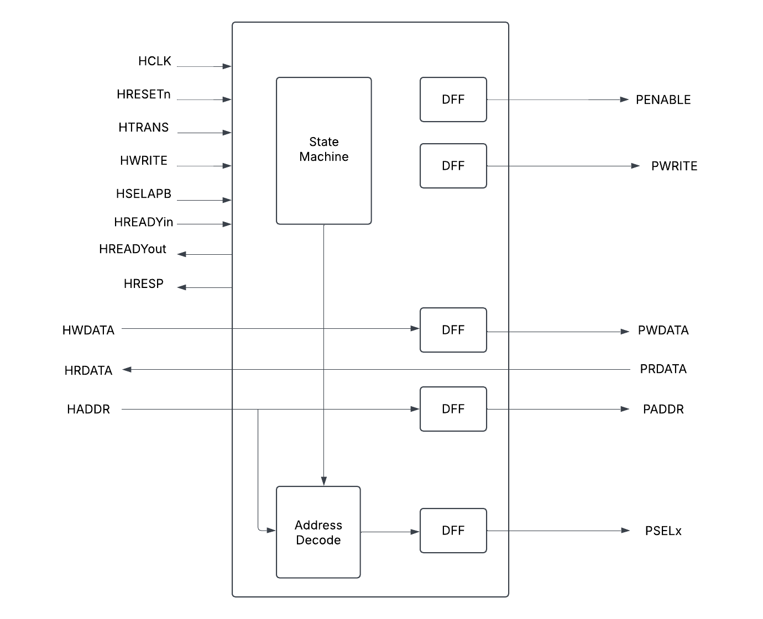

Fig-1: Top Level Block Diagram
The above diagram shows the top-level model of AHB to APB bridge. In our design, we are not focusing much on the state machine, address decode and DFF. More prominence is given to the input and output signals, AHB – APB interface.

Specifications for the design

Specifications to be implemented in milestone-1:
Feature | Description
AHB Interface | Supports AHB-lite/AHB protocol for master-side communication
APB Interface | Generates APB transactions with correct timing and control
Write transactions | Ensure data is correctly written from AHB-APB
Read transactions | Ensure data is correctly read from APB_AHB
Reset Handling | Ensure bridge recovers correctly after rest

Specifications to be implemented in future milestones:
Feature | Description
Binary Encoding | Ensure binary encoding instead of one-hot encoding
Slave | Implement 4 slaves

Verification Requirements

Verification Levels

Verification will be performed at two levels: block (module) level and top level.
- At the block level, each individual component/module—AHB Master, AHB Slave Interface, APB Controller, and APB Interface—will undergo verification separately.
- At the top level, the complete AHB-APB Bridge will be verified as an integrated system.

What hierarchy level are you verifying and why?
- The AHB to APB Bridge is the hierarchy level that is being verified.
- The top-level module combines all sub-modules, such as the AHB slave interface and APB FSM controller, ensuring seamless integration and functionality.
- Verification at this stage allows us to test the complete AHB-to-APB bridge, checking signal flow, timing, and adherence to protocol specifications.
- It ensures correct interaction between the AHB and APB protocols while confirming that the bridge meets the overall system requirements.

How is the controllability and observability at the level you are verifying?
- At the AHB to APB bridge level, both controllability and observability are high because we can:
- Easily control different stimulus scenarios via the testbench components.
- Monitor and verify expected vs. actual results using monitors, scoreboards, coverage, and assertions.
This ensures thorough verification of the bridge’s functionality before integrating it into a larger SoC.

Are the interfaces and specifications clearly defined at the level you are verifying. List them.

  - AHB_slave_interface: This module handles the interface with the AHB bus. It implements pipeline logic for address, data, and control signals. It also generates valid logic and implements tempselx logic. The complexity of this module is moderate due to the pipelining and logic generation involved.
  - APB_FSM_Controller: This module is a finite state machine (FSM) that controls the APB bus. It has several states and transitions between them based on various conditions. The complexity of this module is high due to the FSM implementation.
  - APB_Interface: This module interfaces with the APB bus. It maps input signals to output signals and generates random data for read operations. The complexity of this module is low.
  - Bridge_Top: This module is the top-level module that instantiates the AHB_slave_interface and APB_FSM_Controller. The complexity of this module is low as it primarily serves as a structural component to connect the other modules.
  - The design has clean interfaces between the AHB bus, APB bus, and the bridge. Each module has clearly defined inputs and outputs, and the data flow between modules is well-structured.
  - The specification of the design is clear, with each module's functionality and interaction with other modules well-defined. The FSM in the APB_FSM_Controller is particularly well-specified, with clear states and transitions.

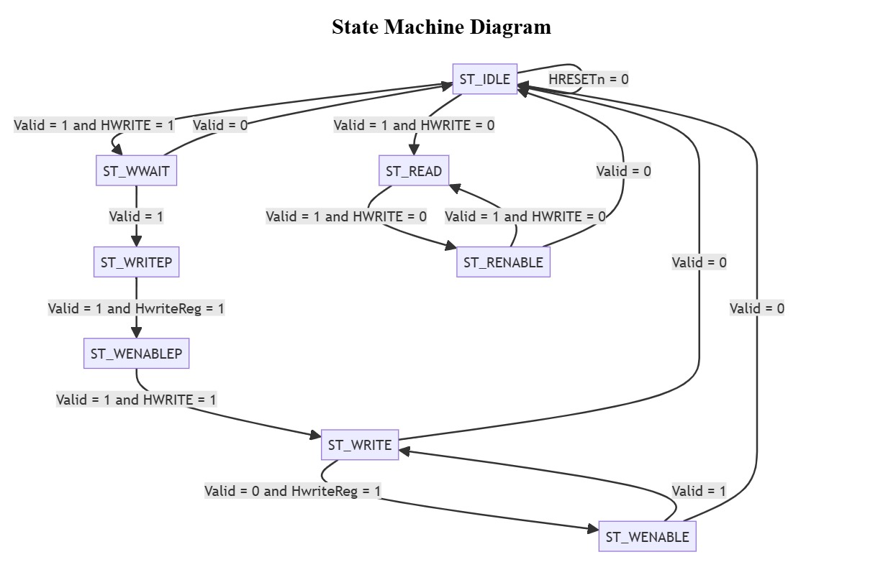

Fig-2: FSM state diagram of APB controller

Required Tools

List of required software and hardware toolsets needed.
- The QuestaSim simulator will be utilized for simulation and coverage analysis. QuestaSim is a comprehensive tool that supports advanced verification methodologies and provides extensive debugging features. It supports both VHDL and Verilog languages, which makes it suitable for our project as we are using SystemVerilog for our design. QuestaSim will be used to run the simulations of our testbenches against the RTL design.
- SystemVerilog (SV) and SystemVerilog Assertions (SVA) will be used to develop the testbench. SystemVerilog is a hardware description and hardware verification language used to model, design, and verify electronic systems. It extends the Verilog hardware description language with powerful verification features. We will use SystemVerilog to write our testbenches due to its advanced verification capabilities, such as classes, randomization, and functional coverage, which will help us create robust and comprehensive tests for our design.

Risks and Dependencies

List all the critical threats or any known risks. List contingency and mitigation plans.

- Risks: The main risks in our project include potential bugs in the design, delays in the verification process due to unforeseen complexities or difficulties, and the learning curve associated with using advanced verification methodologies and tools. We also have a very tight schedule. To mitigate these risks, we will use a systematic and thorough verification approach, start our work early, and seek help when needed.

- Dependencies: Our project depends on the availability of the QuestaSim simulator, the completion of the RTL design, and the availability of the ARM documentation for the AHB-APB bridge. We will need to coordinate with the design team to ensure that the design is completed on schedule and that any changes to the design are communicated to us promptly.

Functions to be Verified.

Functions from specification and implementation

List of functions that will be verified. Description of each function
- Address Latching (to be verified):
The bridge latches the address and maintains its validity throughout the transfer, ensuring the correct address is used during the entire transfer process.
- Address Decoding and Peripheral Select (to be verified):
The bridge decodes the address and generates a corresponding peripheral select signal, ensuring that only one select signal is active at a time, which guarantees the correct peripheral is selected.
- Bus Handshake and Control Signal Retiming (to be verified):
The bridge manages the bus handshake and control signal retiming for the local peripheral bus, ensuring proper interface with both the AHB and APB.
- Data Transfer (to be verified):
The bridge facilitates data transfer between the AHB and APB, handling both read and write operations.
- Reset and Clock Signal Handling (to be verified):
The bridge manages reset and clock signals, ensuring it functions correctly within the broader system context.
- Error Handling (to be verified):
The bridge must detect and properly respond to any errors that arise during the transfer process.
- Timing Parameters (to be verified):
The bridge must comply with the timing parameters outlined in the AMBA specification, covering both input and output signals.
- Support for Different Transfer Types (to be verified):
The bridge should accommodate various transfer types, including single and burst transfers.
- Support for Different Bus Masters (to be verified):
The bridge should correctly handle transfers initiated by different bus masters.
- Support for Different Peripheral Devices (to be verified):
The bridge should interface properly with a range of peripheral devices on the APB.
- System Debug (not to be verified):
The RTL code does not explicitly address system debugging. However, system debug functionality is typically integrated into the system design at a higher level.

List of critical functions and non-critical functions for tapeout
- Critical: System reset, data write, data read, and addressing are essential functions that must be correct before further verification can take place.
- Not verified at this level: System debugging is not explicitly defined in the RTL code and may not be verified at this stage.
- Secondary: After verifying the critical functions, additional checks can be carried out to ensure the system behaves properly under various conditions. This could involve testing the system’s response to invalid data, incorrect addresses, and other error scenarios.

Tests and Methods

Testing methods to be used: Black/White/Gray Box.
- In the early stages, we will use black box verification, focusing on the system’s inputs and outputs. This method is ideal for initial testing, where we aim to confirm that the system behaves as expected based on the provided inputs. We will also utilize assertions for sanity checks and to verify the transitions of the finite state machine.
- As we advance, we will shift to grey box verification. This hybrid method combines our understanding of the system’s internal components, allowing us to gain deeper insights into how the AHB Master, AHB Slave Interface, APB FSM Controller, and APB Interface interact and contribute to the overall functionality of the AHB-APB bridge design.

Testbench Architecture; Component used (list and describe Drivers, Monitors, scoreboards, checkers etc.)

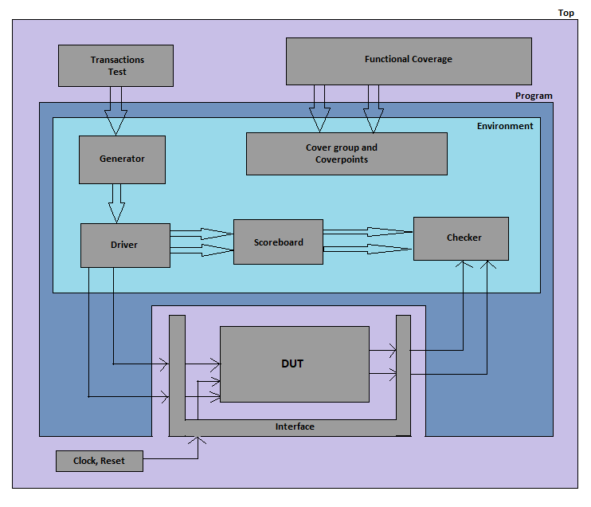

Fig-3: Testbench Architecture
- Transactions Test
- This block defines various test scenarios for verification.
- It generates different types of transactions to validate the bridge’s functionality.
2. Functional Coverage
- Collects coverage metrics to ensure all required scenarios are exercised.
- Uses cover groups and cover points to track transaction types, sizes, bursts, etc.
3. Generator
- Generates stimulus (AHB transactions) based on the test scenarios.
- Sends transactions to the Driver for execution.
4. Driver
- Converts the generated transactions into real AHB signals.
- Drives the interface signals to the DUT (Design Under Test).
5. Scoreboard
- Stores expected results and compares them with actual outputs.
- Ensures correctness by checking if the DUT behaves as expected.
6. Checker
- Monitors and validates data flow between AHB and APB.
- Detects errors in protocol transactions.
7. Cover Group and Cover Points
- Defines coverage metrics for functional verification.
- Ensures all operational conditions are tested.
8. DUT (Design Under Test)
- The actual AHB to APB Bridge that is being tested.
- Converts high-performance AHB transactions into low-power APB transactions.
9. Interface
- Defines the connection between the DUT and the testbench.
- Handles signals such as address, data, response, and control.
10. Clock and Reset
- Provides clock and reset signals to synchronize the testbench and DUT.

Verification Strategy: (Dynamic Simulation, Formal Simulation, Emulation etc.) Describe why you chose the strategy.
  - AHB_slave_interface: We will provide inputs like the AHB bus signals and verify outputs such as the valid signal and the tempselx logic. Additionally, we will check the pipelining of address, data, and control signals.
  - APB_FSM_Controller: We will supply inputs like the valid signal, Hwrite signal, and Hwritereg signal, and check the FSM state transitions. We will also verify the output signals that control the APB bus.
  - APB_Interface: We will apply inputs such as the Pwrite signal and the Penable signal, and verify outputs like the Prdata signal and the Pready signal.
  - Bridge_Top: We will drive inputs to both the AHB_slave_interface and the APB_FSM_Controller, and check the outputs from these modules to ensure proper interaction.
  - We will design our testbench in a modular fashion, enabling the reuse of test sequences and scenarios. This approach will allow us to efficiently test different components and levels of the design.

What is your driving methodology?
  - Deterministic: This approach works well for small, simple, and straightforward designs under verification (DUV). However, due to the complexity of our design, relying solely on a deterministic approach may not be sufficient.
  - Random: Random testing can reveal unexpected issues, but excessive random testing might miss problems due to a lack of focus, and insufficient random testing might result in inadequate coverage. We will use constrained random testing, which allows us to control the injection of sequences into the random environment. This method is particularly well-suited for our design, as it involves numerous permutations.
  - Formal Verification: Formal verification is ideal for designs with many permutations, using mathematical techniques to prove correctness under all possible conditions. However, it demands significant resources and expertise. Given our current resources and timeline, we will focus on simulation-based verification (both black box and grey box) for now, but may consider formal verification for critical parts of the design if needed.

What will be your checking methodology?

- Based on box, stimulus strategy, abstraction level: Our verification strategy will follow the grey box verification approach, using a constrained random stimulus strategy and considering the abstraction level of intent/context. This means we will evaluate both the external behavior of the system (inputs and outputs) and certain internal aspects, with a range of test scenarios generated through constrained random stimulus.
- Check all outputs: We will verify all system outputs to ensure they function as expected for the given inputs. This includes checking FSM state transitions, data read from the system, and signals controlling the APB bus.
- Design context vs microarchitecture vs architecture checking: Our checks will focus on the design context and microarchitecture levels, as we are primarily concerned with the behavior and functionality of the AHB-APB bridge and its components. We will verify that the design performs as intended in its context and that the microarchitecture operates correctly.
- Style: golden vector, reference model, transaction-based: Given our schedule, resource constraints, and access to the RTL Design and the ARM bridge documentation/user manual, the most feasible approach will be using a Transaction-Based Reference Model. Here’s why:
- Transaction-Based Reference Model: This method aligns well with our available resources. We can define various transactions (e.g., read, write, reset) based on the ARM documentation and verify that the system behaves correctly for each. This approach is especially suitable for our grey box testing, where we have some visibility into the internal design.

Testcase Scenarios (Matrix)

- a. Defining Each Test:
- Each test will have a label, a description, and a targeted feature. For instance, a test could be abelled “Read Operation Test”, described as “This test verifies the functionality of read operations”, and specifically target the read operation feature of the AHB-APB bridge.
- Tests will be mapped to functional requirements and coverage goals, ensuring that every requirement and verification objective is addressed.
- b. Grouping Tests into Scenarios:
- Tests with similar verification objectives will be categorized into scenarios. For example, all tests related to read operations will be grouped into a “Read Operations Scenario.”
- Each scenario will be defined by:
  - Configuration: The system setup for the scenario.
  - Granularity: The level of detail in the tests.
  - Strategy: The approach used to verify the targeted features.
- c. Incremental Test Development:
- The testing process will begin with a fundamental set of tests covering key features of the AHB-APB bridge, such as basic read and write operations.
- Additional tests will be gradually introduced to extend coverage across more features and scenarios, enabling both rapid test deployment and thorough verification.
- d. Randomized Coverage-Based Matrix:
- A randomized coverage-based matrix will guide test development by defining constraints, configurations, data variations, key attributes, critical sequences, error conditions, and boundary cases.
- For example, the matrix may specify:
  - Constraining the Hwrite signal to values 0 or 1.
  - Testing various AHB-APB bridge states.
  - Validating both small and large data values.
  - Running sequences of read and write operations.
  - Checking invalid command handling.
  - Evaluating edge-case scenarios where the bridge operates at its performance limits.

HTRANS | HSIZE | HBURST | OPERATION | Description | Inputs | Expected  Outputs | Functions Being Tested
NONSEQ | Byte | Single | Read | Single byte read | HADDR, HWDATA | PRDATA, HREADY | Read Operation
NONSEQ | Halfword | Single | Write | Single halfword write | HADDR, HWDATA | HREADY | Write Operation
NONSEQ | Word | Single | Read | Single word read | HADDR, HWDATA | PRDATA, HREADY | Read Operation
NONSEQ | Byte | Single | Write | Single byte write operation with error | HADDR, HWDATA | HREADY, HRESP = Error | Write Operation with Error
NONSEQ | Halfword | Incrementing Burst | Read | Incrementing burst read with halfword size | HADDR, HWDATA | PRDATA, HREADY | Read Operation with Burst
NONSEQ | Word | Incrementing Burst | Write | Incrementing burst write operation with word size | HADDR, HWDATA | HREADY | Write Operation with Burst

Coverage requirements

- Feedback and Quality Control Mechanism:
- To assess and enhance verification quality, we will utilize coverage metrics, including:
- Functional Coverage: Measures how much of the design’s functionality has been tested.
- Code Coverage: Evaluates how much of the design’s code has been exercised.
- Assertion Coverage: Tracks how many assertions have been validated or invalidated.
- These metrics will help identify untested areas in the design, guiding test development for better coverage.
- Ensuring Coverage of All Functional Stimuli:
- Our goal is to verify that all functional requirements are met by covering:
- All Command Types: Testing every command the AHB-APB bridge supports, such as read and write operations.
- Diverse Data Types and Ranges: Validating different data sizes and patterns to ensure the bridge handles all variations correctly.
- Concurrent Stimulus Handling: Evaluating scenarios where multiple commands are issued simultaneously.
- Error Scenarios: Introducing erroneous conditions from initiators or responders to verify the bridge’s behavior under invalid inputs or incorrect responses.
- Ensuring Coverage of Key Design Aspects:
- To confirm that the design has reached critical operational points, tests will address:
- Design Architecture and States: Covering all states and operational modes of the AHB-APB bridge, including the APB_FSM_Controller.
- Functional Sequences: Testing different sequences of operations, including read/write patterns, state transitions, and mode shifts.
- All Output Variations: Ensuring that every possible output state and signal value is accounted for.
- Coverage Feedback for Validation Environment:
- Beyond design verification, we will also assess coverage within the validation environment, including:
- Test Sequence Coverage: Evaluating how thoroughly the predefined test sequences have been executed.
- Assertion Coverage: Measuring the effectiveness of assertions in detecting issues.

UVM Testbench

Testbench Components

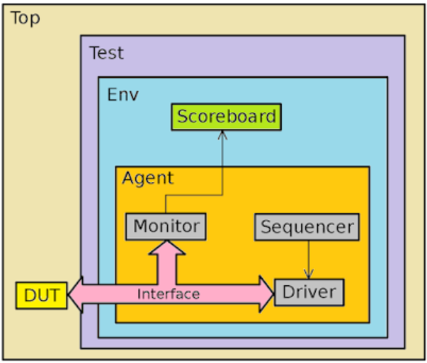

Fig-4: UVM Testbench Architecture

Above image represents a Universal Verification Methodology (UVM) testbench architecture. At the core is the Device Under Test (DUT), which interacts with the testbench through an Interface. The Agent is responsible for driving stimuli to the DUT and consists of three key components: the Sequencer, which generates sequences of transactions; the Driver, which receives these transactions and converts them into pin-level signals for the DUT; and the Monitor, which observes the DUT's responses and forwards collected data for analysis. The Environment (Env) is a higher-level component that contains one or more agents and other verification components. A crucial element of the environment is the Scoreboard, which compares expected and actual outputs to check the DUT's correctness. At the highest level, the Test encapsulates the environment and controls the overall simulation execution, ensuring that different scenarios and corner cases are covered.

Testbench Description

This testbench consists of two verification agents: AHB and APB, each handling the respective bus protocols. The AHB agent includes a driver, monitor, sequencer, and sequence items, ensuring transactions are generated and checked effectively. Similarly, the APB agent manages the APB transactions. A scoreboard is implemented to compare expected and actual results, ensuring correctness. The environment configures and connects all components, enabling comprehensive test execution.
Various test scenarios are executed using dedicated UVM test classes to ensure functional correctness under different operating conditions. This structured verification framework enhances reusability, scalability, and automation, making it an efficient approach for verifying AHB to APB bridges in complex SoC environments.
tb_top.sv
The tb_top module serves as the top-level testbench for verifying the AHB to APB bridge using UVM (Universal Verification Methodology). It includes the necessary interface connections, instantiates the Design Under Test (DUT), and initiates test execution.

The testbench imports the UVM library and includes various files, such as sequence items, agents, drivers, monitors, sequencers, scoreboard, and the test environment. It defines N_TX to control the number of transactions generated during simulation. The AHB and APB interfaces (ahb_intf and apb_intf) are instantiated to facilitate signal interaction with the DUT. The bridge_top module, representing the DUT, is connected to these interfaces, allowing seamless communication between the AHB and APB buses.

During simulation, the testbench configures the virtual interfaces using uvm_config_db::set, ensuring that UVM components have access to the respective bus signals. The run_test() function executes specific UVM test cases, such as ahb_apb_single_write_test and ahb_apb_single_read_test, to validate basic read and write transactions. A clock generator toggles the clock signal every 5 time units, ensuring proper timing synchronization. This structured testbench enables efficient functional verification of the AHB to APB bridge, ensuring data integrity and protocol compliance.

ahb_apb_env.sv
The ahb_apb_env class extends uvm_env and serves as the test environment for verifying the AHB to APB bridge using UVM. This environment encapsulates the necessary components, including the AHB agent, APB agent, and scoreboard, ensuring that transactions are generated, monitored, and verified correctly. By structuring the environment in a modular way, it provides flexibility in enabling or disabling components based on test requirements through a configuration object.
During the build phase, the environment retrieves its configuration from the uvm_config_db, ensuring that the necessary components are instantiated only if they are enabled in the configuration. The AHB agent, responsible for generating and monitoring AHB transactions, is created if ahb_agent_enabled is set. Similarly, the APB agent is instantiated if apb_agent_enabled is enabled. The scoreboard, which plays a crucial role in checking the correctness of transactions by comparing expected and actual results, is created if scoreboard_enabled is set. This approach allows for a scalable and reusable testbench, making it adaptable to different verification scenarios.
In the connect phase, the environment establishes connections between the monitor ports of the AHB and APB agents and the analysis FIFOs in the scoreboard. This ensures that transaction data captured by the monitors is correctly passed to the scoreboard for validation. Additionally, the UVM topology is printed, providing a hierarchical view of the testbench components, which is useful for debugging and verification analysis. By managing stimulus application, response monitoring, and result validation, the ahb_apb_env class plays a critical role in ensuring the reliability and correctness of the AHB to APB bridge.

ahb_apb_env_config.sv
The ahb_apb_env_config class extends uvm_object and serves as a configuration object for the AHB to APB test environment. It provides a structured way to enable or disable specific components within the verification environment, ensuring flexibility and reusability. By using UVM's configuration database (uvm_config_db), this class allows different tests to dynamically control the behavior of the testbench without modifying the core environment code.
The configuration class contains boolean flags—ahb_agent_enabled, apb_agent_enabled, and scoreboard_enabled—that determine whether the respective components are instantiated in the environment. This modular approach allows for selective activation of agents and the scoreboard, making it easier to configure test scenarios ranging from simple to complex verification tasks.
Additionally, the class includes ahb_agent_is_active and apb_agent_is_active, which use the uvm_active_passive_enum to specify whether the AHB and APB agents should operate in an active or passive mode. This is crucial for defining the role of the agents, such as whether they generate transactions or only observe bus activity.
The configuration class also stores virtual interface handles, ahb_vif and apb_vif, which link the testbench components to the actual DUT interfaces. This allows seamless interaction between the UVM test environment and the RTL design. By centralizing these settings in a single class, ahb_apb_env_config provides a scalable and efficient way to manage testbench configurations, promoting code reusability and maintainability.

ahb_apb_test.sv
The ahb_apb_base_test class extends uvm_test and serves as the foundational test class for verifying the AHB to APB bridge. It sets up the test environment by creating an instance of the ahb_apb_env_config class, which configures the testbench components such as the AHB and APB agents, the scoreboard, and their active or passive states. The class retrieves the AHB and APB virtual interfaces from the uvm_config_db, ensuring that the test environment interacts correctly with the DUT. Once the environment configuration is set, an instance of ahb_apb_env is created, effectively instantiating the testbench. This structured approach ensures modularity, reusability, and flexibility in defining different test scenarios.
Building upon the base test, the ahb_apb_random_test class introduces randomized testing to stress-test the AHB to APB bridge under varying conditions. It extends ahb_apb_base_test and includes random sequences for both AHB and APB agents. The build_phase creates instances of ahb_random_sequence and apb_random_sequence, which generate randomized transactions to simulate diverse traffic patterns. In the run_phase, the test raises an objection to ensure the simulation does not terminate prematurely and then initiates the random sequences in parallel using the fork-join construct. After executing the sequences, the test drops the objection and sets a drain time to allow any pending transactions to complete. This test is essential for verifying the robustness of the bridge by exploring various input scenarios and potential corner cases in an automated manner.

ahb_apb_single_test.sv
The ahb_apb_single_write_test class extends ahb_apb_base_test and is designed to verify a single write transaction through the AHB to APB bridge. This test ensures that data written via the AHB interface correctly propagates to the APB interface. During the build_phase, instances of ahb_single_write_sequence and apb_single_write_sequence are created, which generate and drive the corresponding write transactions. The run_phase raises an objection to prevent the simulation from ending prematurely and initiates both sequences in parallel using fork-join, ensuring that the AHB and APB sequences operate simultaneously. Once the transactions are complete, the test drops the objection and sets a drain time to allow any pending operations to settle. This test is crucial in verifying the correct write operation across the bridge.
Similarly, the ahb_apb_single_read_test extends ahb_apb_base_test and is dedicated to verifying a single read operation through the bridge. It follows the same structure as the write test but focuses on ensuring that data requested via the AHB interface is correctly retrieved from the APB side. The build_phase initializes instances of ahb_single_read_sequence and apb_single_read_sequence, which generate and drive the necessary read transactions. In the run_phase, the sequences are executed in parallel, ensuring that the read request from AHB and the corresponding response from APB are properly synchronized. Like the write test, the simulation is kept active until all transactions are completed. This test is essential for validating the correct data transfer during read operations and ensuring the integrity of the bridge functionality.

ahb_agent.sv
The ahb_agent class is a key component in the UVM-based verification environment for the AHB to APB bridge. As an extension of uvm_agent, it acts as a container for the AHB driver, sequencer, and monitor, facilitating seamless communication between test sequences and the device under test (DUT). The agent is designed to operate in either active or passive mode, depending on the configuration settings provided through ahb_apb_env_config.
During the build phase, the agent retrieves its configuration from the UVM configuration database. It then instantiates the AHB monitor unconditionally to observe transactions on the AHB interface. If the agent is configured as active, it also instantiates the driver and sequencer. The driver is responsible for converting high-level sequence transactions into AHB protocol-compliant signals, while the sequencer manages transaction flow by coordinating sequences from the testbench.
In the connect phase, if the agent is active, the driver is linked to the sequencer through the sequence item port. This connection ensures that the sequencer can send transactions to the driver for execution on the AHB interface. This modular design allows flexibility in configuring the verification environment, enabling both stimulus generation (active mode) and passive monitoring (passive mode) as needed for comprehensive testing of the AHB interface.

ahb_driver.sv
The ahb_driver class is a UVM component responsible for driving transactions onto the AHB interface. It extends uvm_driver and operates on ahb_sequence_item transactions received from the sequencer. This driver plays a crucial role in converting high-level test sequences into protocol-compliant signal-level interactions with the DUT.
During the build phase, the driver retrieves the environment configuration from the UVM configuration database. This configuration provides essential details such as the virtual AHB interface (ahb_vif), which is stored in drv_intf during the connect phase. This allows the driver to interact with the DUT through the interface provided in the testbench.
In the run phase, the driver continuously waits for new transactions from the sequencer using seq_item_port.get_next_item(req). Each received transaction is passed to the drive_packet() task, where it is driven onto the AHB interface. Before initiating a new transaction, the driver ensures that the previous transaction has completed by waiting for the HREADY signal.
The drive_packet task manages different types of AHB transactions. If the transaction is not in the BUSY state, the driver updates the control signals such as HRESETn, HSELAHB, HADDR, HTRANS, and HWRITE. For read operations, HWDATA is set to an undefined value (32'hxxxx_xxxx), while for write operations, data handling varies based on the transfer type:
- Non-sequential (HTRANS == 2'b10): The driver stores the write data and marks a pending write.
- Sequential (HTRANS == 2'b11): The driver updates HWDATA with the previously stored value and marks the write as pending.
- Idle (HTRANS == 2'b00): If there is a pending write, the stored data is driven onto HWDATA, and the pending flag is cleared.
Each transaction is logged using uvm_info, ensuring visibility into the transactions being executed. This structured and configurable driver implementation ensures accurate stimulus generation for AHB transactions, contributing to an effective UVM-based verification environment.

ahb_intf.sv
The ahb_intf interface defines the AHB (Advanced High-performance Bus) signals and facilitates communication between the driver, monitor, and the DUT (Device Under Test). It encapsulates the necessary signals required for AHB transactions, ensuring that the driver and monitor can interface with the DUT in a structured and synchronized manner. The interface is designed to include key AHB control signals such as HRESETn for reset indication, HADDR for the address bus, HWDATA and HRDATA for data transmission, HTRANS for the transaction type, HWRITE for the write signal, HSELAHB for the selection signal, and HREADY for the ready signal. These signals are essential for managing the AHB bus operations and enable seamless communication between the verification components and the DUT.
In this interface, the modports are defined to distinguish the roles of different components, namely the driver and the monitor. The AHB_DRIVER modport is used by the AHB driver to control and drive the signals onto the interface. It references the ahb_driver_cb clocking block, which ensures the correct timing for driving the various signals like HADDR, HWDATA, HTRANS, and others. On the other hand, the AHB_MONITOR modport is used by the AHB monitor to observe the transactions happening on the bus. This modport references the ahb_monitor_cb clocking block, which ensures the signals like HRDATA and HRESP are correctly sampled without interfering with the bus operations.
The interface also includes two clocking blocks that handle the synchronization of the signals. The ahb_driver_cb clocking block is used for driving signals, ensuring that the driver's control and address signals are updated at the appropriate times with respect to the clock. It also handles the sampling of the HREADY signal to confirm when the bus is ready for the next transaction. The ahb_monitor_cb clocking block is used for monitoring purposes, where all relevant signals, including HRDATA and HRESP, are sampled to observe the bus activity without affecting the ongoing transactions.
By utilizing clocking blocks and modports in this structured manner, the design ensures efficient communication between the verification components and the DUT. This approach minimizes potential timing issues and ensures that the signals are correctly updated or sampled based on the defined clocking behavior, improving the reliability and stability of the simulation process.

ahb_monitor.sv
The ahb_monitor class is a key component in the verification environment that is responsible for monitoring the AHB (Advanced High-performance Bus) transactions during simulation. It extends the uvm_monitor class and is designed to interface with the AHB interface, capturing various transaction signals and sending them for further processing or checking, such as into a scoreboard.
The monitor class begins with the declaration of several important variables. These include mon_intf, a virtual reference to the AHB interface, mon2sb, an instance of the ahb_sequence_item which holds the captured transaction data, and monitor_port, a UVM analysis port that will send the captured transaction data to downstream components such as a scoreboard. Additionally, env_config_h holds the configuration settings for the AHB environment, which are fetched from the configuration database.
In the build_phase, the monitor fetches the environment configuration from the UVM configuration database (uvm_config_db). If the configuration retrieval fails, it raises a fatal error. The monitor_port is also instantiated in this phase, which will be used to send captured transactions to other components for further analysis.
During the connect_phase, the monitor binds to the AHB interface (using mon_intf) from the environment configuration, enabling it to sample the signals during the simulation.
The run_phase is responsible for continuously monitoring AHB transactions during simulation. It operates within a loop, where the monitor waits for the positive edge of the clock signal (mon_intf.clk) and then captures the transaction details by calling the monitor_transaction task. This task is the core of the monitoring process.
The monitor_transaction task captures the AHB transaction details by reading signals from the interface (HRESETn, HADDR, HTRANS, HWRITE, HWDATA, HSELAHB, HRDATA, HREADY, HRESP) and stores them in the mon2sb object, which is of type ahb_sequence_item. After capturing the data, it logs the captured transaction for debugging or reporting purposes using the uvm_info function. Finally, it sends the captured transaction to the monitor_port for downstream analysis or comparison.
The overall structure of the ahb_monitor class allows for efficient monitoring and reporting of AHB transactions, enabling easier validation and debugging in the verification environment. By continuously sampling and sending transaction data, it ensures that all transactions on the bus are recorded, facilitating the detection of any anomalies or failures in the design.

ahb_sequence.sv
The ahb_sequence class is a basic sequence designed to generate a fixed number of transactions, specified by N_TX. Each transaction is created by randomizing an instance of ahb_sequence_item and sending it through the sequence item port using start_item(req) and finish_item(req). The randomization process sets the values of the fields within the sequence item, ensuring a wide variety of bus transactions are tested. This class serves as a fundamental building block for generating random AHB transactions.
The ahb_random_sequence class extends the basic ahb_sequence class and is more focused on generating specific types of AHB transactions based on the value of the HTRANS field. The sequence starts by generating a "T_IDLE" transaction (HTRANS == 2'b00), followed by a "T_NONSEQ" transaction (HTRANS == 2'b10), and then it enters a loop that alternates between "T_SEQ" (HTRANS == 2'b11) and "T_IDLE" transactions. This randomization approach allows for thorough testing of the different types of AHB bus transactions and their associated states.
The ahb_single_write_sequence class focuses on generating a sequence of write transactions on the AHB bus. This sequence consists of three transactions, each testing different configurations of the bus signals related to a write operation. The first transaction sets the bus to an idle state with HWRITE == 1'b1 and HTRANS == 2'b00. The second transaction sets HWRITE == 1'b1 and HTRANS == 2'b10, indicating a non-sequential write operation. The third transaction sets the bus for a sequential write operation, with HWRITE == 1'b1 and HTRANS == 2'b00. This sequence ensures that the DUT correctly handles write operations in various bus states.
Similarly, the ahb_single_read_sequence class is designed to generate a sequence of read transactions. It also generates three transactions, each with a different combination of signals related to read operations. The first transaction sets the bus to an idle state with HWRITE == 1'b0 and HTRANS == 2'b00. The second transaction configures the bus for a non-sequential read (HWRITE == 1'b0 and HTRANS == 2'b10). The third transaction sets the bus for a sequential read operation, with HWRITE == 1'b0 and HTRANS == 2'b00. This sequence is crucial for testing how the DUT handles read transactions in various conditions.
In summary, these UVM sequence classes are designed to generate and drive different types of AHB transactions, including random, write, and read operations. Each sequence class targets specific bus behaviors and transactions, ensuring that the DUT is thoroughly tested for both expected and edge-case conditions. These classes are part of a larger UVM testbench and help automate the verification process, enabling efficient and comprehensive functional testing of the AHB interface.

ahb_sequence_item.sv
The ahb_sequence_item class is a UVM sequence item used to model a single AHB (Advanced High-performance Bus) transaction. It represents the various signals involved in an AHB transaction, including control signals, data, and the response from the transaction. This class inherits from uvm_sequence_item and contains fields such as reset (HRESETn), address (HADDR), transaction type (HTRANS), write enable (HWRITE), data to be written (HWDATA), and select signal (HSELAHB), along with response signals like HRDATA, HREADY, and HRESP.
The class includes randomization constraints to ensure that the signals are generated within valid and realistic ranges. The LOW_RESET constraint biases the reset signal to be mostly inactive, the VALID_ADDRESS constraint ensures the address stays within a specified range, and SELECT_BRIDGE ensures the bridge select signal is more likely to be active.
Additionally, the do_print function is used to print the values of the AHB signals, and the post_randomize function increments a transaction counter and logs the generated transaction for analysis. The class is designed to facilitate the generation and tracking of AHB bus transactions in a UVM-based verification environment.

ahb_sequencer.sv
The ahb_sequencer class is a UVM sequencer that generates and controls the sequence of AHB transactions. It is a templated class that operates with ahb_sequence_item as the sequence item type. As part of the UVM environment, the sequencer manages the order and flow of sequence items that represent individual AHB bus transactions.
The class inherits from uvm_sequencer, which provides built-in methods to handle sequence item management, such as starting and controlling the execution of transactions. The new function initializes the sequencer with the specified name and parent component. This class is typically used to organize and coordinate the flow of AHB transaction sequences during the verification process in a UVM-based testbench.

apb_agent.sv
The apb_agent class is a UVM agent designed to handle APB (Advanced Peripheral Bus) transactions in a UVM-based testbench. It integrates several key components, including a sequencer, driver, and monitor, to facilitate the generation, transmission, and observation of APB transactions during verification.
In the build_phase, the agent retrieves its configuration from the UVM configuration database (uvm_config_db) and creates the necessary components (monitor, driver, and sequencer). The agent also checks if the APB agent is active based on the configuration before instantiating the driver and sequencer.
The connect_phase connects the sequencer's sequence item port to the driver's sequence item export, establishing the communication between the sequencer and the driver. This ensures that the sequencer can drive the required transactions to the driver. The apb_agent plays a crucial role in managing and coordinating APB transactions in the testbench, ensuring accurate verification of APB-based systems.

apb_driver.sv
The apb_driver class is a UVM driver that handles the driving of APB transactions in a verification environment. It operates with the apb_sequence_item type, driving transactions based on the sequence items provided by the sequencer.
In the build_phase, the driver retrieves the environment configuration from the UVM configuration database (uvm_config_db) to ensure that it has the necessary setup for the APB interface. If the configuration is not found, it triggers a fatal error.
During the connect_phase, the driver connects to the APB virtual interface (drv_intf) obtained from the environment configuration. This establishes the connection between the driver and the APB bus signals.
The run_phase continuously fetches sequence items from the sequencer, then invokes the drive_packet task to drive the corresponding APB signals to the DUT. The drive_packet task uses the apb_driver_cb clocking block to assign values to the APB response signals (PRDATA, PSLVERR, PREADY). It also logs the transaction using UVM info for debugging and analysis. This class is essential for driving APB transactions during the verification process, ensuring the correct behavior of the DUT.

apb_intf.sv
The apb_intf interface defines the signals and clocking for the APB (Advanced Peripheral Bus) protocol, which is typically used for communication between peripheral devices in a system. The interface includes multiple signals for data, address, control, and status, organized according to the number of slaves (N) specified by the N macro.
The interface contains signals such as PRDATA, PWDATA, PADDR, PSLVERR, PREADY, PSELx, PENABLE, and PWRITE, which are used for data transfer, address selection, and peripheral status during the APB communication. The array size of these signals is determined by N, representing the number of slaves in the system.
Two modports are defined within the interface: APB_DRIVER and APB_MONITOR. The APB_DRIVER modport is used for the driver to interface with the APB bus, and it specifies a clocking block apb_driver_cb for controlling signals like PRDATA, PSLVERR, and PREADY. The APB_MONITOR modport is for the monitor to read the APB signals, with a clocking block apb_monitor_cb that includes inputs for monitoring the bus transactions.
In summary, the apb_intf interface encapsulates the APB protocol's key signals and defines clocking blocks for both the driver and monitor roles, facilitating communication between the components in a verification environment.

apb_monitor.sv
The apb_monitor class is a UVM (Universal Verification Methodology) component designed to monitor the APB (Advanced Peripheral Bus) transactions in a verification environment. It is responsible for observing the signals from the APB interface and creating corresponding apb_sequence_item objects that encapsulate the transaction details.
The class inherits from uvm_monitor and has a virtual apb_intf.apb_monitor interface (mon_intf), which connects to the APB signals via the env_config_h configuration handle. It also includes an analysis port (monitor_port) to communicate the captured transactions to other components, like a scoreboard.
In the build_phase, the monitor retrieves the configuration from the uvm_config_db and initializes the analysis port. In the connect_phase, it binds to the APB interface specified in the configuration. The run_phase continuously monitors the APB transactions by waiting for the positive edge of the clock and invoking the monitor task.
In the monitor task, the monitor captures key APB signals such as PRDATA, PSLVERR, PREADY, PWDATA, PENABLE, PSELx, PADDR, and PWRITE, and stores them in an apb_sequence_item object. The transaction is then printed using uvm_info and written to the analysis port. This allows other components in the testbench to process the monitored APB transactions for validation or analysis purposes.

apb_sequence.sv
The apb_sequence, apb_random_sequence, apb_single_write_sequence, and apb_single_read_sequence classes are all UVM sequences that model different types of APB (Advanced Peripheral Bus) transactions in a verification environment.
- apb_sequence: This is a basic sequence class that generates a series of APB transactions (apb_sequence_item). It iterates a fixed number of times (N_TX) and creates a new sequence item, randomizes it, and then completes the transaction by calling finish_item.
- apb_random_sequence: This sequence class generates random APB transactions but with some constraints. It runs for N_TX - 8 iterations, where it randomizes the apb_sequence_item with the constraint that the PSLVERR field is set to 8'b0. After that, it generates 10 transactions where PSLVERR is set to 8'b1, and then finalizes with one more transaction where PSLVERR is set to 8'b0 again. This sequence adds variability to the transaction flow.
- apb_single_write_sequence: This sequence specifically models a set of single write transactions. It generates three write transactions in a loop, ensuring that each transaction has the PSLVERR field set to 8'b0 during the randomization process.
- apb_single_read_sequence: Similar to the write sequence, the apb_single_read_sequence generates a set of three read transactions. Each read transaction has the PSLVERR field set to 8'b0 during randomization, following the same structure as the write sequence.
These classes provide a structured way to simulate different types of APB bus transactions in a testbench, ensuring that various scenarios such as random errors or regular read/write transactions are covered during verification. Each sequence uses the UVM methods start_item and finish_item to control the initiation and completion of each transaction in the simulation.

apb_sequence_item.sv
The class includes several randomized fields representing key APB signals, such as PRDATA, PSLVERR, and PREADY, each parameterized based on the number of slaves (N). The VALID_READY and LOW_APB_ERROR constraints ensure realistic signal distributions, favoring valid ready and low error conditions. The class includes utility methods such as do_print for structured printing of transaction details and post_randomize to track the number of generated transactions while logging each randomized instance. This sequence item facilitates stimulus generation in a UVM-based verification environment, ensuring robust testing of APB transactions across multiple slave devices.
apb_sequencer.sv
The apb_sequencer class is a UVM sequencer that manages and controls the generation of apb_sequence_item transactions in an APB-based verification environment. It extends uvm_sequencer with a parameterized type of apb_sequence_item, ensuring that the sequencer handles only APB-specific sequence items. The class includes the uvm_component_utils macro to enable factory registration, allowing for easy configuration and component instantiation in the testbench. The constructor initializes the sequencer with a default name and an optional parent component. This sequencer plays a crucial role in coordinating the flow of transaction items from sequences to the APB driver, ensuring systematic stimulus generation for the APB interface verification.
ahb_apb_scoreboard.sv
The ahb_apb_scoreboard class is a UVM scoreboard responsible for verifying transactions between the AHB (Advanced High-performance Bus) and APB (Advanced Peripheral Bus) interfaces. It extends uvm_scoreboard and utilizes uvm_tlm_analysis_fifo to receive transaction packets from both AHB and APB. The class maintains counters for AHB and APB packets, as well as a count of verified transactions. A covergroup is implemented to capture functional coverage on key AHB signals, including reset, read/write operations, and transaction types. The run_phase continuously retrieves transaction packets from the FIFOs, logs the received transactions, and invokes predict_data() to generate expected APB transactions based on received AHB data. The predict_data() function maintains address and write control consistency while verifying APB responses. The configure_pselx() function determines the correct slave selection based on address mapping. The check_apb_data() and check_ahb_data() tasks compare predicted and actual data to verify correctness. Finally, the report_phase() provides a summary of packet counts, verification status, and functional coverage metrics, ensuring comprehensive validation of the AHB-to-APB bridge functionality.

Coverage Requirements

Describe Code and Functional Coverage goals for the DUV

The target is to cover all functional stimulus requirements and to ensure the design has reached interesting points as well as corner cases. Coverage will be measured using code coverage tool in Questasim to ensure all lines of code and branches have been executed. We will also implement a transaction model checking and coverage to make sure we covered all the interesting bus transactions.
For our project, initially we got a coverage of 88.88%, the final coverage is 91.02%.

Formulate conditions of how you will achieve the goals. Explain the Covergroups and Coverpoints and your selection of bins.
- The code defines the coverage_collector class, which is responsible for gathering and analyzing coverage data in an AHB APB Bridge Verification environment. This class receives transactions through a mailbox (driv2cor) from the driver and utilizes a virtual interface (vif) to interact with the design under verification (DUV). A covergroup (cov_cg) is used to define coverage points based on different transaction properties such as trans_type, Htrans, Hsize, and Hburst, along with their cross-coverage points. The execute task runs indefinitely, fetching transactions from the mailbox and displaying their details. Although the sample_coverage and print_coverage functions are defined to sample and report coverage, they are currently commented out in the provided code.

- The Transaction class, which represents a transaction within the AHB APB bridge system. This class includes various randomized transaction fields, such as Haddr, Hwdata, Htrans, Hsize, Hburst, Paddr, Pwdata, and control signals. It also defines constraints to ensure valid transaction values, like limiting Hsize and Hburst to specific values. A covergroup (cov_cg) within the class monitors key transaction properties, including Hwrite, Htrans, Hsize, and Hburst, and their cross-coverage points. The update_trans_type function sets the transaction type based on the Hwrite signal and samples coverage, while the print_transaction function prints the transaction details for debugging and verification. This class serves as the fundamental data structure for transactions in the verification environment.

Assertions

Describe the assertions that you are planning to use and how it will help you improve the overall coverage and functional aspects of the design.
- The assertions in scoreboard.sv ensure the correctness of data write and read operations in the AHB APB Bridge verification. The first assertion in the data_write() task checks if the data written by the driver (tx1.Hwdata) is correctly stored in the scoreboard’s memory model (mem_tb[temp_addr]). If the data is not stored properly, an error is flagged, ensuring functional accuracy and preventing memory corruption. Similarly, the second assertion in data_read() verifies whether the data read from the DUT (tx2.Prdata) matches the expected data stored in the scoreboard’s memory. If there is a mismatch, it indicates a failure in the read operation, allowing immediate debugging. These assertions significantly enhance coverage and functional verification by ensuring data integrity, detecting corruption, and identifying gaps in test scenarios. They also improve verification efficiency by providing immediate failure detection, reducing debugging time, and ensuring that different transaction scenarios are validated.
Ultimately, these assertions play a crucial role in verifying the DUT’s behavior, ensuring that it meets functional requirements, and improving the robustness of the AHB APB Bridge verification environment.

Resources requirements

Team members and who is doing what and expertise.

Milestone - 5:
Task No. | Task Description | Status | Team member
1 | All the test cases completed and reflected in the coverage reports | Completed | All
2 | Create a few scenarios of bug-injection and verify. Show your work. | Completed | All
3 | Finalize documents and presentations. At this point, your Design Specification document, and Verification Plan documents will have all the updated and latest data. | Completed | All

Schedule

Create a table with a plan of completion. You can use milestones as a guide to fill this.

Date | Milestone | Details
25th Jan | Initial Discussion | GitHub Setup and Task Division
31st Jan | Milestone 1 | Designed Synthesizable RTL, Directed Testbench, Design Spec & Verification Plan
18th Feb | Milestone 2 & 3 | Class-Based Testbench, Design Improvements, Enhancing Verification Plan
26th Feb | Milestone 4 | UVM-Based Test, Corner Case Testing with Constrained Random Stimulus
5th Mar | Milestone 5 | Improving Coverage and Adding Bug Injections
11th Mar | Final Project Presentation | Presentation Scheduled for team 8

References Uses / Citations/Acknowledgements

The resources include:
- Two graduate students work.
- computing resources.
- and software licenses.

