1. Develop a system using UML for Passport Management System; it should

verify the passport details of the applicant by the central computer. The details regarding the passport will be provided to the central computer and the computer will verify the details of the applicant and provide approval to the office. Then the passport will issue from the office to the applicant.

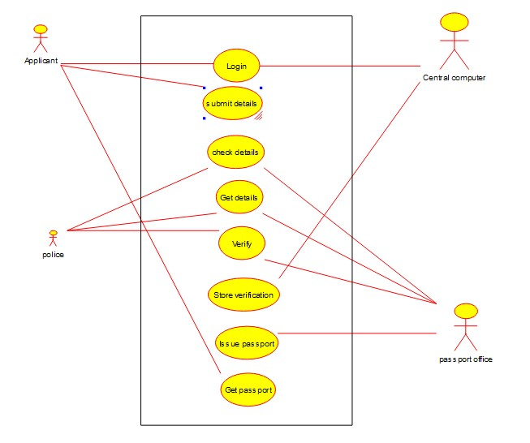

Class diagram:

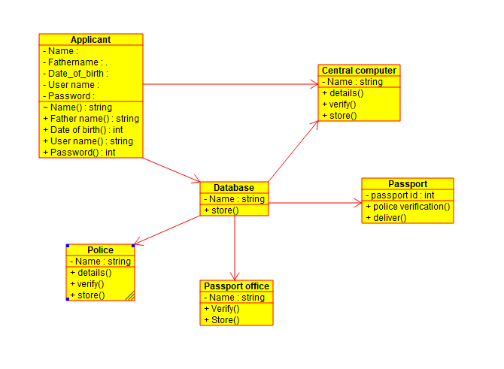

Activity Diagram:

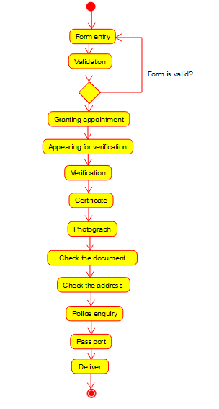

2) Develop a system using UML for implementing the Book Bank process.

It should verify the details of the student by the central computer. The

details regarding the student will be provided to the central computer

through the administrator in the book bank and the computer will verify the details of the student and provide approval to the office. Then the books that are needed by the student will issue from the office to him.

Use case diagram:

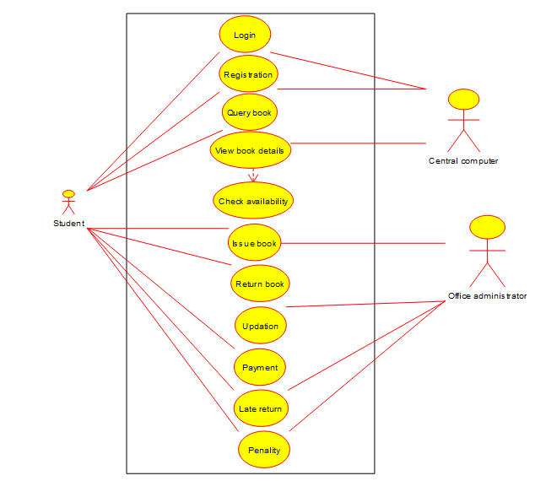

Activity Diagram:

