**Spring Core and Maven**

**Exercise 1: Configuring a Basic Spring Application**

* Create a Maven project named LibraryManagement.
* Add Spring Core dependencies in the pom.xml file.
* Create a package com.library.service and add a class BookService.
* Create a package com.library.repository and add a class BookRepository.
* Create an XML configuration file named applicationContext.xml in the src/main/resources directory.
* Define beans for BookService and BookRepository classes in the applicationContext.xml file.
* Create a main class to load the Spring context and test the configuration.

**Pom.xml:**

<?xml version="1.0" encoding="UTF-8"?>

<project xmlns="http://maven.apache.org/POM/4.0.0" xmlns:xsi="http://www.w3.org/2001/XMLSchema-instance"

xsi:schemaLocation="http://maven.apache.org/POM/4.0.0 http://maven.apache.org/xsd/maven-4.0.0.xsd">

<modelVersion>4.0.0</modelVersion>

<groupId>com.library</groupId>

<artifactId>LibraryManagement</artifactId>

<version>0.0.1-SNAPSHOT</version>

<name>LibraryManagement</name>

<!-- FIXME change it to the project's website -->

<url>http://www.example.com</url>

<properties>

<project.build.sourceEncoding>UTF-8</project.build.sourceEncoding>

<maven.compiler.release>17</maven.compiler.release>

</properties>

<dependencies>

<dependency>

<groupId>org.springframework</groupId>

<artifactId>spring-core</artifactId>

<version>6.2.6</version>

</dependency>

<dependency>

<groupId>org.springframework</groupId>

<artifactId>spring-context</artifactId>

<version>6.2.7</version>

</dependency>

</dependencies>

</project>

**BookService.java:**

package com.library.service;

public class BookService {

public void listBooks() {

System.*out*.println("Listing books...");

}

}

**BookRepository.java:**

package com.library.repository;

public class BookRepository {

public void fetchAllBooks() {

System.*out*.println("Fetching books from repository...");

}

}

**ApplicationContext.xml:**

<?xml version="1.0" encoding="UTF-8"?>

<beans xmlns="http://www.springframework.org/schema/beans"

xmlns:xsi="http://www.w3.org/2001/XMLSchema-instance"

xsi:schemaLocation="http://www.springframework.org/schema/beans

https://www.springframework.org/schema/beans/spring-beans.xsd">

<bean id="bookRepository" class="com.library.repository.BookRepository"/>

<bean id="bookService" class="com.library.service.BookService"/>

</beans>

**Main.java:**

package com.library.main;

import com.library.repository.BookRepository;

import com.library.service.BookService;

import org.springframework.context.ApplicationContext;

import org.springframework.context.support.ClassPathXmlApplicationContext;

public class LibraryManagementApplication {

public static void main(String[] args) {

ApplicationContext context = new ClassPathXmlApplicationContext("applicationContext.xml");

BookService bookService = (BookService)context.getBean("bookService");

bookService.listBooks();

BookRepository bookrepo = (BookRepository)context.getBean("bookRepository");

bookrepo.fetchAllBooks();;

}

}

**Output:**

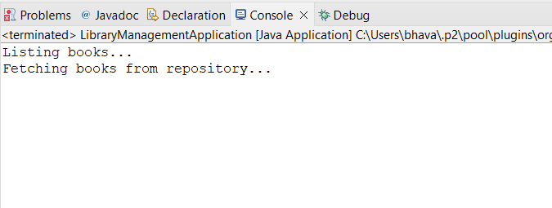

**Exercise 2: Implementing Dependency Injection**

* Update applicationContext.xml to wire BookRepository into BookService.
* Ensure that BookService class has a setter method for BookRepository.
* Run the LibraryManagementApplication main class to verify the dependency injection.

**ApplicationContext.xml:**

<?xml version="1.0" encoding="UTF-8"?>

<beans xmlns="http://www.springframework.org/schema/beans"

xmlns:xsi="http://www.w3.org/2001/XMLSchema-instance"

xsi:schemaLocation="

http://www.springframework.org/schema/beans

https://www.springframework.org/schema/beans/spring-beans.xsd">

<bean id="bookRepository" class="com.library.repository.BookRepository" />

<bean id="bookService" class="com.library.service.BookService">

<property name="bookRepository" ref="bookRepository"/>

</bean>

</beans>

**BookService.java:**

package com.library.service;

import com.library.repository.BookRepository;

public class BookService {

private BookRepository bookRepository;

public void setBookRepository(BookRepository bookRepository) {

this.bookRepository = bookRepository;

}

public void listBooks() {

System.*out*.println("Listing books...");

bookRepository.fetchAllBooks();

}

}

**Main.java:**

package com.library.main;

import com.library.service.BookService;

import org.springframework.context.ApplicationContext;

import org.springframework.context.support.ClassPathXmlApplicationContext;

public class LibraryManagementApplication {

public static void main(String[] args) {

ApplicationContext context = new ClassPathXmlApplicationContext("applicationContext.xml");

BookService bookService = (BookService)context.getBean("bookService");

bookService.listBooks();

}

}

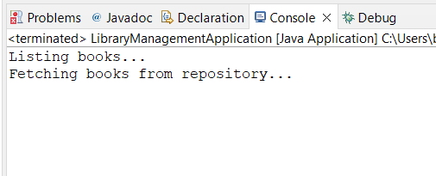**Output:**

**Exercise 4: Creating and Configuring a Maven Project**

* Include dependencies for Spring Context, Spring AOP, and Spring WebMVC in pom.xml file for LibraryManagement maven project.
* Configure the Maven Compiler Plugin for Java version 1.8 in the pom.xml file.

**Pom.xml:**

<project xmlns="http://maven.apache.org/POM/4.0.0"

xmlns:xsi="http://www.w3.org/2001/XMLSchema-instance"

xsi:schemaLocation="http://maven.apache.org/POM/4.0.0

http://maven.apache.org/xsd/maven-4.0.0.xsd">

<modelVersion>4.0.0</modelVersion>

<groupId>com.library</groupId>

<artifactId>LibraryManagement</artifactId>

<version>1.0-SNAPSHOT</version>

<properties>

<maven.compiler.source>1.8</maven.compiler.source>

<maven.compiler.target>1.8</maven.compiler.target>

</properties>

<dependencies>

<dependency>

<groupId>org.springframework</groupId>

<artifactId>spring-context</artifactId>

<version>5.3.33</version>

</dependency>

<dependency>

<groupId>org.springframework</groupId>

<artifactId>spring-aop</artifactId>

<version>5.3.33</version>

</dependency>

<dependency>

<groupId>org.springframework</groupId>

<artifactId>spring-webmvc</artifactId>

<version>5.3.33</version>

</dependency>

<dependency>

<groupId>javax.servlet</groupId>

<artifactId>javax.servlet-api</artifactId>

<version>4.0.1</version>

<scope>provided</scope>

</dependency>

</dependencies>

<build>

<plugins>

<plugin>

<groupId>org.apache.maven.plugins</groupId>

<artifactId>maven-compiler-plugin</artifactId>

<version>3.10.1</version>

<configuration>

<source>1.8</source>

<target>1.8</target>

</configuration> </plugin>

</plugins>

</build> </project>