**SPRING REST USING SPRING BOOT 3**

**Create a Spring Web Project using Maven**

1.Open <https://start.spring.io>

2.Fill in:

* Group: com.cognizant
* Artifact: spring-learn
* Name: spring-learn
* Java Version: 17 (or your installed version).

3. Click Add Dependencies:

* Select: Spring Web
* Select: Spring Boot DevTools.

4. Click Generate to download the ZIP.

5. Extract the downloaded spring-learn.zip.

6. Place it inside your Eclipse workspace folder.

7. Open Command Prompt and Navigate to the extracted project folder:

cd C:\EclipseWorkspace\spring-learn

8. Run the Maven build command:

mvn clean package -Dhttp.proxyHost=proxy.cognizant.com -Dhttp.proxyPort=6050 -Dhttps.proxyHost=proxy.cognizant.com -Dhttps.proxyPort=6050 -Dhttp.proxyUser=123456

9. Open Eclipse IDE and Go to: File > Import and Choose: Maven > Existing Maven Projects and Click Next.

10. Browse and select the extracted folder: C:\EclipseWorkspace\spring-learn and Click Finish.

**Pom.xml:**

<?xml version="1.0" encoding="UTF-8"?>

<project xmlns="http://maven.apache.org/POM/4.0.0" xmlns:xsi="http://www.w3.org/2001/XMLSchema-instance"

xsi:schemaLocation="http://maven.apache.org/POM/4.0.0 https://maven.apache.org/xsd/maven-4.0.0.xsd">

<modelVersion>4.0.0</modelVersion>

<parent>

<groupId>org.springframework.boot</groupId>

<artifactId>spring-boot-starter-parent</artifactId>

<version>3.5.3</version>

<relativePath/> <!-- lookup parent from repository -->

</parent>

<groupId>com.cognizant</groupId>

<artifactId>spring-learn</artifactId>

<version>0.0.1-SNAPSHOT</version>

<name>spring-learn</name>

<description>Demo project for Spring Boot</description>

<url/>

<licenses>

<license/>

</licenses>

<developers>

<developer/>

</developers>

<scm>

<connection/>

<developerConnection/>

<tag/>

<url/>

</scm>

<properties>

<java.version>17</java.version>

</properties>

<dependencies>

<dependency>

<groupId>org.springframework.boot</groupId>

<artifactId>spring-boot-starter-web</artifactId>

</dependency>

<dependency>

<groupId>org.springframework.boot</groupId>

<artifactId>spring-boot-devtools</artifactId>

<scope>runtime</scope>

<optional>true</optional>

</dependency>

<dependency>

<groupId>org.springframework.boot</groupId>

<artifactId>spring-boot-starter-test</artifactId>

<scope>test</scope>

</dependency>

</dependencies>

<build>

<plugins>

<plugin>

<groupId>org.springframework.boot</groupId>

<artifactId>spring-boot-maven-plugin</artifactId>

</plugin>

</plugins>

</build>

</project>

**SpringLearnApplication.java:**

package com.cognizant.spring_learn;

import org.slf4j.Logger;

import org.slf4j.LoggerFactory;

import org.springframework.boot.SpringApplication;

import org.springframework.boot.autoconfigure.SpringBootApplication;

@SpringBootApplication

public class SpringLearnApplication {

private static final Logger *LOGGER* = LoggerFactory.*getLogger*(SpringLearnApplication.class);

public static void main(String[] args) {

SpringApplication.*run*(SpringLearnApplication.class, args);

*LOGGER*.info("SpringLearnApplication main() executed");

}

}

**Output:**

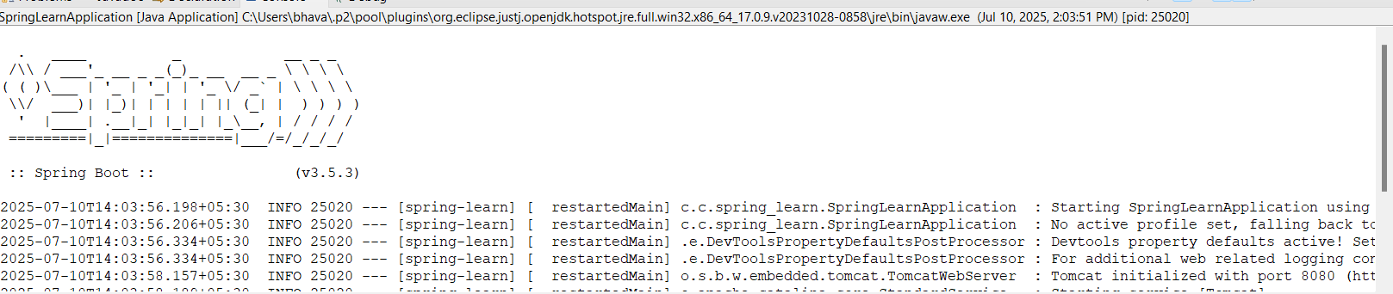

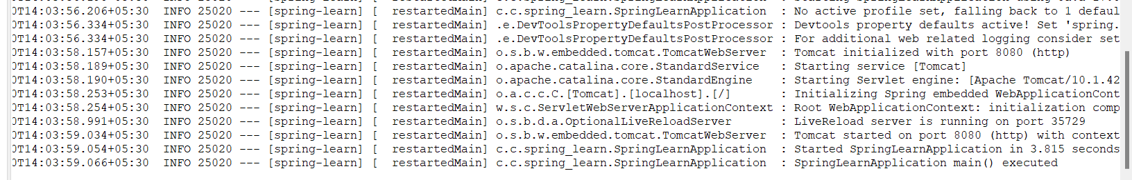

**Spring Core – Load Country from Spring Configuration XML**

1.Add necessary dependencies and resources in pom.xml file.

2.Confirm application.properties has logging configuration.

3.Configure the country.xml file and create a bean for a country in it and set the property and values for the bean.

4.Create the Country class with code and name as instance variables.

5. Implement empty parameter constructor with inclusion of debug log within the constructor with log message as “Inside Country Constructor.”

6. Generate getters and setters with inclusion of debug with relevant message within each setter and getter method.Generate toString() method.

7. Create a method displayCountry() in SpringLearnApplication.java, which will read the country bean from spring configuration file and display the country details.

8. Invoke displayCountry() method in main() method of SpringLearnApplication.java.

**Application.properties:**

spring.application.name=spring-learn

logging.level.com.cognizant.spring_learn=DEBUG

logging.level.root=DEBUG

**Country.xml:**

<?xml version="1.0" encoding="UTF-8"?>

<beans xmlns="http://www.springframework.org/schema/beans"

xmlns:xsi="http://www.w3.org/2001/XMLSchema-instance"

xsi:schemaLocation="

http://www.springframework.org/schema/beans

http://www.springframework.org/schema/beans/spring-beans.xsd">

<bean id="country" class="com.cognizant.spring_learn.Country">

<property name="code" value="IN" />

<property name="name" value="India" />

</bean>

</beans>

**Country.java:**

package com.cognizant.spring_learn;

import org.slf4j.Logger;

import org.slf4j.LoggerFactory;

public class Country {

private static final Logger *LOGGER* = LoggerFactory.*getLogger*(Country.class);

private String code;

private String name;

public Country() {

*LOGGER*.debug("Inside Country Constructor.");

}

public String getCode() {

*LOGGER*.debug("Getting code: {}", code);

return code;

}

public void setCode(String code) {

*LOGGER*.debug("Setting code to {}", code);

this.code = code;

}

public String getName() {

*LOGGER*.debug("Getting name: {}", name);

return name;

}

public void setName(String name) {

*LOGGER*.debug("Setting name to {}", name);

this.name = name;

}

@Override

public String toString() {

return "Country [code=" + code + ", name=" + name + "]";

}

}

**SpringLearnApplication.java:**

package com.cognizant.spring_learn;

import org.springframework.boot.SpringApplication;

import org.springframework.boot.autoconfigure.SpringBootApplication;

import org.slf4j.Logger;

import org.slf4j.LoggerFactory;

import org.springframework.context.ApplicationContext;

import org.springframework.context.support.ClassPathXmlApplicationContext;

@SpringBootApplication

public class SpringLearnApplication {

private static final Logger LOGGER = LoggerFactory.getLogger(SpringLearnApplication.class);

public static void main(String[] args) {

LOGGER.debug("START");

SpringApplication.run(SpringLearnApplication.class, args);

displayCountry();

LOGGER.debug("END");

}

public static void displayCountry() {

ApplicationContext context = new ClassPathXmlApplicationContext("country.xml");

Country country =(Country) context.getBean("country", Country.class);

LOGGER.debug("Country : {}", country.toString());

}

}

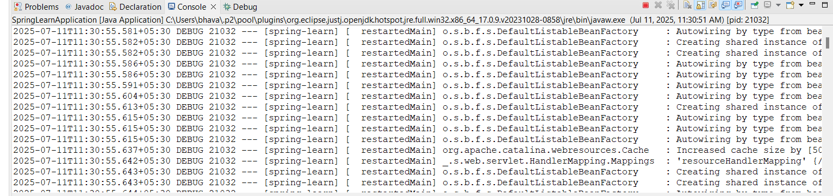**Ouput:**

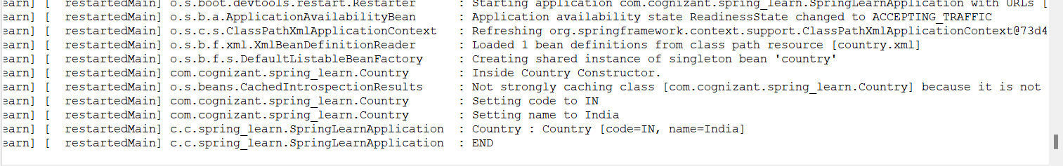

**Hello World RESTful Web Service** 

**HelloController.java:**

package com.cognizant.spring_learn.controller;

import org.slf4j.Logger;

import org.slf4j.LoggerFactory;

import org.springframework.web.bind.annotation.GetMapping;

import org.springframework.web.bind.annotation.RestController;

@RestController

public class HelloController {

private static final Logger *LOGGER* = LoggerFactory.*getLogger*(HelloController.class);

@GetMapping("/hello")

public String sayHello() {

*LOGGER*.debug("START: sayHello()");

String response = "Hello World!!";

*LOGGER*.debug("END: sayHello()");

return response;

}

}

**Application.properties:**

server.port=8083

logging.level.com.cognizant.spring_learn=DEBUG

**SpringLearnApplication.java:**

package com.cognizant.spring_learn;

import org.springframework.boot.SpringApplication;

import org.springframework.boot.autoconfigure.SpringBootApplication;

@SpringBootApplication

public class SpringLearnApplication {

public static void main(String[] args) {

SpringApplication.*run*(SpringLearnApplication.class, args);

}

}

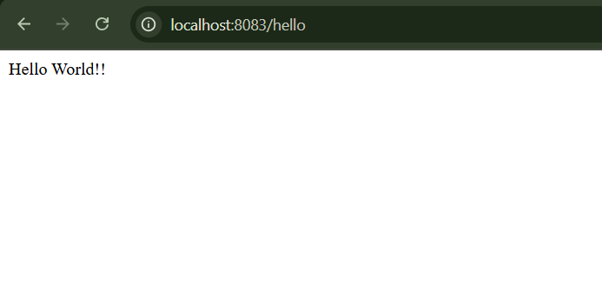**Output:**

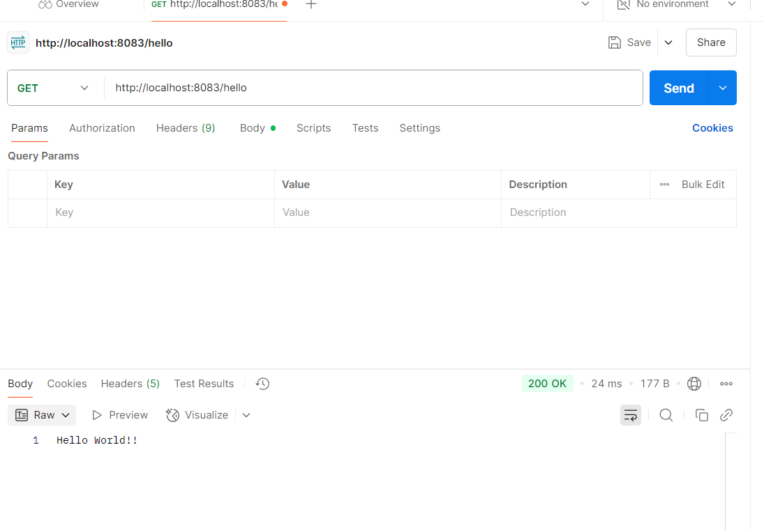

**REST - Country Web Service**

**CountryController.java:**

package com.cognizant.spring_learn.controller;

import com.cognizant.spring_learn.Country;

import org.slf4j.Logger;

import org.slf4j.LoggerFactory;

import org.springframework.context.ApplicationContext;

import org.springframework.context.support.ClassPathXmlApplicationContext;

import org.springframework.web.bind.annotation.RequestMapping;

import org.springframework.web.bind.annotation.RestController;

@RestController

public class CountryController {

private static final Logger *LOGGER* = LoggerFactory.*getLogger*(CountryController.class);

@RequestMapping("/country")

public Country getCountryIndia() {

*LOGGER*.debug("START: getCountryIndia()");

ApplicationContext context = new ClassPathXmlApplicationContext("country.xml");

Country country = context.getBean("country", Country.class);

*LOGGER*.debug("Country loaded: {}", country.toString());

*LOGGER*.debug("END: getCountryIndia()");

return country;

}

}

**Ouput:**

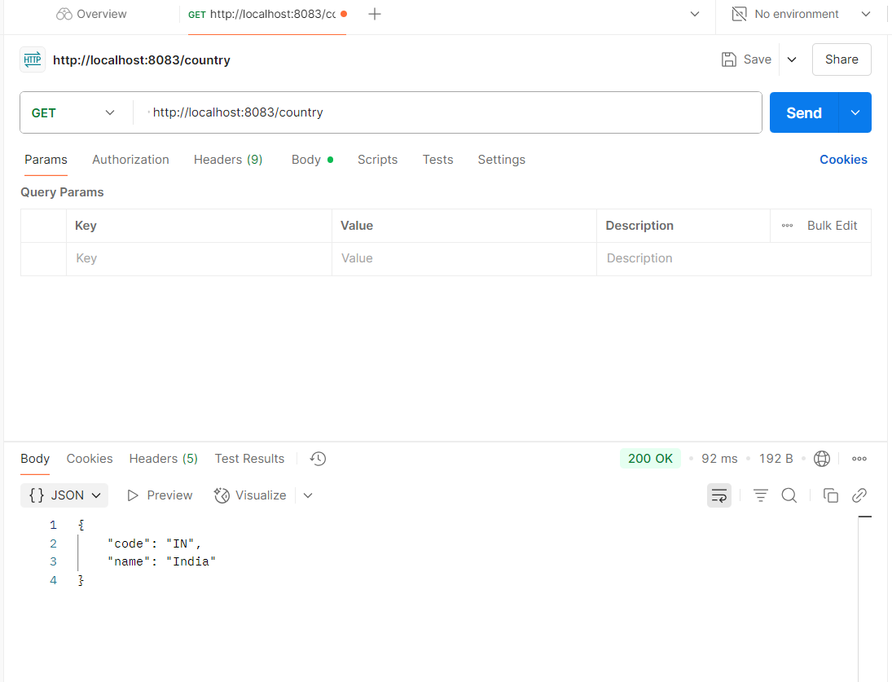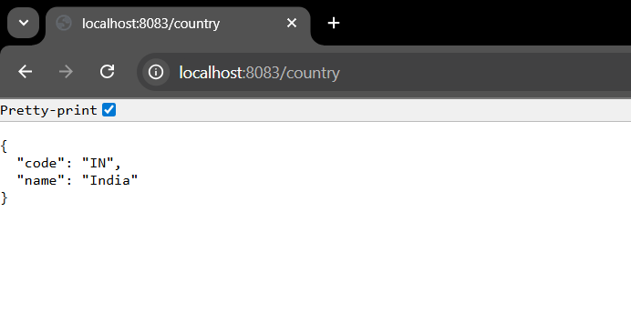

**REST - Get country based on country code** 

**Country.xml:**

<?xml version="1.0" encoding="UTF-8"?>

<beans xmlns="http://www.springframework.org/schema/beans"

xmlns:xsi="http://www.w3.org/2001/XMLSchema-instance"

xsi:schemaLocation="http://www.springframework.org/schema/beans

http://www.springframework.org/schema/beans/spring-beans.xsd">

<bean id="country" class="com.cognizant.spring_learn.Country">

<property name="code" value="IN" />

<property name="name" value="India" />

</bean>

<bean id="countryList" class="java.util.ArrayList">

<constructor-arg>

<list>

<bean class="com.cognizant.spring_learn.Country">

<property name="code" value="IN" />

<property name="name" value="India" />

</bean>

<bean class="com.cognizant.spring_learn.Country">

<property name="code" value="US" />

<property name="name" value="United States" />

</bean>

<bean class="com.cognizant.spring_learn.Country">

<property name="code" value="JP" />

<property name="name" value="Japan" />

</bean>

</list>

</constructor-arg>

</bean>

</beans>

**CountryService.java:**

package com.cognizant.spring_learn.service;

import com.cognizant.spring_learn.Country;

import org.springframework.context.ApplicationContext;

import org.springframework.context.support.ClassPathXmlApplicationContext;

import org.springframework.stereotype.Service;

import java.util.List;

@Service

public class CountryService {

public Country getCountry(String code) {

ApplicationContext context = new ClassPathXmlApplicationContext("country.xml");

List<Country> countryList = (List<Country>) context.getBean("countryList");

return countryList.stream()

.filter(c -> c.getCode().equalsIgnoreCase(code))

.findFirst()

.orElse(null);

}

}

**CountryController.java:**

package com.cognizant.spring_learn.controller;

import com.cognizant.spring_learn.Country;

import com.cognizant.spring_learn.service.CountryService;

import org.slf4j.Logger;

import org.slf4j.LoggerFactory;

import org.springframework.beans.factory.annotation.Autowired;

import org.springframework.web.bind.annotation.*;

@RestController

public class CountryController {

private static final Logger *LOGGER* = LoggerFactory.*getLogger*(CountryController.class);

@Autowired

private CountryService countryService;

@GetMapping("/countries/{code}")

public Country getCountry(@PathVariable String code) {

*LOGGER*.debug("START: getCountry()");

Country country = countryService.getCountry(code);

*LOGGER*.debug("END: getCountry()");

return country;

}

}

**Output:**

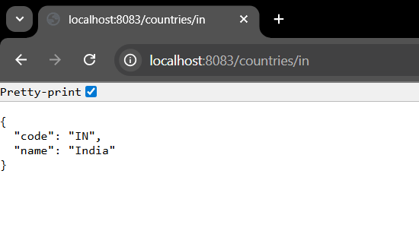

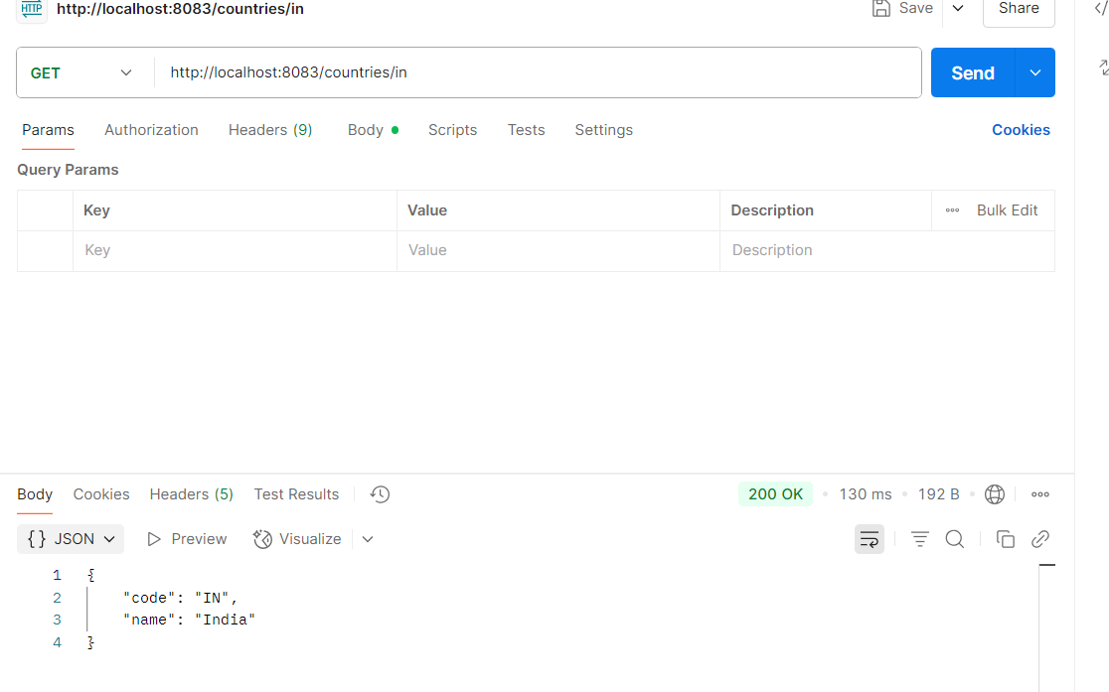

**Create authentication service that returns JWT**

**Pom.xml:**

<?xml version="1.0" encoding="UTF-8"?>

<project xmlns="http://maven.apache.org/POM/4.0.0" xmlns:xsi="http://www.w3.org/2001/XMLSchema-instance"

xsi:schemaLocation="http://maven.apache.org/POM/4.0.0 https://maven.apache.org/xsd/maven-4.0.0.xsd">

<modelVersion>4.0.0</modelVersion>

<parent>

<groupId>org.springframework.boot</groupId>

<artifactId>spring-boot-starter-parent</artifactId>

<version>3.5.3</version>

<relativePath/> <!-- lookup parent from repository -->

</parent>

<groupId>com.cognizant</groupId>

<artifactId>spring-learn</artifactId>

<version>0.0.1-SNAPSHOT</version>

<name>spring-learn</name>

<description>Demo project for Spring Boot</description>

<url/>

<licenses>

<license/>

</licenses>

<developers>

<developer/>

</developers>

<scm>

<connection/>

<developerConnection/>

<tag/>

<url/>

</scm>

<properties>

<java.version>17</java.version>

</properties>

<dependencies>

<dependency>

<groupId>org.springframework.boot</groupId>

<artifactId>spring-boot-starter-web</artifactId>

</dependency>

<dependency>

<groupId>org.springframework.boot</groupId>

<artifactId>spring-boot-starter-security</artifactId>

</dependency>

<dependency>

<groupId>org.springframework.boot</groupId>

<artifactId>spring-boot-devtools</artifactId>

<scope>runtime</scope>

<optional>true</optional>

</dependency>

<dependency>

<groupId>org.springframework.boot</groupId>

<artifactId>spring-boot-starter-test</artifactId>

<scope>test</scope>

</dependency>

<dependency>

<groupId>io.jsonwebtoken</groupId>

<artifactId>jjwt-api</artifactId>

<version>0.11.5</version>

</dependency>

<dependency>

<groupId>io.jsonwebtoken</groupId>

<artifactId>jjwt-impl</artifactId>

<version>0.11.5</version>

<scope>runtime</scope>

</dependency>

<dependency>

<groupId>io.jsonwebtoken</groupId>

<artifactId>jjwt-jackson</artifactId>

<version>0.11.5</version>

<scope>runtime</scope>

</dependency>

</dependencies>

<build>

<plugins>

<plugin>

<groupId>org.springframework.boot</groupId>

<artifactId>spring-boot-maven-plugin</artifactId>

</plugin>

</plugins>

</build>

</project>

**AuthController.java:**

package com.cognizant.spring_learn.controller;

import io.jsonwebtoken.JwtBuilder;

import io.jsonwebtoken.Jwts;

import io.jsonwebtoken.SignatureAlgorithm;

import io.jsonwebtoken.security.Keys;

import org.slf4j.Logger;

import org.slf4j.LoggerFactory;

import org.springframework.web.bind.annotation.*;

import java.util.Base64;

import java.util.Date;

import java.util.HashMap;

import java.util.Map;

@RestController

public class AuthController {

private Logger logger = LoggerFactory.*getLogger*(AuthController.class);

@GetMapping("/authenticate")

public Map<String, String> authenticate(@RequestHeader("Authorization") String authHeader) {

logger.info("START: authenticate()");

logger.debug("Authorization Header: {}", authHeader);

String user = getUser(authHeader);

logger.debug("Decoded User: {}", user);

String token = generateJwt(user);

Map<String, String> map = new HashMap<>();

map.put("token", token);

logger.info("END: authenticate()");

return map;

}

private String getUser(String authHeader) {

logger.info("START: getUser()");

String base64Credentials = authHeader.substring("Basic".length()).trim();

byte[] decoded = Base64.*getDecoder*().decode(base64Credentials);

String decodedString = new String(decoded);

String username = decodedString.split(":")[0];

logger.debug("Extracted Username: {}", username);

logger.info("END: getUser()");

return username;

}

private String generateJwt(String user) {

return Jwts.*builder*()

.setSubject(user)

.setIssuedAt(new Date())

.setExpiration(new Date(System.*currentTimeMillis*() + 20 * 60 * 1000))

.signWith(Keys.*hmacShaKeyFor*("mysecretkeymysecretkeymysecretkey!".getBytes()), SignatureAlgorithm.*HS256*)

.compact();

}

}

**SecurityConfig:**

package com.cognizant.spring_learn.config;

import org.springframework.context.annotation.Bean;

import org.springframework.context.annotation.Configuration;

import org.springframework.security.config.Customizer;

import org.springframework.security.config.annotation.web.builders.HttpSecurity;

import org.springframework.security.core.userdetails.User;

import org.springframework.security.core.userdetails.UserDetailsService;

import org.springframework.security.provisioning.InMemoryUserDetailsManager;

import org.springframework.security.web.SecurityFilterChain;

@Configuration

public class SecurityConfig {

@Bean

public UserDetailsService userDetailsService() {

return new InMemoryUserDetailsManager(

User.*withUsername*("user").password("{noop}pwd").roles("USER").build(),

User.*withUsername*("admin").password("{noop}adminpwd").roles("ADMIN").build()

);

}

@Bean

public SecurityFilterChain filterChain(HttpSecurity http) throws Exception {

http.csrf().disable()

.authorizeHttpRequests(auth -> auth

.requestMatchers("/countries").hasRole("USER")

.requestMatchers("/authenticate").hasAnyRole("USER", "ADMIN")

.anyRequest().authenticated()

)

.httpBasic(Customizer.*withDefaults*());

return http.build();

}

}

**Ouput:**

