**Microservices With SpringBoot 3 and Spring Cloud**

**Creating Microservices for account and loan**

**Account Microservice:**

1.Create directory in D-drive or C-drive as: D:\<Your_Employee_ID>\microservices

2.Go to <https://start.spring.io> and give Group: com.cognizant and Artifact: account

3. Add Spring Boot DevTools and Spring Web Dependencies

4. Click Generate, download the zip, and extract it to:

D:\<Your_Employee_ID>\microservices\account

5. Open Command Prompt and navigate to above created folder: mvn clean package

6.Open eclipse and File > Import > Maven > Existing Maven Projects and Select the account folder and click finish.

7.create a account controller class with get method.

8.Run the account application in browser with default port number 8080.

**AccountController.java:**

package com.cognizant.account.controller;

import org.springframework.web.bind.annotation.*;

import java.util.HashMap;

import java.util.Map;

@RestController

@RequestMapping("/accounts")

public class AccountController {

@GetMapping("/{number}")

public Map<String, Object> getAccountByNumber(@PathVariable String number) {

Map<String, Object> response = new HashMap<>();

response.put("number", number);

response.put("type", "savings");

response.put("balance", 234343);

return response;

}

}

**AccountApplication.java:**

package com.cognizant.account;

import org.springframework.boot.SpringApplication;

import org.springframework.boot.autoconfigure.SpringBootApplication;

@SpringBootApplication

public class AccountApplication {

public static void main(String[] args) {

SpringApplication.run(AccountApplication.class, args);

}

}

**Output:**

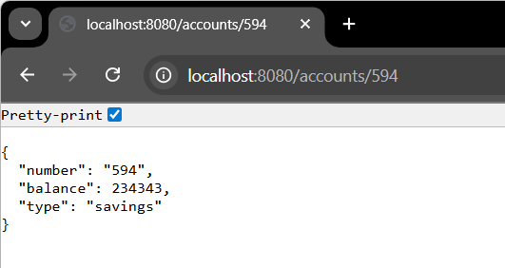

**Loan Microservice:**

1.Create directory in D-drive or C-drive as: D:\<Your_Employee_ID>\microservices

2.Go to <https://start.spring.io> and give Group: com.cognizant and Artifact: loan

3. Add Spring Boot DevTools and Spring Web Dependencies

4. Click Generate, download the zip, and extract it to:

D:\<Your_Employee_ID>\microservices\loan

5. Open Command Prompt and navigate to above created folder: mvn clean package

6.Open eclipse and File > Import > Maven > Existing Maven Projects and Select the loan folder and click finish.

7.create a loan controller class with get method.

8.Change port number to 8081 in application.properties.

9.Run the account application in browser.

**LoanController.java:**

package com.cognizant.loan.controller;

import org.springframework.web.bind.annotation.*;

import java.util.HashMap;

import java.util.Map;

@RestController

@RequestMapping("/loans")

public class LoanController {

@GetMapping("/{number}")

public Map<String, Object> getLoanByNumber(@PathVariable String number) {

Map<String, Object> response = new HashMap<>();

response.put("number", number);

response.put("type", "car");

response.put("loan", 400000);

response.put("emi", 3258);

response.put("tenure", 18);

return response;

}

}

**Application.properties:**

spring.application.name=loan

server.port=8081

**LoanApplication.java:**

package com.cognizant.loan;

import org.springframework.boot.SpringApplication;

import org.springframework.boot.autoconfigure.SpringBootApplication;

@SpringBootApplication

public class LoanApplication {

public static void main(String[] args) {

SpringApplication.run(LoanApplication.class, args);

}

}

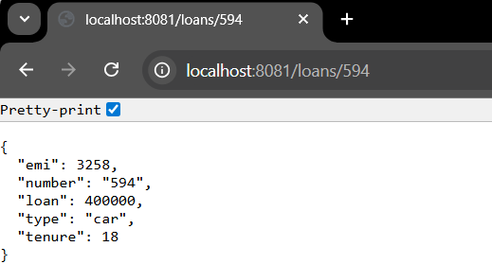**Output:**