**REACT**

**Exercise-1:MyFirstReact**

1. To create a new React app, Install Nodejs and Npm from the following link:

<https://nodejs.org/en/download/>

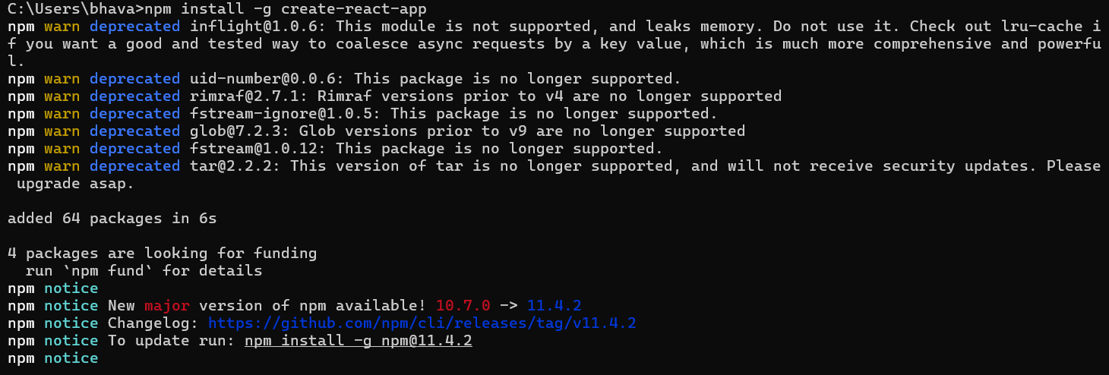2. Install Create-react-app by running the following command in the command prompt:

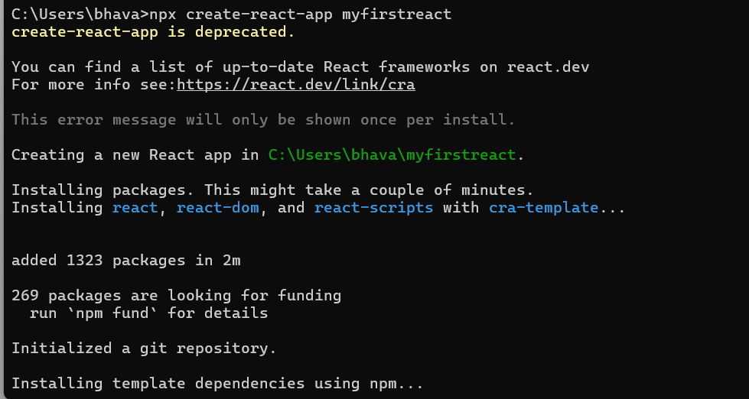3. To create a React Application with the name of “myfirstreact”, type the following command:

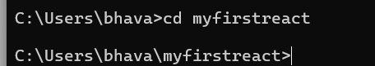4. Once the App is created, navigate into the folder of myfirstreact by typing the following command:

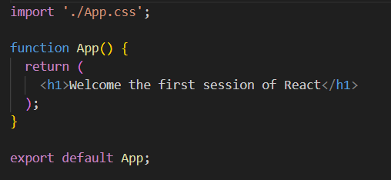5. Open the folder of myfirstreact in Visual Studio Code and change code in app.js:

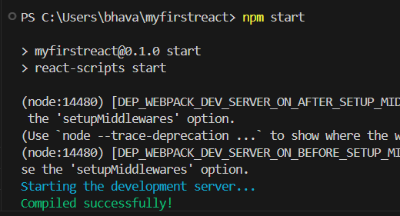9. Run the following command to execute the React application:

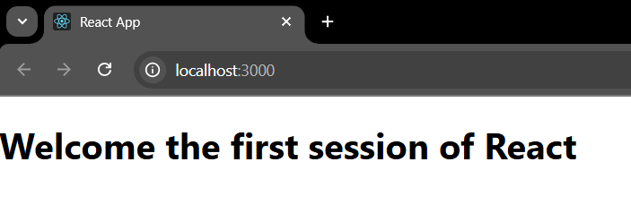**Output:**

**Exercise-2:StudentApp**

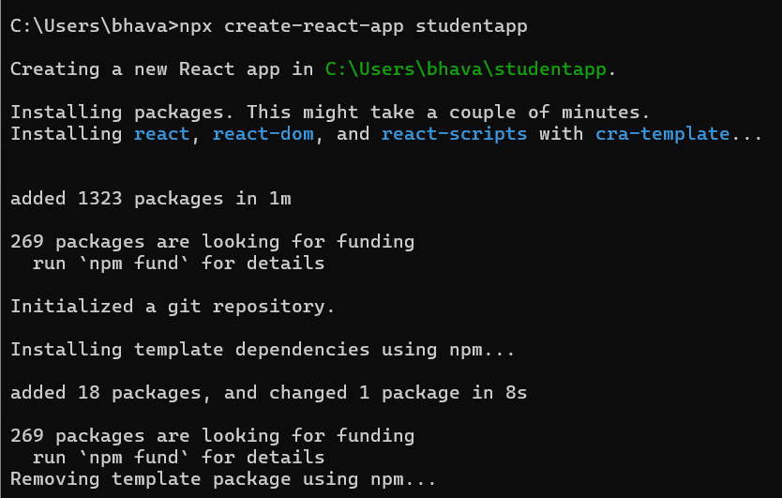1.Create a React project named “StudentApp” with the command:

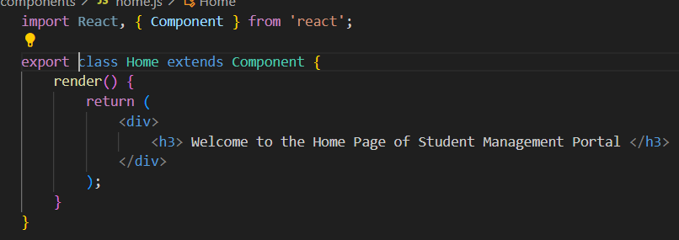2. Create a new folder under Src folder with the name “Components”. Add a new file named “Home.js” and edit the code in it:

3. Repeat the same steps for Creating “About” and “Contact” component by adding a new file as ”About.js”, “Contact.js” under “Src” folder and edit the code as mentioned for “Home” Component.

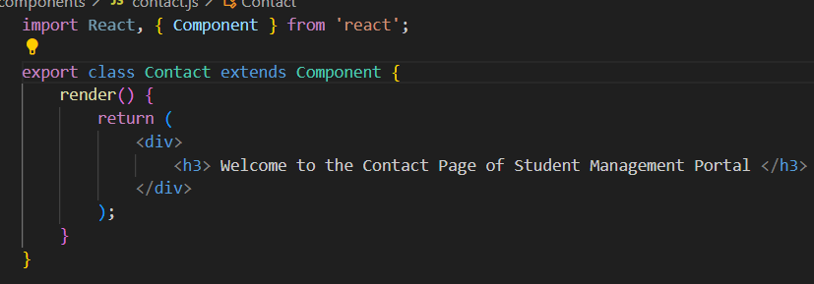

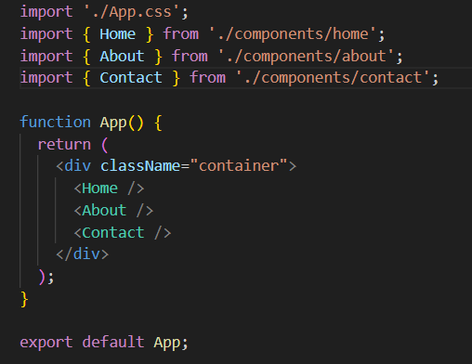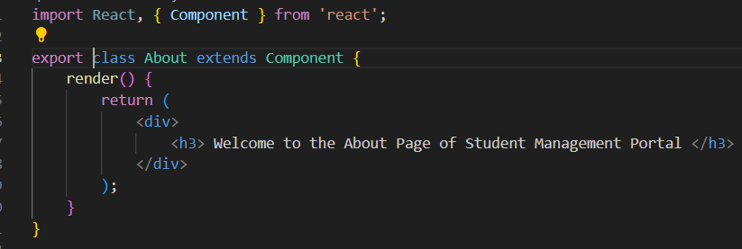4. Edit the App.js to invoke the Home, About and Contact component as follows:

5.In the terminal start the studentapp by giving following command:

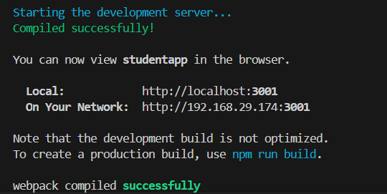**Output:**

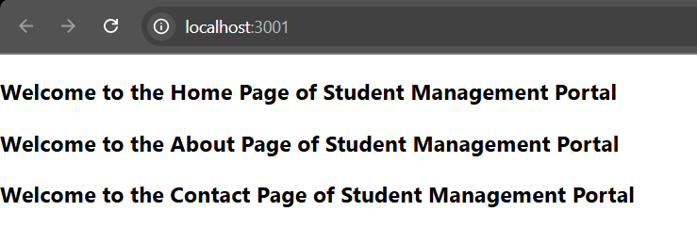

**Exercise-3:ScoreCalculatorApp**

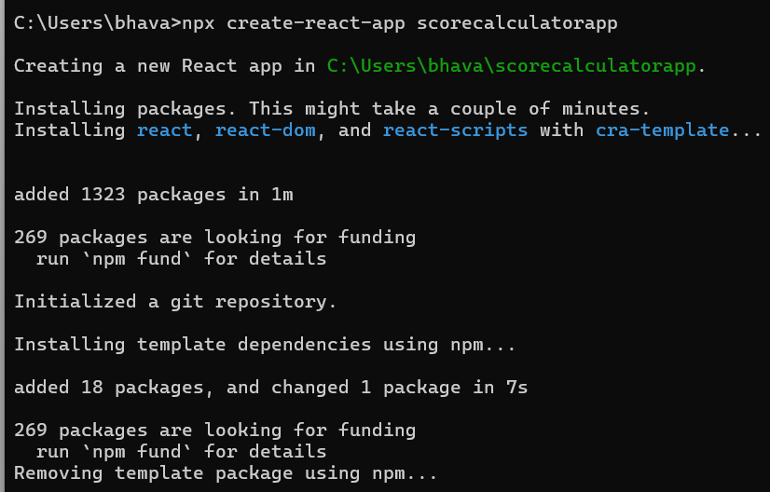1.Create a React project named “scorecalculatorapp” type the following command in terminal:

2. Create a new folder under Src folder with the name “Components”. Add a new file named “CalculateScore.js” and edit the code:

import './Stylesheets/mystyle.css'

const percentToDecimal = (decimal) => {

  return (decimal.toFixed(2) + '%')

}

const calcScore = (total, goal) => {

  return percentToDecimal(total / goal)

}

export const CalculateScore = ({ Name, School, total, goal }) => (

  <div className="formatstyle">

    <h1><font color="Brown">Student Details:</font></h1>

    <div className="Name">

      <b><span> Name: </span></b>

      <span>{Name}</span>

    </div>

    <div className="School">

      <b><span> School: </span></b>

      <span>{School}</span>

    </div>

    <div className="Total">

      <b><span>Total:</span></b>

      <span>{total}</span>

      <span>Marks</span>

    </div>

    <div className="Score">

      <b>Score:</b>

      <span>

        {

          calcScore(

            total,

            goal

          )

        }

      </span>

    </div>

  </div>

)

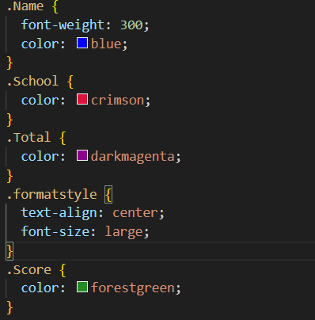3. Create a Folder named Stylesheets and add a file named “mystyle.css” in order to add some styles to the components:

4. Edit the App.js to invoke the CalculateScore functional component as follows:

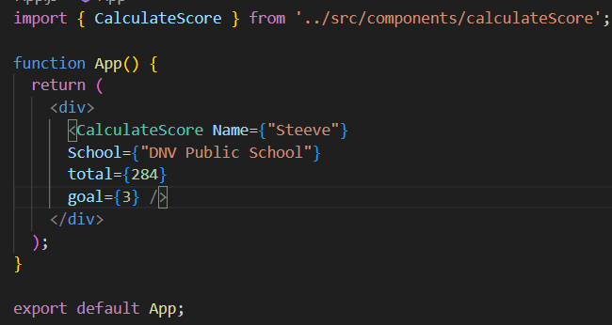

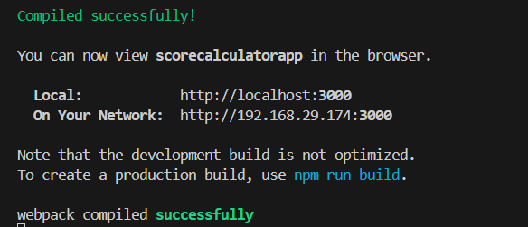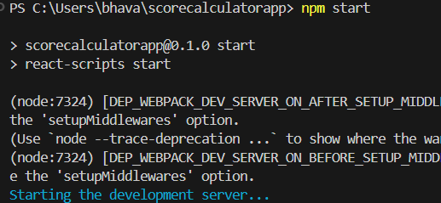5. In the terminal start the scorecalculatorapp by giving following command:

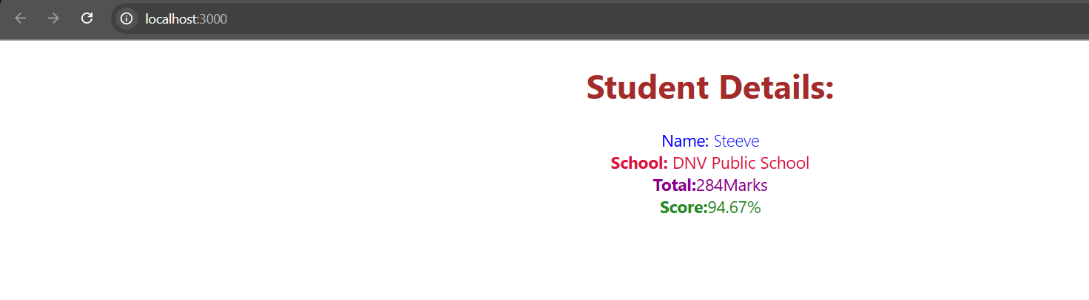**Output:**

**Exercise-4:BlogApp**

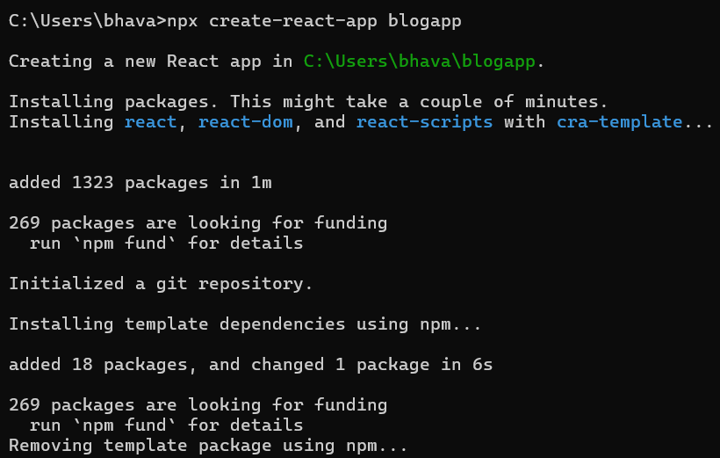1.Create a new react application using *create-react-app* tool with the name as “blogapp”:

2. Create a new file named as Post.js in src folder

Post.js:

class Post {

  constructor(id, title, body) {

    this.id = id;

    this.title = title;

    this.body = body;

  }

}

export default Post;

3. Create a new file named as Posts.js in src folder in which we create methods like loadPosts() which will be responsible for using Fetch API and componentDidMount() hook to make calls to loadPosts() and the render() which will display the title and post of posts in html page using heading and paragraphs respectively and componentDidCatch() method which will be responsible for displaying any error happing in the component as alert messages.

import React from 'react';

import Post from './post';

class Posts extends React.Component {

  constructor(props) {

    super(props);

    this.state = {

      posts: [],

    };

  }

  loadPosts() {

    fetch('https://jsonplaceholder.typicode.com/posts')

      .then((response) => response.json())

      .then((data) => {

        const posts = data.map(p => new Post(p.id, p.title, p.body));

        this.setState({ posts });

      })

      .catch((error) => {

        console.error('Error fetching posts:', error);

        alert('Error loading posts');

      });

  }

  componentDidMount() {

    this.loadPosts();

  }

  render() {

    return (

      <div>

        <h1>Blog Posts</h1>

        {this.state.posts.map(post => (

          <div key={post.id}>

            <h2>{post.title}</h2>

            <p>{post.body}</p>

          </div>

        ))}

      </div>

    );

  }

  componentDidCatch(error, info) {

    alert('An error occurred in Posts component.');

    console.error('Error:', error);

    console.error('Info:', info);

  }

}

export default Posts;

4. Add the Posts component to App component:

import React from 'react';

import Posts from './posts';

function App() {

  return (

    <div className="App">

      <Posts />

    </div>

  );

}

export default App;

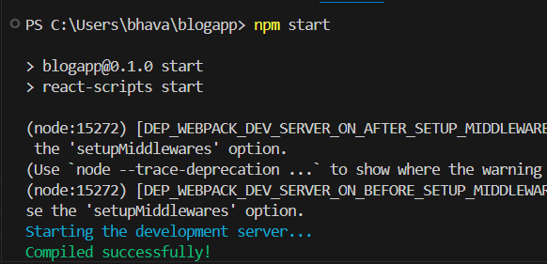5.Run the application by following command:

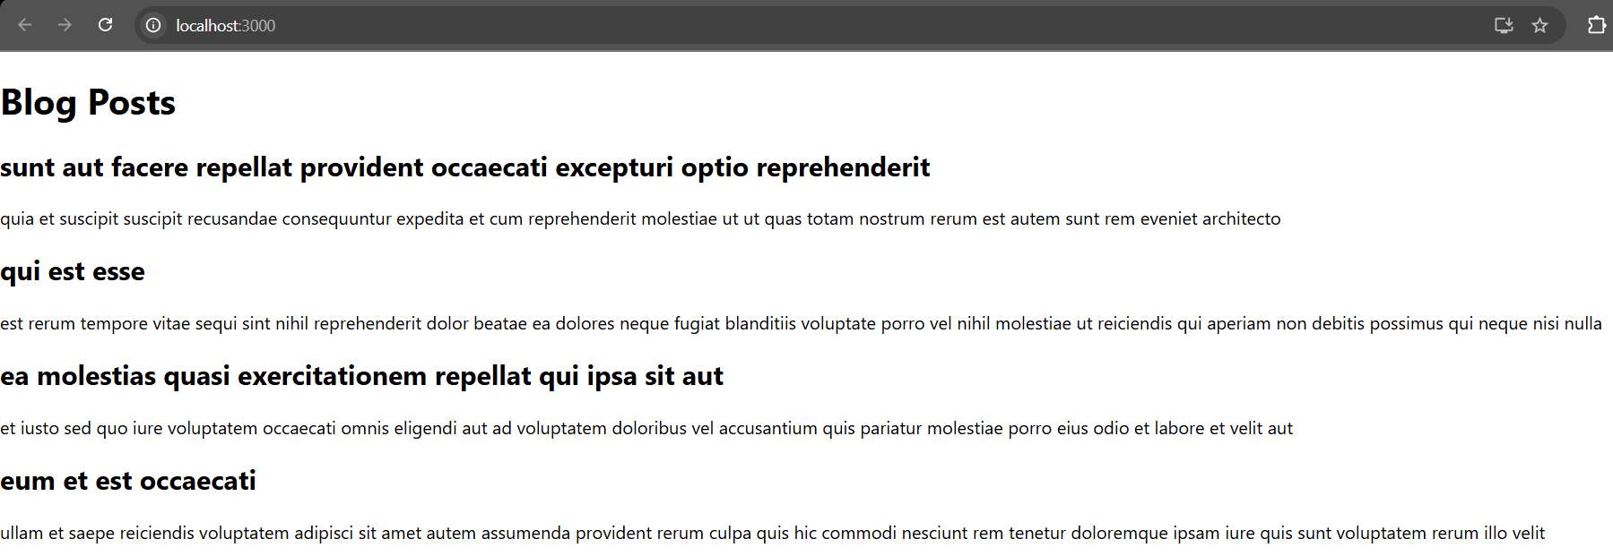**Output:**

**Exercise-5: cohorttracker App**

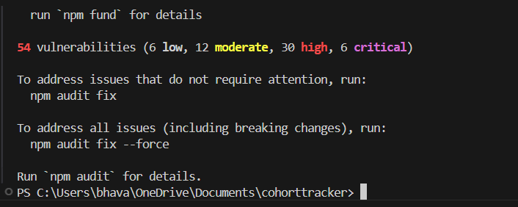1.Open Coharttracker App in VS Code and restore the node packages using “npm install”.

2. Create a new file called “CohortDetails.module.css” in src.

**CohortDetails.module.css:**

.box {

  width: 300px;

  display: inline-block;

  margin: 10px;

  padding: 10px 20px;

  border: 1px solid black;

  border-radius: 10px;

}

dt {

  font-weight: 500;

}

**3. CohartDetails.js:**

import styles from './CohortDetails.module.css';

function CohortDetails(props) {

    return (

        <div className={styles.box}>

            <h3 style={{ color: props.cohort.currentStatus === 'Ongoing' ? 'green' : 'blue' }}>

                {props.cohort.cohortCode} -

                <span>{props.cohort.technology}</span>

            </h3>

            <dl>

                <dt>Started On</dt>

                <dd>{props.cohort.startDate}</dd>

                <dt>Current Status</dt>

                <dd>{props.cohort.currentStatus}</dd>

                <dt>Coach</dt>

                <dd>{props.cohort.coachName}</dd>

                <dt>Trainer</dt>

                <dd>{props.cohort.trainerName}</dd>

            </dl>

        </div>

    );

}

export default CohortDetails;

**4.** Run the application using “npm start” command.

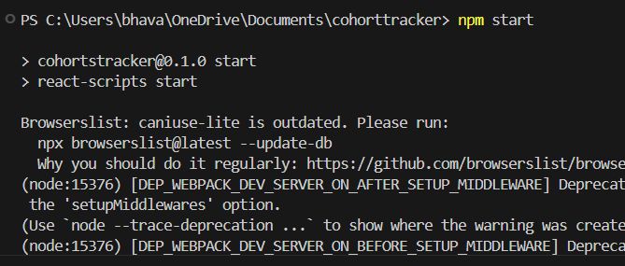**Output:**

