**REACT**

**Exercise-9:cricketapp**

1.Create a React Application named “cricketapp”.

2. In ListofPlayers component declare an array with 11 players and store details of their names and scores using the map feature of ES6 and display the details of all players.

3.In scoreBelow70 component filter the players with scores below 70 using arrow functions of ES6 and display them.

4.In IndianTeamData declare an array IndianTeam for separating them into odd players and even players and also declare two arrays T20players and RanjiTrophy players and merge the two arrays using the Merge feature of ES6.

5.Create three components OddPlayers,EvenPlayers and ListofIndianPlayers to display odd players and even players of IndianTeam and merged players respectively.

**ListofPlayers:**

import React from 'react';

const ListofPlayers = ({ players }) => {

  return (

    <ul>

      {players.map((item, index) => (

        <li key={index}>

          Mr. {item.name} <span>{item.score}</span>

        </li>

      ))}

    </ul>

  );};

export default ListofPlayers;

**ScoreBelow70:**

import React from 'react';

const ScoreBelow70 = ({ players }) => {

  const players70 = [];

  players.map((item) => {

    if (item.score <= 70) {

      players70.push(item);

    }

    return null;

  });

  return (

    <ul>

      {players70.map((item, index) => (

        <li key={index}>

          Mr. {item.name} <span>{item.score}</span>

        </li>

      ))}

    </ul>

  );

};

export default ScoreBelow70;

**IndianTeamData:**

export const IndianTeam = ['Sachin1', 'Dhoni2', 'Virat3', 'Rohit4', 'Yuvaraj5', 'Raina6'];

const T20Players = ['First Player', 'Second Player', 'Third Player'];

const RanjiTrophyPlayers = ['Fourth Player', 'Fifth Player', 'Sixth Player'];

export const IndianPlayers = [...T20Players, ...RanjiTrophyPlayers];

**OddPlayers:**

export function OddPlayers([first, , third, , fifth]) {

  return (

    <div>

      <li>First : {first}</li>

      <li>Third : {third}</li>

      <li>Fifth : {fifth}</li>

    </div>

  );

}

**EvenPlayers:**

export function EvenPlayers([, second, , fourth, , sixth]) {

  return (

    <div>

      <li>Second : {second}</li>

      <li>Fourth : {fourth}</li>

      <li>Sixth : {sixth}</li>

    </div>

  );

}

**ListofIndianPlayers:**

import React from 'react';

const ListofIndianPlayers = ({ IndianPlayers }) => {

  return (

    <ul>

      {IndianPlayers.map((item, index) => (

        <li key={index}>Mr. {item}</li>

      ))}

    </ul>

  );

};

export default ListofIndianPlayers;

**App.js:**

import React from 'react';

import ListofPlayers from './components/ListofPlayers';

import ScoreBelow70 from './components/ScoreBelow70';

import { OddPlayers } from './components/OddPlayers';

import { EvenPlayers } from './components/EvenPlayers';

import ListofIndianPlayers from './components/ListofIndianPlayers';

import { IndianPlayers, IndianTeam } from './components/IndianTeamData';

function App() {

  const flag = true;

  const players = [

    { name: 'Jack', score: 50 },

    { name: 'Michael', score: 70 },

    { name: 'John', score: 40 },

    { name: 'Ann', score: 61 },

    { name: 'Elisabeth', score: 61 },

    { name: 'Sachin', score: 95 },

    { name: 'Dhoni', score: 100 },

    { name: 'Virat', score: 84 },

    { name: 'Jadeja', score: 64 },

    { name: 'Raina', score: 75 },

    { name: 'Rohit', score: 80 }

  ];

  if (flag === true) {

    return (

      <div>

        <h1>List of Players</h1>

        <ListofPlayers players={players} />

        <hr />

        <h1>List of Players having Scores Less than 70</h1>

        <ScoreBelow70 players={players} />

      </div>

    );

  } else {

    return (

      <div>

        <div>

          <h1>Indian Team</h1>

          <h1>Odd Players</h1>

          {OddPlayers(IndianTeam)}

          <hr />

          <h1>Even Players</h1>

          {EvenPlayers(IndianTeam)}

        </div>

        <hr />

        <div>

          <h1>List of Indian Players Merged:</h1>

          <ListofIndianPlayers IndianPlayers={IndianPlayers} />

        </div>

      </div>

    );

  }

}

export default App;

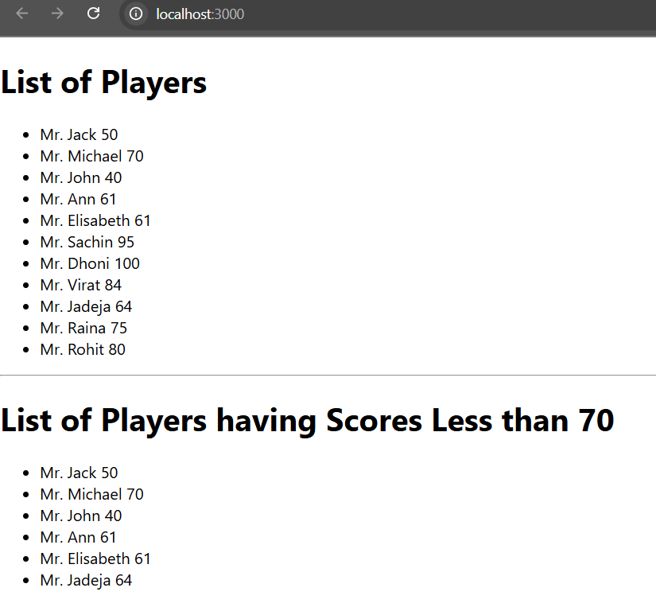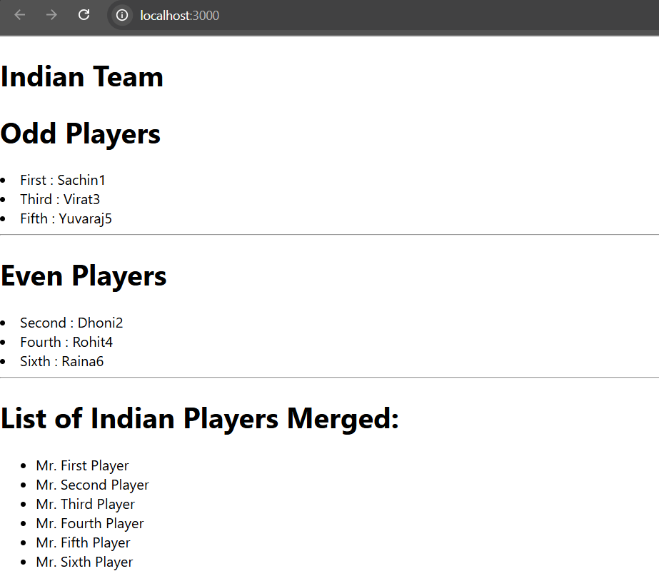**Output:**

**Exercise-10:officespacerentalapp**

1.Create a React Application named “officespacerentalapp”.

2.Create an element to display the heading of the page.

3.Create an attribute to display the image of the office space.

4.Create an object of office to display the details like Name, Rent and Address.

5.Create a list of Object and loop through the office space item to display more data.

6.To apply Css, Display the color of the Rent in Red if it’s below 60000 and in Green if it’s above 60000.

**App.js:**

import React from 'react';

import './App.css';

function App() {

  const heading = "Office Space";

  const jsxatt = <img src="https://static.vecteezy.com/system/resources/previews/015/334/578/non_2x/modern-office-interior-photo.jpg" width="25%" height="25%" alt="Office Space" />;

  const offices = [

    {

      Name: "DBS",

      Rent: 55000,

      Address: "Chennai"

    },

    {

      Name: "WeWork",

      Rent: 70000,

      Address: "Bangalore"

    }

  ];

  return (

    <div className="App">

       <h1>{heading}, at Affordable Range</h1>

      {jsxatt}

      {offices.map((item, index) => {

        const rentColor = item.Rent <= 60000 ? 'textRed' : 'textGreen';

        return (

          <div key={index}>

            <h2>Name: {item.Name}</h2>

            <h3 className={rentColor}>Rent: Rs. {item.Rent}</h3>

            <h3>Address: {item.Address}</h3>

          </div>

        );

      })}

    </div>

  );

}

export default App;

**App.css:**

.App {

  padding-left:10%;

  font-family: Arial, sans-serif;

}

.textRed {

  color: red;

}

.textGreen {

  color: green;

}

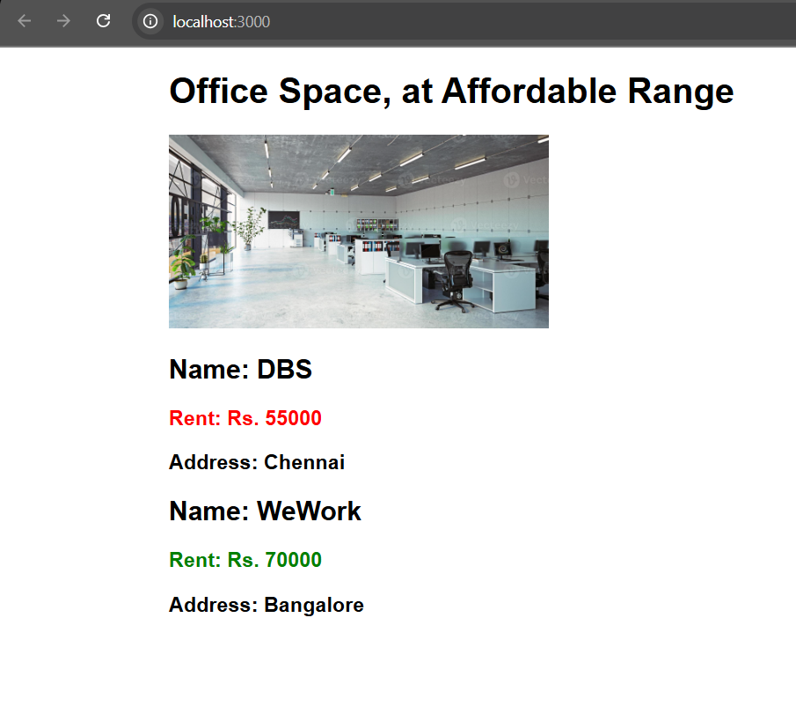**Output:**

**Exercise-11:eventexamplesapp**

1.Create a React Application “eventexamplesapp”.

2.Create “Increment” button to increase the value of the counter and “Decrement” button to decrease the value of the counter.

3.The “Increase” button should invoke multiple methods that is to increment the value and say Hello followed by a static message.

4. Create a button “Say Welcome” which invokes the function which takes “welcome” as an argument.

5. Create a button which invokes synthetic event “OnPress” which display “I was clicked”.

6. Create a “CurrencyConvertor” component which will convert the Indian Rupees to Euro when the Convert button is clicked.

**App.js:**

import React, { useState } from 'react';

import './App.css';

import CurrencyConvertor from './CurrencyConvertor';

function App() {

  const [count, setCount] = useState(5);

  const handleIncrement = () => {

    setCount(prev => prev + 1);

    sayHello();

  };

  const handleDecrement = () => {

    setCount(prev => prev - 1);

  };

  const sayHello = () => {

    alert("Hello! Member1");

  };

  const sayMessage = (msg) => {

    alert(msg);

  };

  const onPress= (e) => {

    alert("I was clicked");

  };

  return (

    <div className="App">

      <h2>{count}</h2>

      <button onClick={handleIncrement}>Increment</button>

      <button onClick={handleDecrement}>Decrement</button>

      <button onClick={() => sayMessage("welcome")}>Say welcome</button>

      <button onClick={onPress}>Click on me</button>

      <CurrencyConvertor />

    </div>

  );}

export default App;

**CurrencyConvertor.js:**

import React, { useState } from 'react';

const CurrencyConvertor = () => {

  const [amount, setAmount] = useState('');

  const [currency, setCurrency] = useState('');

  const handleSubmit = (e) => {

  e.preventDefault();

  if (currency.toLowerCase() === "euro") {

    const result = parseFloat(amount) * 80;

    alert(`Converting to Euro Amount is ${result}`);

  } else {

    alert("Currency not supported");

  }

};

  return (

    <div style={{ textAlign: 'left', marginTop: '30px' }}>

      <h2 style={{ color: 'green' }}>Currency Convertor!!!</h2>

      <form onSubmit={handleSubmit}>

        <label>Amount: </label>

        <input

          type="text"

          value={amount}

          onChange={(e) => setAmount(e.target.value)}

        /><br /><br />

        <label>Currency: </label>

        <input

          type="text"

          value={currency}

          onChange={(e) => setCurrency(e.target.value)}

        /><br /><br />

        <button type="submit">Submit</button>

      </form>

    </div>

  );};

export default CurrencyConvertor;

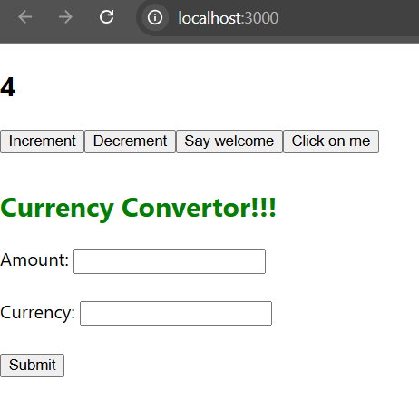**Output:**

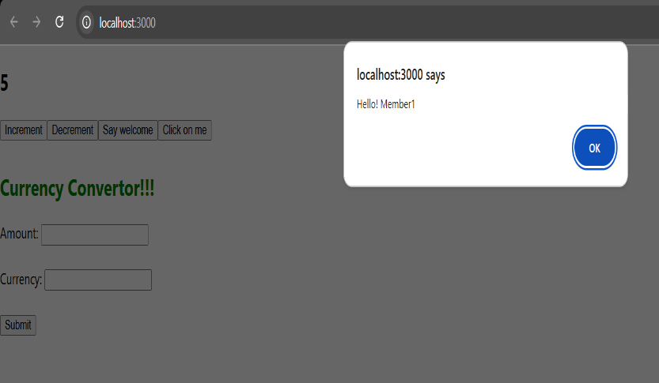

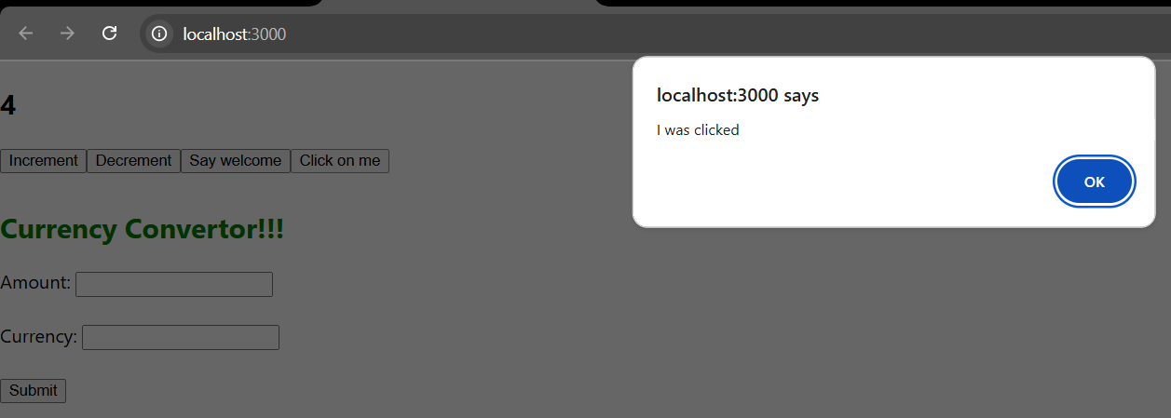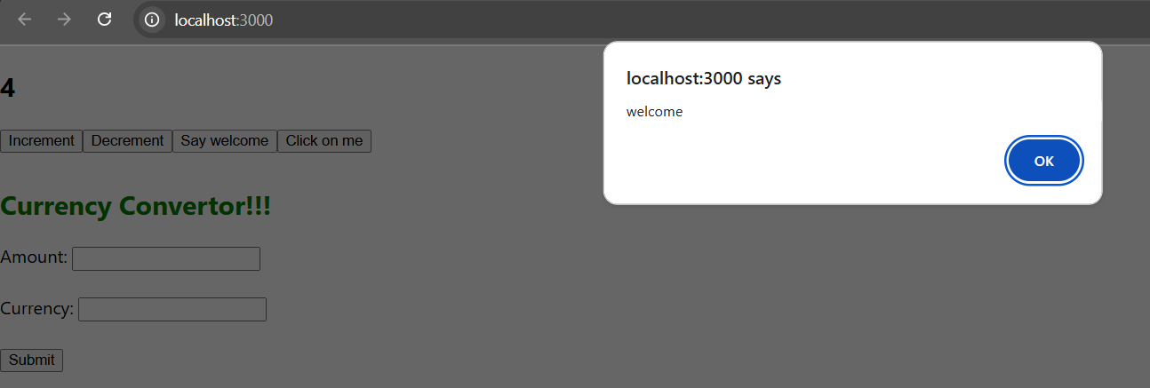

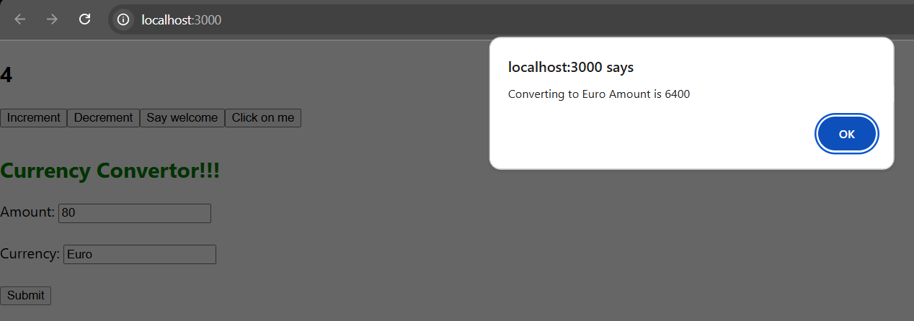

**Exercise-12:ticketbookingapp**

1.Create a React Application named “ticketbookingapp”.

2.In this application the guest user can browse the page where the flight details are displayed whereas the logged in user only can book tickets.

3.The Login and Logout buttons display different pages.

4.Once the user is logged in the User page will be displayed. When the user clicks on Logout, the Guest page will be displayed.

**App.js:**

import React, { useState } from "react";

import "./App.css";

function LoginButton(props) {

  return (

    <button onClick={props.onClick}>

      Login

    </button>

  );

}

function LogoutButton(props) {

  return (

    <button onClick={props.onClick}>

      Logout

    </button>

  );

}

function GuestPage() {

  return (

    <div>

      <h2>Welcome, Guest!</h2>

      <p>Here are the available flights:</p>

      <ul>

        <li>Flight A - 10:00 AM</li>

        <li>Flight B - 12:00 PM</li>

        <li>Flight C - 3:00 PM</li>

      </ul>

      <h3>Please sign up</h3>

    </div>

  );

}

function UserPage() {

  return (

    <div>

      <h2>Welcome back!</h2>

      <p>Here are the available flights:</p>

      <ul>

        <li>Flight A - 10:00 AM <button>Book</button></li>

        <li>Flight B - 12:00 PM <button>Book</button></li>

        <li>Flight C - 3:00 PM <button>Book</button></li>

      </ul>

    </div>

  );

}

function App() {

  const [isLoggedIn, setIsLoggedIn] = useState(false);

  const handleLoginClick = () => {

    setIsLoggedIn(true);

  };

  const handleLogoutClick = () => {

    setIsLoggedIn(false);

  };

  let button;

  let page;

  if (isLoggedIn) {

    button = <LogoutButton onClick={handleLogoutClick} />;

    page = <UserPage />;

  } else {

    button = <LoginButton onClick={handleLoginClick} />;

    page = <GuestPage />;

  }

  return (

    <div className="App">

      {page}

      {button}

    </div>

  );

}

export default App;

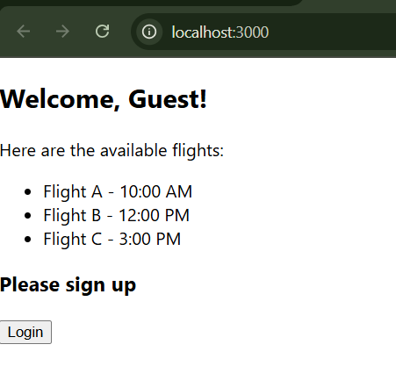**Output:**

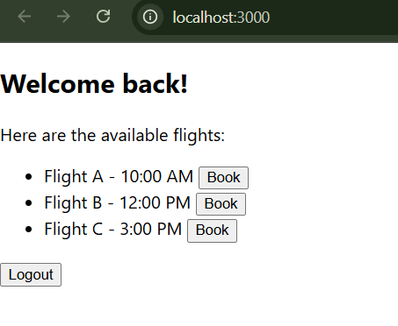

**Exercise-13:bloggerapp**

1.Create a React App named “bloggerapp”.

2.Create three components BookDetails,CourseDetails,BlogDetails to display information of books,courses and blogs repectively.

3.create another component data to store the sample data.

**Data.js:**

export const books = [

  { id: 101, bname: 'Master React', price: 670 },

  { id: 102, bname: 'Deep Dive into Angular 11', price: 800 },

  { id: 103, bname: 'Mongo Essentials', price: 450 },

];

export const courses = [

  { id: 1, cname: 'Angular', date: '4/5/2021' },

  { id: 2, cname: 'React', date: '6/3/2021' },

];

export const blogs = [

  {

    id: 1,

    title: 'React Learning',

    author: 'Stephen Biz',

    content: 'Welcome to learning React!'

  },

  {

    id: 2,

    title: 'Installation',

    author: 'Schewzdenier',

    content: 'You can install React from npm.'

  },

];

**BookDetails.js:**

import React from 'react';

export default function BookDetails(props) {

  return (

    <div className='book'>

      <h1>Book Details</h1>

      <ul>

        {props.books.map(book => (

          <li key={book.id}>

            <h3>{book.bname}</h3>

            <h4>{book.price}</h4>

          </li>

        ))}

      </ul>

    </div>

  );

}

**CourseDetails.js:**

import React from 'react';

export default function CourseDetails(props) {

  return (

    <div className='course'>

      <h1>Course Details</h1>

      <ul>

        {props.courses.map(course => (

          <li key={course.id}>

            <h3>{course.cname}</h3>

            <h4>{course.date}</h4>

          </li>

        ))}

      </ul>

    </div>

  );

}

**BlogDetails.js:**

import React from 'react';

export default function BlogDetails(props) {

  return (

    <div className='blog'>

      <h1>Blog Details</h1>

      <ul>

        {props.blogs.map(blog => (

          <li key={blog.id}>

            <h3>{blog.title}</h3>

            <p><strong>{blog.author}</strong></p>

            <p>{blog.content}</p>

          </li>

        ))}

      </ul>

    </div>

  );

}

**App.js:**

import React from 'react';

import './App.css';

import BookDetails from './components/BookDetails';

import BlogDetails from './components/BlogDetails';

import CourseDetails from './components/CourseDetails';

import { books, courses, blogs } from './components/data';

function App() {

  return (

    <div className="App">

      <BookDetails books={books} />

      <BlogDetails blogs={blogs} />

      <CourseDetails courses={courses} />

    </div>

  );

}

export default App;

**App.css:**

.course, .blog, .book {

  display: inline-block;

  vertical-align: top;

  padding: 20px;

  width: 25%;

}

.book, .blog {

  border-right: 4px solid green;

}

.App{

  display: flex;

  justify-content: center;

  margin-top: 100px;

}

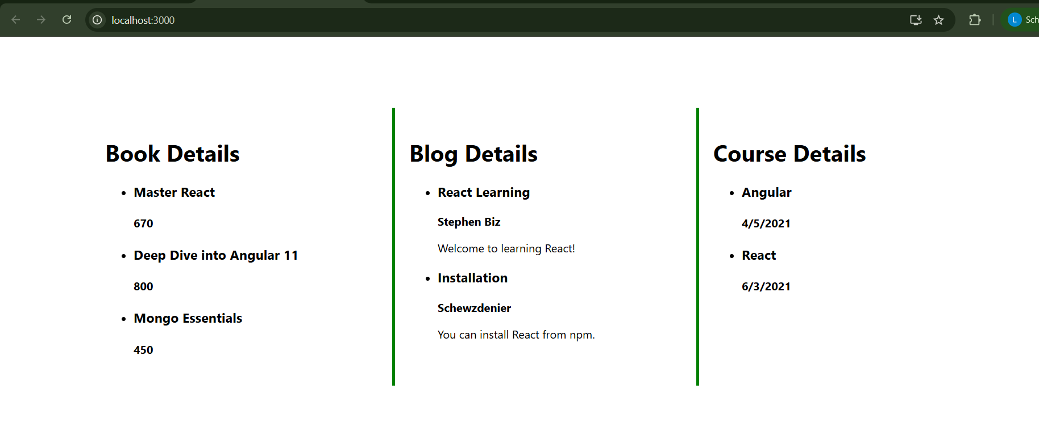**Output:**