[@Rishi Das](mailto:rishi.das@ericsson.com)

Once you detect below problem, please restart the related jboss-hc from JBoss console (Debojyoti has done it before).  Currently, they are started now.

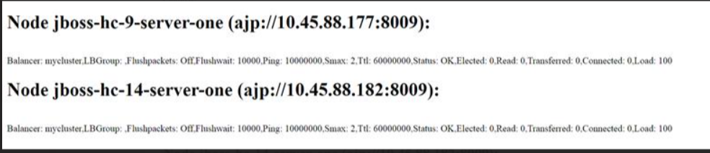

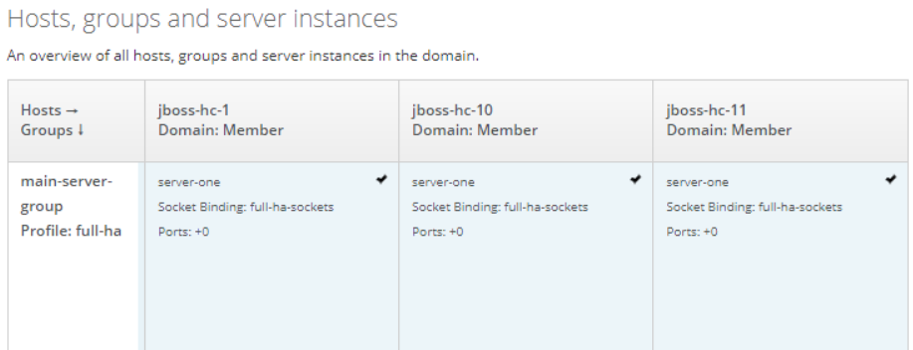

In addition, as written in previous email,  MIST team can do some troubleshooting according to below guide:

1. When you detect the “internal error” issue, refresh the EI chart, and note down the user and the time.
2. Locate which JBoss server it is connect to with below command (UIN and time are from step1, the red part should be replaced with correct UIN and time).

*# clustercmd --jboss -- "grep 613489360 /opt/ericsson/eea/log/aggregator-web-service-sql-logs.log|grep '2022-12-01 20:49'"*

1. You will get one JBoss server containing the logs from above command.  For example: rel14620jbs005.

It probably means this JBoss server has corrupted cache files. All the aggregator web clients connected to this JBoss server will report “internal error”.

1. Now you login to this JBoss server and identify the corrupted cache files in this JBoss server. And remove those files.

# ssh rel14620jbs005

# grep /local/jboss/aggregator-web-service-internal-available-values-cache /opt/ericsson/eea/log/server-one/serverlog/server.log

# rm -rf <the_corrupted_cache_files>

1. Now you can restart the related jboss-hc for this JBoss server rel14620jbs005 **from JBoss console** (Don’t need to restart whole JBoss cluster). You can find out the correct jboss-hc (jboss-hc-9 is for rel14620jbs005) from below mapping.

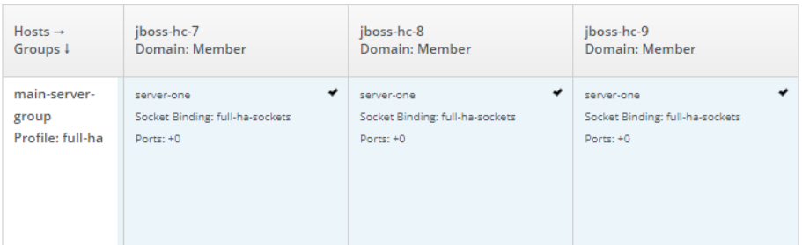

                  10.45.88.184 rel14620jbs012  jboss-hc-1

                  10.45.88.185 rel14620jbs013  jboss-hc-2

                  10.45.88.186 rel14620jbs014  jboss-hc-3

                  10.45.88.187 rel14620jbs015  jboss-hc-4

                  10.45.88.173 rel14620jbs001  jboss-hc-5

                  10.45.88.174 rel14620jbs002  jboss-hc-6

                  10.45.88.175 rel14620jbs003  jboss-hc-7

                  10.45.88.176 rel14620jbs004  jboss-hc-8

                  10.45.88.177 rel14620jbs005  jboss-hc-9

                  10.45.88.178 rel14620jbs006  jboss-hc-10

                  10.45.88.179 rel14620jbs007  jboss-hc-11

                  10.45.88.180 rel14620jbs008  jboss-hc-12

                  10.45.88.181 rel14620jbs009  jboss-hc-13

                  10.45.88.182 rel14620jbs010  jboss-hc-14

                  10.45.88.183 rel14620jbs011  jboss-hc-15

1. Now you refresh the EI chart.

If the EI chart is loaded successfully, it is ok.

If the EI chart still reports “internal error”, repeat step1 ~ step6. (Probably you will find the crash cache files in another JBoss server)

[05:30] Vipul Vyas

as per tyler - as per Tyler, Next time, you can try to these 2 methods. If the "internal error" happens after the loading for more than 6 seconds. You can try to restart the aggreagtor web service.

[05:30] Vipul Vyas

It the "internal error" happens immediately after you refresh the EI chart page, you can try trouble shooting with the method in my email.

[05:30] Vipul Vyas

trying to restart aggreagtor web service.

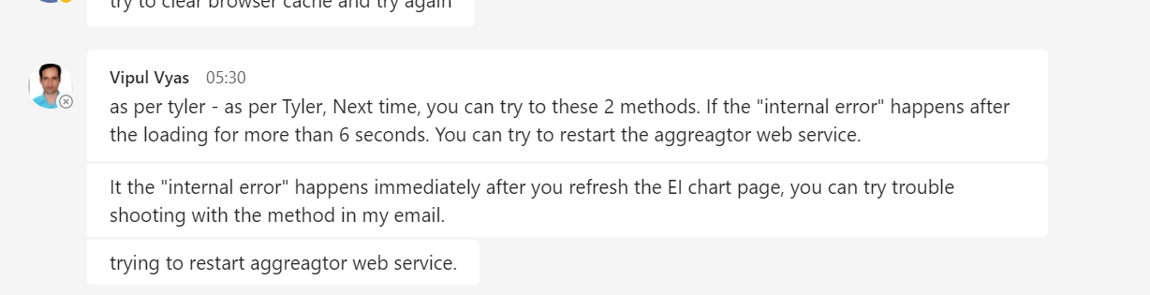

As per tyler 1. Next time, you can try to these 2 methods. If the "internal error" happens after the loading for more than 6 seconds.  
You can try to restart the aggreagtor web service.\  
  
  
2. It the "internal error" happens immediately after you refresh the EI chart page, you can try trouble shooting with the method in my email.  
  
  
to find out correpted cahche we need to put UIN number and current Date and time in this below path and run inthe jbs012 server(before run this path  
in the jbs012 we need to first stop the "aggreagtor web service" from Jboss admin console (Deployment- Server Group-view-aggreagtor web service and then  
EN/diable --- it will take time.)  
  
  
clustercmd --jboss -- "grep 613828688 /opt/ericsson/eea/log/aggregator-web-service-sql-logs.log|grep '2022-11-10 01:00"  
  
  
first we need to login into the ark44  
  
  
check first throgh below command  
arkctl status domaincontroller loadbalancer  
arkctl stop domaincontroller loadbalancer  
arkctl start domaincontroller loadbalancer  
  
  
  
or  
  
  
we can try with below commands.  
  
  
1. arkctl status domaincontroller hostcontroller loadbalancer  
  
  
2. arkctl stop domaincontroller hostcontroller loadbalancer  
  
  
3. arkctl start domaincontroller hostcontroller loadbalancer  
  
  
  
in ark we have to go with  
  
  
ssh rel14620jbs012 or ssh jbos012 IP : [10.45.90.184](http://10.45.90.184/)  
  
  
cd /opt/ericsson/eea/ark/config/jboss_conf/CNE-deployable/  
ls -lrth  
  
  
Then run below script.  
  
  
./[restart_docker_host.sh](http://restart_docker_host.sh/)  
  
  
after that we need to check Jboss mod cluster for virtual host exit ot not in every Node.  
  
  
then restart one by one HC server from Jboss admin console.