**DAILY ONLINE ACTIVITIES SUMMARY**

|  |  |  |  |  |  |  |  |  |
| --- | --- | --- | --- | --- | --- | --- | --- | --- |
| **Date:** | **19-05-2020** | | | | | **Name:** | **Anusha** | |
| **Sem & Sec** | **6th sem & A sec** | | | | | **USN:** | **4AL17CS007** | |
| **Online Test Summary** | | | | | | | | |
| **Subject** | | **CGV IA Test 1** | | | | | | |
| **Max. Marks** | | **53** | | **Score** | | | **60** | |
| **Certification Course Summary** | | | | | | | | |
| **Course** | **Introduction to IOT, Cyber Security essentials** | | | | | | | |
| **Certificate Provider** | | | **CISCO Networking Academy** | | **Duration** | | | **3hr( spent daily by me to learn)** |
| **Coding Challenges** | | | | | | | | |
| **Problem Statement:**  1.Python Program to Execute the Values of Two Number using ^ (exclusive or operator).  2.Write Python Program to Reverse a Given Number. This is a Python Program to reverse a given number. | | | | | | | | |
| **Status:Completed** | | | | | | | | |
| **Uploaded the report in Github** | | | | | **Yes** | | | |
| **If yes Repository name** | | | | | <https://github.com/AnushaR2416/Coding-assessment> | | | |
| **Uploaded the report in slack** | | | | | **Yes** | | | |

**Online test Detail:**

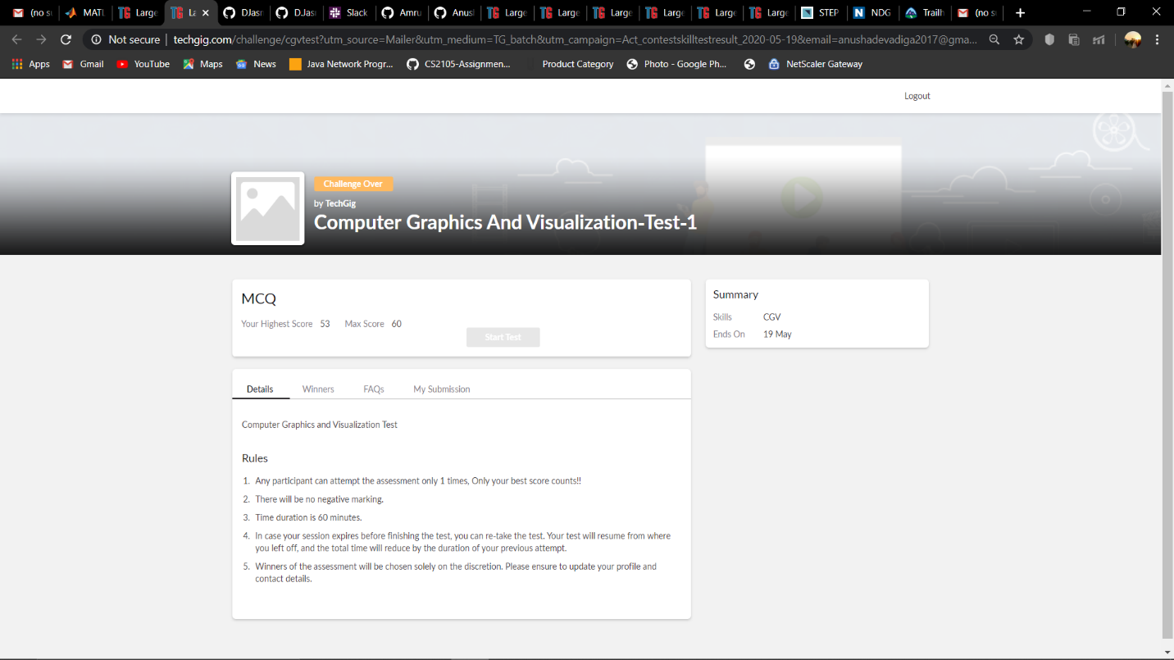

**Online Certification Details**

Modules completed:

- Introduction to IOT

- Cyber Security essentials

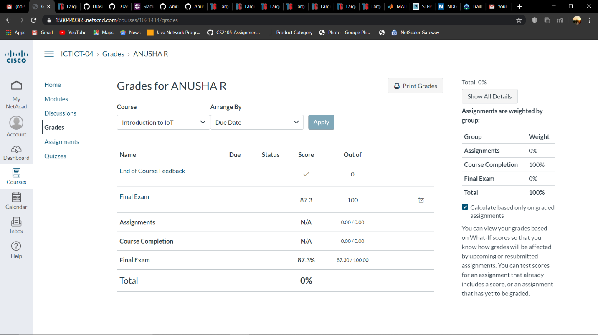

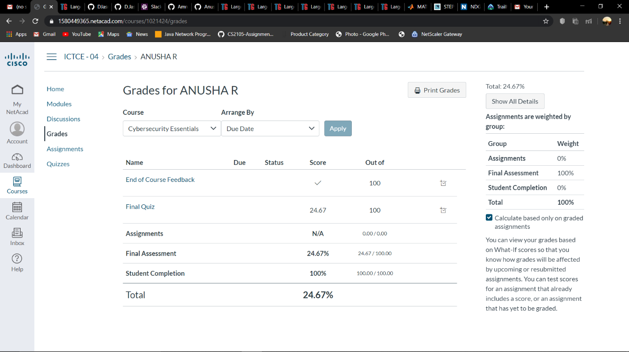

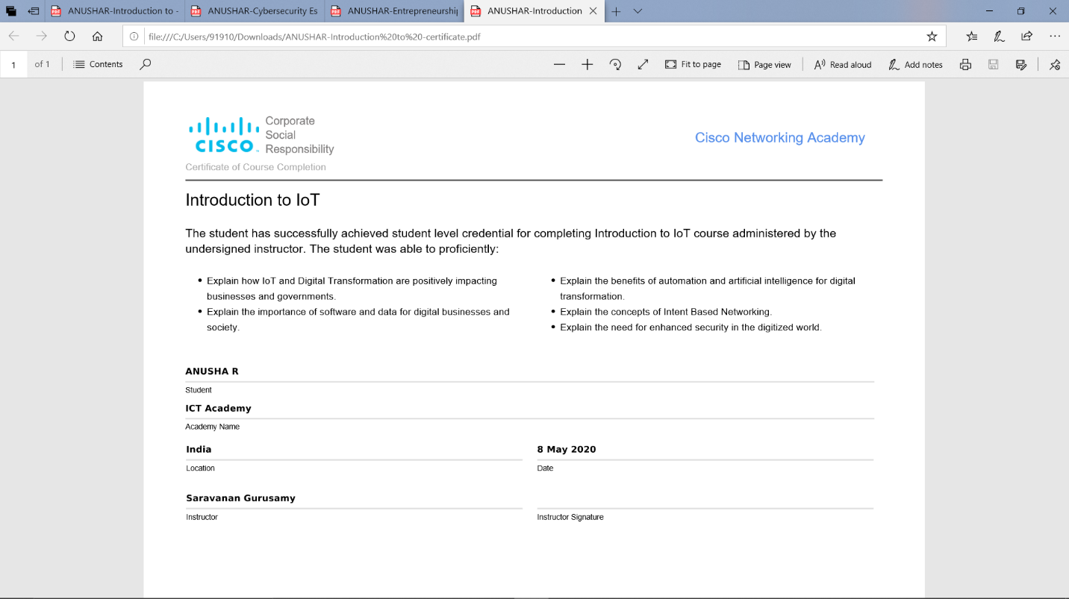

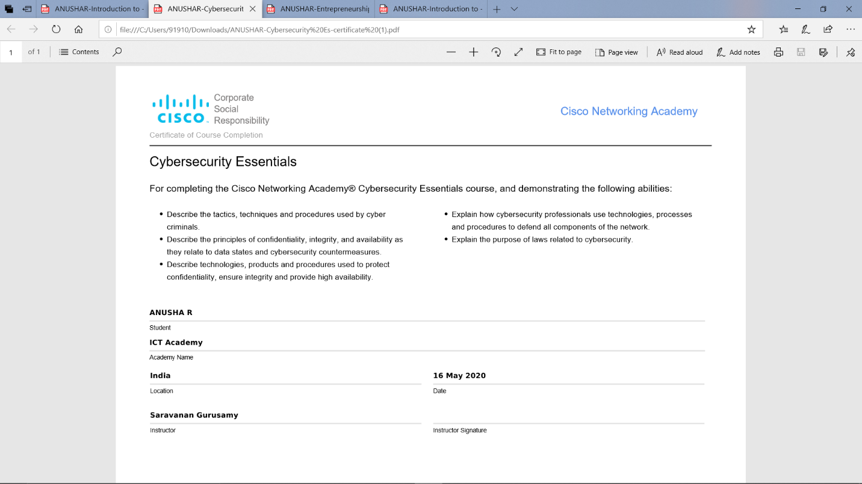

**Coding Challenge Details**

1.Python Program to Execute the Values of Two Number using ^ (exclusive or operator)

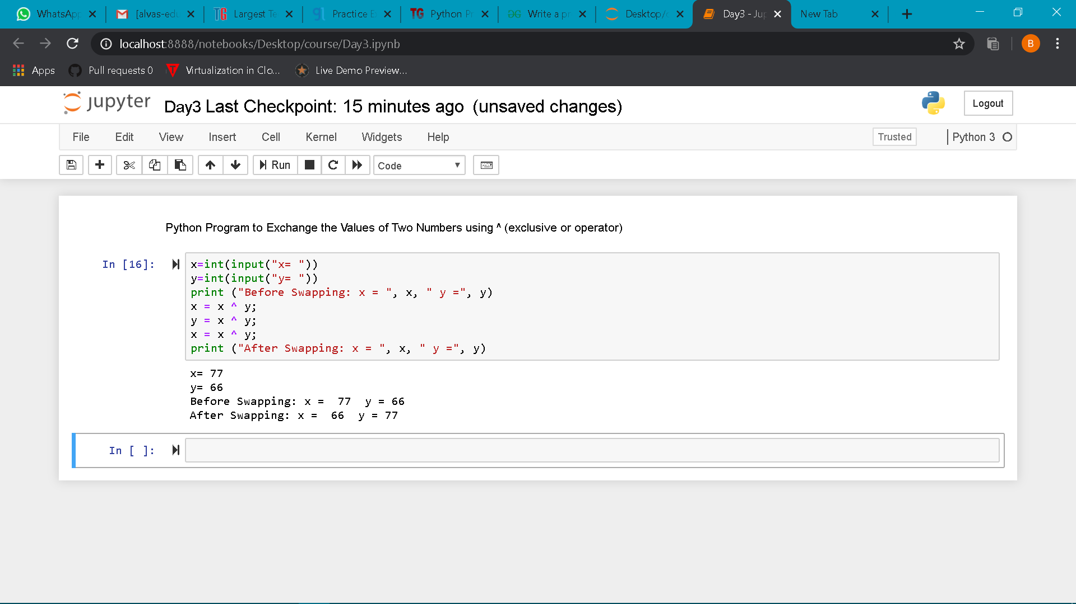

2. Write Python Program to Reverse a Given Number. This is a Python Program to reverse a given number.

