**DAILY ONLINE ACTIVITIES SUMMARY**

|  |  |  |  |  |  |  |  |  |
| --- | --- | --- | --- | --- | --- | --- | --- | --- |
| **Date:** | **23/05/2020** | | | | | **Name:** | **Anusha** | |
| **Sem & Sec** | **6th sem & A sec** | | | | | **USN:** | **4AL17CS007** | |
| **Online Test Summary** | | | | | | | | |
| **Subject** | | **PAP IA Test** | | | | | | |
| **Max. Marks** | | **30** | | **Score** | | | **15** | |
| **Certification Course Summary** | | | | | | | | |
| **Course** | **Machine Learning Onramp** | | | | | | | |
| **Certificate Provider** | | | **MathWorks** | | **Duration** | | | **3 hr(spent by me on that day to learn)** |
| **Coding Challenges** | | | | | | | | |
| **Problem Statement:**   1. Python program to print positive numbers in a list given a list of numbers, write a Python program to print all positive numbers in given list. 2. Python program to count positive and negative numbers in a list given a list of numbers, write a Python program to count positive and negative numbers in a List. | | | | | | | | |
| **Status: Completed** | | | | | | | | |
| **Uploaded the report in Github** | | | | | **Yes** | | | |
| **If yes Repository name** | | | | | <https://github.com/AnushaR2416/Coding-assessment> | | | |
| **Uploaded the report in slack** | | | | | **Yes** | | | |

**Online Test Details**

PAP TEST Details:

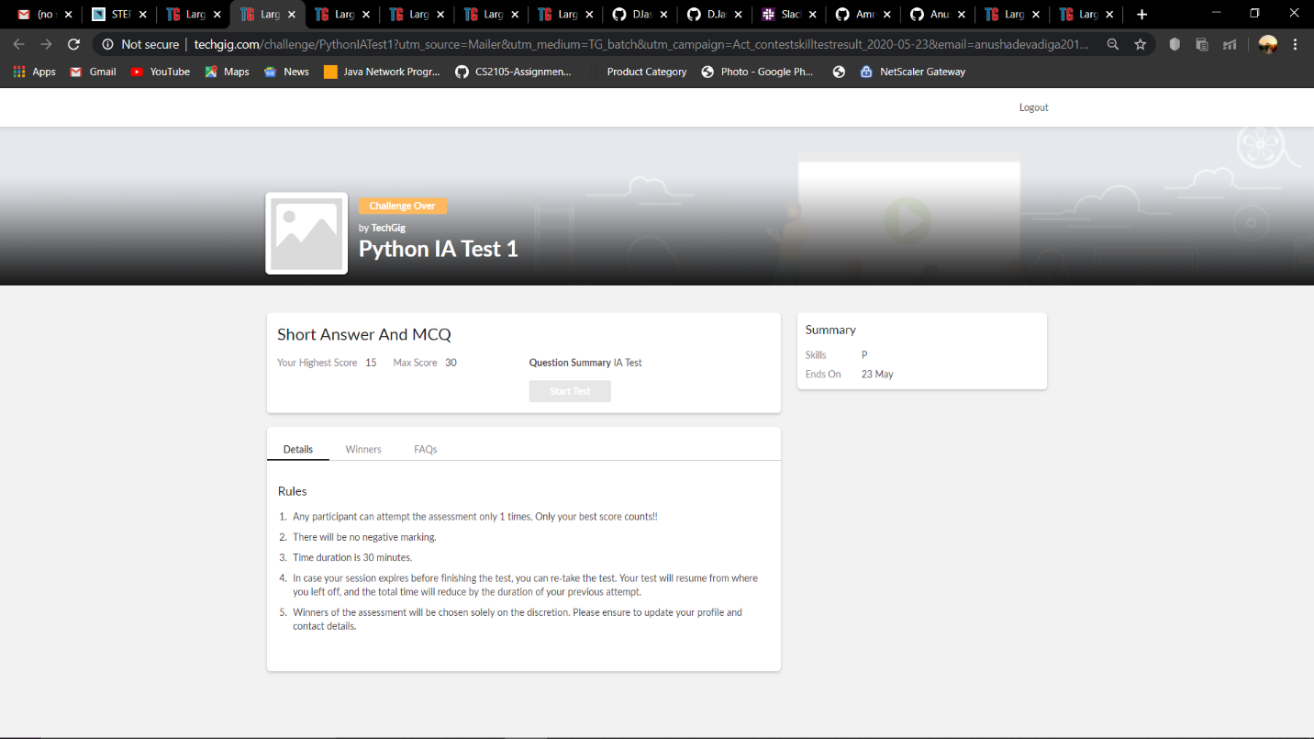

**Online Certification Details**

Lessons completed:

1. **Overview of Machine Learning**
2. **Classification Workflow**
3. **Importing and Preprocessing Data**
4. **Engineering Features**
5. **Classification Models**
6. **Conclusion**

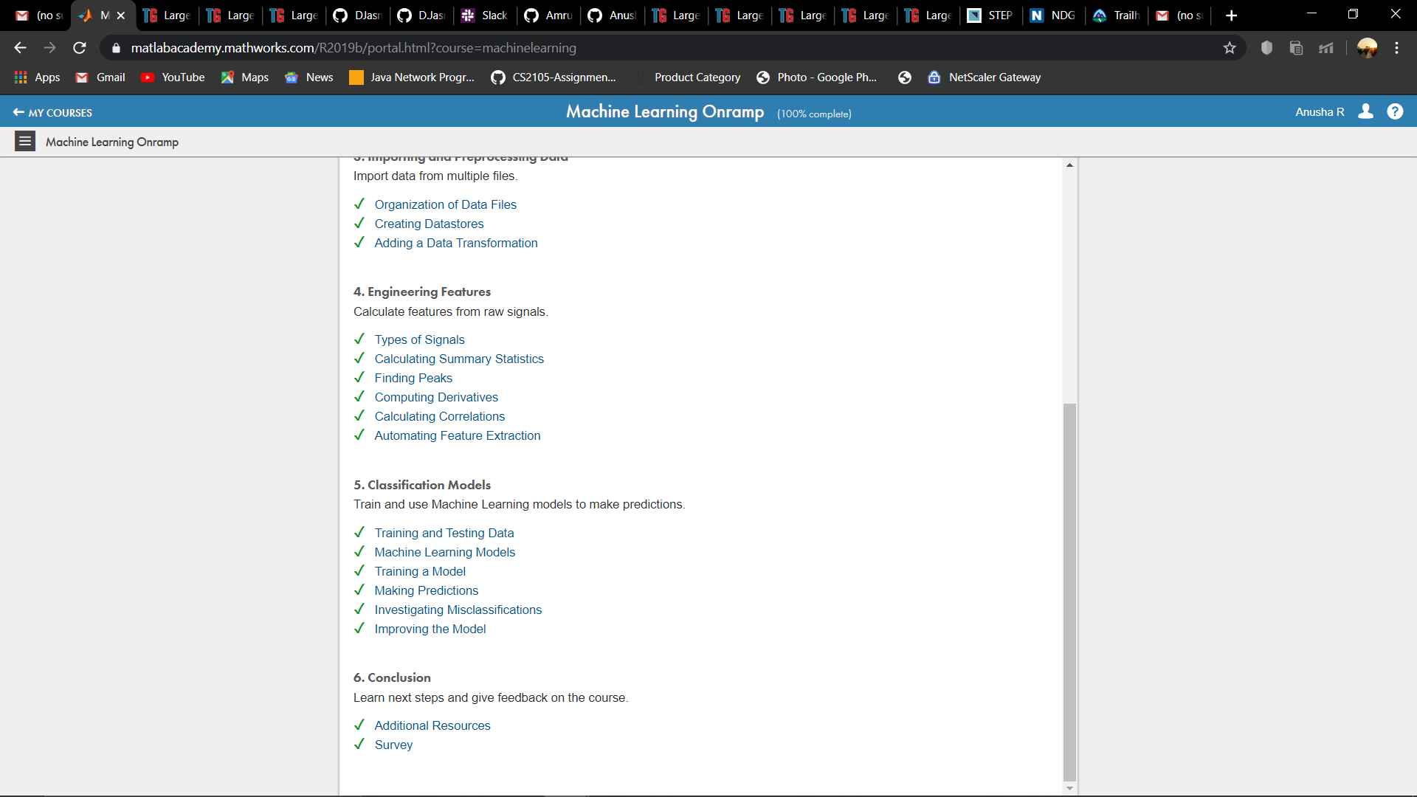

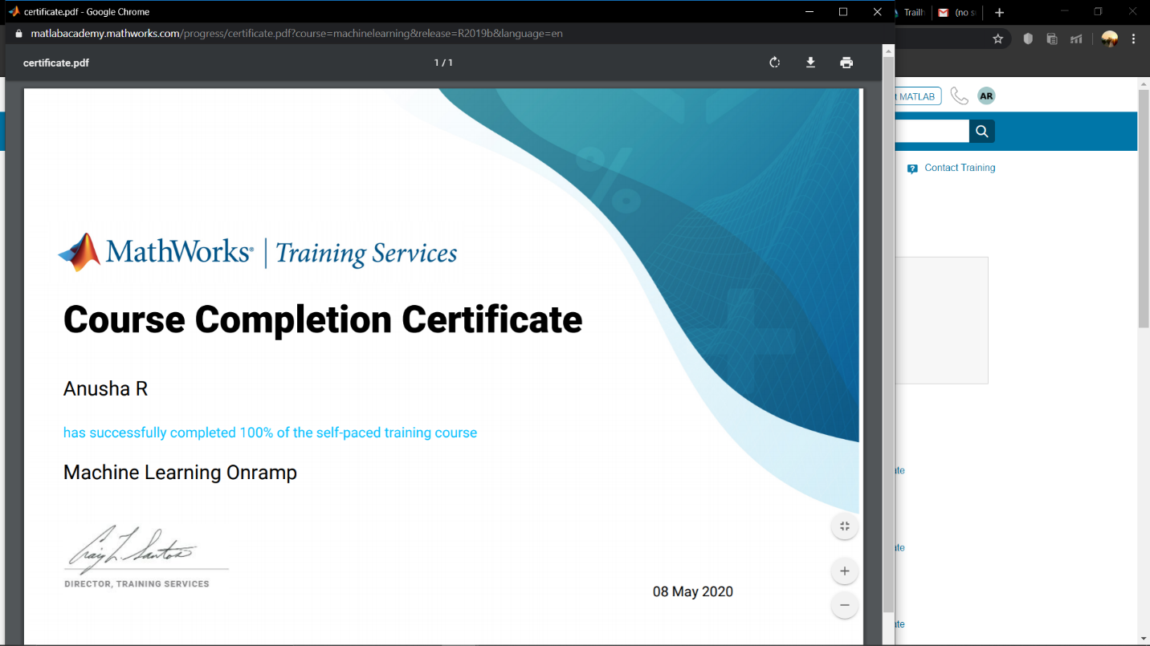

**Coding Challenge Details**

1. Python program to print positive numbers in a list given a list of numbers, write a Python program to print all positive numbers in given list.

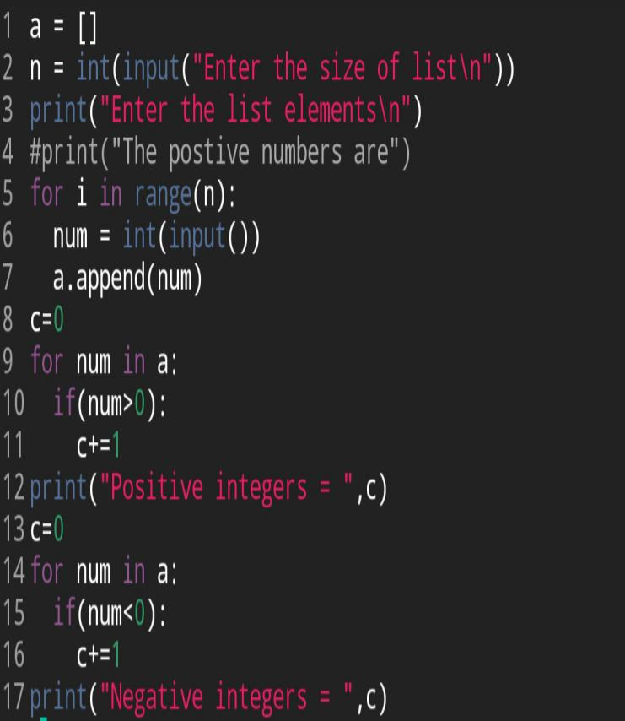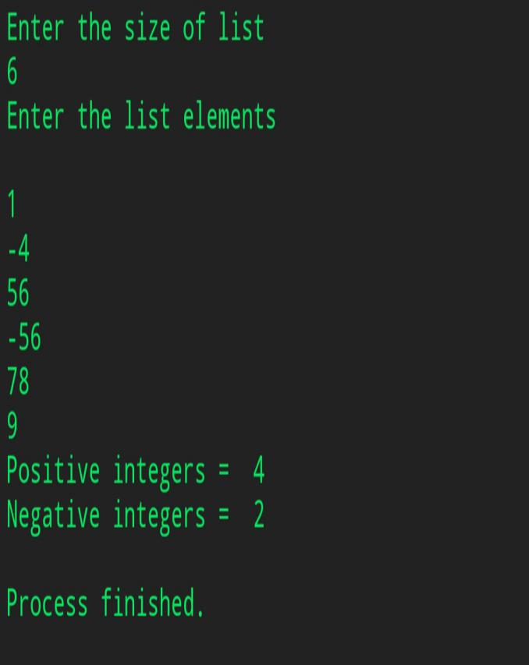

1. Python program to count positive and negative numbers in a list given a list of numbers, write a Python program to count positive and negative numbers in a List.

