**DAILY ONLINE ACTIVITIES SUMMARY**

|  |  |  |  |  |  |  |  |  |
| --- | --- | --- | --- | --- | --- | --- | --- | --- |
| **Date:** | **27/05/2020** | | | | | **Name:** | **ANUSHA** | |
| **Sem & Sec** | **6th sem & A sec** | | | | | **USN:** | **4AL17CS007** | |
| **Online Test Summary** | | | | | | | | |
| **Subject** | | **SSCD IA Test - 2** | | | | | | |
| **Max. Marks** | | **30** | | **Score** | | | **23** | |
| **Certification Course Summary** | | | | | | | | |
| **Course** | **Software-Defined Storage Concepts,** **Network Virtualization Concepts** | | | | | | | |
| **Certificate Provider** | | | **VMware** | | **Duration** | | | **2 hr(spent by me on that day to learn)** |
| **Coding Challenge** | | | | | | | | |
| **Problem Statement:**   1. Python Program to print all the numbers not divisible either by 3 or 2 lying between 1 &50 2. Python Program to print given digit is palindrome or not | | | | | | | | |
| **Status: Completed** | | | | | | | | |
| **Uploaded the report in Github** | | | | | **Yes** | | | |
| **If yes Repository name** | | | | | <https://github.com/AnushaR2416/Coding-assessment> | | | |
| **Uploaded the report in slack** | | | | | **Yes** | | | |

**Online Test Details**

SSCD TEST-2 Details:

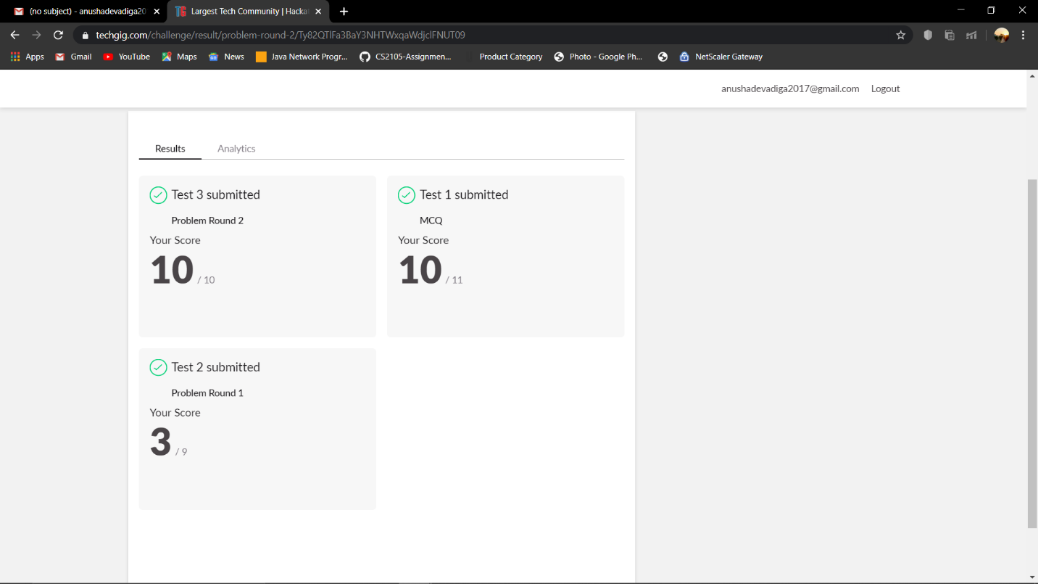

**Online Certification Details**

Lessons completed:

1. Software-Defined Storage Concepts
2. Network Virtualization Concepts

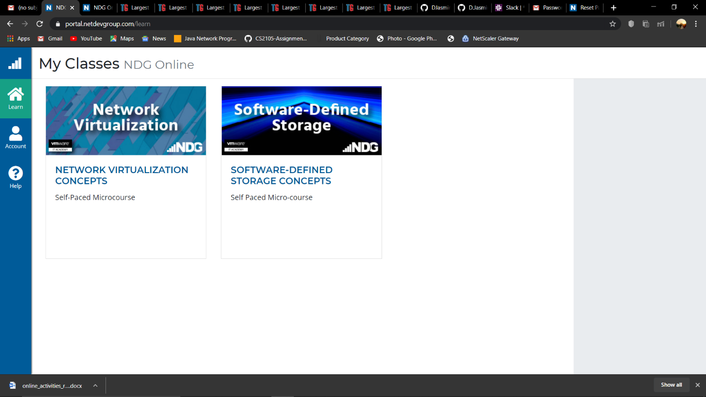

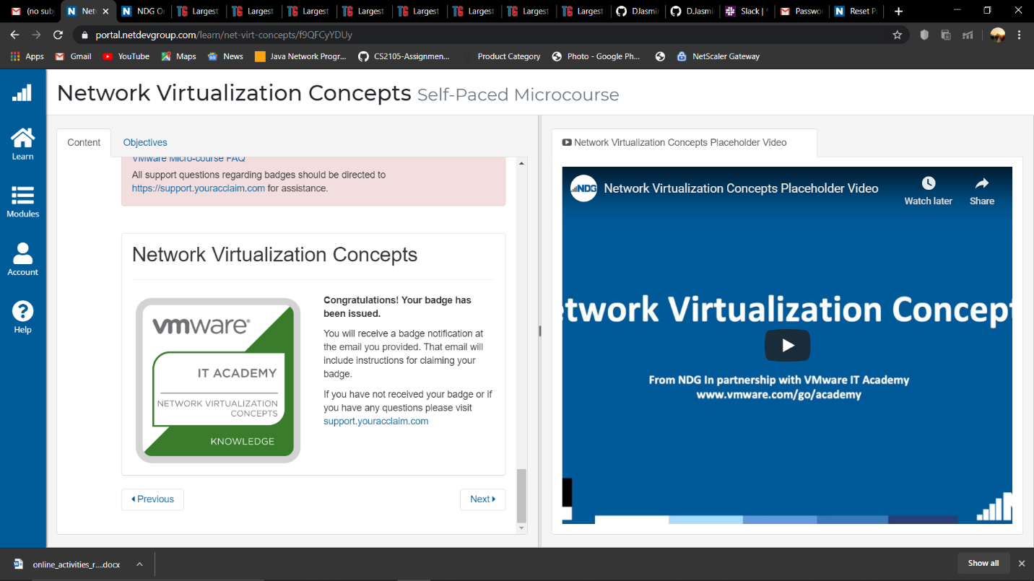

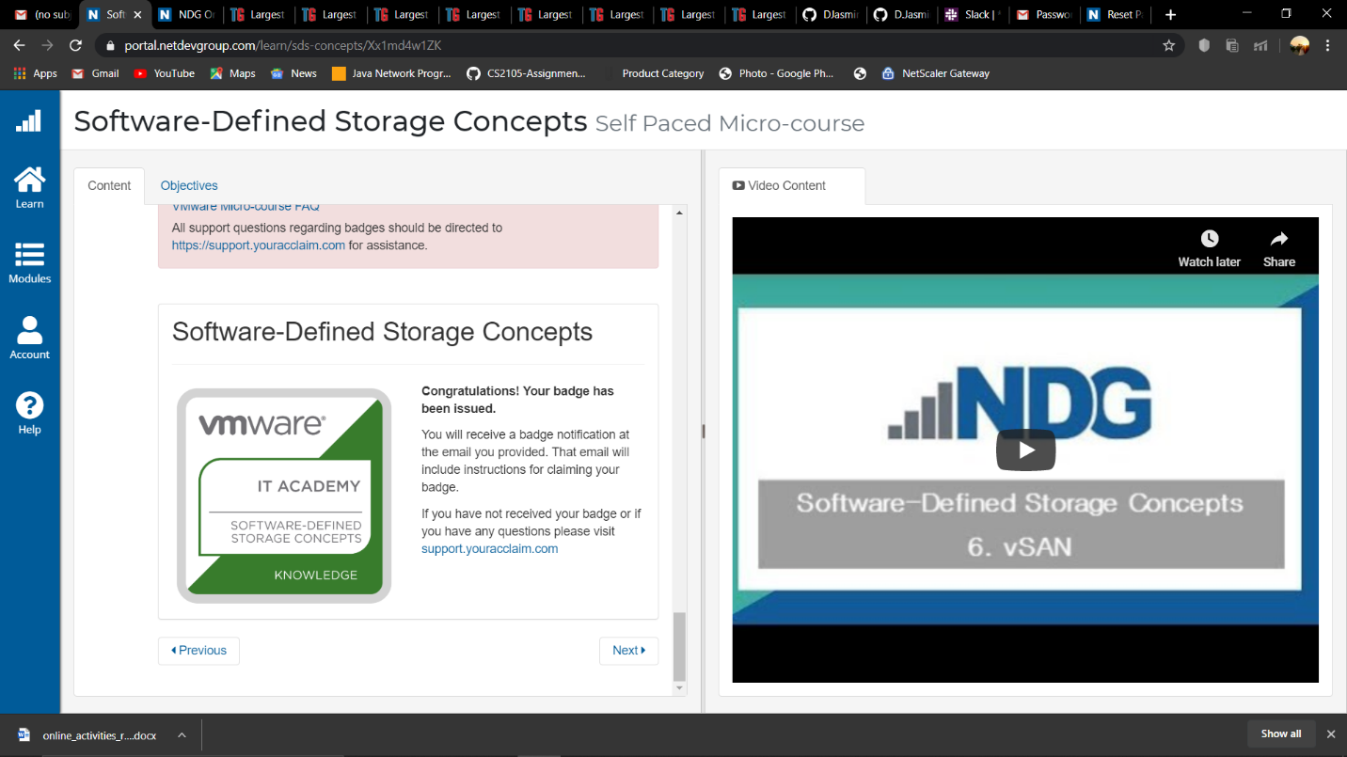

**Coding Challenge Details**

1. Python Program to print all the numbers not divisible either by 3 or 2 lieing between 1 &50

2. Python Program to print given digit is plaindrome or not.

