**UNIT-4**

**Cloud Computing:**

The first mention of cloud computing was in a **1997** paper entitled “Intermediaries in Cloud-Computing: A New Computing Paradigm”.Much like the Internet of Things (IoT), cloud computing is a natural evolution of **related, existing, and new concepts in the information and communications technologies (ICT) arena**, based on the widespread **adoption of virtualization, cluster computing , grid computing, service-oriented architecture, web services, parallel and distributed file systems , load balance and batch scheduling , autonomic, and utility computing technologies**. Cloud computing is the on-demand delivery of *computing services (ex: servers, storage, databases, networking, software, analytics, and intelligence)* over the Internet with pay-as-you-go basis.

Cloud computing provides computation, software, data access, and storage services that do not require end-user knowledge of the physical location and configuration of the system that delivers the services. Details are abstracted from end-users, who no longer have the need for expertise in, or control over, the technology infrastructure “in the cloud” that supports them.

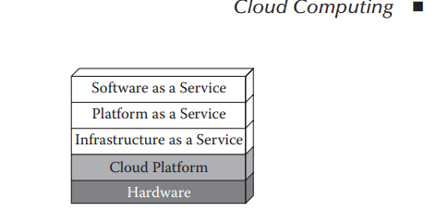

**Infrastructure as a Service (IaaS):**

* IaaS is also known as Hardware as a Service (HaaS).
* It is a computing infrastructure managed over the internet.
* The main advantage of using IaaS is that it helps users to avoid the cost and complexity of purchasing and managing the physical servers.

**Example:** DigitalOcean, Linode, Amazon Web Services (AWS), Microsoft Azure, Google Compute Engine (GCE), Rackspace, and Cisco Metacloud.

**Platform as a Service (PaaS):**

* PaaS cloud computing platform is created for the programmer to develop, test, run, and manage the applications.

**Example**: AWS Elastic Beanstalk, Windows Azure, Heroku, Force.com, Google App Engine, Apache Stratos, Magento Commerce Cloud, and OpenShift.

**Software as a Service (SaaS):**

* SaaS is also known as "on-demand software".
* It is a software in which the applications are hosted by a cloud service provider.
* Users can access these applications with the help of internet connection and web browser.

**Example**: BigCommerce, Google Apps, Salesforce, Dropbox, ZenDesk, Cisco WebEx, ZenDesk, Slack, and GoToMeeting.

**Cloud Middleware:**

* Like Internet of Things, the cloud computing system is also a multitier architecture built on a middleware stack.
* At the lowest machine virtualization (SSV) level, there are middleware that help reduce the overhead of virtualization.
* SSV is useful and widely used, but it is costly.
* The performance cost of virtualization, for I/O-intensive workloads in particular, can be heavy.
* Common approaches to solve the I/O virtualization overhead focus on the I/O stack, thereby missing optimization opportunities in the overall stack.

As an example, VAMOS(Virtualization aware middleware) , built by IBM, is a novel middleware architecture that runs its middleware modules at the hypervisor level.

* VAMOS reduces I/O virtualization overhead by cutting down on the overall number of guest/ hypervisor switches for I/O intensive workloads.
* Applying VAMOS to a database application improved its performance by up to 32 %.
* Here, the middleware concept is extended to include software that does interprocess communication not necessary over a network.

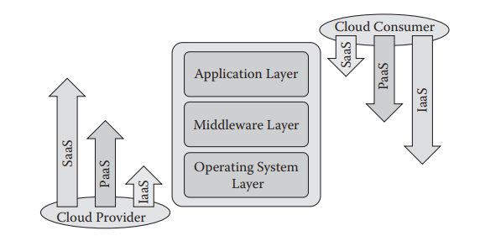

* At the cluster computing or grid computing level, many types of work are done by middleware.
* The parallel computing environments such as PVM(parallel Virtual Machine) and MPI(Message Passing Interface) are (HPC)(High Performance Computing) middleware by definition; the Hadoop system and the job scheduler such as Condor, LoadLeveler, and others are all middleware.
* The HPC middleware fills the gap that the operating systems and the programming languages lack to support parallel computing.
* At the cluster computing or grid computing level, many types of work are done by middleware.
* The parallel computing environments such as PVM(parallel Virtual Machine) and MPI(Message Passing Interface) are (HPC)(High Performance Computing) middleware by definition; the Hadoop system and the job scheduler such as Condor, LoadLeveler, and others are all middleware.
* The HPC middleware fills the gap that the operating systems and the programming languages lack to support parallel computing.
* Many research works demonstrate a typical grid computing system and its components based on grid middleware before cloud computing.
* A grid computing system aims to serve all kinds of applications.

**Grid computing** is the foundation of cloud computing infrastructure, so grid middleware is the basis of IaaS middleware.

* In addition, the IaaS middleware may include components such as system management, network management, billing and operation support systems, provision, configuration, automation, orchestration, service level agreement (SLA) management, and so on.

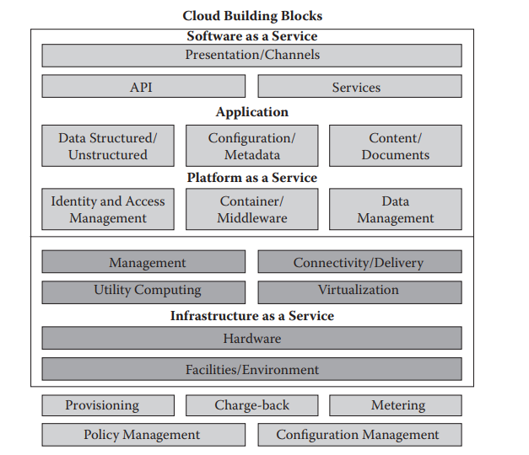

* Multitenancy is one of the basic functions of PaaS middleware, evolving from the traditional platform middleware.
* The multitenant efficiency functionalities of a PaaS platform are often required and implemented in a traditional middleware such as the threetiered application servers.
* The more middleware is shared, the cloud systems scale to larger numbers of tenants and with lower operational costs.
* Salesforce.com was included for the first time in 2010, most likely because its foundational platform (force.com) is recognized as one of the most important cloud (PaaS) middleware vendors.
* The cloud middleware consists of two kinds of middleware—IaaS and PaaS middleware—and their relation is shown in Figure.

Note: SaaS are not middleware, they are applications on top of middleware.

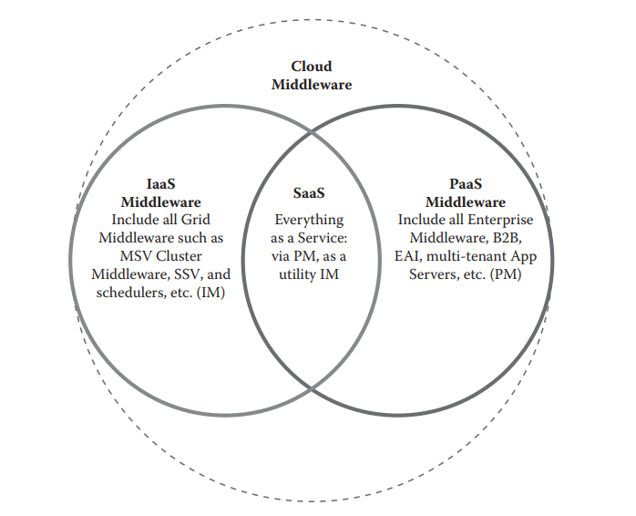

**NIST’s SPI Architecture and Cloud Standards**

According to U.S. National Institute of Standards and Technology (NIST) Cloud computing is a model for enabling ubiquitous, convenient, on demand network access to a shared pool of configurable computing resources (e.g., networks, servers, storage, applications, and services) that can be rapidly provisioned and released with minimal management effort or service provider interaction.

This cloud model is composed of the following:

* Three service models: IaaS, PaaS, and SaaS
* Four deployment models: private cloud, public cloud, community cloud, and hybrid cloud
* Five essential characteristics: on-demand self-service, broad network access, resource pooling, rapid elasticity, and measured service

**Cloud Deployment Models**

* The cloud deployment model identifies the specific type of cloud environment based on ownership, scale, and access, as well as the cloud’s nature and purpose.
* The location of the servers you’re utilizing and who controls them are defined by a cloud deployment model.
* It specifies how your cloud infrastructure will look, what you can change, and whether you will be given services or will have to create everything yourself.
* Relationships between the infrastructure and your users are also defined by cloud deployment types.

**Private Cloud**

* The private cloud deployment model is a dedicated environment for one user or customer. You don’t share the hardware with any other users, as all the hardware is yours.
* It is a one-to-one environment for single use, so there is no need to share your hardware with anyone else.
* The main difference between private and public cloud deployment models is how you handle the hardware.
* It is also referred to as “internal cloud,” which refers to the ability to access systems and services within an organization or border.

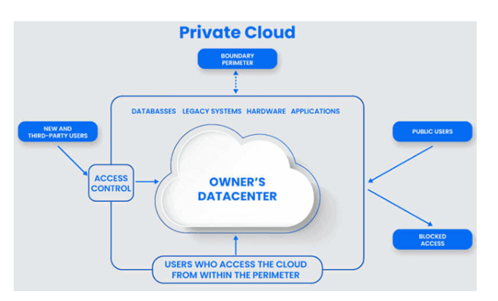

**Public Cloud**

* The public cloud is available to the general public, and resources are shared between all users.
* They are available to anyone, from anywhere, using the Internet. The public cloud deployment model is one of the most popular types of cloud.
* This computing model is hosted at the vendor’s data center. The public cloud model makes the resources, such as storage and applications, available to the public over the WWW. It serves all the requests; therefore, resources are almost infinite.

**Community Cloud**

* Community clouds are cloud-based infrastructure models that enable multiple organizations to share resources and services based on standard regulations.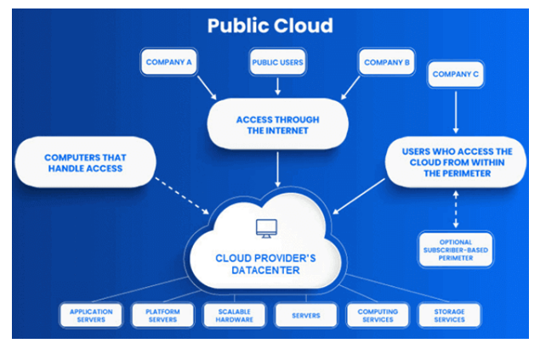
* It provides a shared platform and resources for organizations to work on their business requirements.
* This Cloud Computing model is operated and managed by community members, third-party vendors, or both.
* The organizations that share standard business requirements make up the members of the community cloud.

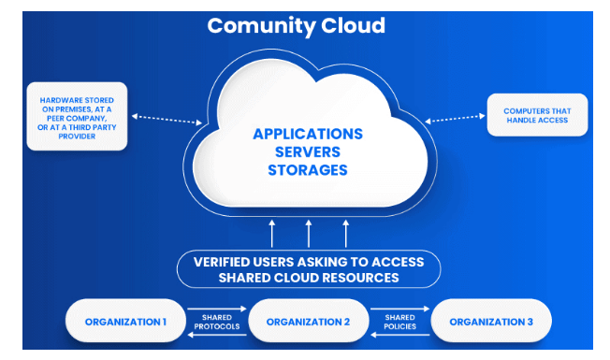

**Hybrid Cloud**

* A hybrid cloud deployment model combines public and private clouds.
* Creating a hybrid cloud computing model means that a company uses the public cloud but owns on-premises systems and provides a connection between the two.
* They work as one system, which is a beneficial model for a smooth transition into the public cloud over an extended period.
* Some companies cannot operate solely in the public cloud because of security concerns or data protection requirements.
* So, they may select the hybrid cloud to combine the requirements with the benefits of a public cloud.
* It enables on-premises applications with sensitive data to run alongside public cloud applications.

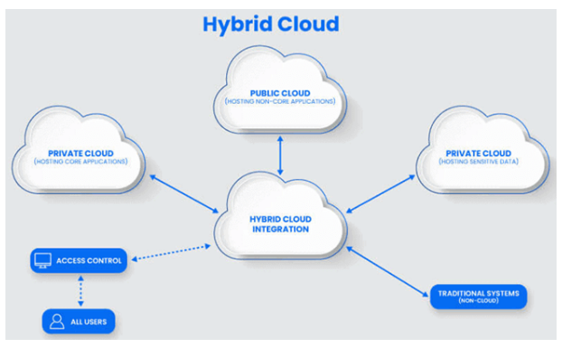

* The NIST specification is a milestone that clarifies and settles most of the confusion and arguments about cloud computing.
* It can be used as a starting point for standardization.
* Electronics and Telecommunications Research Institute (ETRI) of Korea proposed to address standards on nine aspects
  + Definition, taxonomy, terminologies
  + Provisioning model
  + Business process
  + Security
  + Interoperability
  + Legality
  + Environmental issues
  + Architecture
  + Availability
* The NIST specification covers a few of the aspects, such as the standardization of definition, taxonomy, and terminologies.
* Some of the standardization in the grid computing domain provided a foundation for extended work, such as the MPI(Message Passing Interface), openMP standards, as well as job description language standards for job scheduling.
* The following are some of the works done by those standards organizations:
  + NIST: Working definition of cloud computing
  + Distributed Management Task Force: Open Virtualization Format, Open Cloud Standards Incubator, DSP-IS0101 Cloud Interoperability White Paper V1.0.0
  + Cloud Management Working Group: DSP-IS0102 Architecture for Managing Clouds White Paper V1.0.0, and DSP-IS0103 Use Cases and Interactions for Managing Clouds White Paper V1.0.0
  + European Telecommunications Standards Institute: TC cloud definition
  + Open Cloud Consortium: Open Cloud Testbed, Open Science Data Cloud, benchmarks, reference implementation
  + The Cloud Computing Interoperability Forum: framework/ ontology, semantic web/resource description framework, unified cloud interface
  + The Open Group: SOA, The Open Group Architecture Framework
  + TM Forum: Cloud Services Initiative, Enterprise Cloud Leadership Council Goals, Future Collaborative Programs, BSS/OSS/SLA
  + ITU-T FG Cloud: Introduction to the Cloud Ecosystem: Definitions, Taxonomies and Use Cases;

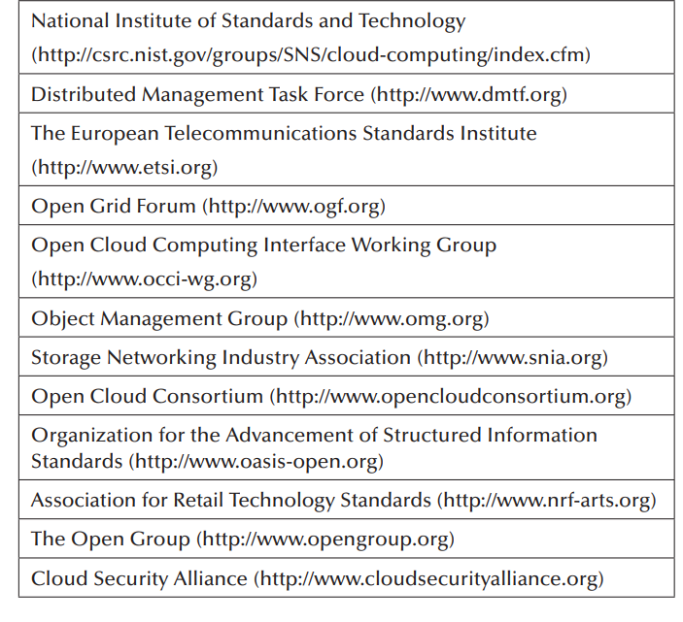

**Cloud Providers and Systems**

* Cloud computing started in 2006 when Amazon began offering its Simple Storage Service and soon following up with its Elastic Compute service, and Google’s CEO Eric Schmidt’s speech about cloud computing.
* Gartner estimated that, among the three SPI segments, SaaS generates most of the revenue, because it directly creates value for the end users.
* IaaS helps reduce the costs of organizational users, which has the fastest growth.
* The cloud computing boom has brought a surge of opportunity to the open-source world.
* Many open-source applications are now available on a SaaS basis.
* Other open-source projects have taken the steps necessary to make them easy to use in the cloud, for example, by making preconfigured images available through Amazon Web Services or other public clouds.
* Most open-source developers are contributing to the growth of cloud computing by creating the tools that make cloud computing feasible.
* They offer infrastructure, middleware, and other software that make it easier for companies to develop and run their applications in the cloud.

The following is a list of open-source projects:

* Open-source IaaS and PaaS projects: OpenStack, cloud. com Cloud Stack, OpenNebula, Eucalyptus, AppScale, Scalr, Traffic Server, RedHat Cloud, Cloudera (Hadoop), Puppet, Enomaly, Joyent, Globus Nimbus, Reservoir, Amanda/Zmanda, XCP, TPlatform.
* Open-source SaaS projects: Zoho, Phreebooks, Pentaho, Palo BI Suite, Jaspersoft, Processmaker, eyeOS, Alfresco, SugarCRM, SourceTap, KnowledgeTree, OpenKM, Collabtive, Zimbra, Feng Office, Open ERP, Openbravo, Compiere, Orange HRM, JStock, Ubuntu, OpenProj, openSIS, TimeTrex, GlobaSight.

**Five-layer panoramic view of cloud vendors and products.**

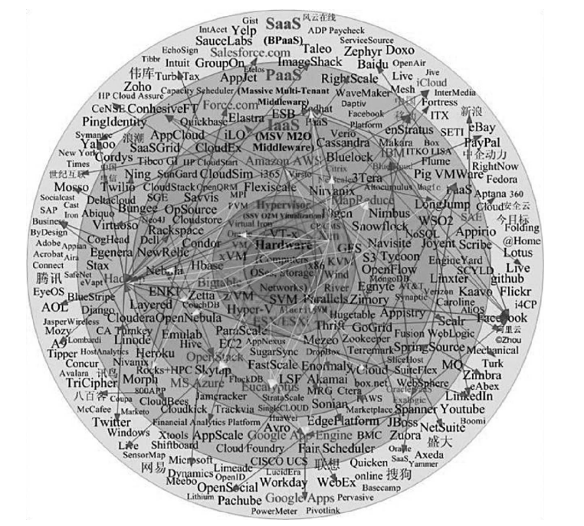

* The diagram is about panoramic view graphic of existing cloud providers and their products and services in five layers
  1. Chip and hardware supports for virtualization: Intel-VT (VT-x, VT-x2), AMD-V (SVM), SUN/Oracle UltraSPARC T1, T2, T2+, SPARC T3, and others
  2. Hypervisors (one-to-many SSV virtualization) vendors and products
  3. IaaS (many-to-one MSV virtualization) grid/cluster computing, web services–based delivery vendors and products
  4. PaaS (multitiered middleware) vendors and products
  5. SaaS vendors and products

**The Internet of Things and Cloud Computing:**

* The term Internet of Things is not as popular as cloud computing it is evidenced by the Google Trends chart.
* Part of the reason is that IoT is referred to by different terms such as machine-to-machine (M2M), connected world, smarter planet, smart grid, and the like in the United States.

However, Google trends show that machine to machine is a more popular term than cloud computing, while M2M is less popular

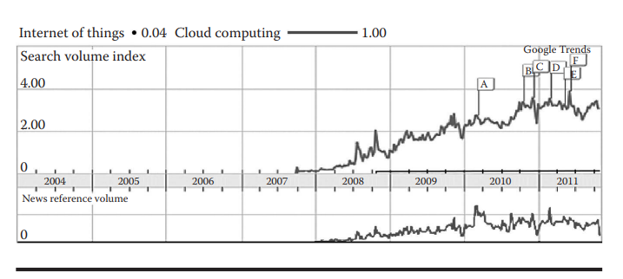

**IoT versus cloud computing**

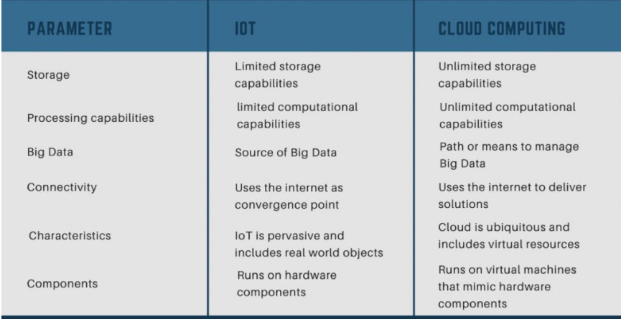

* IoT and cloud computing can be categorized as distributed computing and have many things in common or closely related:
  + Both are a type of distributed computing that relies heavily on communication networks.
  + Cloud computing is an enabling technology of the IoT.
  + The cloud and IoT are best considered as a continuum of Internet connectivity with cloud as (focusing on) the “head” and IoT as the “tails” of an octopus as shown in Figure.

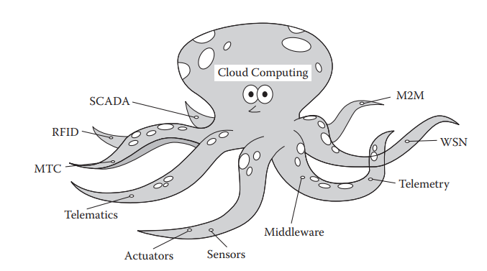

* We are in the early stages of the Internet of Things, the much-anticipated era when all devices can talk to intermediary services and to each other.
* But for this era to achieve its full potential, operators must fundamentally change the way they build and run clouds .
* The reason is that M2M interactions are far less failure tolerant than machine-to-human interactions.
* Imagine when a fleet of trucks can no longer report its whereabouts to a central control system designed to regulate how long drivers can stay on the road without resting, or when the power in your building goes out and the heating, ventilation, and air-conditioning (HVAC) system dies on a hot day because of a cloud outage.
* In the very near future, everything from elevators to cell phones to city buses will either be subject to connected control systems or use networks to report back critical information.
* The sheer volume of data flowing through networks will mushroom.
* In a dedicated or collocated hardware world, that would result in prohibitively expensive hardware requirements.
* Thus, the cloud becomes the only viable option to affordably connect, track, and manage the new Internet of Things
* In the very near future, everything from elevators to cell phones to city buses will either be subject to connected control systems or use networks to report back critical information.
* The sheer volume of data flowing through networks will mushroom.
* In a dedicated or collocated hardware world, that would result in prohibitively expensive hardware requirements.

1. Connectivity: connection for mobile and constrained objects
2. Content: massive data produced from things
3. Cloud: cloud service and cloud content storage
4. Context: context-aware design to improve performance
5. Collaboration: cooperative communications, inter-things, service sharing
6. Cognition: mine the knowledge from massive data and provide autonomous system adjustment for improvements

* Currently, no one is putting truly mission-critical applications in the cloud.
* As we build the Internet of Things and slowly ease it first onto private clouds and later onto public clouds, we have no choice but to improve the core of the cloud or risk catastrophic consequences from failures.
* Because on the Internet of Things, no one can blame it on user error and simply ask that a hotel air conditioner, an airplane, or a bank of traffic lights restart its virtual server on the fly and reset its machine image.
* In short, the Internet of Things will not take off without an up-to-date, secure, and scalable cloud computing infrastructure.

**Mobile Cloud Computing:**

* Smart phones are becoming thin clients of cloud services, which render software and content vendors such as Microsoft, Google, and Apple into the upper streams of the smart phone value chain.
* Apple’s iCloud services, announced in June 2011 that run on Amazon Web Service and Microsoft Azure IaaS, symbolize the start of Cloud Phones which is followed by traditional mobile phone firms and Internet services companies such as Google worldwide.
* In fact, a large percentage of Android and iPhone widgets are already cloud services based. This is real mobile cloud computing (mCC).
* Apple’s iCloud services allow users to store data such as music files on remote computer servers for download to multiple devices such as iPhones, iPods, iPads, and personal computers running Mac OS X or Microsoft Windows.
* Windows Live Mesh is a free-to-use Internet-based file synchronization application by Microsoft that is designed to allow files and folders between two or more computers to be in sync with each other on Windows and Mac OS X computers.
* Android Cloud to Device Messaging (C2DM) is a service that helps developers sending data from servers to their applications on Android devices.
* The service provides a simple, lightweight mechanism that servers can use to tell mobile applications to contact the server directly, to fetch updated application or user data.
* The C2DM service handles all aspects of queuing of messages and delivery to the target application running on the target device.
* With HTML5, the widget client may again be unified with one browser client just as it happened on PCs while at the same time keeping the revenue generation model of charging the users based on application widget download.
* The HTML5 has features such as offline support, canvas drawing based on low footprint SVG graphics, GeolocationAPI, video and audio streaming support without flash, WebStorage, CSS3 Selectors, 2D animations for mobile cloud applications.
* ADT’s Pulse is a project associated with Android@Home. It not only allows you to arm and disarm your ADT security system, but also includes very impressive controls for lights, security cameras, and even thermostats.
* Another example is the Schlage LiNK iPhone applications that can let you turn off your home lights remotely while enjoying a vacation in Hawai.

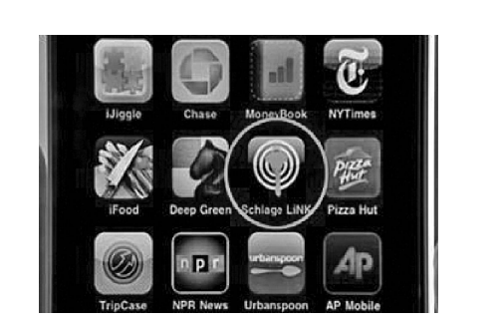

* This relationship also allows the Schlage LiNK to work easily with a Trane thermostat, and so on.
* As IP-enabled, affordable sensor devices of all types become available and are placed around the earth forming a “sensing cloud,” integrating the diverse sensor data streams into the web can serve different user or machine queries.
* In the sensorMap project of Microsoft and the Pachube project, people are encouraged to contribute real-time sensor information to the cloud subject to privacy and security constraints.
* Intelligent mobile devices can act as hubs or sources and sinks of such real-time streams as shown in the Pachube ecosystem graphic.
* It’s not hard to imagine that, over time, all of the phones and mobile devices will become thin clients that receive cloud services and smart devices that send information such as location or environment data to the cloud, to finally achieve the full potentials of M2M; i.e., machine to machine, machine to mobile, machine to man connectivity.
* Telecom operators have been investing big money to build cloud infrastructure for M2M applications.
  + Verizon Wireless and Sierra Wireless have announced a new collaboration to co-market Sierra Wireless’ AirVantage , a cloud-based platform for developing, deploying, and operating the next generation of connected devices and M2M applications.
  + AT&T is working with Axeda to build cloud-based applications for telematics, security solutions, monitoring, supervisory control and data acquisition (SCADA), point of sale, asset management and similar M2M deployments. AT&T’s innovative service delivery platforms complement its network and expertise for a broad range of wireless data applications and industries;
  + In China, China Mobile (Big Cloud), China Telecom (Nebula), and China Unicom are all building cloud computing to support iCloud/iPhone-like “Cloud Phone” and M2M applications.
* Mobile computing, cloud computing, and IoT are intertwined with each other, like the many facets of a diamond. The core is connectivity and software-enabled resource sharing and services.

**MAI versus XaaS: The Long Tail and the Big Switch**

* The difference between EAI and business-to-business/business-to consumer (B2B/B2C) is that one is for internal Intranet and the other is for external Internet integration.
* The concepts of M2M application integration (MAI) and XaaS (Everything as a Service) were proposed they are the extensions of EAI and B2B/B2C respectively in the IoT space.
* Today, the majority of IoT devices live in the MAI systems that exist in the Intranet and Extranet.
* Only a fraction of the devices are available on the Internet. The focus of MAI is connectivity and monitoring.
* In the future, XaaS of IoT will provide more services to a larger audience, as shown in Figure.

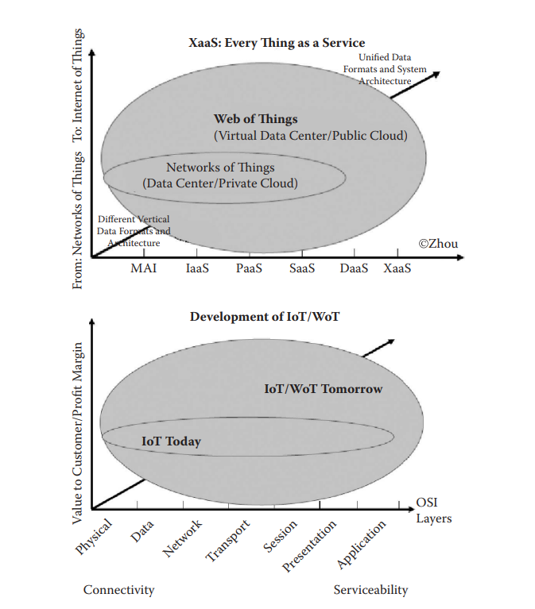

**Evolution of IoT in the cloud.**

* The Long Tail theory was popularized by Chris Anderson in an October 2004 Wired magazine article , in which he mentioned Amazon and Netflix as examples of businesses exploiting the Long Tail strategy and making enormous profits.
* The Long Tail refers to the statistical property that a larger share of population rests within the tail of a probability distribution than observed under a “normal” distribution. Anderson believes that IoT finally makes sense after so many years .
* The web technology on top of the Internet makes the harvesting of Amazon’s online book-selling business Long Tail cost-effective.

Examples of things that are on the Internet are meters or sensors in Google’s Powermeter, Microsoft’s Sensormap, or on Pachube.com; the list is not long.

* By the same token, with the constant development of the Internet of Things, more and more things or objects will be connected to the intranet, extranet, and finally the Internet with proper security measures, making the harvesting and utilization of the IoT Long Tail cost-effective and secure.
* New innovative business models like that of Amazon and Netflix of today will emerge, and the ubiquitous IoT applications will become widespread and prosper.
* At the beginning of IoT development, many people thought it was a Blue Ocean opportunity just like when the web and the browser were invented.
* As we can see now, the MAI of IoT is an extended application of EAI, and the XaaS is an extension of web applications that cover devices and things.
* Most of the current IoT applications are foundational works that involve “Red Ocean” competitions.
* However, gold mining opportunities do exist when more and more ubiquitous devices are connected to the web; new application paradigms and new business models are on the horizon, as shown in Figure.

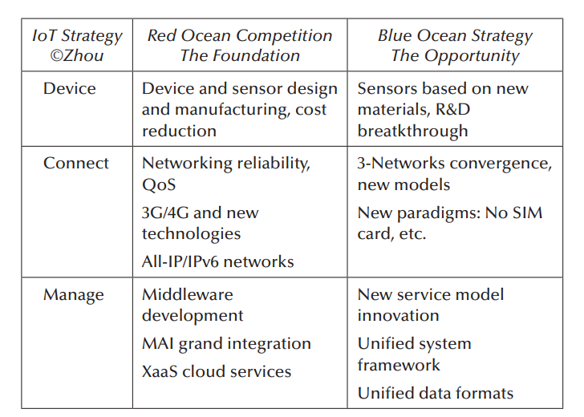

IoT Red Ocean versus Blue Ocean

**The Big Switch:**

* The early years of electrification were technologically limited.
* An electrical grid wasn’t feasible and electricity was generated locally.
* Technology changed over time and electricity was rapidly centralized and networked.
* Power was produced remotely and delivered via a vast network of wires and cables.
* Computing resources can be used and charged just as electricity is consumed and billed
* Examples are Amazon’s EC2 (Elastic Computing Cloud) and S3 (Simple Storage Services).
* With the Internet of Things comes the big paradigm switch: as described before, the power grid becomes a two-way electricity supply, a smart grid system where people can store their electricity surplus generated by their solar system back to the smart grid.
* The ubiquitous Internet of Things makes the consumption of everything possible, just like electricity and computing resources.

Examples include changing the driving route home in a telematics-enabled car by checking on a traffic congestion map generated using sensor-based vehicle-to-road, vehicle-to-vehicle ITS systems, a service provided by a TSP, and so on.

**The Cloud of Things Architecture**

* IoT and cloud computing have many comparable characteristics.

Cloud computing has three layers:

IaaS, PaaS, and SaaS (SPI).

IoT also consists of three layers: devices, connect, and manage (DCM) or devices, networks, and applications (DNA).

* Cloud computing has public cloud, private cloud, hybrid cloud, and so forth. The IoT also has Intranet of Things, Extranet of Things, Internet of Things, and so on.
* Mimicking the NIST specification of cloud computing, a tentative IoT architecture/framework specification is proposed.
* One of the foundations of this specification is the four-pillar categorization of IoT.
* Below figure shows the general framework of the Internet of Things. Its definition, attributes, characteristics, use cases, underlying technologies, issues, risks, and benefits will be refined and changed over time in spirited debates by the public and private sectors.
* The Internet of Things provides the means to access and control two categories of ubiquitous and uniquely identifiable devices—those that have inherent intelligence and those that are externally enabled—via all sorts of wired and/or wireless communications in all kinds of networking environments, supported by cloud computing technologies with adequate security measures, to achieve pervasive connectivity and grand integration and to provide services such as monitoring, locating, controlling, reporting, decision support, and so on.

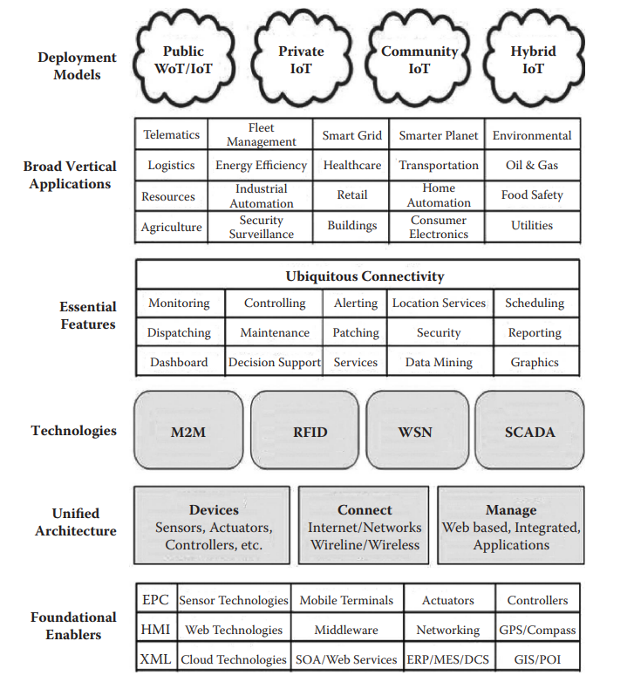

**The Cloud of Things architectural specification**

**Four Deployment Models**

* **Private IoT:** The IoT MAI system is operated solely for an organization such as a building management system operated by a property management firm. It may be managed by the organization or a third party and may exist on premise (intranet) or off premise (extranet).
* **Public IoT:** The IoT system is made available to the general public or a large industry group and is owned by an organization, such as Pachube, selling IoT services.
* **Community IoT:** The integrated system is shared by several organizations and supports a specific community that has shared concerns (e.g., mission, security requirements, policy, and compliance considerations). It may be managed by the organizations or a third party and may exist on premise or off premise.
* **Hybrid IoT:** The IoT system is an integrated composition of two or more of the above IoT systems (private, community, or public) that remain unique entities but are bound together by standardized or proprietary technology that enables data and application portability.

**Vertical Applications**

* Telematics, fleet management, transportation
* Smart grid, energy efficiency
* Smarter planet
* Environmental protection
* Logistics, retail
* Healthcare
* Security/surveillance
* Resources (such as water resource management, etc.)
* Industrial automation
* Home automation, buildings
* Food safety, agriculture
* Security surveillance .