**UNIT-5**

1. **Data Caching**

* Caching Data is a process that stores multiple copies of data or files in a temporary storage location—or cache—so they can be accessed faster.
* It saves data for software applications, servers, and web browsers, which ensures users need not download information every time they access a website or application to speed up site loading.
* Cached data typically includes multimedia such as images, files, and scripts, which are automatically stored on a device the first time a user opens an application or visits a website.
* This is used to quickly load the application or website’s information every time the user subsequently opens or visits it.
* A [Domain Name System (DNS)](https://www.fortinet.com/resources/cyberglossary/what-is-dns) caches DNS records to perform faster lookups, content delivery networks (CDNs) use caching to [reduce latency](https://www.fortinet.com/resources/cyberglossary/latency), and web browsers cache requested Hyper Text Markup Language (HTML) files, images, and JavaScript to load websites faster.
* For example, when a user visits a website for the first time, an application or browser retains information to help them access it faster and more efficiently.

**How Does Caching Work?**

* Cached data works by storing data for re-access in a device’s memory.
* The data is stored high up in a computer’s memory just below the central processing unit (CPU).
* It is stored in a few layers, with the primary cache level built into a device’s microprocessor chip, then two more secondary levels that feed the primary level.
* This data is stored until it's time to live (TTL), which indicates how long content needs to be cached for, expires or the device’s disk or hard drive cache fills up.

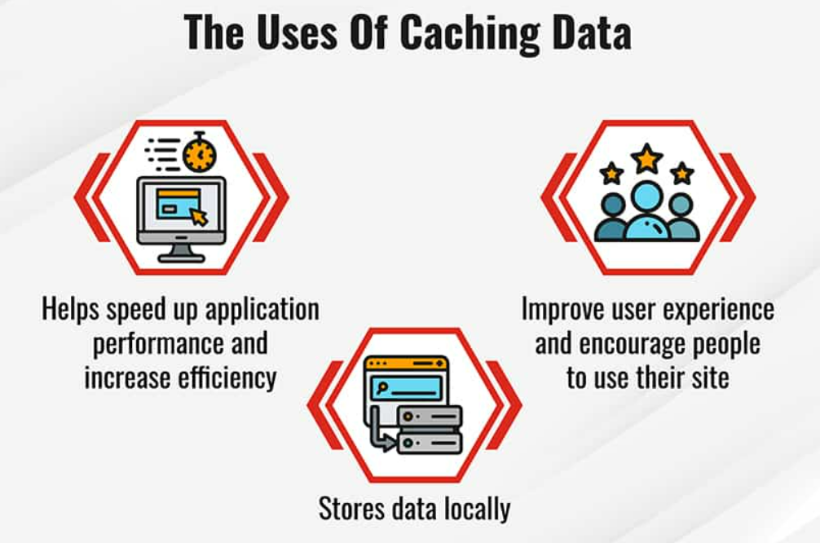

**Benefits of Caching**

* When a user visits a new website, their browser needs to download data to load and display the content on the page.
* To speed up this process for a user's future visit, browsers cache the content on the page and save a copy of it on the device hard drive.
* As a result, the next time the user goes to that website, the content is already stored on their device and the page will load faster.
* Cache memory offers extremely low latency, which means it can be accessed quickly.
* As a result, it speeds up loading the second time a user accesses an application or website.
* Cache cannot store a lot of memory, so it only stores small files like images and web text.
* Data can be cached in many ways, but it is typically reliant on the website’s owner to set a "header," which tells a device that data can be cached and for how long.
* This instructs a user’s browser what information to download and where to store the temporary files.
* The user can then create policies and preferences around what data they cache and even clear their whole cache to reduce the amount of data stored on their device.

**2. Smart Parking**

* An IoT-based parking system is a centralized management that enables drivers to search for and reserve a parking spot remotely through their smart phones.
* It offers a convenient arrangement for drivers to park their cars when they are looking to avoid potential traffic congestion.
* The system’s hardware sensors detect available slots and communicate the information to the drivers in that area in real-time.
* IoT technology ensures that they do not have to worry about finding an available space again – allowing them to travel conveniently.
* Besides, the connected device sends alerts about peak times and surcharges.
* No one wants to struggle to find a parking slot or pay more at any given point.
* Using smart parking technology will help maximize the consumption of existing parking space, increase the effectiveness of parking operations, and facilitate easier traffic flow with just a few taps on a mobile app.
* Smart parking solutions are intended to give drivers complete control of their journey - from start to finish - without having to hunt for parking.
* The IoT technology helps save costs and minimize travel time.
* IoT forms the foundation for real-time [**data collection**](https://www.intuz.com/blog/guide-on-iot-data-collection) and analysis.
* IoT provides the means to connect various devices and sensors in the parking ecosystem and fetch data that can be used to optimize operations.
* **The massive problem with the current parking management :**
* Research shows that most cars search for parking spots for around [**3.5 to 14 minutes**](https://www.researchgate.net/publication/313879093_How_Much_Urban_Traffic_is_Searching_for_Parking).
* Drivers who lack patience sometimes park illegally and if caught, have to pay hefty fines.
* Another research shows that up to [**68%**](https://www.un.org/development/desa/en/news/population/2018-revision-of-world-urbanization-prospects.html) of the world's population would reside in urban areas by 2050.
* As we advance, this will directly affect how drivers park their cars in urban areas.
* They help in eliminating the following problems:
* Overpaying
* Environmental impact
* Parking inappropriately
* Overcrowded parking spaces
* Insufficient parking space utilization

**How IoT can be used in parking management**

* Drivers can plan trips and commutes keeping slot occupancy in mind.
* Parking facility managers can optimize the use of the personnel and the available space.
* Create “smart” parking meters that accept payments via credit card or smartphone and provide real-time information on space availability.
* Send real-time data from IoT sensors to a cloud server and share it with users to provide them with the details of free-parking spaces.
* Determine the number and position of vacant parking spaces precisely using **[IoT](https://www.intuz.com/guide-on-top-iot-sensor-types)** [**sensors**](https://www.intuz.com/guide-on-top-iot-sensor-types).
* Reduce congestion and improve traffic flow by using sensors to monitor parking space availability and direct drivers to available spaces.
* The parking management company can use a cloud-based IoT dashboard. It uses gathered sensor data to mine intelligible insights that are visually appealing and provides a clear picture of the parking facility.
* Optimize parking operations and improve security by tracking vehicles entering and exiting a parking facility.
* [**Mobile applications**](https://www.intuz.com/mobile-app-development-guide) can display parking data to drivers and send alerts in case of a security breach.

**IoT-based sensing devices used for smart parking**

* Ultrasonic sensors measure the distance of a target object by eliminating ultrasonic sound waves and convert the reflected sound into an electrical signal.
* Electromagnetic field detection is helpful to detect metals as they pick up minute changes in the magnetic field.
* Infrared sensors can detect motion and gauge temperature changes in the immediate surroundings.

**Benefits of IoT in smart parking management**

* Reduced costs
* Enhanced security
* Increased efficiency
* Improved customer experience.

**3. Home**

* A smart home is a household with internet-connected appliances those appliances remotely controlled by using a tablet or smartphone.
* It uses [smart devices](https://www.helpwire.app/blog/iot-devices/) such as smart TVs, smart thermostats, air conditioners, and even a robot vacuum.
* They are then connected together in a single network, through either hardwired or wireless systems like Zigbee, Wi-Fi, Bluetooth, and NFC, among others.
* Using the Internet of Things (IoT) technology, smart appliances can communicate and share real time data with each other.
* This allows the devices to perform scheduled and automated tasks.
* IoT home gadgets bounce data back and forth with the use of sensors, learning and processing the patterns to automatically adjust themselves according to customers comfort.
* Some smart home Internet of Things applications are automatic light switches, burglar alarms, and voice-activated sound systems.

**IoT Applications in the Smart Home**

* + Electricity
  + Climate
  + Leak Protection
  + Multimedia
  + Home Security

**4. Learning in Cities**

* Smart city is defined as a city that uses IoT and ICT (information and communications technology) to enhance infrastructure and services provided to citizens and businesses.
* A smart city project aims to streamline a city’s day-to-day operations.
* A smart city uses several technologies, such as IoT, artificial intelligence (AI), software solutions, communication networks, and more.
* IoT is the key to turning a city into a smart city.
* IoT is a system of several connected devices, such as sensors, vehicles, and home appliances.
* IoT devices can communicate and transfer data via the internet without any human intervention.

Key characteristics of a smart city or IoT smart city are:

* + Smart city infrastructure based on advanced technology
  + Environmental friendly initiatives
  + Smart public transport system
  + Integrated urban planning
  + Ability to allow citizens to interact with smart city ecosystems, connected buildings, mobile devices, etc.

**Internet of Things and Smart Cities**

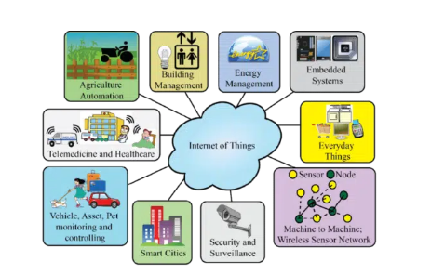

* IoT technology is at the core of smart cities. From connected vehicles and connected buildings to internet-connected garbage bins and IoT-based fleet management, there are many IoT solutions for smart cities.
* The internet of things for smart cities allows city officials to manage and control connected devices remotely and ensure smooth operations.
* Although smart cities involve several factors, smart city architecture in IoT usually progresses through three basic steps.
  + First, IoT sensors (installed throughout the city) collect real-time data.
  + Next, analytics systems or data analysts analyze the sensors’ data to gain valuable insights.
  + Finally, smart city organizers use the insights to create smart solutions, optimize operations, and improve efficiency and services provided to the residents.

**Applications of IoT in Smart Cities**

* Smart Lighting Systems
* Smart Traffic Management
* IoT-based Smart Waste Management in Cities
* IoT-based Transport and Healthcare
* IoT for Smart Parking

**Advantages of IoT Solutions for Smart Cities**

* Enhanced Efficiency and Effectiveness
* Reduced Crime
* Better Environment
* Better Services
* Reduced Traffic Congestion

**Smart City Cloud Computing and IoT**

* IoT-based devices produce a lot of data. Hence, they need a place to store this data, but these devices usually have limited storage, performance capabilities, and power supplies. This is where [cloud computing](https://www.ridge.co/blog/what-is-cloud-computing/)comes in.
* The cloud offers shared resources, such as networks, storage, software, and servers. Smart cities can store the data collected by IoT sensors in the cloud’s unlimited storage.
* Cloud services and smart city cloud platforms also enable city officials to embed IoT data within IoT-connected electronic devices.

**Smart Cities Examples**

* **London:** London has developed a SmartPark project for smart parking to reduce traffic congestion. This project allows the citizens to locate parking spaces instantly.
* **Paris:** Paris has announced the [Paris Smart City 2050 project](https://www.businessinsider.com/paris-as-a-smart-city-2015-1), which aims to create several high-rise buildings with positive energy output.
* **Pune:**One of the biggest examples of a smart city in India is Pune, which is working on adopting IoT technology to improve the quality of life for citizens. Pune has already implemented smart LED and e-bikes.
* The [Nordic Smart City Network](https://nscn.eu/) is based on a collaboration of 20 cities in five Nordic countries. The purpose of the network is to “explore the Nordic way to create livable and sustainable cities.”

**5. Data Delivery Pricing:**

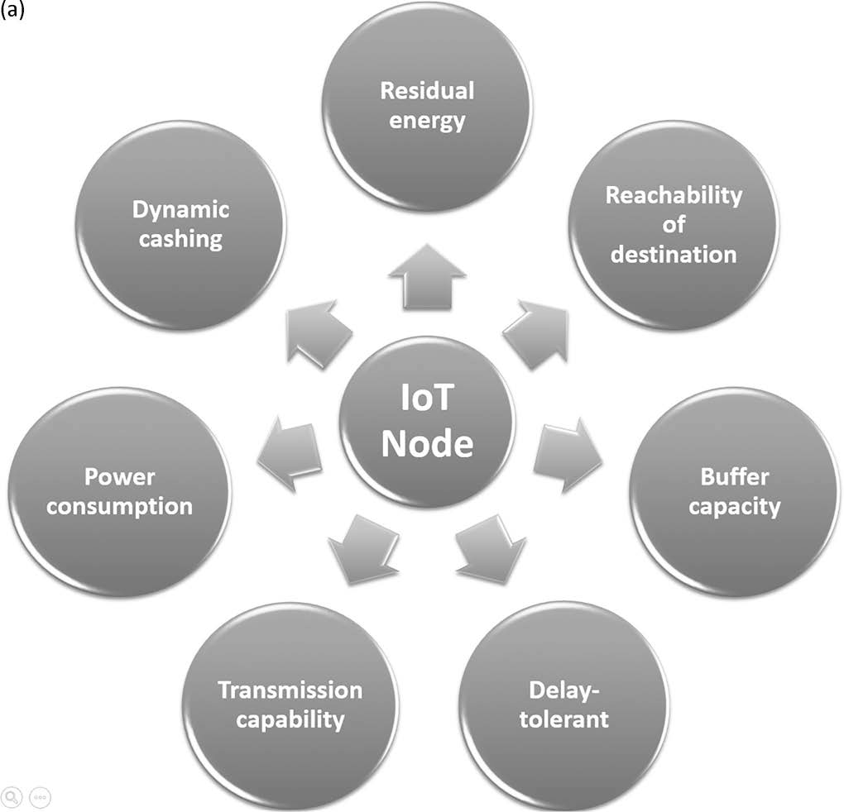

**6. Planting & Farming**

* Smart farming refers to managing farms using modern Information and communication technologies to increase the quantity and quality of products while optimizing the human labor required.
* Technologies available for present-day farmers are:
  + Sensors: soil, water, light, humidity, temperature management
  + Software:  specialized software solutions that target specific farm types or applications agnostic [IoT platforms](https://www.iotforall.com/how-to-choose-the-best-iot-platform)
  + Connectivity: [cellular](https://www.iotforall.com/cellular-iot-explained-nb-iot-vs-lte-m), [LoRa](https://www.iotforall.com/making-connectivity-accessible-for-all-with-lora-and-lorawan)
  + Location: GPS, Satellite
  + Robotics: Autonomous tractors, processing facilities
  + Data analytics: standalone analytics solutions, data pipelines for downstream solutions

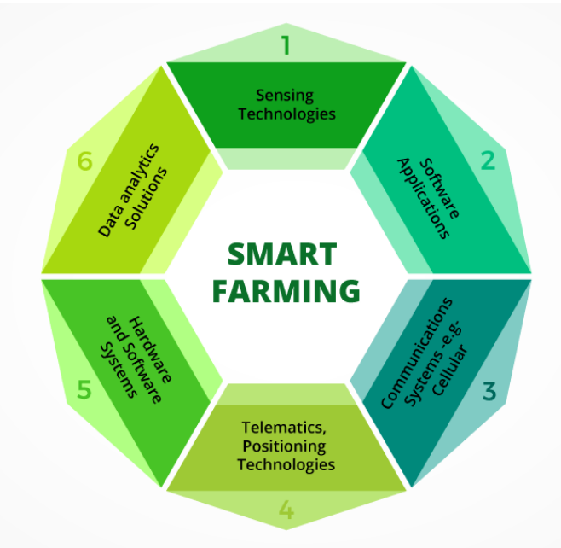

**The IoT-Based Smart Farming Cycle**

* IoT devices installed on a farm should collect and process data in a repetitive cycle that enables farmers to react quickly to emerging issues and changes in ambient conditions. Smart farming follows a cycle similar to this one:
* 1. Observation . Sensors record observational data from the crops, livestock, soil, or atmosphere.
* 2. Diagnostics. The sensor values are fed to a cloud-hosted IoT platform with predefined decision rules and models—also called “business logic”—that ascertain the condition of the examined object and identify any deficiencies or needs.
* 3. Decisions . After issues are revealed, the user, and/or machine learning-driven components of the IoT platform determine whether location-specific treatment is necessary and, if so, which.
* 4. Action . After end-user evaluation and action, the cycle repeats from the beginning.

**IoT Solutions to Agricultural Problems**

* Precision Farming
* Precision Livestock Farming
* Automation in Smart Greenhouses
* Agricultural Drones
* Third Green Revolution